Helping Hand in Service

Visit by Simon Knutsson, Natalie Stone, Holden Karnofsky and Elie Hassenfeld on 9/21/10. We met with Helping Hand in Service founder and president Dr. Kavita Kapoor.

We recently visited a small charity in the slum Geeta Nagar in South Mumbai. Some observations about Geeta Nagar:

- The slum was much smaller than Dharavi and felt somewhat less crowded. It is located on a strip of land along the ocean at the Southern tip of Mumbai. While the scenic view and ocean breeze made this slum feel more pleasant to than Dharavi, we were told that flooding is frequently a problem.
- We were told that many of the adults living in the slum worked outside the slum as drivers and maids for the wealthy households of the surrounding areas such as Colaba and Nariman Point. Unlike in Dharavi, most of the people we met appeared to be comfortable conversing in English.
- We were told that the slum has electricity and running water, but that the water supply is unreliable.

- We visited during a Hindu festival in honor of the god Ganesh, and we passed at least a dozen large, colorful statues of the god (pictured to the right), which would be immersed in the ocean at the end of the festival (meaning that new statues were purchased each year). One of Helping Hand in Service's teachers complained to us that the money raised by the committee responsible for the statues (Rs. 30,000-50,000, or about $670-$1,110) would be better spent on schools or on supporting the slum's cancer patients.
- There appeared to be at least a few expensive motorcycles in the slum.

The charity we saw, Helping Hand in Service, focuses on providing pre-school and supplementary education to children and some adults in the community. Helping Hand in Service's President, Dr. Kavita Kapoor, was kind enough to take us to the organizations' classrooms and to speak with us about the organization.

Helping Hand in Service began as a feeding program for a few children in a day care program and has grown into an organization with 18 teachers and 5 classrooms, and serving over 300 children and 100 women. The organization's current annual budget is about $27,000. We saw all five classrooms on our visit, which were scattered throughout the slum in rented rooms. We also saw an abandoned Lion's Club building that Helping Hand in Service is seeking funds to purchase and convert into a school building. Four of classrooms we saw had classes in progress at that time:
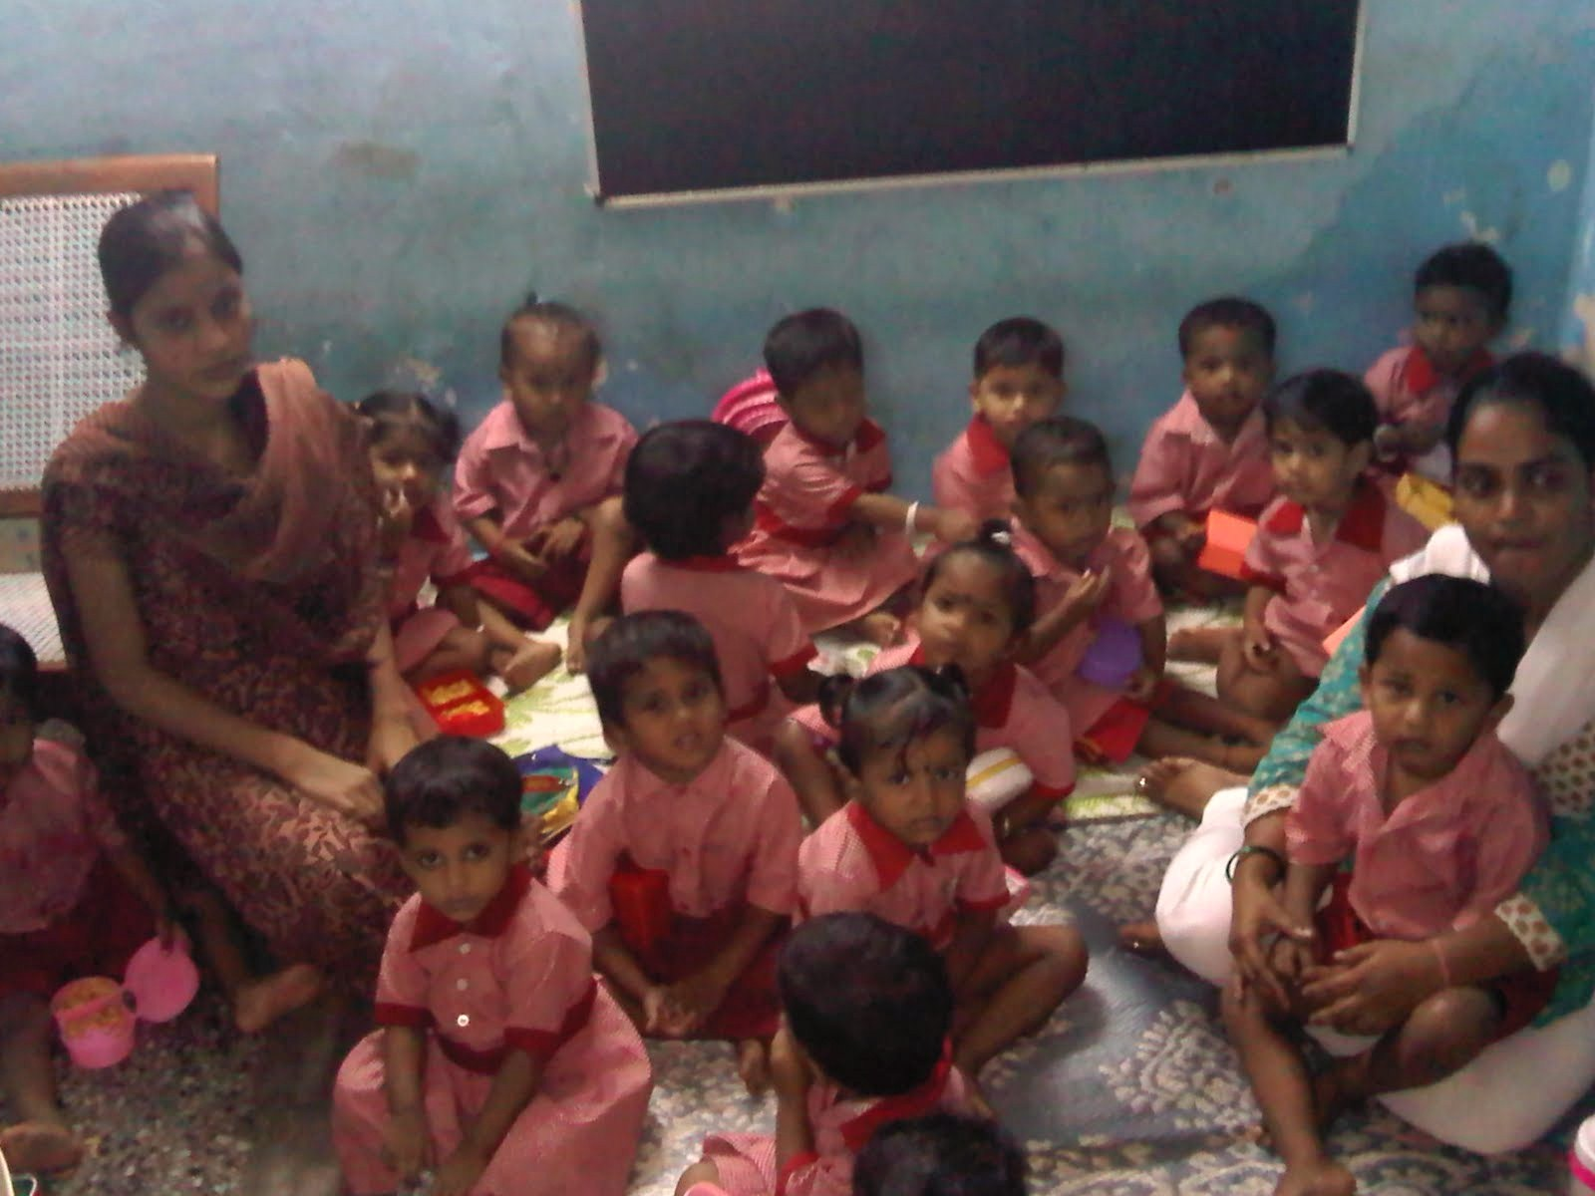
Play group

The first class we saw was for 2-3 year olds. There were 22 children and 2 teachers. The children were all in uniforms and sat quietly while we were there. We were told that they receive a breakfast of bread, jam, and fruit every day.

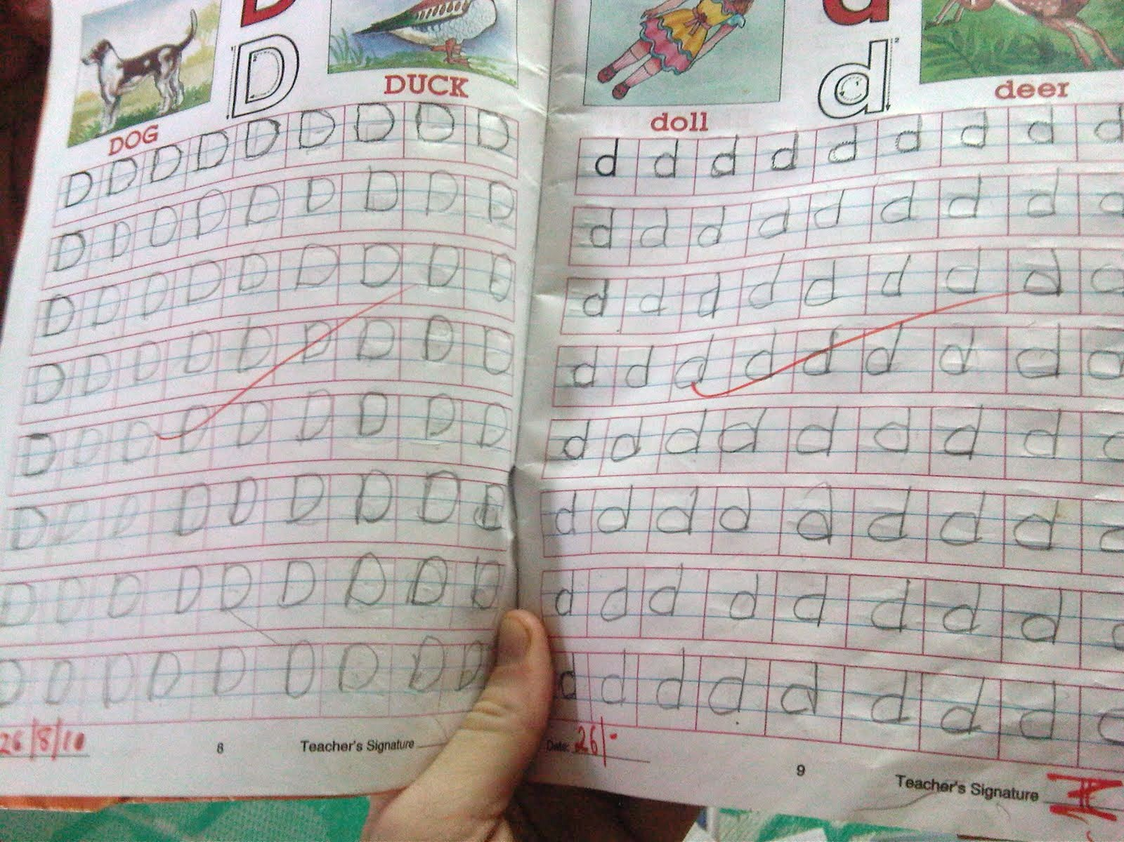
Senior kindergarten

The second class was in a small, tidy room with about 13 students and one teacher. We were told that these were students who had applied for primary school, had not been admitted, and were expected to attend the following school year. When we entered, the students were working on a handwriting exercise, copying English letters repeatedly.

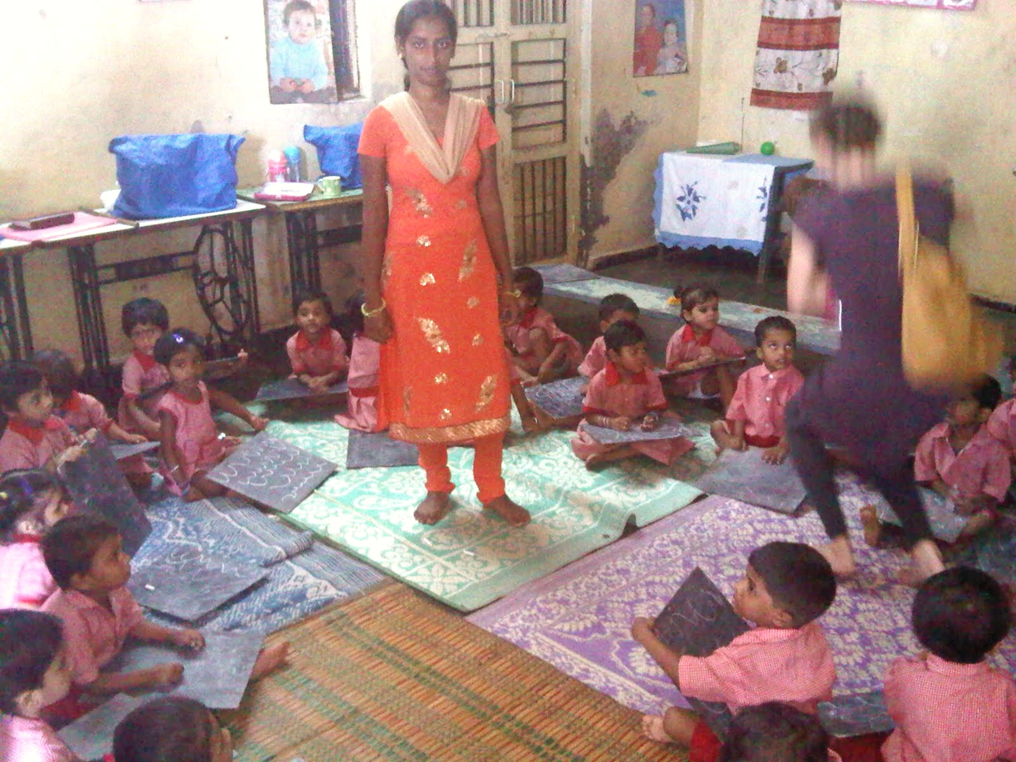
Nursery

This was the largest class we saw, with 38 students and 2 teachers. The children appeared to be between 3 and 5 years old. The room was large and very warm. The children appeared to be working on a handwriting exercise with chalk and slates. The slates that had writing on them (primarily repeated shapes, rather than letters). Instruction was in both Hindi and English. The teacher told us that she had participated in the Helping Hand in Service program when she was younger.

Outside the nursery class, we saw a latrine, which Dr. Kapoor told us was built with donor funds to prevent children urinating over the edge of the ocean and risking injury. During the five or so minutes we were outside the nursery, we did not see anyone use the toilet, though we did observe several young boys in school uniforms urinating towards the ocean.

Dr. Kapoor told us that the nursery program cannot currently accept all children who would like to join the program.

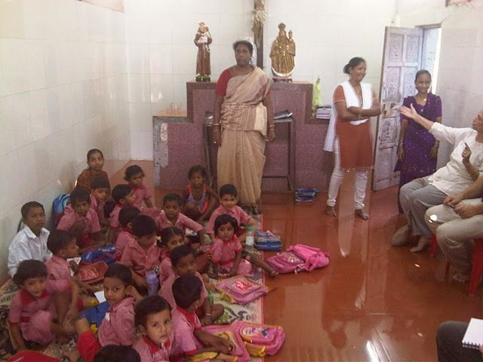
Junior kindergarten

This class took place in a small local church. The students sung English songs familiar to us ("got a peanut, got a peanut, got a peanut, just now…" and "when you're happy and you know it"). There were 2 teachers and about 25 students. The teacher spoke Hindi to the students, but conversed easily with us in English. Two of the students were considerably older than the others. We were told that one of them, a seven-year-old boy, had been in the second grade in his village, but that he had recently come to Mumbai and was enrolled in the pre-school to learn English. We were told that this was a requirement for entering school in Mumbai. The other was an adolescent girl who we were told had also recently come to Mumbai and spoke neither Hindi nor English.

In each of the classrooms we visited, Dr. Kapoor distributed candy to each of the children, or gave the candy to us and asked us to distribute it.

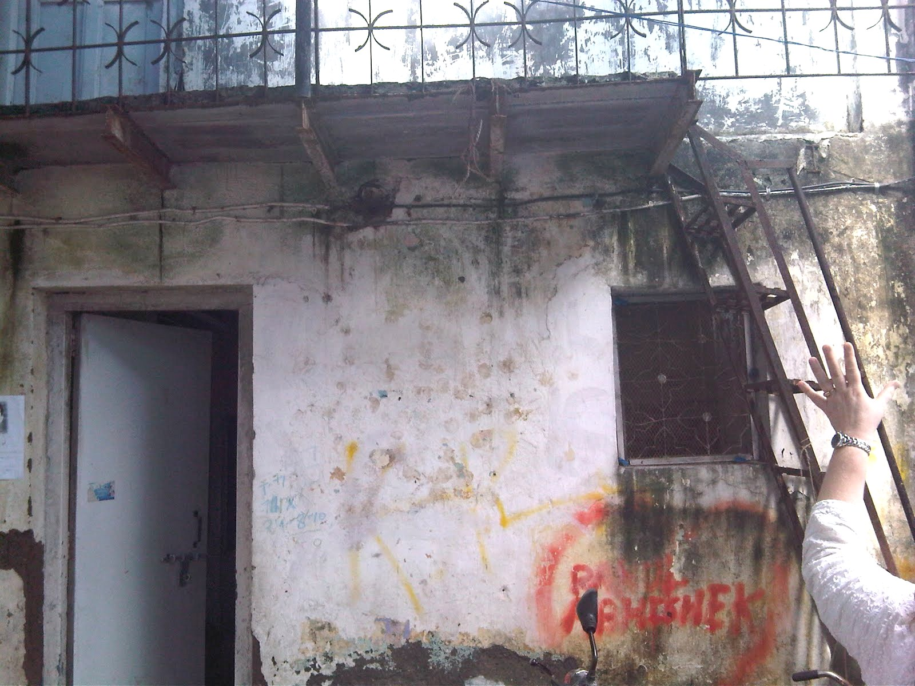
Computer class

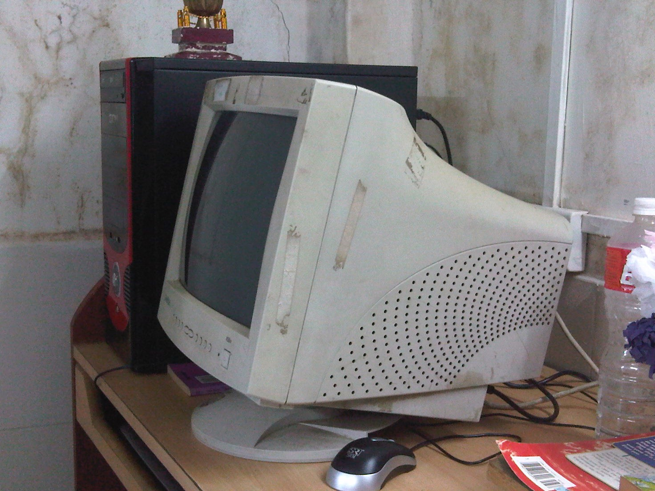
This class was not in session when we visited. We visited the computer room and spoke with the computer instructor, a 16-year old student with limited English skills. It was a very small room at the top of a rusty ladder (pictured to the left). We were told that there were 17 students who attend the program, 7 at a time in the classroom. 2 or 3 of the five computers appeared to be working. The instructor and Dr. Kapoor told us they had been purchased about a year ago. We started one computer and Word and Excel displayed the introduction they do the first time you use the programs and there were no "recent documents" on the computer we looked at.

Other programs

In addition to its pre-school and computer classes, Dr. Kapoor told us that Helping Hand in Service runs a summer camp, tutoring programs, a tailoring class for adult women, and field trips and picnics for children. We did not see these programs during our visit.

Helping Hand in Service also sponsors "deserving" college students who Dr. Kapoor believes would not be able to attend college otherwise. The program provides school fees, uniforms, books, shoes, and bus fare. We asked Ms. Kapoor how she selects students to sponsor and she told us that she focuses on students who do not have parents or whose parents do not have an income. This programs costs Helping Hands in Services about Rs. 25,000 (about $565) per student, about Rs. 15,000 of which is for tuition (about $340).

Additional conversations and thoughts

We had an interesting conversation with Dr. Kapoor and a teacher from Helping Hand in Service about giving cash directly to the poor, a topic we’ve written about before. They believed that, in general, neither visitors nor Helping Hand in Service should give cash directly to residents in the slum because of the risk that recipients wouldn’t spend the money well, wouldn’t work as much, or that it would be spent by the men of the community on alcohol (even if the money was given to the women). The teacher was adamant that the men in the community are lazy and spend any money they can on alcohol. Dr. Kapoor said that Helping Hand in Service does gives cash to certain women in the slum who she is familiar with, who were "deserving," and who she believes will use the money well; Helping Hand in Service might, for example, pay for a doctor’s visit for someone who was unable to afford it.
The teacher we spoke to also told us about what she perceives as a pattern in the slum—the men go out and drink, get into fights, end up in jail, and their wives take loans from friends or money lenders to get them out of jail.

Dr. Kapoor spoke directly to specific needs for additional funds: a building so that they could serve the children for whom they don't have space in their preschool; food for a woman who has five children and whose husband was in the hospital for nine months. She appears to know people in the community well; she has an understanding of their situation, and aside from funding the organization's "programs" she gives (or raises funds) where she thinks funds can be used.

