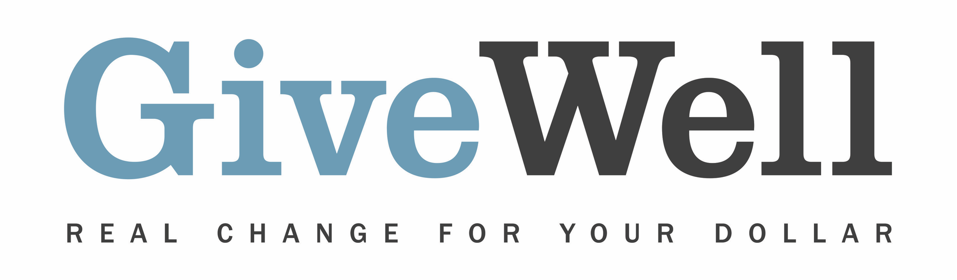
Dear (RECIPIENT'S NAME) ,
(YOUR NAME) has made a donation of $(DONATION AMOUNT) in your name designated for the support of Georgetown University Initiative on Innovation, Development, and Evaluation (gui²de)’s Zusha! Road Safety Campaign.

Zusha! is a campaign intended to reduce road accidents. Stickers are distributed to public service vehicles encouraging passengers to speak up and urge drivers to drive more safely.

Zusha! is one of GiveWell’s standout charities. GiveWell is a nonprofit dedicated to finding outstanding giving opportunities. Thousands of hours have gone into finding and analyzing GiveWell's recommended charities. For more information on these charities, including Zusha!, and GiveWell’s work, please visit us online at www.givewell.org.

Thank you for your support!

Sincerely,
GiveWell Staff
www.givewell.org

