Organization:
Opportunity International
2122 York Road, Ste. 340
Oak Brook, IL 60523
800-793-9455
www.opportunity.org

Contact:
Richard Spalholz
Regional Director
630-242-4178
rspalholz@opportunity.org

EIN: 54-0907624

Application under CLEAR FUND CAUSE 2:
Help people in Africa become economically self-supporting

Confidentiality: We request that the detailed Budget on page 4 remain confidential.
I. OVERVIEW: Opportunity International

Opportunity International’s mission is to provide opportunities for people in chronic poverty to transform their lives. Our strategy is to create jobs, stimulate small businesses, and strengthen communities among the poor. Our method is to work through indigenous partner organizations that provide small business loans, training, and counsel. Our commitment is motivated by Jesus Christ's call to serve the poor. Our core values are respect, commitment to the poor, integrity, and stewardship.

Opportunity International’s History
Opportunity International was founded in 1971 by a small group of American business leaders who sought a solution to global poverty that tapped into the spirit of enterprise and created dignity without dependency. They first loaned money to several poor entrepreneurs in Colombia. Those businesses grew and the “micro entrepreneurs” repaid their loans – proving on a small scale that the poor are both business savvy and credit worthy. Opportunity International is now working in 28 developing countries to give the poor authentic hope through loans, savings, insurance, and training.

Our Core Programs
Opportunity is focused on the needs of our target client group, the poorest of the economically active, and therefore maintains a sustained focus on developing new products to service this market and tailoring existing products to better fit their needs. We are also committed to the holistic transformation of our clients’ lives, which means that we provide more than financial services: we provide training, mentoring and tools to grow economically, socially and spiritually.
- Micro loan products to match the needs of micro-businesses
Trust Group Business Loans. Opportunity’s Trust Group product is a development-intensive group lending methodology where the small loans are tailored to the smallest businesses, typically owned by poor women, with average monthly incomes well below the poverty line. Growth in loan size occurs with each successful loan completion, with average terms of 3-5 months. Clients are organized into groups who serve as an informal bank and cross-guarantee each other's loans. Group meetings after include training in leadership, financial management, community development and use of credit.
Solidarity Group Business Loans provide larger loans to smaller groups of microentrepreneurs whose businesses can absorb more capital, but still operate under a group guarantee.
Individual Business Loans are designed for microenterprises with greater need for capital and also for clients graduating from group products whose businesses have grown. In some cases this loan may be secured with some form of collateral, while in other cases it may be through co-guarantors.

- High-tech savings products to meet clients’ needs while providing capital to the bank for growth. The commercial banking model allows Opportunity to provide deposit products while developing an affordable source of capital for growth. Opportunity has introduced biometric client identification technology as a way to make managing small deposits from the poor a feasible proposition.
- Insurance products tailored to meet the needs of families and businesses
Opportunity International is a pioneer in the development of insurance products designed to provide a financial safety net for the poor, with over 600,000 policy holders and more than 3 million lives covered. In Africa, our insurance focus has been on designing products that mitigate the impact of HIV/AIDS and the high mortality rate on the family members of our clients. Opportunity is pioneering other innovative insurance products such as a weather index insurance product developed with the World Bank in Malawi.
II. FEATURED PROGRAM: Microfinance Bank for the Poor in Mozambique

The Need in Mozambique

Mozambique is one of the poorest countries in the world – it ranks 198 among 208 countries in per capita income. The aftermath of civil war and numerous natural disasters have strangled the country’s economy. Seventy percent of the population lives below the poverty line, and less than 20 percent have completed primary school. Now HIV/AIDS is ravaging Mozambique – one of every seven adults is infected. And 420,000 children in Mozambique are orphans. Life expectancy (at birth) has fallen to 31 years, and 1.1 million people are living with HIV/AIDS, which fells the most economically productive family members.

The financial sector in Mozambique is in its infancy. The few services that exist do not reach the majority population, especially in rural areas outside of the capital. Collateral requirements limit access to credit. Almost all rural households have access to at least a plot of land to farm, but this land is usually on long term lease from the government and this property is of little collateral value.

The HIV/AIDS pandemic is crippling the economic development of Mozambique. The working population is either struggling physically from the deadly virus, or having to support extended family and friends in their loss. Small incomes are stretched to the limit.

Background – Opportunity International in Mozambique

In February 2004, Opportunity International received a $5.1 million 1 to 1 matching grant under the President’s Emergency Plan for AIDS Relief (PEPFAR) to response to AIDS and poverty in Africa. In partnership with Habitat for Humanity, Opportunity was one of only five organizations to receive these first-round USAID grants, and is using these funds to provide financing, training and housing to AIDS orphans and their caregivers. In March 2005, Banco Oportunidade de Mozambique, Opportunity’s new “bank for the poor”, received its license from the central bank of Mozambique.

Banco Oportunidade de Mozambique has four main branches in Maputo, Beira, Quelimane and Chimoio and has opened two new satellite offices in Mocuba (near Quelimane) and Vila de Manica (near Chimoio). As of June 2007, BOM was serving 6,520 active loan clients and 9,471 savings clients.


Banco Oportunidade de Mozambique is one of Opportunity’s most innovative partners in terms of using technology to most efficiently serve the poor. Through a partnership with the Bill and Melinda Gates Foundation, Opportunity is developing the technology to increase outreach in rural areas, home to many of the poorest families in Africa.
Biometric Technology
BOM has implemented biometric technology for clients – a first in Mozambique

Biometric Recognition
BOM uses biometric identification to conveniently ensure the safety of client transactions. Clients’ fingerprints are stored in the system, and when they want to withdraw money, the system matches the prints on-line. The system is being used in the satellite and mobile branches. Biometrics is a key component of Opportunity’s goal of reaching the rural poor because it provides immediate identity verification. The use of biometric identification also helps serve clients who face literacy challenges.

Mobile Banking in Chimoio
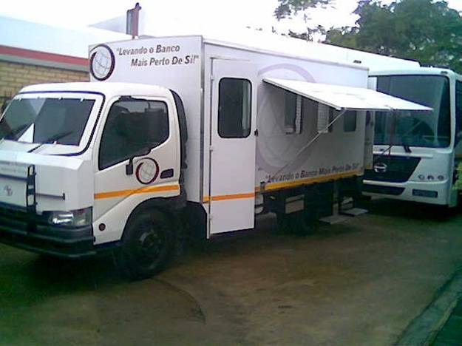
BOM has recently purchased an armored vehicle to use as a mobile bank branch. It is staffed by two client services officers, loan officers, and a driver and accompanied by an armed security guard. The vehicle is fitted with a tracking device to further ensure the safety of the staff and to protect the assets. The mobile branch will enables BOM to reach clients in very rural areas where setting up a full branch is not cost-effective and most importantly a way for rural clients to access banking services in a high security setting. The areas in Manica Province that will be served are Catandica, Sussendenga, Gondola and Inchope as well as Nhamatanda in the neighboring Sofala Province.

Strategic Alliances

To make microfinance most effective, Opportunity encourages its partners to form local alliances that provide for the needs of their clients and help build strong, sustainable communities.

Habitat for Humanity Partnership
The partnership between Opportunity International’s Banco Oportunidade de Mozambique (BOM) and Habitat for Humanity in Mozambique (HFHM) are working together in the Chimoio area. HFHM and BOM provide training to BOM clients in Inheritance and Succession Planning. At the end of training, the families are helped to design a basic will. A week later, a notary will be brought along to write each family’s wishes into an official certificate that declares the family succession rights.

HIV/AIDS Training
BOM has partnerships with three HIV/AIDS Education Organizations: Health Alliance International, Kubatsirana and TIOS. BOM also seeks partnership with organizations that focus on orphans and vulnerable children with the aim to provide HIV/AIDS and skills training.

REQUEST FOR SUPPORT

Opportunity International requests a Clear Fund grant of $25,000 for our program in Mozambique.

Fund Use | Percent | Cost
General & Administrative | 15% | $ 3,750
Program Management | 5% | $ 1,250
Technical Assistance (MIS; product design; impact assessment; market analysis) | 10% | $ 2,500
Partner Equity for Loan Funds | 70% | $17,500
Total | 100% | $25,000

Impact
Opportunity’s average first Trust Group loan size in Mozambique is $127. This means that your grant will be disbursed as loan funds to 137 entrepreneurs. The loan cycle is 4 months, and as these loans are repaid and recycled (3 times per year) the impact grows as the money continues to be at work. Over 10 years, this would mean over 4,000 loans made through the initial grant from the Clear Fund.
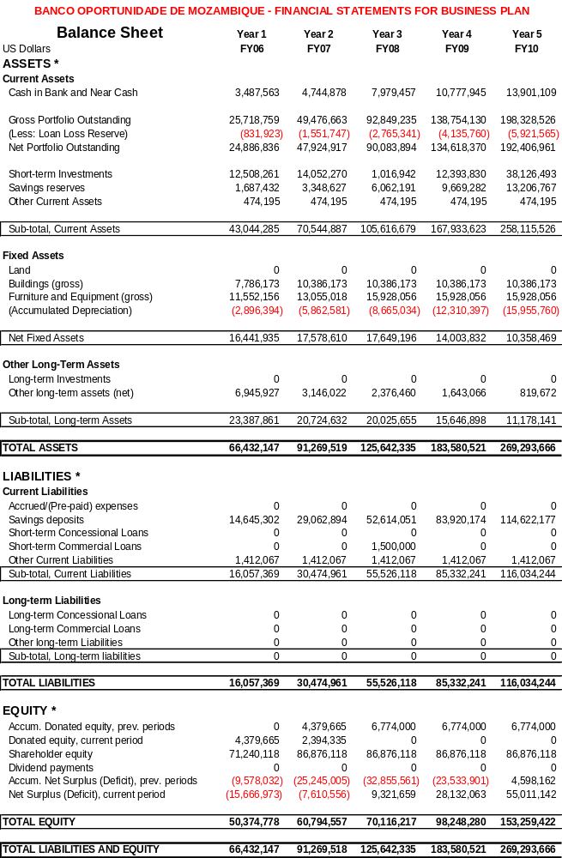
III. EVALUATION

A. Opportunity International’s Evaluation Processes

Partner Reporting Metrics
Opportunity has extensive experience in the development and implementation of planning, budgeting, reporting, and monitoring systems for its network. To provide better program and financial tracking for its partners, Opportunity developed and now manages a quarterly reporting and monitoring system including a standardized finance and program data report, a trend analysis report for each agency, country and region, and a comparative performance review report that compares agencies across regions and across the world in nearly 20 critical financial performance areas.

Standards and Accreditation
Opportunity’s programs are evaluated against stringent Opportunity International Network standards that require complete accounting, quarterly reporting on the impact and efficiency of the program, and adherence to Opportunity’s Core Values of Stewardship, Respect, Integrity, and Commitment to the Poor. Every three years, the two programs will undergo a Network-required accreditation process, which consists of a self-evaluation and peer review process.

Client Impact Monitoring
Opportunity International has been piloting several different approaches to client impact monitoring and client satisfaction tracking. The objective is to establish a dual-survey approach:
1. Client Tracking Survey, which focuses on client behavior and its impact on product needs and client retention. The first introductory workshop for this will take place before the end of 2007.
2. Client Strategic Survey, which will seek to address broader economic, social and demographic issues. This will be designed by the end of 2007 and will incorporate indicators that relate to this objective of the grant, namely impact of financial services on clients and their family members. The survey will track: change in income, change in assets, the percent of clients with children whose children are in school, the health of clients’ children over time, the percent of clients who move out of poverty over time.

Client Retention. Opportunity believes that in order to best keep track of clients’ needs and preferences, it must have a good understanding of why clients remain in the program and why they do not. As part of the implementation of a the client impact monitoring system, Opportunity will track each client’s relationship with the bank, including the circumstances under which the client renews, drops out, or graduates.

A common misconception is that all client drop-out is negative. However, this is not necessarily the case. For instance, a client might choose to “rest,” or choose not to borrow a subsequent loan but intend to renew in the future; remain a client with another service the institution offers, such as savings; or, perhaps the client was happy with the services but no longer needs them: the first loan was enough of an infusion of capital to push the client where he/she needs to be. In the latter case, Opportunity does not wish to keep clients indebted who no longer need a service just for the sake of client retention. Rather, through a deeper understanding of client retention and client drop-out, Opportunity hopes to develop products and services which will best meet client needs and help them to permanently work themselves out of poverty. (For a deeper discussion, see “The Challenges of Measuring Client Retention,” written by Chuck Waterfield under sponsorship of the SEEP Network and USAID.)
B. Attachments – Impact and Evaluation

PORTFOLIO PERFORMANCE OF OPPORTUNITY MOZAMBIQUE
 |  | 2005 Q4 | 2006 Q1 |  | 2006 Q2 | 2006 Q3 | 2006 Q4
All Lending Methodologies
Total Loan Portfolio
 | Number of Outstanding Clients | 2,611 | 3,324 |  | 3,889 | 4,471 | 4,931
 | Value of Outstanding Portfolio | 482,545 | 490,654 |  | 638,037 | 789,321 | 959,502
 | Average Loan Balance | 185 | 148 |  | 164 | 177 | 195
 | Portfolio in Arrears > 1 Day | - | 1.19% |  | 2.13% | 1.10% | 0.96%
 | Portfolio in Arrears > 30 Days | - | 0.63% |  | 0.76% | 0.43% | 0.45%
 | Portfolio at Risk > 1 Day | 2.46% | 1.88% |  | 2.96% | 2.90% | 2.06%
 | Portfolio at Risk > 30 Days | 0.52% | 1.16% |  | 1.34% | 0.75% | 0.73%
Total Lending Activity
 | Number of Loans Made | 991 | 1,866 |  | 2,707 | 2,496 | 2,633
 | Value of Loans Made | 311,690 | 405,226 |  | 672,675 | 589,357 | 783,642
 | Average Loan Size | 315 | 217 |  | 248 | 236 | 298
 | Average First Loan Size | - | 243 |  | 201 | 127 | 197
 | Percent of Loans to Women | 55.50% | 52.36% |  | 53.38% | 51.28% | 52.83%
Individual Lending Methodology
Individual Loan Portfolio
 | Number of Outstanding Clients | 808 |  | 1,053 | 1,325 | 1,571 | 1,809
 | Value of Outstanding Portfolio | 230,450 |  | 315,417 | 443,187 | 547,850 | 693,094
 | Average Loan Balance | 285 |  | 300 | 334 | 349 | 383
 | Portfolio in Arrears > 1 Day | - |  | 1.17% | 2.16% | 0.77% | 0.64%
 | Portfolio in Arrears > 30 Days | - |  | 0.57% | 0.58% | 0.21% | 0.29%
 | Portfolio at Risk > 1 Day | 1.77% |  | 1.68% | 2.39% | 2.25% | 1.39%
 | Portfolio at Risk > 30 Days | 0.77% |  | 1.13% | 1.27% | 0.63% | 0.50%
Individual Lending Activity
 | Number of Loans Made | 474 |  | 516 | 881 | 756 | 914
 | Value of Loans Made | 170,813 |  | 242,787 | 428,363 | 364,417 | 526,404
 | Average Loan Size | 360 |  | 471 | 486 | 482 | 576
 | Average First Loan Size | - |  | 564 | 367 | 154 | 298
 | Percent of Loans to Women | 50.63% |  | 56.20% | 55.62% | 53.31% | 51.53%
Trust Group Lending Methodology
Trust Group Loan Portfolio
 | Number of Outstanding Clients | 354 |  | 219 | 240 | 233 | 236
 | Value of Outstanding Portfolio | 157,005 |  | 13,897 | 14,957 | 19,025 | 13,090
 | Average Loan Balance | 444 |  | 63 | 62 | 82 | 55
 | Portfolio in Arrears > 1 Day | - |  | 2.09% | 3.62% | 3.23% | 3.62%
 | Portfolio in Arrears > 30 Days | - |  | - | 1.83% | 1.08% | -
 | Portfolio at Risk > 1 Day | 0.62% |  | 4.23% | 9.83% | 13.24% | 5.42%
 | Portfolio at Risk > 30 Days | - |  | 2.86% | 1.83% | 1.08% | -
Trust Group Lending Activity
 | Number of Loans Made | 34 |  | 183 | 190 | 187 | 146
 | Value of Loans Made | 54,063 |  | 19,549 | 24,977 | 20,585 | 19,148
 | Average Loan Size | 1,590 |  | 107 | 131 | 110 | 131
 | Average First Loan Size | - |  | 86 | 122 | 105 | 127
 | Percent of Loans to Women | 58.82% |  | 46.99% | 39.47% | 41.18% | 47.26%
Other Lending Methodologies
Other Loan Portfolio
 | Number of Outstanding Clients | 1,449 |  | 2,052 | 2,324 | 2,667 | 2,886
 | Value of Outstanding Portfolio | 95,090 |  | 161,341 | 179,893 | 222,445 | 253,318
 | Average Loan Balance | 66 |  | 79 | 77 | 83 | 88
 | Portfolio in Arrears > 1 Day | - |  | 1.13% | 1.93% | 1.72% | 1.70%
 | Portfolio in Arrears > 30 Days | - |  | 0.80% | 1.11% | 0.92% | 0.90%
 | Portfolio at Risk > 1 Day | 7.20% |  | 2.06% | 3.79% | 3.60% | 3.72%
 | Portfolio at Risk > 30 Days | 0.79% |  | 1.07% | 1.47% | 1.02% | 1.42%
Other Lending Activity
 | Number of Loans Made | 483 |  | 1,167 | 1,636 | 1,553 | 1,573
 | Value of Loans Made | 86,814 |  | 142,891 | 219,334 | 204,354 | 238,091
 | Average Loan Size | 180 |  | 122 | 134 | 132 | 151
 | Average First Loan Size | - |  | 126 | 121 | 116 | 145
 | Percent of Loans to Women | 60.04% |  | 51.50% | 53.79% | 51.51% | 54.10%

The pages that follow are from Opportunity’s first monitoring system, the Client Information and Impact Management System (CIIMS). This is being significantly revised to better meet the needs of the organization (explanation of the new systems is on page 5) but the information provides insight into Opportunity’s method of impact monitoring.



