UNITED METHODIST COMMITTEE ON RELIEF

ADVANCE PROJECT REPORTING FORM

(Please type, or if hand writing, print using block letters)

DEADLINE:

JANUARY 31, 2006 for funds received in 2006

Project Name: Health, Water and Sanitation, Dominican Republic
Advance Number: 410001
Address: 1224 East Washington Street, Phoenix, AZ 85034
Contact Name/Title: Glynka FritzMiller, Manager of Foundation Relations
E-mail Address: glynkaf@fh.org
Telephone and Fax Number: phone: 480-609-7718, fax: 480-998-4806
(Please include country code)
Sponsoring Organization: N/A
Address:

E-mail/Website:
Telephone and Fax Number:
(Please include country code)

NAME OF PERSON COMPLETING FORM: Glynka FritzMiller / Raquel Muñoz CONTACT NUMBER/EMAIL: glynkaf@fh.org / rmunoz@fhi.net

Objectives: should be simple, able to be measured, realistic and attainable in the situation and be timely. The community needs to be a partner in the planning for it to be effective.

Indicators: are the things you will measure to know that you achieved your objectives.

Activities: are those things you will do to reach your agreed upon objectives, outcomes and impacts. This should also include the plan for who will handle the finances and how they will be recorded and accounted for.

Outcomes: are what will change in the lives of the individual participants during the project reporting period and how will you know (indicators).

Impacts: are long-term change(s) that will occur in the community because of your work and how you will know (indicators).

Reporting:
- You will need to report on the activities, outcomes and finances. If you cannot see outcomes when you need to submit the report, please indicate the reason(s) why. For example, you will need to wait until the harvest is done to know how much increased income there was for a particular family but you can report on how the crop seems to be doing. One of your outcomes of the planning phase should be your baseline data and a plan for the next two years.
- Additionally you will report on the impacts every year.

Give a brief description of the project including some baseline study information (i.e. what was the situation before start of project?)

The community of Antena is located in the Province of Elias Piña, Dominican Republic. The environment of the community and health of the people has been affected significantly in the last years due to the lack of sanitation.

This project improves sanitation conditions in Antena through latrine construction, hygiene training and leadership organization initiatives.

Before the implementation of this project only 30% of families had latrines in good condition and 70% of families had either no latrines or latrines in very bad condition.

- What are the project objectives?

In 2006, Food for the Hungry – Dominican Republic sought to:
- Build 17 latrines
- Carry out 4 hours of training for health promoters on preventive health topics
- Devote 5 hours of meeting with community leadership

- Which objectives were met and when? What were some of the activities and main indicators in achieving the objectives?
All of the above objectives were achieved in 2006.

The primary activities were: Coordination/meetings with community leaders to plan the project, selection of beneficiary families, community mobilization for non-specialize labor from and support of the local Food for the Hungry staff during each phase of the project.

- Which objectives were not met? What were some of the main indicators that brought you to this conclusion?

There were no unmet objectives.

- Did some goals/objectives change? If so, please explain.

There were no changes on goals/objectives

- What were some of the outcomes?

- 17 latrines were built
- 23 people were trained on how to use and care for latrines

- What were some of the impacts?
- The environment of families and the community is healthier overall as they are using their new latrines. In coming years, we expect a decrease in sanitation-related illness among children.
- Leaders in the community are motivated to continue searching for support to provide for areas that are lacking latrines.

- Were women and/or youth involved in planning and implementation of this project? If so, please explain how.
Yes, women participated in the project by cleaning, cooking for the construction teams and receiving training. A group of local youth participated through the voluntary brigades for construction.
- Please provide the number of persons served by project.
Children: 50
Women: 25
Men: 25
- Does your project have a sustainability component, if so, describe briefly.
Sustainability was emphasized throughout this project. Each activity was designed to enable the community leaders to face their own challenges and find solutions.

One significant piece of this project was that the leaders suggested connecting the latrines to the local sanitary system, so that the families will have latrines for a lifetime.

- Please be sure to complete the attached Project Budget Financial form thoroughly. If there is a more detailed project Financial Report, please enclose. Further, if your organization, or sponsoring organization has an Annual Report, we would welcome receiving a copy.
- Receiving project stories and/or photographs with descriptive captions would be very much appreciated. This would be very helpful to us in promoting your project to our constituency.
See photos attached.

PLEASE RETURN COMPLETED FORMS TO: Carol Thompson, UMCOR
475 Riverside Drive, Room 330
New York, NY, 10115
Telephone: (212) 870-3909
Fax: (212) 870-3624
E-mail: cthompso@gbgm-umc.org

PROJECT BUDGET
FINANCIAL REPORT FORM

Please be sure to list other agencies/organizations that support this project.
INCOME | AMOUNT
UMCOR Advance | $6,000
Others: Please detail
In-kind contributions (i.e. local contribution) | $802.00
In-kind donations (i.e. labor, equipment, etc.)
TOTAL | $6,802.00

EXPENSES | AMOUNT
a. Salaries/Stipend | $481
b. Material Goods | $4,687
c. Office Supplies | $200
d. Transportation | $300
Enabling Services  (IT support, Human Resources, Accounting and Auditing, banking services, Project oversite) | $454
US Ministry  (resource raising and reporting, grant administration (10%)) | $680
Other: Please detail
TOTAL | $6,802.00

Mercedes’ Testimony of Change

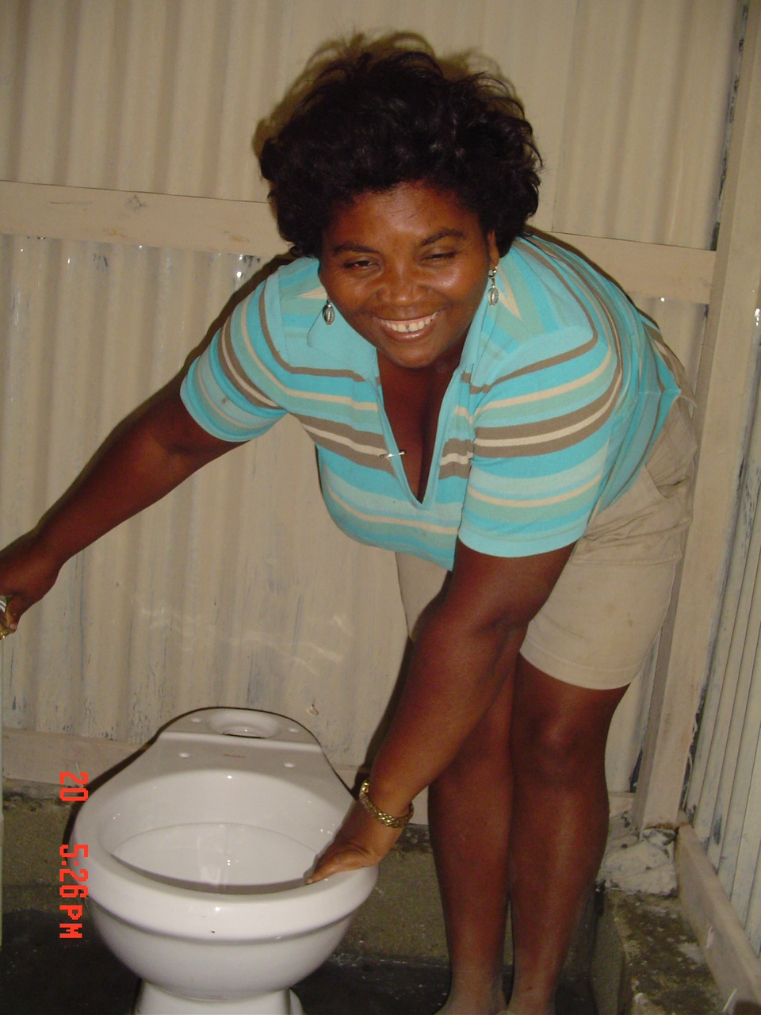
Mercedes Figuereo is a 35-year-old-woman living in “La Antena” with her seven children and husband Leonida. She has lived there for years and is one of the women of the community that is now benefiting from the recent sanitation project. According to Mercedes, who works as the Secretary of the Community Committee, one of the main problems in Antena has been the lack of sanitation. “Even the latrines available in the community are in bad condition”, said Mercedes – referring to the bathrooms built ten years ago. She added, that the lack of good sanitation and hygiene affects the children most of all. Skin problems and parasites are very common among the infants.

Mercedes said, “The new latrines and the trainings we have received encouraged a group of families to work together to clean up the community. Now we know our children’s health will not be threatened by parasites.
I am particularly thankful that we have received this gift and trust that we will continue working together to overcome all the problems that we face as a community.”

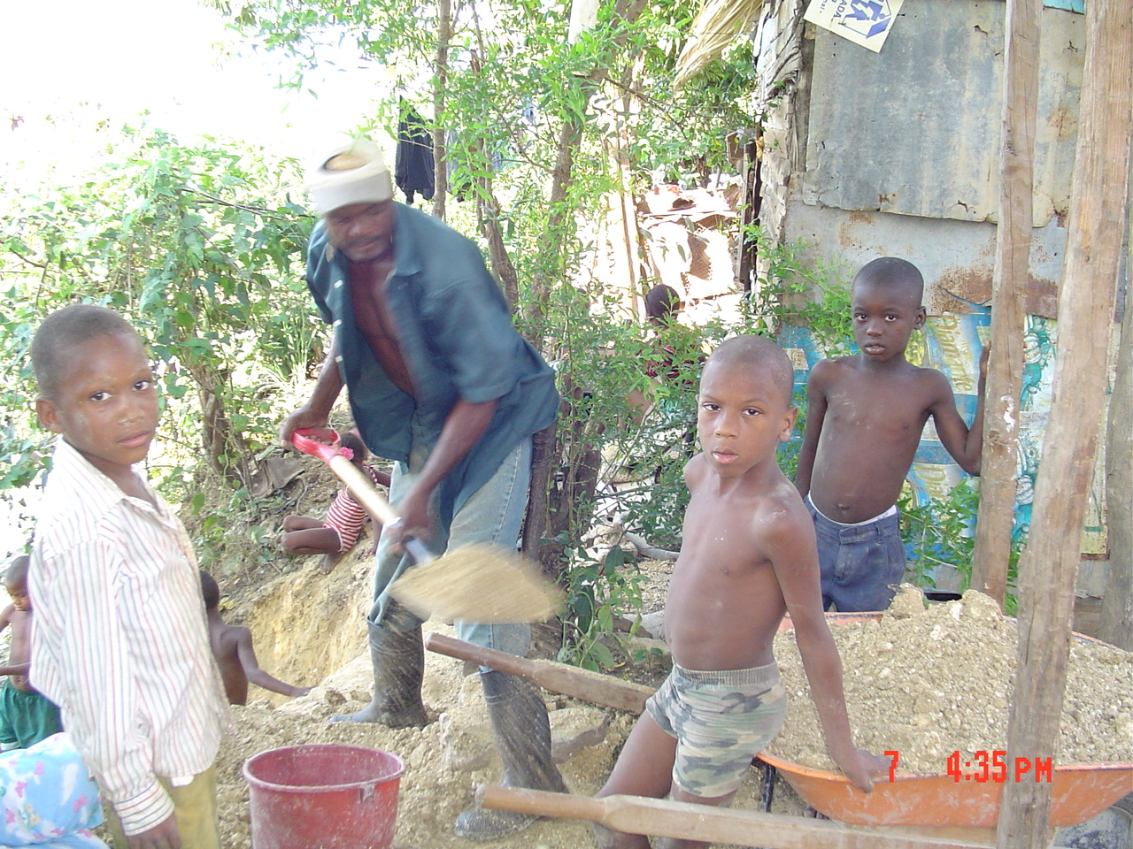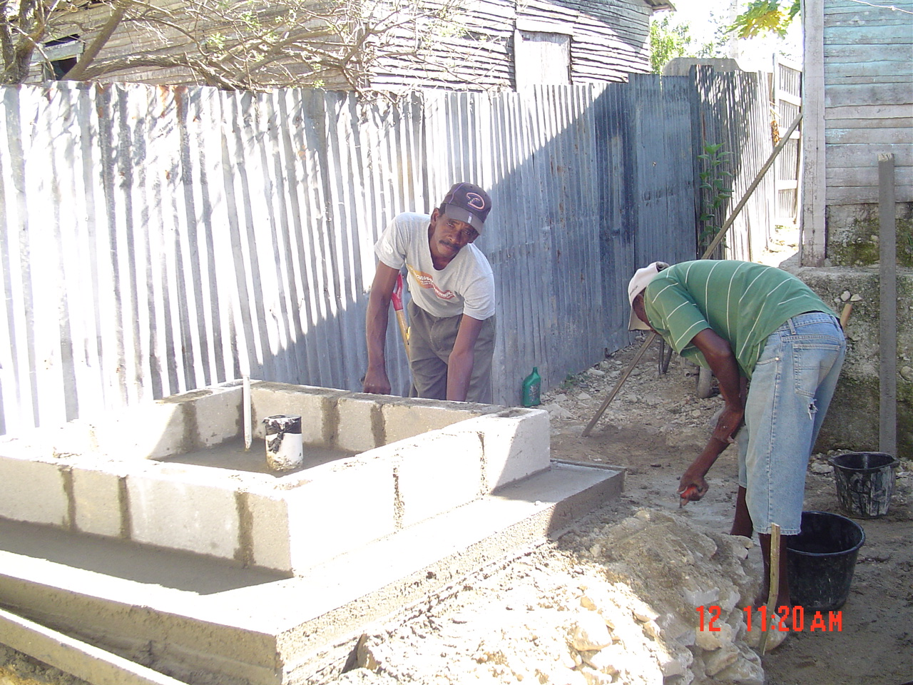
Working on Latrines

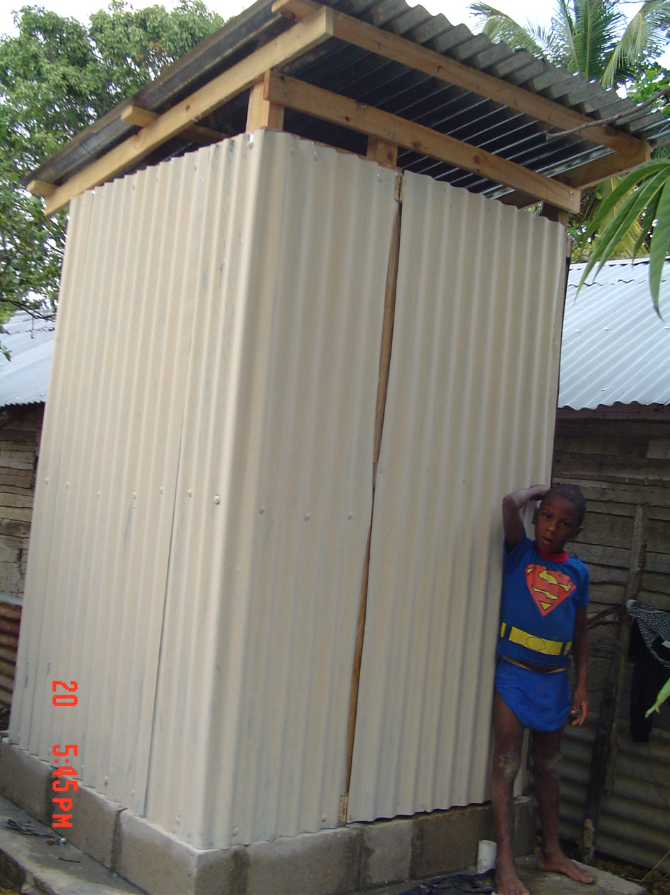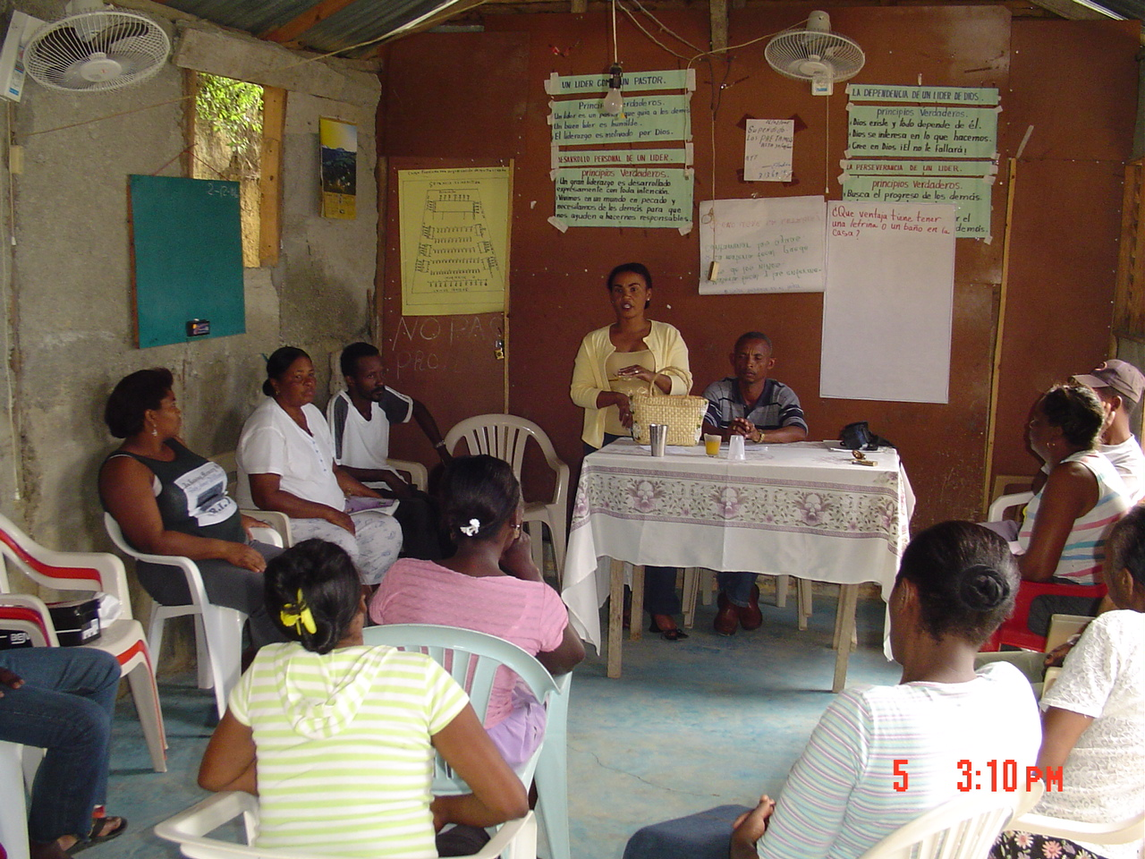
The new Latrine Latrine and Sanitation Training

