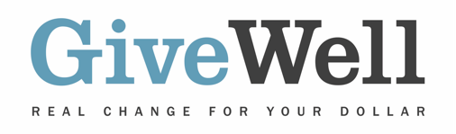
Dear (RECIPIENT'S NAME) ,
(YOUR NAME) has made a donation of $(DONATION AMOUNT) in your name designated for the support of Evidence Action's No Lean Season program.

No Lean Season provides no-interest loans to poor rural households during the time of seasonal income and food insecurity ("lean season") in rural northern Bangladesh. Loans are conditional on a household member stating their intent to migrate to seek short-term employment. GiveWell believes there is strong evidence for the positive impact of seasonal migration subsidies on household income and consumption.

No Lean Season is recommended by GiveWell, a nonprofit dedicated to finding outstanding giving opportunities. Thousands of hours have gone into finding and analyzing GiveWell's recommended charities. They are evidence-backed, thoroughly vetted, and underfunded. For more information on these charities, including No Lean Season, and GiveWell’s work, please visit us online at www.GiveWell.org.

Thank you for your support!

Sincerely,

GiveWell Staff
www.GiveWell.org

