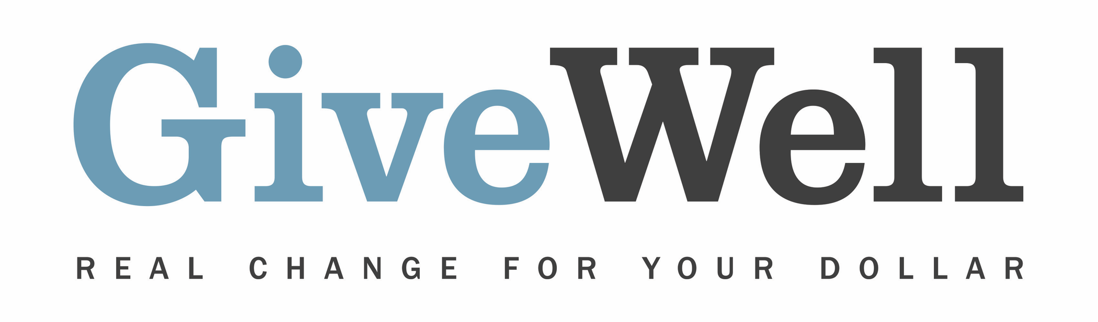
Dear (RECIPIENT'S NAME) ,
(YOUR NAME) has made a donation of $(DONATION AMOUNT) in your name to GiveWell. This donation is designated for the support of GiveWell’s Maximum Impact Fund.

GiveWell will apply its judgment to allocate this donation among its recommended charities according to where it sees the highest-value funding opportunities (taking into account charities’ funding needs and donations from other sources). GiveWell recommends eight top charities:

- Malaria Consortium’s seasonal malaria chemoprevention program
- Against Malaria Foundation
- Helen Keller International’s vitamin A supplementation program
- Evidence Action’s Deworm the World Initiative
- Sightsavers’ deworming program
- END Fund’s deworming program
- GiveDirectly
- SCI Foundation (formerly known as the Schistosomiasis Control Initiative)

GiveWell is a nonprofit dedicated to finding outstanding giving opportunities. Thousands of hours have gone into finding and analyzing GiveWell's recommended charities. They are evidence-backed, thoroughly vetted, and underfunded. For more information on these charities and GiveWell’s work, please visit us online at www.GiveWell.org.

Thank you for your support!

Sincerely,
GiveWell Staff
www.GiveWell.org

