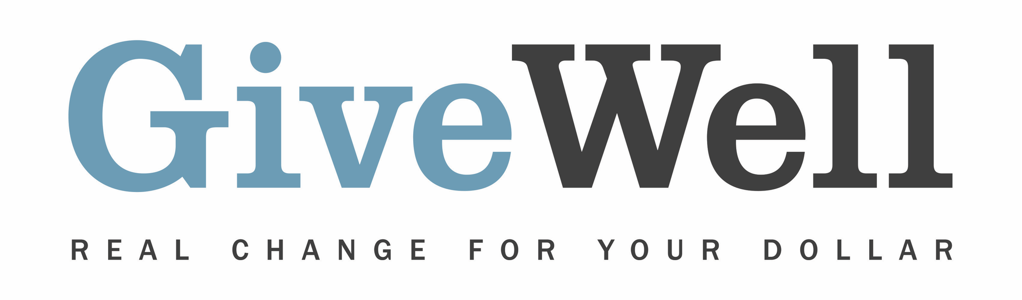
Dear (RECIPIENT'S NAME) ,
(YOUR NAME) has made a donation of $(DONATION AMOUNT) in your name designated for the support of the Global Alliance for Improved Nutrition’s Universal Salt Iodization program (GAIN-USI).

Iodine deficiency, which remains common in the developing world, harms cognitive development. Fortifying salt with iodine successfully alleviates this problem. GAIN-USI’s salt fortification activities vary considerably across countries and include advocacy, technical assistance, supplying equipment, monitoring, and training government officials and salt producers.

GAIN-USI is one of GiveWell’s standout charities. GiveWell is a nonprofit dedicated to finding outstanding giving opportunities. Thousands of hours have gone into finding and analyzing GiveWell's recommended charities. For more information on these charities, including GAIN-USI, and GiveWell’s work, please visit us online at www.givewell.org.

Thank you for your support!

Sincerely,
GiveWell Staff
www.givewell.org

