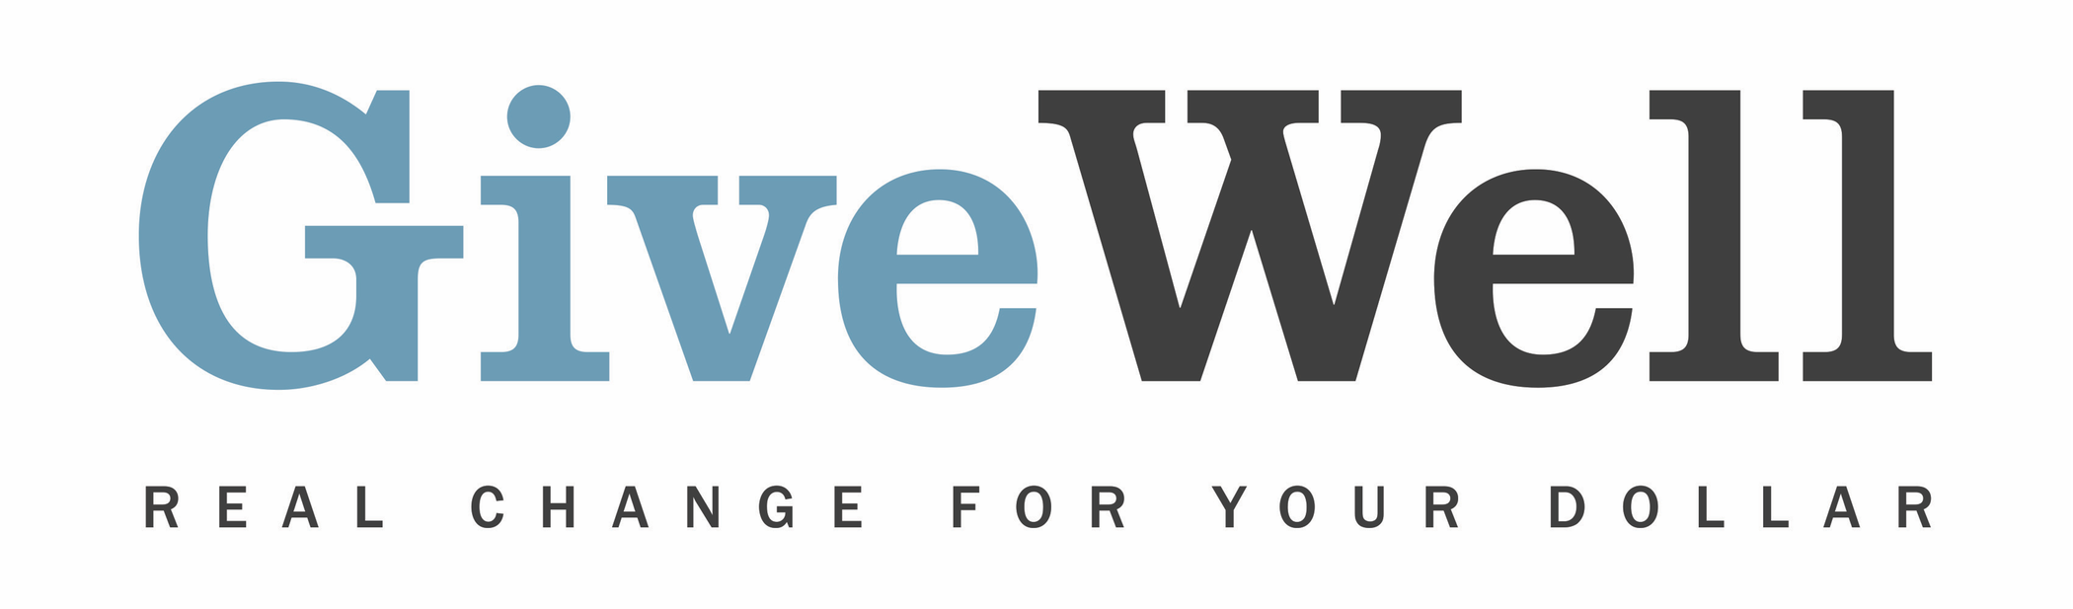
Dear (RECIPIENT'S NAME) ,
(YOUR NAME) has made a donation of $(DONATION AMOUNT) in your name to GiveWell. This donation will support GiveWell’s operations.
GiveWell is a nonprofit dedicated to finding outstanding giving opportunities. Unlike charity evaluators that focus solely on financials, assessing administrative or fundraising costs, we conduct in-depth research aiming to determine how much good a program accomplishes (in terms of lives saved or improved) per dollar spent. Rather than try to rate as many charities as possible, we focus on the few charities that stand out most in order to find and confidently recommend the best giving opportunities, according to our criteria, to donors. In 2020, our recommended charities received over $240 million from donors as a result of GiveWell’s recommendation.
GiveWell currently recommends nine top charities: Malaria Consortium (seasonal malaria chemoprevention program only), Against Malaria Foundation, Helen Keller International (vitamin A supplementation program only), SCI Foundation, Sightsavers (deworming program only), New Incentives, Evidence Action’s Deworm the World Initiative, END Fund (deworming program only), and GiveDirectly. These charities help prevent malaria, avert child mortality, treat people for parasitic worm infections, and provide direct cash transfers to very poor individuals.
If you're interested in staying up to date on GiveWell's progress, you can sign up for updates here: www.givewell.org/updates.

Thank you for your support!

Sincerely,
GiveWell Staff
www.GiveWell.org

