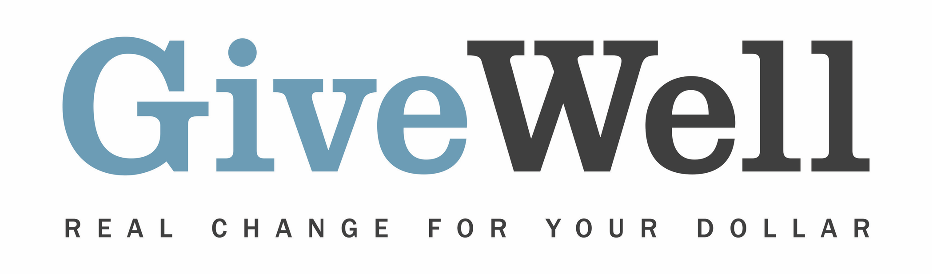
Dear (RECIPIENT'S NAME),
(YOUR NAME) has made a donation of $(DONATION AMOUNT) in your name to GiveWell. This donation is designated for the support of GiveWell’s Top Charities Fund.

GiveWell will allocate this donation among the following four programs it recommends according to where it sees the highest-value funding opportunities (taking into account the programs’ funding needs and donations from other sources):

- Malaria Consortium’s seasonal malaria chemoprevention program, which distributes preventive anti-malarial drugs to young children
- Against Malaria Foundation, which distributes insecticide-treated nets to prevent malaria
- Helen Keller International’s vitamin A supplementation program, which distributes vitamin A capsules to preschool-age children
- New Incentives, which promotes childhood vaccinations in Nigeria

GiveWell is a nonprofit dedicated to finding outstanding giving opportunities. More than 50,000 hours each year go into researching evidence-backed, cost-effective programs to save or improve lives. For more information on these organizations and GiveWell’s work, please visit us online at www.GiveWell.org.

Thank you for your support!

Sincerely,
GiveWell Staff
www.GiveWell.org

