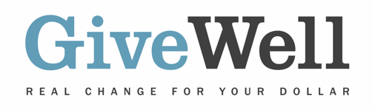

Dear (RECIPIENT'S NAME),
(YOUR NAME) has made a donation of $(DONATION AMOUNT) in your name designated for the support of New Incentives, a program recommended by GiveWell.

New Incentives encourages caregivers of infants in northern Nigeria to complete a series of routine, potentially life-saving childhood immunizations by providing a small cash transfer when each vaccine is given. There is strong evidence that the program increases vaccination rates, and that the vaccines effectively prevent the diseases they target. Based on this evidence, along with evidence that vaccine-preventable diseases are a significant cause of child mortality in Nigeria, we believe New Incentives' program is likely to substantially reduce child mortality.

GiveWell is a nonprofit dedicated to finding outstanding giving opportunities. More than 50,000 thousand hours each year go into researching evidence-backed and cost-effective programs to save or improve lives. For more information on these organizations, including New Incentives, and GiveWell’s work, please visit us online at www.GiveWell.org.

Thank you for your support!

Sincerely,
GiveWell Staff
www.GiveWell.org

