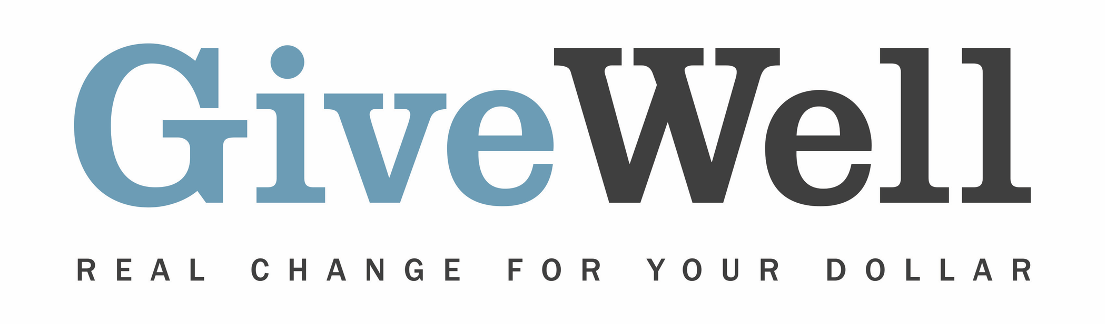

Dear (RECIPIENT'S NAME),
(YOUR NAME) has made a donation of $(DONATION AMOUNT) in your name designated for the support of Malaria Consortium’s seasonal malaria chemoprevention program, a program recommended by GiveWell.

Malaria Consortium works on preventing, controlling, and treating malaria and other communicable diseases in Africa and Asia. Malaria Consortium's seasonal malaria chemoprevention (SMC) program distributes preventive anti-malarial drugs to young children to prevent illness and death from malaria, one of the leading causes of child deaths in Africa. There is strong evidence that SMC reduces malaria, and GiveWell believes that SMC is one of the most cost-effective programs that donors can support. Our recommendation of Malaria Consortium is only for its SMC program.

GiveWell is a nonprofit dedicated to finding outstanding giving opportunities. More than 50,000 hours each year go into researching evidence-backed and cost-effective programs to save or improve lives. For more information on these organizations, including Malaria Consortium, and GiveWell’s work, please visit us online at www.givewell.org.

Thank you for your support!

Sincerely,
GiveWell Staff
www.givewell.org

