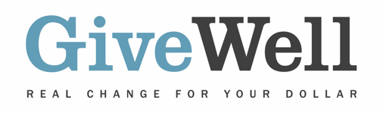

Dear (RECIPIENT'S NAME),
(YOUR NAME) has made a donation of $(DONATION AMOUNT) in your name designated for the support of Helen Keller International's vitamin A supplementation program, a program recommended by GiveWell.

Helen Keller supports programs focused on reducing malnutrition and averting blindness and poor vision. GiveWell recommends Helen Keller for its work on vitamin A supplementation (VAS) in sub-Saharan Africa. VAS involves mass distribution of vitamin A capsules to preschool-age children, and there is strong independent evidence that this can reduce child mortality. GiveWell believes that VAS is one of the most cost-effective programs that donors can support. Our recommendation of Helen Keller is only for its VAS program.

GiveWell is a nonprofit dedicated to finding outstanding giving opportunities. More than 50,000 hours each year go into researching evidence-backed and cost-effective programs to save or improve lives. For more information on these organizations, including Helen Keller, and GiveWell’s work, please visit us online at www.GiveWell.org.

Thank you for your support!

Sincerely,
GiveWell Staff
www.GiveWell.org

