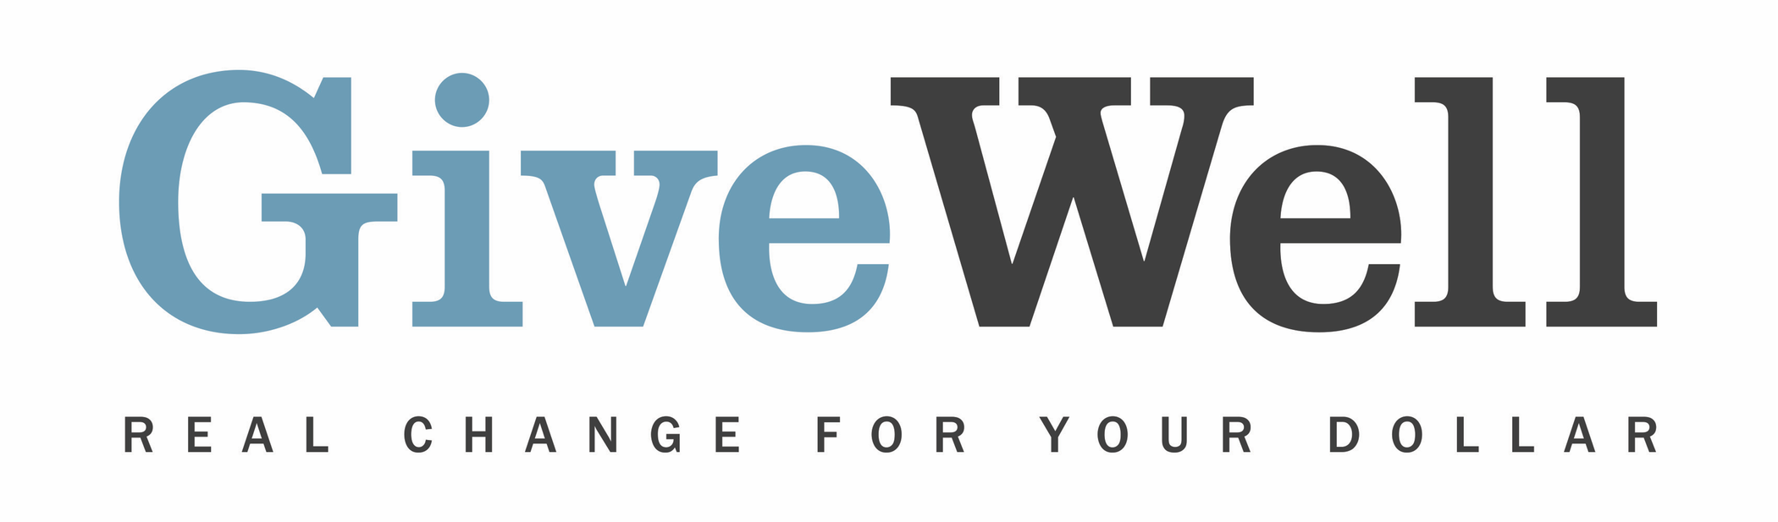
Dear (RECIPIENT'S NAME) ,
(YOUR NAME) has made a donation of $(DONATION AMOUNT) in your name designated for the support of Evidence Action’s Deworm the World Initiative.

The Deworm the World Initiative supports programs that treat children for parasitic worm infections that cause short-term symptoms and may impact children's long-term development and earnings in adulthood. These worms are extremely inexpensive to treat. Deworm the World advocates for, funds, provides technical assistance to, and monitors government-run school-based deworming programs.

Deworm the World is recommended by GiveWell, a nonprofit dedicated to finding outstanding giving opportunities. Thousands of hours have gone into finding and analyzing GiveWell's recommended charities. They are evidence-backed, thoroughly vetted, and underfunded. For more information on these charities, including Deworm the World, and GiveWell’s work, please visit us online at www.givewell.org.

Thank you for your support!

Sincerely,
GiveWell Staff
www.givewell.org

