Annual Report – Grant to the Schistosomiasis Control Initiative to support schistosomiasis and STH control in Ethiopia

Organisation Name | Schistosomiasis Control Initiative
Report Date (Reporting Period) | 14th August 2013 (September 2012-August 2013)
Grant Size and Donation | £100,000/year for 5 years. This report covers the first year of the grant
Summary of what grant was for | To support the control of schistosomiasis (SCH) and soil-transmitted helminths (STHs) in Ethiopia
- NEGLECTED TROPICAL DISEASE UPDATE
The visibility, political advocacy, and donor commitment behind the control of neglected tropical disease (NTD) control has increased significantly over the past decade. Many countries are now implementing successful large-scale control programmes. In January 2012 the World Health Organization (WHO) drew up a roadmap for overcoming the global impact of NTDs. Following the publication of this document, the WHO, alongside partners from the pharmaceutical industry, NGDOs, governments, and funders committed to the London Declaration on Neglected Tropical Diseases’. This declaration constitutes a set of ambitious targets to aim for the eradication of Guinea Worm, the elimination of lymphatic filariasis, leprosy, sleeping sickness, and blinding trachoma, and the control and eventual elimination of SCH, STH, Chagas disease, visceral leishmaniasis, and onchocerciasis.
This marked a turning point in the control of NTDs with an increased awareness that the eyes of the NTD community are now fixed firmly on those countries yet to commence large-scale control programmes, such as Ethiopia.
- PROGRAMME UPDATE - ETHIOPIA
Background
Ethiopia has a significant burden of SCH and STH. Political momentum and donor advocacy is building behind large-scale control of many NTDs in the country, including SCH and STHs. Ethiopia is Africa’s second most populous nation (85 million people), with Ethiopia and Nigeria together estimated to harbour half of Africa’s NTD burden. Ethiopia has arrived relatively late to NTD control, especially given their need and relatively robust political and administrative set-up. As far as we are aware there has not been any large scale SCH or STH control in the country until now. However, political momentum is now firmly behind large-scale NTD control in the country.
Activities to Date
Launch of Ethiopia’s NTD Master Plan
The Ethiopian Federal Ministry of Health (FMoH), along with the input of the WHO, has developed a national NTD Masterplan outlining the country’s plans for NTD control. This Masterplan was launched at an international symposium (with financial support from SCI), held in Addis Ababa in June 2013. The symposium brought together many partners, including WHO, funding organisations, pharmaceutical companies, implementing agencies and researchers from across the country, with approximately 400 delegates in attendance. The outputs of the symposium were an increased momentum behind NTD control and recognition that the programme was being owned and driven by the FMoH themselves. It also provided the launch of the Addis Ababa declaration for the control of NTDs in Ethiopia. The FMoH’s NTD co-ordinator, Oumer Shafi has been provided with an increase in human resources within the Ministry. Oumer visited the UK in June 2013 to meet with SCI and to attend (and present at) the SCI Open Day
Financial support for drug distribution (Information also provided in Annex 1)
Merck Serono have donated 3.5 million tablets of praziquantel (sufficient to treat 1.4 million children) and Johnson and Johnson have donated 6.8 million tablets of mebendazole (sufficient to treat 6.8 million children). The praziquantel is due to expire at the end of October 2013 and so it is imperative the tablets are distributed before then. The SCI has provided $250,000 to the FMoH to support the distribution of these drugs in four regions (Amhara, Oromiya, SNNPR, and Somali), and a further $100,000 to the Nala Foundation (an Israeli NGO) to support treatment in a fifth region, Tigray. All of the drugs have now been distributed to the regions, with treatment planned for September when the schools are in session. A report of these distribution campaigns will be written for circulation to NTD partners in Ethiopia, and can be shared with the funders.
Mapping of Disease Distribution (Information also provided in Annex 2)
In order to effectively plan control programmes accurate mapping is essential. The SCI and the Ethiopian Health and Nutrition Research Institute (EHNRI) are partnering to plan, implement, and analyse the mapping surveys. Information has been collected from previous mapping surveys, ecological data, and local knowledge, in order to identify those areas where SCH infection is thought plausible. Mapping will take place across the regions of Tigray, Amhara, Oromiya, SNNPR, and in focal areas in the regions of Afar, Somali, Gambella, and Benishangul-Gumuz (Figure 2).
The SCI is providing financial support for mapping. Approximately 78,000 school-aged children from 2,600 schools will be sampled to provide a representative picture of the distribution of infection of both forms of SCH and STHs, as well as of water, sanitation and hygiene facilities. 41 mapping teams will conduct the surveys, commencing in October, with all teams working simultaneously in order to complete the mapping in an estimated two months
Comprehensive School health and nutrition programme
The SCI are involved in a comprehensive school-health and nutrition programme in the Southern nations, nationalities and peoples region (SNNPR). This programme involves an integrated approach of implementing improved water and sanitation facilities, home-grown school-feeding, and deworming. This project is funded by Dubai Cares and is co-ordinated by the Partnership for Child Development (also based at Imperial College) with input from the World Food Programme (for school-feeding), SNV (a Dutch NGO for the water and sanitation elements), and the SCI (for the deworming elements). The implementation will occur in a pilot project of 30 schools, alongside a situation analysis survey of 500 schools across the region. These elements will be used to develop a business case to be presented to the funder and government to highlight what could be achieved if the programme was scaled up to regional/national level.
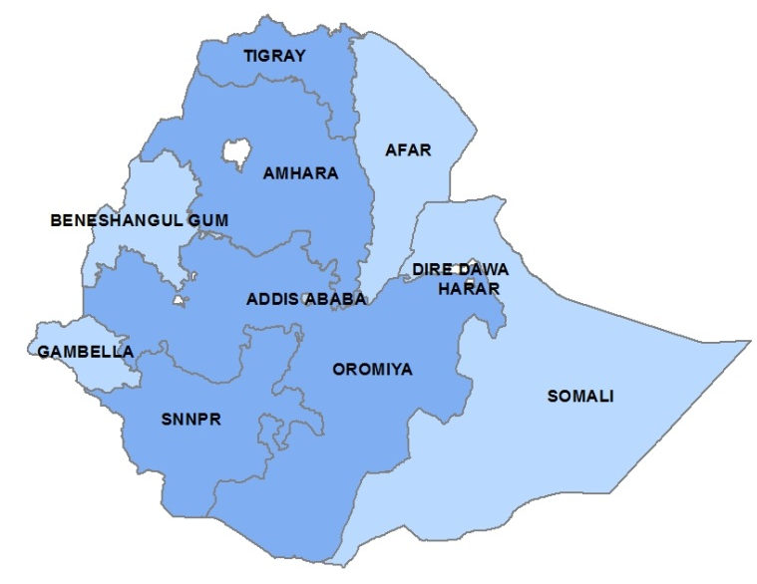
Figure 2. Areas of Ethiopia where mapping will occur. Dark blue indicates regions to be mapped entirely. Light blue indicates regions where focal mapping will take place.

Future Activities
- National-scale control
The mapping surveys are due to finish in mid-December. Following this the data will be analysed and used to construct a risk map of infections across the country. These data and maps will then be used to help plan a long-term (4-5 year) national-scale disease control programme, to commence in 2014. Although the final figures will only be confirmed following the mapping surveys, it is likely that between 15-30m people will require treatment for SCH/STH in the country. As far as possible the SCH/STH programme will co-ordinate with other disease control programmes in the country, in order to leverage activities and promote sustainability. This will target particularly the control programmes against lymphatic filariasis, onchocerciasis, trachoma, and podoconiosis.
- Monitoring and Evaluation
As part of the national control programme, a longitudinal cohort of individuals will be recruited in order to help monitor the health impact of the programme. These individuals (mostly school-aged children) will be taken from a representative sample of areas across the country, with the size of the cohort estimated using a statistical sample-size calculator. These individuals will be followed up prior to mass treatment at baseline and every year in order to provide an estimate of the impact of the control programme on those people who receive treatment.
- Possible country visit
If required, a visit to observe mapping or treatment activities could be relatively easily arranged. The mapping activities are confirmed for between October 11th and December 11th. Treatment is perhaps more visually appealing, and it is likely to occur in the first half of 2014 but there is less certainty about the dates.
- FINANCIALS
A summary of how the financial support from the donor has been spent is shown below in Table 1. The grant was used to support both mass drug administration in five regions (Amhara, Oromiya, SNNPR, Somali, and Tigray - £50,000) and procurement for mapping (£50,000).
Budget Line | Budgeted Cost | Actual Expenditure | Variance | Donor’s Funding used for Line Item | Other funding sources | Budgeted cost for next period | Notes
Mass Drug Administration | £224,603 | £207,859 | £16,744 | £50,000 | Private Donors | TBC | 1
Mapping of SCH/STH, and Water and sanitation | £482,964 | £257,581 | £225,383 | £50,000 | Private Donors | £225,383 | 2
Launch of NTD Master Plan | £32,198 | £32,198 | £0 | £0 | Private Donors | £0
Table 1. Summary of financial activity of the grant. Notes: 1. The cost of mass drug administration activities for next year will depend on the results of the mapping surveys, and the amount of praziquantel available for purchase/donation. 2. The mapping activities spread across two reporting periods. Where expenditure has been accrued in US dollars this has been converted to GBP using the rate of 1.55291/1 (www.xe.com, 14th August 2013).
Below we provide some suggestions for further discussion for the possible future use of the grant monies if the programme in Ethiopia becomes included in an expanded DfID programme.
- Capacity building of human resources.
Partners at both the FMoH and EHNRI are very keen to develop their skills and experience, particularly through studying for PhDs and, to a lesser extent, MScs. One possible avenue would be to support registration of post-graduate students at Imperial College, through the College Partner Research Scheme. This provides an opportunity to study for a qualification at greatly reduced cost.
An increase in human resource capacity could also include the funding of a new recruit to work in the FMoH’s NTD team (headed by Mr Oumer Shafi). This was identified as a priority area by partners at the recent symposium for the launch of the Ethiopian NTD Master Plan.
- Integration of control activities
This could help fund further work to help integrate deworming with other control activities, such as water and sanitation improvements, school-feeding programmes, shoe-donation programmes, behaviour change programmes, snail control activities. This could also explore collaboration with other health intervention programmes, such as NTD control, vaccine programmes, maternal and child health, vitamin distribution, among others.
- Transfer for use in other SCI-supported countries, other SCI activities.

http://whqlibdoc.who.int/hq/2012/WHO_HTM_NTD_2012.1_eng.pdf
http://www.unitingtocombatntds.org/downloads/press/london_declaration_on_ntds.pdf
http://www.afro.who.int/en/ethiopia/press-materials/item/5661-ethiopia-launches-national-master-plan-on-neglected-tropical-diseases.html
http://www.unitingtocombatntds.org/reports/Addis%20Ababa%20Declaration%20for%20NTDs%20in%20Ethiopia.pdf
http://www1.imperial.ac.uk/partnershipchilddevelopment/ and http://www.schoolsandhealth.org/Pages/HGSF.aspx)
http://www3.imperial.ac.uk/registry/admissions/prischeme

