Supplementary figure 6a. Reduction in incidence of all episodes of clinical malaria (primary case definition) during each 6-month period ordered by malaria incidence (per-protocol population)
A. Children 5-17 months: [1-6 months] | B. Children 5-17 months: [7-12 months] | C. Children 5-17 months: [13-18 months]
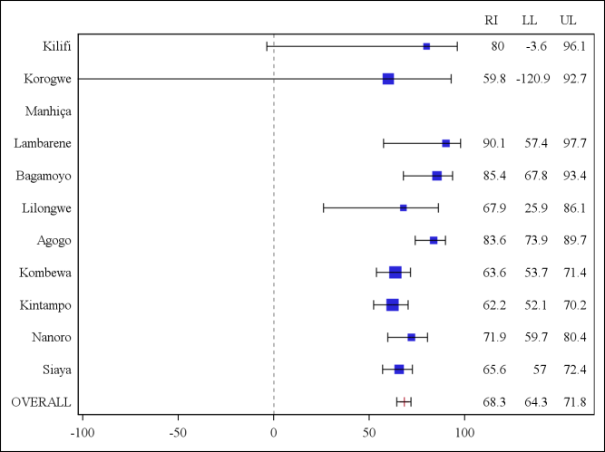 | 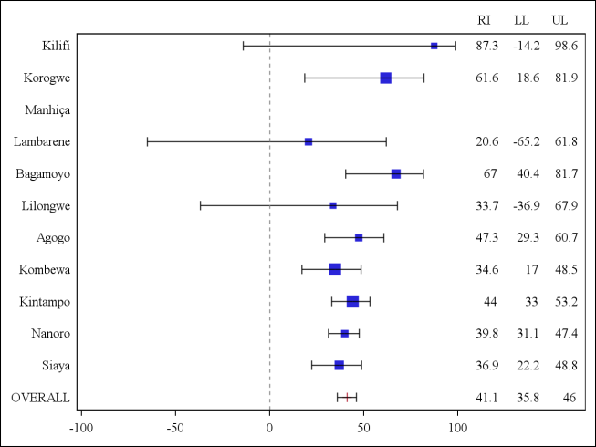 | 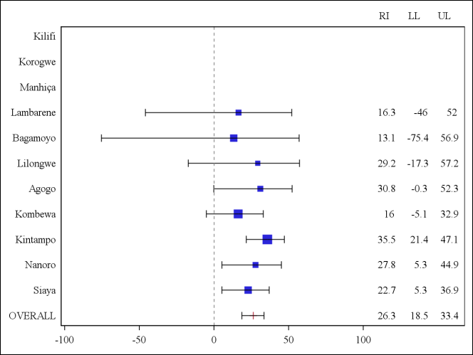
D. Infants 6-12 weeks: [1-6 months] | E. Infants 6-12 weeks: [7-12 months] | F. Infants 6-12 weeks: [13-18 months]
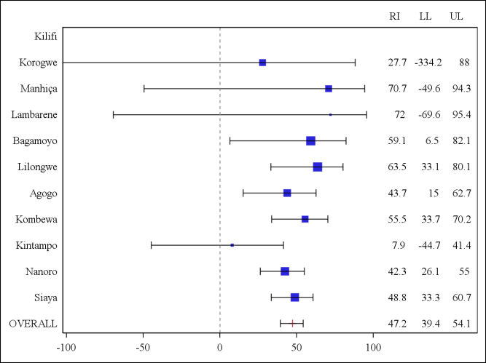 | 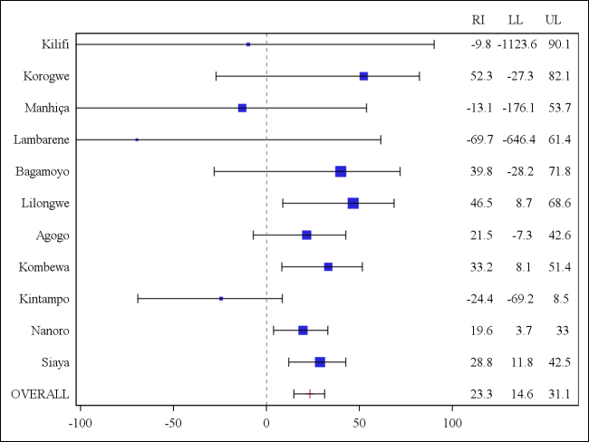 | 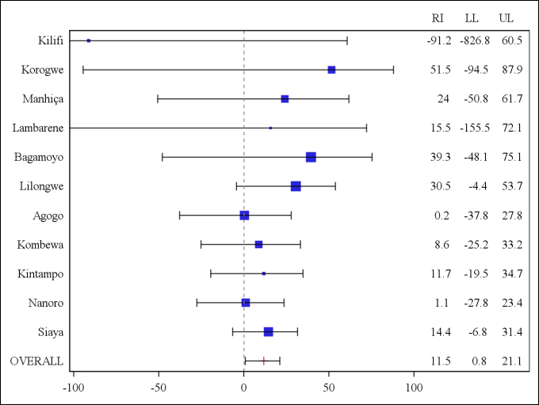
Clinical malaria primary case definition: Illness in a child brought to a study facility with a temperature of ≥ 37.5°C and P. falciparum asexual parasitemia at a density of > 5000 parasites per cubic millimeter or a case of malaria meeting the primary case definition of severe malaria.
RI: percentage of reduction in incidence of all episodes of clinical malaria (primary case definition) over the 6-month period.
LL = lower limit of the 95% confidence interval.
UL = Upper limit of the 95% confidence interval.
[1-6 months] = 14 days post dose-3 until 6 months post dose-3.
[7-12 months] = 6 months post dose-3 until 12 months post dose-3.
[13-18 months] = 12 months post dose-3 until 18 months post dose-3.
The size of each blue square reflects the relative number of subjects enrolled at each study site. The horizontal bars show the lower limit and upper limit of the 95% confidence interval.
Study sites are ordered from lowest (Kilifi) to highest (Siaya) incidence of clinical malaria, defined as a measured or reported fever within previous 24h and parasite density >0 parasites per cubic millimeter (i.e. clinical malaria secondary case definition), measured in control infants 6-12 weeks of age at enrollment during 12 months of follow-up.
The incidence of clinical malaria (total number of episodes/person year) and the reduction in incidence was calculated by 6-monthly periods and presented with 95% CIs. These results are expressed as a reduction in incidence and not a vaccine efficacy because the randomization is lost when dividing the analysis by 6-month breakdown. Children who begin the analysis at 6 months or 12 months post dose-3 are not the same group of children than those who were randomized at month zero.

Supplementary figure 6b. Reduction in incidence of all episodes of clinical malaria (primary case definition) during each 6-month period ordered by malaria incidence (intention-to-treat population)
A. Children 5-17 months: [0-8 months] | B. Children 5-17 months: [9-14 months] | C. Children 5-17 months: [15-20 months]
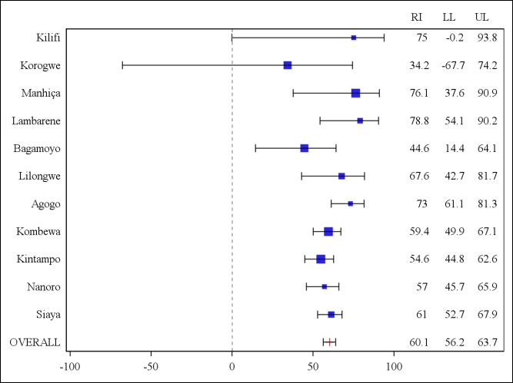 | 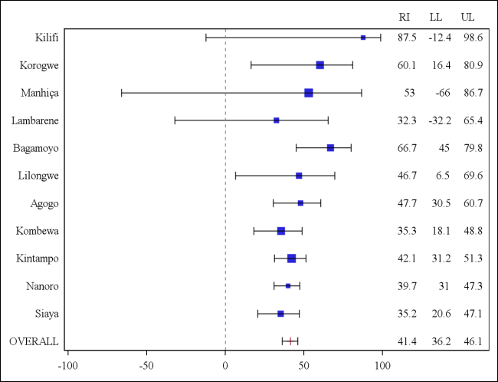 | 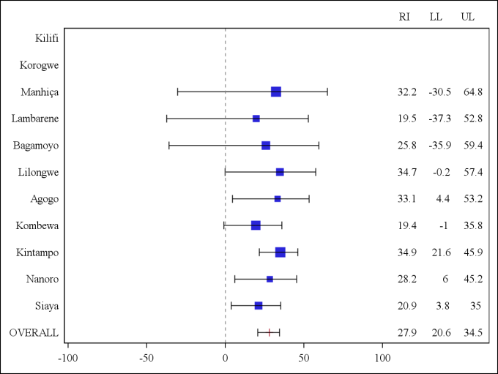
D. Infants 6-12 weeks: [0-8 months] | E. Infants 6-12 weeks: [9-14 months] | F. Infants 6-12 weeks: [15-20 months]
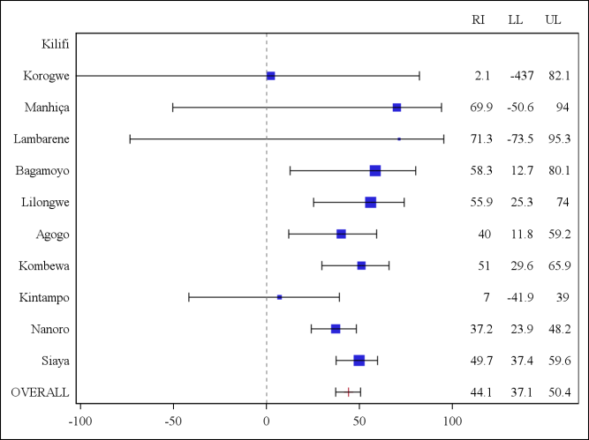 | 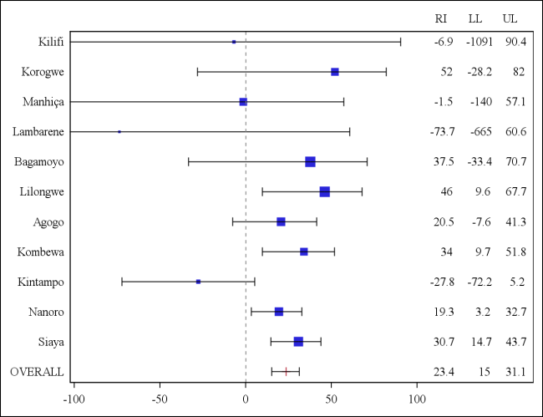 | 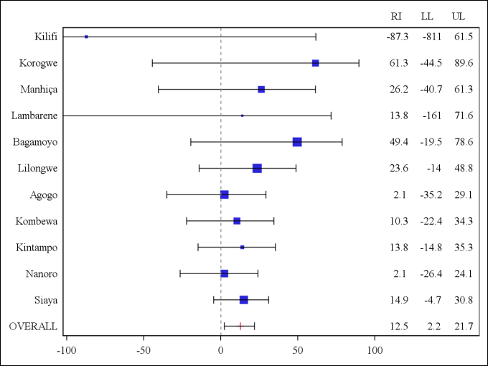
Clinical malaria primary case definition: Illness in a child brought to a study facility with a temperature of ≥ 37.5°C and P. falciparum asexual parasitemia at a density of > 5000 parasites per cubic millimeter or a case of malaria meeting the primary case definition of severe malaria.
RI: percentage of reduction in incidence of all episodes of clinical malaria (primary case definition) over the 6-month period.
LL = lower limit of the 95% confidence interval.
UL = Upper limit of the 95% confidence interval.
[0-8 months] = from dose-1 until 8 months post dose-1.
[9-14 months] = 8 months post dose-1 until 14 months post dose-1.
[15-20 months] = 14 months post dose-1 until 20 months post dose-1.
The size of each blue square reflects the relative number of subjects enrolled at each study site. The horizontal bars show the lower limit and upper limit of the 95% confidence interval.
Study sites are ordered from lowest (Kilifi) to highest (Siaya) incidence of clinical malaria, defined as a measured or reported fever within previous 24h and parasite density >0 parasites per cubic millimeter (i.e. clinical malaria secondary case definition), measured in control infants 6-12 weeks of age at enrollment during 12 months of follow-up.
The incidence of clinical malaria (total number of episodes/person year) and the reduction in incidence was calculated by 6-monthly periods and presented with 95% CIs. These results are expressed as a reduction in incidence and not a vaccine efficacy because the randomization is lost when dividing the analysis by 6-month breakdown. Children who begin the analysis at 6 months or 12 months post dose-3 are not the same group of children than those who were randomized at month zero.

