Report on the data from Delhi Survey
Pots were distributed to 5240 children aged 1-20. The sample was stratified into three groups MCD schools (1600), Government Schools (1600) and Slums (2040) and weighted in its distribution according to the populations and numbers of schools and slums in each district (and zone where appropriate). At all sites 40 children were sampled (with a target of 30 samples returned from each site and a total sample size of 3870). Throughout this report the data remains coded for anonymity. Appendix One contains the details of coding and site names for the reference of the survey team.
Appendix One: List of all site codes and descriptions
Table One: Showing Sample Breakdown and Average Return Rate by type of site
Site Type | Total Sites | Pots Distributed | Pots Returned | Return Rate | Lowest Return | Highest Return
Government Schools | 40 | 1600 | 1136 | 71.0% | 40.0% | 95.0%
MCD Schools | 40 | 1600 | 1174 | 73.4% | 45.0% | 92.5%
Slums | 47 | 2040 | 1358 | 66.6% | 32.5% | 100.0%

Table Two: Showing District Breakdown of Sample by Site Type
District | Number of Sites
 | Government School | MCD School | Slum
Central | 3 | 9 | 4
East | 3 | 3 | 7
New Delhi | 3 | 0 | 0
North | 3 | 3 | 4
North East | 5 | 3 | 1
North West | 8 | 7 | 5
South | 5 | 9 | 11
South West | 6 | 3 | 8
West | 4 | 3 | 7
Total Sites | 40 | 40 | 47

NB: 4 sites in the slums were sampled twice (80 pots) as return rate was so low. All results are presented below. Site level details of distributions and returned are available in annex one.
1572 children did not provide a sample and were therefore dropped from the analysis. Of the 3668 children remaining, 441 were dropped from the data set due to missing parasitological data and a further 3 who lacked age data. A total of 3224 children were finally included in this analysis slightly less than the desired sample size due to very challenging conditions of sample return in the under fives and slum areas. It can be seen from the table below that the analysed sample is very similar in characteristics to that of that sample randomly selected.
Table Three: Features of the initial sample selected compared to those returning samples and those analysed
 | Number |  |  | Percentage
 | Selected | Returned | Analysed | Selected | Returned | Analysed
Sex
Male | 2788 | 2074 | 1823 | 54.7% | 56.6% | 56.5%
Female | 2313 | 1592 | 1401 | 45.3% | 43.4% | 43.5%
Age Range
0-4 | 602 | 386 | 340 | 11.8% | 10.5% | 10.5%
5-12 | 3479 | 2562 | 2263 | 68.3% | 69.9% | 70.2%
13-18 | 1005 | 709 | 615 | 19.7% | 19.4% | 19.1%
19+ | 10 | 7 | 6 | 0.2% | 0.2% | 0.2%
Site Type
Government School | 1600 | 1136 | 995 | 28.6% | 31.0% | 30.9%
MCD School | 1600 | 1174 | 1094 | 28.6% | 32.0% | 33.9%
Slum | 2400 | 1358 | 1135 | 42.9% | 37.0% | 35.2%

Results of Initial Analysis
The overall prevalence of STH in Delhi children recorded by this survey was 15.8% (95% CI 14.6% - 17.1%). There was no difference between the prevalence between males and females. The highest prevalence recorded at any site was 83.3% at a slum, 83.3% at an MCD school and 64.7% at a government school. In all cases the lowest prevalence of STH recorded was 0.0%.
Table Four: Prevalence by Sex
 |  | Prevalence |  |  |  | 95% CI Any STH
Sex | Number | Hookworm | Ascaris | Trichuris | Any STH | Lower | Upper
Female | 1401 | 1.1% | 11.0% | 5.4% | 14.8% | 12.9% | 16.6%
Male | 1823 | 1.5% | 12.1% | 5.7% | 16.6% | 14.9% | 18.3%

The prevalence was led by Ascaris (Roundworm) which represented the large majority of infections detected with hookworm having the lowest prevalence overall at 1.3% (95% CI 0.9%-1.7%). From the table below it can be seen that prevalence varied substantially by district with the highest prevalences being recorded in North East (31.0%) and Central district(30.1%) and the lowest in New Delhi (2.6%) , followed by South West District (7.5%).

Table Five: Prevalence by District
 |  | Prevalence |  |  |  | 95% CI Any STH
District | Number | Hookworm | Ascaris | Trichuris | Any STH | Lower | Upper
Central | 435 | 3.2% | 23.0% | 12.9% | 30.1% | 25.8% | 34.4%
East | 307 | 0.3% | 12.7% | 2.3% | 13.7% | 9.8% | 17.5%
New Delhi | 77 | 1.3% | 0.0% | 1.3% | 2.6% | 0.0% | 6.2%
North | 242 | 0.4% | 9.5% | 2.1% | 11.2% | 7.2% | 15.1%
North East | 203 | 1.5% | 29.6% | 3.9% | 31.0% | 24.7% | 37.4%
North West | 510 | 1.2% | 5.9% | 3.7% | 9.4% | 6.9% | 11.9%
South | 650 | 1.5% | 8.2% | 8.2% | 16.0% | 13.2% | 18.8%
South West | 429 | 0.2% | 6.1% | 1.6% | 7.5% | 5.0% | 9.9%
West | 371 | 1.6% | 11.9% | 6.5% | 16.4% | 12.7% | 20.2%
Total | 3224 | 1.3% | 11.6% | 5.6% | 15.8% | 14.6% | 17.1%

Table Six: Prevalence by Type of Site
There were significant differences between the type of site with MCD schools and slums consistently having higher prevalence that the government schools. A trend which was clear in the data throughout many of the districts.
 | Government School |  | MCD School |  | Slum
District | Prevalence STH | N | Prevalence STH | N | Prevalence STH | N
central | 27.3% | 77 | 26.1% | 245 | 40.7% | 113
east | 4.8% | 84 | 14.5% | 69 | 18.2% | 154
New Delhi | 2.6% | 77
North | 10.5% | 76 | 10.3% | 68 | 12.2% | 98
North East | 20.7% | 121 | 50.7% | 73 | 11.1% | 9
North West | 7.0% | 187 | 8.6% | 220 | 15.5% | 103
South | 7.8% | 115 | 18.0% | 244 | 17.5% | 291
South West | 6.4% | 140 | 11.2% | 98 | 6.3% | 191
West | 4.2% | 118 | 15.6% | 77 | 25.0% | 176
Overall | 9.6% | 995 | 18.60% | 1094 | 18.50% | 1135

Table Seven: Prevalence by Age
 |  | Prevalence |  |  |  | 95% CI Any STH
Age | Number | Hookworm | Ascaris | Trichuris | Any STH | Lower | Upper
0-5 | 340 | 1.8% | 15.9% | 4.7% | 19.1% | 14.9% | 23.3%
6-12 | 2263 | 1.4% | 11.1% | 6.6% | 16.1% | 14.6% | 17.6%
13-18 | 615 | 1.0% | 11.1% | 2.3% | 12.7% | 10.0% | 15.3%
19+ | 6 | 0.0% | 33.3% | 0.0% | 33.3% | 0.0% | 74.7%

When data is stratified by age, it there is little difference between age groups, with the lower ages (5 and under) showing marginally higher prevalence with a drop off after primary school age. Though there is little statistical evidence for an actual difference. The over 19s represent a very small sample size and so no conclusion can be drawn from this.

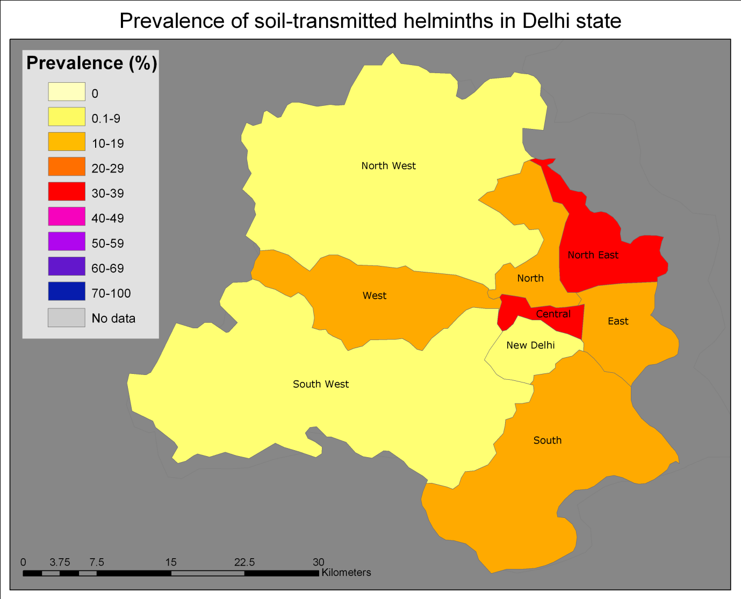
Analysis of Slum Data
As GPS points were not available slum data was also analysed by district (districts of sites are given in annex table) though it is acknowledged that as slums are not ‘organised’ within district administrative divisions this may not be the most realistic way to view the data. As will be seen in the data, variation within each district was huge, and so it is unclear how representative districts are A mapping project of slums is currently being undertaken and it is hoped in the future that data can be mapped using this tool. The religious and socio-economic makeup of slums could prove to be driving factors in the prevalence within slums as well as location and accompanying climate.
Data Summary
The slums comprised a data set of 1135 children aged 1-17 years, made up of 536 females (47.2%) and 599 males (52.8%). The prevalence of all STH in the slums was 18.5% (95% CI 16.2% - 20.8%)
Table Eight: Prevalence of each STH in slums
Worm | Prevalence | 95% CI Lower | 95% CI Upper
Any STH | 18.5% | 16.2% | 20.8%
Hookworm | 1.1% | 0.5% | 1.7%
Ascaris | 14.4% | 12.4% | 16.5%
Trichuris | 7.7% | 6.1% | 9.2%

In the case of the slums, the government requested that children be divided into pre-school (1-4 years) and school age (5-18 years). Children under school age did not show a different prevalence of all STH than children above school age, inclusive of being stratified by sex, where prevalence also shows no significant difference.
Table Nine: Association of infection with age and sex
Age | Sex | Prev Any STH | Lower CI | Upper CI | Number
pre | f | 16.2% | 10.0% | 22.4% | 202
pre | m | 20.0% | 13.8% | 26.2% | 226
school age | f | 18.0% | 14.2% | 21.8% | 334
school age | m | 19.1% | 15.4% | 22.8% | 373
Female |  | 17.5% | 14.3% | 20.8% | 536
Male |  | 19.4% | 16.2% | 22.5% | 599
pre |  | 18.2% | 13.8% | 22.7% | 296
School age |  | 18.6% | 16.0% | 21.2% | 839

Although there is not enough statistical power to display age groups per district, it can be seen from the graph below that there is little reason to believe the pre-school age group to have different district trends to the rest of the children in the slum or are at significantly lower or higher risk.

Table: Prevalence of STH by district and range of prevalence of all STH by district
 |  |  |  |  |  |  | Any STH District Range
District | Number of Sites | Number | Hookworm | Ascaris | Trichuris | Any STH | highest site recorded | lowest site recorded
Central | 4 | 113 | 3.5% | 33.6% | 24.8% | 40.7% | 83.3% | 0.0%
East | 7 | 154 | 0.6% | 18.2% | 1.9% | 18.2% | 36.4% | 0.0%
North | 4 | 98 | 0.0% | 12.2% | 1.0% | 12.2% | 26.7% | 0.0%
North East | 1 | 9 | 0.0% | 11.1% | 0.0% | 11.1% | 11.1% | 11.1%
North West | 5 | 103 | 0.0% | 13.6% | 5.8% | 15.5% | 20.8% | 0.0%
South | 11 | 291 | 1.4% | 9.3% | 9.3% | 17.5% | 59.1% | 0.0%
South West | 8 | 191 | 0.0% | 5.8% | 1.6% | 6.3% | 17.6% | 3.4%
West | 7 | 176 | 1.7% | 18.8% | 10.8% | 25.0% | 75.0% | 0.0%

Note: Site specific prevalence for slums is given in Annex Two

It is also noted that when considering a ‘pre-school’ deworming plan for the slums, in non school going children the age of pre-school is not clearly defined. For our analysis we have taken 4 and under as pre-school in line with the concept that children in school are 5 and above. However, below are presented the mean prevalence for pre-school children taken to be 0-4, 0-5 and 0-6. It can be seen there is little difference between the ages, all require the same treatment.
Pre-school age | Prev. STH | Lower CI | Upper CI | Sample Size
0-4 | 18.3% | 13.8% | 22.7% | 296
0-5 | 16.6% | 13.1% | 20.1% | 428
0-6 | 17.3% | 14.1% | 20.6% | 525

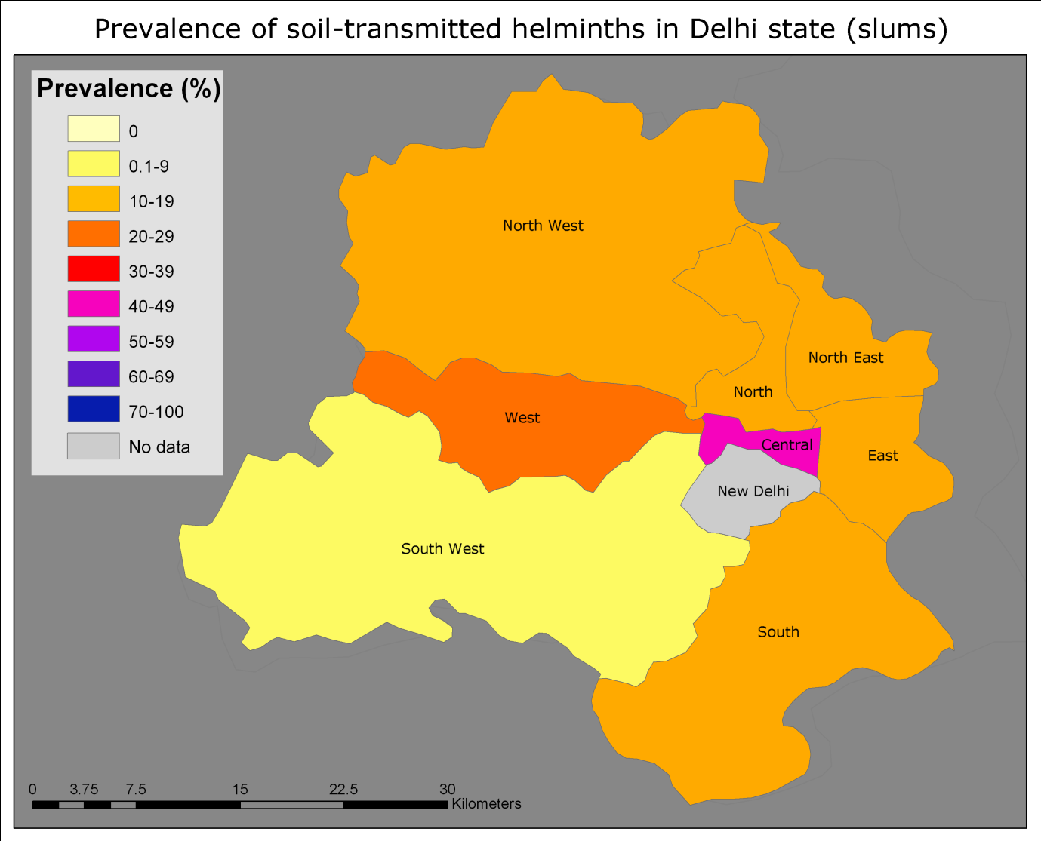

Analysis of Schools Data
Many of the children included in this survey were not of school age and are therefore not representative when considering a treatment programme implemented via schools and for school age children. For the description of data and generation of treatment recommendations for the schools only those children of school age were included in the analysis.
According to the information available, admission for the different schools in 2010 was as follows.
MCD Schools: Run 5-12 and all school children are considered primary school age
Government Schools: Run 5-18 and school children aged 5-12 are primary school age and 13-18 secondary school age.
Children who were not of the appropriate age have not been included in this analysis and a total of 1996 children were included 58.4% male and 41.6% female.
Table showing breakdown of sample for school age analysis.
 |  | School Type
Age | Sex | Government | MCD | Total
5-12 years | female | 229 | 398 | 229
 | male | 244 | 622 | 244
 | Total 5-12 yrs | 473 | 1020 | 473
13-18 years | female | 203 |  | 203
 | Male | 300 |  | 300
 | Total 13-18 yrs | 503 |  | 503
Total |  | 976 | 1020 | 1996

The overall prevalence of STH in school age, school going children was 13.7% (95% CI 12.2%-15.2%) and prevalence of any STH in MCD schools was higher than in government schools 17.6% (95% CI 15.3% - 20.0%) vs 9.5% (95% CI 7.7% - 11.4%). Representing 62.7% of all infections detected, Ascaris was the leading species, followed by trichuris (28.7%) and then hookworm (8.6%). At a district level Ascaris was also the lead species in all districts except South and New Delhi where Trichuris was marginally higher in both cases. There was little difference between males (14.7%, 95% CI 12.7%-16.7%) and females (12.3%, 95% CI 10.1% - 14.5%) prevalence of any STH.
There are clear differences in STH prevalence by district with Central and North Eastern having the highest prevalence and the lowest being found in New Delhi and East and West Districts. In most districts it can be seen that the trend of higher prevalence in MCD schools is still in place, with the only exceptions being North West District, North District and Central district where the prevalence in the two types of school is very similar.
Note: Specific Site results are available in Annex Three

Table showing district level summary for each STH (number and prevalence) by type of school
 |  |  | Ascaris |  | Hookworm |  | Trichuris |  | Any |  | 95% CI Any STH
District |  | Sample | infected | % | infected | % | infected | % | infected | % | low | high
Central | gov | 76 | 13 | 17.1% | 5 | 6.6% | 3 | 3.9% | 20 | 26.3% | 16.3% | 36.3%
 | mcd | 236 | 44 | 18.6% | 4 | 1.7% | 22 | 9.3% | 59 | 25.0% | 19.5% | 30.5%
 | total | 312 | 57 | 18.3% | 9 | 2.9% | 25 | 8.0% | 79 | 25.3% | 20.5% | 30.2%
East | gov | 78 | 3 | 3.8% | 0 | 0.0% | 0 | 0.0% | 3 | 3.8% | 0.0% | 8.1%
 | mcd | 59 | 5 | 8.5% | 0 | 0.0% | 3 | 5.1% | 7 | 11.9% | 3.5% | 20.2%
 | total | 137 | 8 | 5.8% | 0 | 0.0% | 3 | 2.2% | 10 | 7.3% | 2.9% | 11.7%
New Delhi | gov | 76 | 0 | 0.0% | 1 | 1.3% | 1 | 1.3% | 2 | 2.6% | 0.0% | 6.3%
 | mcd | - | - | - | - | - | - | - | - | -
 | total | 76 | 0 | 0.0% | 1 | 1.3% | 1 | 1.3% | 2 | 2.6% | 0.0% | 6.3%
North | gov | 74 | 8 | 10.8% | 0 | 0.0% | 1 | 1.4% | 8 | 10.8% | 3.7% | 17.9%
 | mcd | 60 | 3 | 5.0% | 1 | 1.7% | 3 | 5.0% | 7 | 11.7% | 3.5% | 19.9%
 | total | 134 | 11 | 8.2% | 1 | 0.7% | 4 | 3.0% | 15 | 11.2% | 5.8% | 16.6%
North East | gov | 118 | 23 | 19.5% | 0 | 0.0% | 3 | 2.5% | 24 | 20.3% | 13.0% | 27.6%
 | mcd | 65 | 28 | 43.1% | 2 | 3.1% | 4 | 6.2% | 30 | 46.2% | 33.9% | 58.4%
 | total | 183 | 51 | 27.9% | 2 | 1.1% | 7 | 3.8% | 54 | 29.5% | 22.9% | 36.1%
North West | gov | 185 | 8 | 4.3% | 1 | 0.5% | 5 | 2.7% | 13 | 7.0% | 3.3% | 10.7%
 | mcd | 214 | 8 | 3.7% | 5 | 2.3% | 8 | 3.7% | 19 | 8.9% | 5.1% | 12.7%
 | total | 399 | 16 | 4.0% | 6 | 1.5% | 13 | 3.3% | 32 | 8.0% | 5.4% | 10.7%
South | gov | 115 | 6 | 5.2% | 0 | 0.0% | 5 | 4.3% | 9 | 7.8% | 2.9% | 12.8%
 | mcd | 224 | 15 | 6.7% | 5 | 2.2% | 21 | 9.4% | 38 | 17.0% | 12.0% | 21.9%
 | total | 339 | 21 | 6.2% | 5 | 1.5% | 26 | 7.7% | 47 | 13.9% | 10.2% | 17.6%
South West | gov | 138 | 8 | 5.8% | 0 | 0.0% | 1 | 0.7% | 9 | 6.5% | 2.4% | 10.7%
 | mcd | 96 | 7 | 7.3% | 1 | 1.0% | 3 | 3.1% | 11 | 11.5% | 5.0% | 17.9%
 | total | 234 | 15 | 6.4% | 1 | 0.4% | 4 | 1.7% | 20 | 8.5% | 5.0% | 12.1%
West | gov | 116 | 4 | 3.4% | 0 | 0.0% | 1 | 0.9% | 5 | 4.3% | 0.6% | 8.0%
 | mcd | 66 | 7 | 10.6% | 1 | 1.5% | 3 | 4.5% | 9 | 13.6% | 5.3% | 22.0%
 | total | 182 | 11 | 6.0% | 1 | 0.5% | 4 | 2.2% | 14 | 7.7% | 3.8% | 11.6%
Total | gov | 976 | 73 | 7.5% | 7 | 0.7% | 20 | 2.0% | 93 | 9.5% | 7.7% | 11.4%
 | mcd | 1020 | 117 | 11.5% | 19 | 1.9% | 67 | 6.6% | 180 | 17.6% | 15.3% | 20.0%
 | overall | 1996 | 190 | 9.5% | 26 | 1.3% | 87 | 4.4% | 273 | 13.7% | 12.2% | 15.2%

Overall primary school age children showed slightly higher prevalence than secondary school children. 14.5% (95% CI 12.7% - 16.3%) vs 11.1% (95% CI 8.4%-13.9%). This difference was largely being driven by the site type, and when stratified by site type there was still a slight indication (p=0.07) of a difference between the two age groups but with secondary school children actually having a higher prevalence of STH than the younger ones.
Stratifying by age also showed that comparing government and MCD schools primary school age children, the difference between the two prevalence’s was larger (P=<0.0001).
Table: Prevalence of Any STH for Primary and Secondary School Children by type of school
 | Age Group | Prevalence Any STH | Lower CI | Upper CI | P value cf gov 5-12 years
Gov | 5-12 years | 7.8% | 5.4% | 10.2%
Gov | 13-18 years | 11.1% | 8.4% | 13.9% | 0.0785
MCD | 5-12 years | 17.6% | 15.3% | 20.1% | 0.0000

As can be seen from the graph overleaf in comparison to that above, removing the secondary school children from the analysis does little to change the trends of difference between MCD and Government schools on a district level or significantly affect the district prevalence.

Creating treatment maps and recommendations
Maps and treatment recommendations were made taking into account both the prevalences seen in different age groups, school types and districts alongside practical considerations for developing a treatment programme. As all the analysis the treatment maps are based on children of school age only. As prevalence is considered separately by school type, and in government schools the prevalence in secondary and primary school aged children was not significantly different, children of both primary and secondary age are included in the maps. This is also considering the practical problem of exclusion of this group in the event of a treatment programme and the fact that age group was not a significant determinant in influencing the difference in prevalence between MCD and government schools.
Map showing prevalence of different STH by school type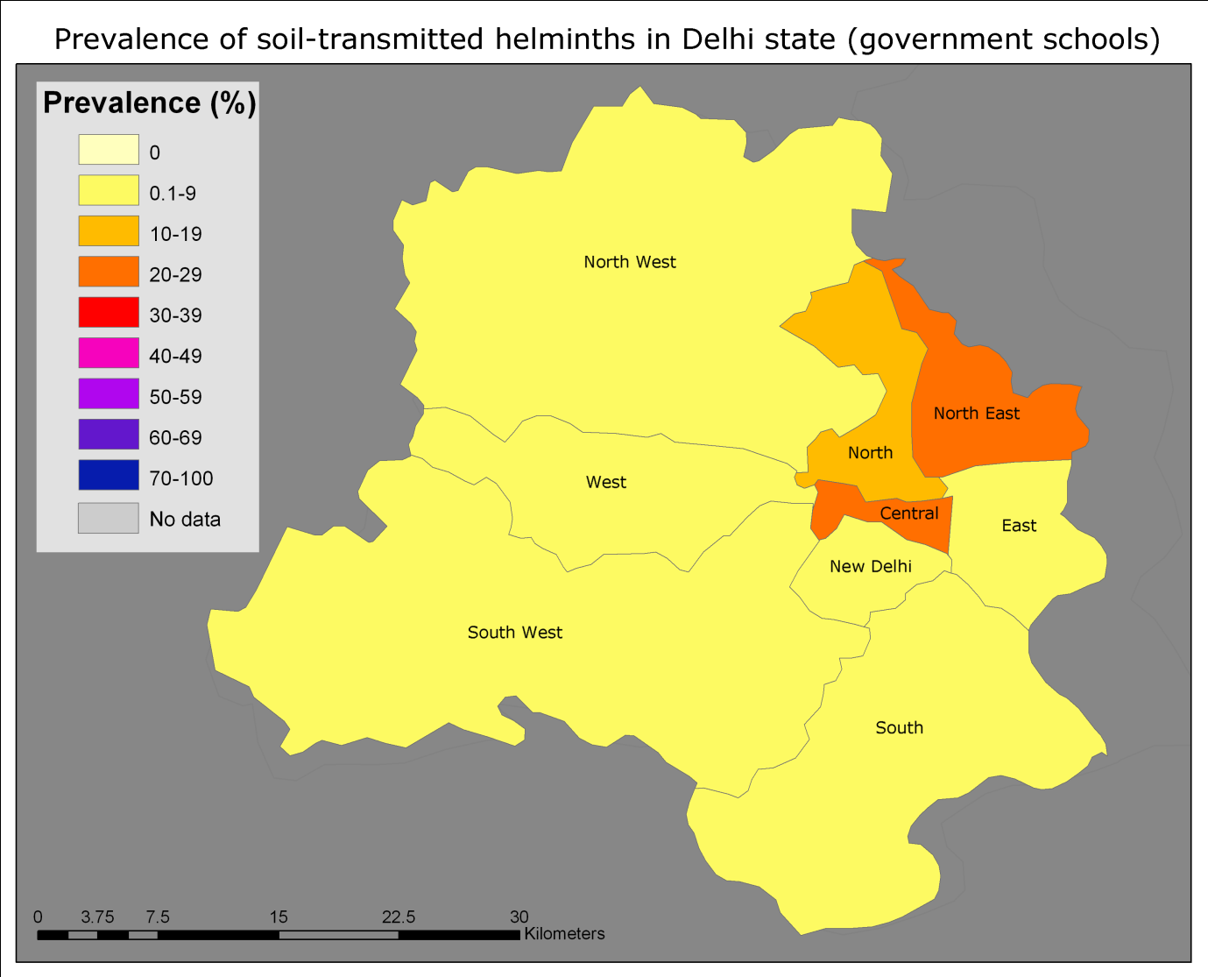
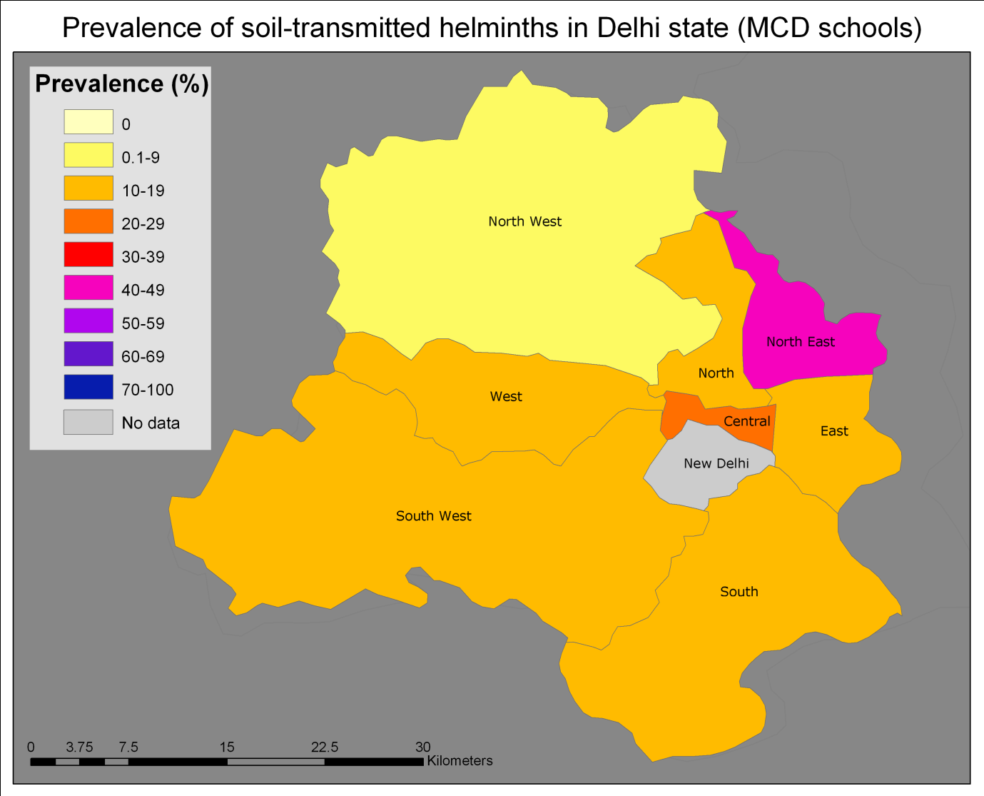
In the development of a map on which to base treatment guidelines, given the ranges of prevalence seen within the districts in both types of school (see below) and the practical and political implications of excluding a school type maps were based on the cumulative prevalence of either MCD schools or Government schools breaching a treatment threshold. Treatment thresholds were based on the normative guidance of the WHO, (20% for annual, 50% for biannual treatment) and where the prevalence was close to the boundary it was included rather than excluded from the treatment plan.
Table showing range of school prevalence by district
District | School Type | highest | lowest
Central | Government | 62.5% | 11.5%
 | MCD | 46.7% | 3.7%
East | Government | 9.7% | 0.0%
 | MCD | 27.8% | 4.0%
New Delhi | Government | 4.2% | 0.0%
North | Government | 22.2% | 0.0%
 | MCD | 22.2% | 0.0%
North East | Government | 46.4% | 0.0%
 | MCD | 76.9% | 17.2%
North West | Government | 16.7% | 0.0%
 | MCD | 16.0% | 0.0%
South | Government | 10.5% | 0.0%
 | MCD | 25.0% | 6.7%
South West | Government | 17.2% | 0.0%
 | MCD | 14.7% | 8.8%
West | Government | 11.1% | 0.0%
 | MCD | 23.8% | 0.0%

Map showing treatment plan for Delhi

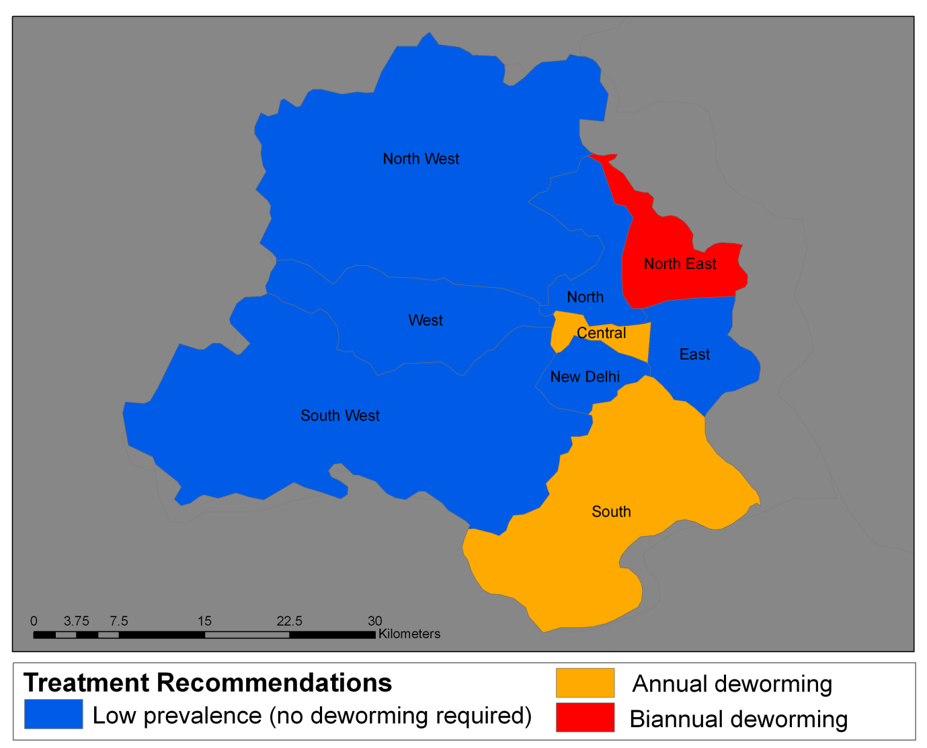
Annex One
Distributions and returns by site

Site Code | Return Rate | Distrib. | Ret. | Viable | Used
D01 | 57.5% | 40 | 23 | 23 | 100.0%
D02 | 67.5% | 40 | 27 | 27 | 100.0%
D03 | 42.5% | 40 | 17 | 16 | 94.1%
D04 | 82.5% | 40 | 33 | 33 | 100.0%
D05 | 85.0% | 40 | 34 | 34 | 100.0%
D06 | 95.0% | 40 | 38 | 38 | 100.0%
D07 | 92.5% | 40 | 37 | 28 | 75.7%
D08 | 95.0% | 40 | 38 | 38 | 100.0%
D09 | 57.5% | 40 | 23 | 23 | 100.0%
D10 | 87.5% | 40 | 35 | 27 | 77.1%
D11 | 55.0% | 40 | 22 | 22 | 100.0%
D12 | 80.0% | 40 | 32 | 31 | 96.9%
D13 | 70.0% | 40 | 28 | 9 | 32.1%
D14 | 57.5% | 40 | 23 | 20 | 87.0%
D15 | 42.5% | 40 | 17 | 11 | 64.7%
D16 | 55.0% | 40 | 22 | 18 | 81.8%
D17 | 85.0% | 40 | 34 | 31 | 91.2%
D18 | 77.5% | 40 | 31 | 30 | 96.8%
D19 | 72.5% | 40 | 29 | 26 | 89.7%
D20 | 90.0% | 40 | 36 | 30 | 83.3%
D21 | 62.5% | 40 | 25 | 21 | 84.0%
D22 | 95.0% | 40 | 38 | 33 | 86.8%
D23 | 40.0% | 40 | 16 | 14 | 87.5%
D24 | 82.5% | 40 | 33 | 32 | 97.0%
D25 | 62.5% | 40 | 25 | 19 | 76.0%
D26 | 75.0% | 40 | 30 | 29 | 96.7%
D27 | 70.0% | 40 | 28 | 24 | 85.7%
D28 | 55.0% | 40 | 22 | 22 | 100.0%
D29 | 50.0% | 40 | 20 | 17 | 85.0%
D30 | 70.0% | 40 | 28 | 26 | 92.9%
D31 | 82.5% | 40 | 33 | 32 | 97.0%
D32 | 60.0% | 40 | 24 | 21 | 87.5%
D33 | 67.5% | 40 | 27 | 23 | 85.2%
D34 | 92.5% | 40 | 37 | 34 | 91.9%
D35 | 60.0% | 40 | 24 | 23 | 95.8%
D36 | 85.0% | 40 | 34 | 13 | 38.2%
D37 | 72.5% | 40 | 29 | 28 | 96.6%
D38 | 77.5% | 40 | 31 | 30 | 96.8%
D39 | 75.0% | 40 | 30 | 18 | 60.0%
D40 | 57.5% | 40 | 23 | 21 | 91.3%
M01 | 92.5% | 40 | 37 | 36 | 97.3%
M02 | 70.0% | 40 | 28 | 26 | 92.9%
M03 | 72.5% | 40 | 29 | 29 | 100.0%
M04 | 85.0% | 40 | 34 | 34 | 100.0%
M05 | 67.5% | 40 | 27 | 27 | 100.0%
M06 | 87.5% | 40 | 35 | 33 | 94.3%
M07 | 80.0% | 40 | 32 | 29 | 90.6%
M08 | 70.0% | 40 | 28 | 27 | 96.4%
M09 | 80.0% | 40 | 32 | 32 | 100.0%
M10 | 45.0% | 40 | 18 | 18 | 100.0%
M11 | 70.0% | 40 | 28 | 27 | 96.4%
M12 | 55.0% | 40 | 22 | 22 | 100.0%
M13 | 92.5% | 40 | 37 | 35 | 94.6%
M14 | 77.5% | 40 | 31 | 29 | 93.5%
M15 | 82.5% | 40 | 33 | 28 | 84.8%
M16 | 55.0% | 40 | 22 | 21 | 95.5%
M17 | 65.0% | 40 | 26 | 21 | 80.8%
M18 | 80.0% | 40 | 32 | 30 | 93.8%
M19 | 87.5% | 40 | 35 | 35 | 100.0%
M20 | 82.5% | 40 | 33 | 32 | 97.0%
M22 | 82.5% | 40 | 33 | 25 | 75.8%
M23 | 72.5% | 40 | 29 | 26 | 89.7%
M25 | 57.5% | 40 | 23 | 22 | 95.7%
M26 | 67.5% | 40 | 27 | 26 | 96.3%
M28 | 67.5% | 40 | 27 | 21 | 77.8%
M29 | 75.0% | 40 | 30 | 30 | 100.0%
M30 | 52.5% | 40 | 21 | 18 | 85.7%
M31 | 57.5% | 40 | 23 | 23 | 100.0%
M32 | 87.5% | 40 | 35 | 31 | 88.6%
M33 | 62.5% | 40 | 25 | 25 | 100.0%
M34 | 80.0% | 40 | 32 | 32 | 100.0%
M35 | 62.5% | 40 | 25 | 24 | 96.0%
M36 | 72.5% | 40 | 29 | 25 | 86.2%
M37 | 77.5% | 40 | 31 | 27 | 87.1%
M38 | 75.0% | 40 | 30 | 29 | 96.7%
M39 | 70.0% | 40 | 28 | 27 | 96.4%
M40 | 87.5% | 40 | 35 | 35 | 100.0%
M41 | 85.0% | 40 | 34 | 34 | 100.0%
M42 | 72.5% | 40 | 29 | 21 | 72.4%
M50 | 72.5% | 40 | 29 | 22 | 75.9%
S01 | 50.0% | 40 | 20 | 18 | 90.0%
S02 | 72.5% | 40 | 29 | 28 | 96.6%
S03 | 92.5% | 40 | 37 | 32 | 86.5%
S04 | 62.5% | 40 | 25 | 25 | 100.0%
S05 | 72.5% | 40 | 29 | 28 | 96.6%
S06 | 85.0% | 40 | 34 | 34 | 100.0%
S07 | 75.0% | 40 | 30 | 29 | 96.7%
S08 | 47.5% | 40 | 19 | 17 | 89.5%
S09 | 75.0% | 40 | 30 | 29 | 96.7%
S10 | 45.0% | 40 | 18 | 15 | 83.3%
S11 | 57.5% | 40 | 23 | 19 | 82.6%
S12 | 65.0% | 40 | 26 | 20 | 76.9%
S13 | 67.5% | 40 | 27 | 24 | 88.9%
S14 | 62.5% | 40 | 25 | 22 | 88.0%
S15 | 62.5% | 40 | 25 | 22 | 88.0%
S16 | 52.5% | 40 | 21 | 19 | 90.5%
S18 | 65.0% | 40 | 26 | 22 | 84.6%
S19 | 75.0% | 40 | 30 | 30 | 100.0%
S20 | 77.5% | 40 | 31 | 29 | 93.5%
S21 | 60.0% | 40 | 24 | 17 | 70.8%
S22 | 50.0% | 40 | 20 | 17 | 85.0%
S23 | 60.0% | 40 | 24 | 23 | 95.8%
S24 | 75.0% | 40 | 30 | 28 | 93.3%
S25 | 72.5% | 40 | 29 | 24 | 82.8%
S26 | 70.0% | 40 | 28 | 27 | 96.4%
S27 | 90.0% | 40 | 36 | 35 | 97.2%
S29 | 32.5% | 80 | 26 | 11 | 42.3%
S30 | 55.0% | 40 | 22 | 20 | 90.9%
S32 | 60.0% | 80 | 48 | 12 | 25.0%
S33 | 77.5% | 40 | 31 | 25 | 80.6%
S36 | 60.0% | 40 | 24 | 24 | 100.0%
S37 | 82.5% | 40 | 33 | 33 | 100.0%
S38 | 70.0% | 40 | 28 | 24 | 85.7%
S39 | 100.0% | 40 | 40 | 38 | 95.0%
S41 | 55.0% | 40 | 22 | 19 | 86.4%
S42 | 60.0% | 40 | 24 | 22 | 91.7%
S43 | 62.5% | 40 | 25 | 24 | 96.0%
S44 | 85.0% | 40 | 34 | 32 | 94.1%
S45 | 90.0% | 40 | 36 | 35 | 97.2%
S47 | 72.5% | 40 | 29 | 24 | 82.8%
S48 | 95.0% | 40 | 38 | 33 | 86.8%
S49 | 75.0% | 40 | 30 | 29 | 96.7%
S50 | 50.0% | 80 | 40 | 7 | 17.5%
S51 | 62.5% | 40 | 25 | 24 | 96.0%
S52 | 60.0% | 80 | 48 | 9 | 18.8%
S53 | 70.0% | 40 | 28 | 28 | 100.0%
S54 | 77.5% | 40 | 31 | 29 | 93.5%

Annex Two: Site Specific Prevalence for Slums

 |  |  | Number infected |  |  |  | Prevalence
Code | District | Number | Asc | HW | Tri | Any | Asc | HW | Tri | Any
S01 | South | 18 | 3 | 0 | 0 | 3 | 16.7% | 0.0% | 0.0% | 16.7%
S02 | South | 28 | 0 | 0 | 0 | 0 | 0.0% | 0.0% | 0.0% | 0.0%
S03 | Central | 32 | 0 | 0 | 0 | 0 | 0.0% | 0.0% | 0.0% | 0.0%
S04 | South | 25 | 2 | 1 | 2 | 4 | 8.0% | 4.0% | 8.0% | 16.0%
S05 | South | 28 | 3 | 0 | 0 | 3 | 10.7% | 0.0% | 0.0% | 10.7%
S06 | South | 34 | 3 | 1 | 1 | 5 | 8.8% | 2.9% | 2.9% | 14.7%
S07 | South | 29 | 3 | 0 | 3 | 5 | 10.3% | 0.0% | 10.3% | 17.2%
S08 | South West | 17 | 3 | 0 | 0 | 3 | 17.6% | 0.0% | 0.0% | 17.6%
S09 | East | 29 | 4 | 0 | 0 | 4 | 13.8% | 0.0% | 0.0% | 13.8%
S10 | North West | 15 | 3 | 0 | 2 | 3 | 20.0% | 0.0% | 13.3% | 20.0%
S11 | North | 19 | 1 | 0 | 0 | 1 | 5.3% | 0.0% | 0.0% | 5.3%
S12 | South | 20 | 4 | 1 | 1 | 5 | 20.0% | 5.0% | 5.0% | 25.0%
S13 | North West | 24 | 300.0% | 0 | 1 | 4 | 12.5% | 0.0% | 4.2% | 16.7%
S14 | South West | 22 | 1 | 0 | 0 | 1 | 4.5% | 0.0% | 0.0% | 4.5%
S15 | South | 22 | 2 | 0 | 13 | 13 | 9.1% | 0.0% | 59.1% | 59.1%
S16 | South | 19 | 0 | 0 | 0 | 0 | 0.0% | 0.0% | 0.0% | 0.0%
S18 | South West | 22 | 2 | 0 | 1 | 2 | 9.1% | 0.0% | 4.5% | 9.1%
S19 | North | 30 | 8 | 0 | 0 | 8 | 26.7% | 0.0% | 0.0% | 26.7%
S20 | South West | 29 | 1 | 0 | 0 | 1 | 3.4% | 0.0% | 0.0% | 3.4%
S21 | South West | 17 | 2 | 0 | 1 | 2 | 11.8% | 0.0% | 5.9% | 11.8%
S22 | North West | 17 | 0 | 0 | 0 | 0 | 0.0% | 0.0% | 0.0% | 0.0%
S23 | North West | 23 | 4 | 0 | 0 | 4 | 17.4% | 0.0% | 0.0% | 17.4%
S24 | East | 28 | 6 | 0 | 0 | 6 | 21.4% | 0.0% | 0.0% | 21.4%
S25 | North | 24 | 0 | 0 | 0 | 0 | 0.0% | 0.0% | 0.0% | 0.0%
S26 | South West | 27 | 0 | 0 | 1 | 1 | 0.0% | 0.0% | 3.7% | 3.7%
S27 | South | 35 | 5 | 1 | 5 | 9 | 14.3% | 2.9% | 14.3% | 25.7%
S29 | East | 11 | 4 | 0 | 1 | 4 | 36.4% | 0.0% | 9.1% | 36.4%
S30 | West | 20 | 8 | 0 | 5 | 11 | 40.0% | 0.0% | 25.0% | 55.0%
S32 | East | 12 | 0 | 0 | 0 | 0 | 0.0% | 0.0% | 0.0% | 0.0%
S33 | North | 25 | 3 | 0 | 1 | 3 | 12.0% | 0.0% | 4.0% | 12.0%
S36 | Central | 24 | 18 | 0 | 10 | 20 | 75.0% | 0.0% | 41.7% | 83.3%
S37 | Central | 33 | 17 | 1 | 17 | 23 | 51.5% | 3.0% | 51.5% | 69.7%
S38 | West | 24 | 3 | 3 | 0 | 6 | 12.5% | 12.5% | 0.0% | 25.0%
S39 | East | 38 | 13 | 1 | 2 | 13 | 34.2% | 2.6% | 5.3% | 34.2%
S41 | West | 19 | 0 | 0 | 0 | 0 | 0.0% | 0.0% | 0.0% | 0.0%
S42 | West | 22 | 2 | 0 | 0 | 2 | 9.1% | 0.0% | 0.0% | 9.1%
S43 | North West | 24 | 4 | 0 | 3 | 5 | 16.7% | 0.0% | 12.5% | 20.8%
S44 | West | 32 | 19 | 0 | 14 | 24 | 59.4% | 0.0% | 43.8% | 75.0%
S45 | West | 35 | 1 | 0 | 0 | 1 | 2.9% | 0.0% | 0.0% | 2.9%
S47 | West | 24 | 0 | 0 | 0 | 0 | 0.0% | 0.0% | 0.0% | 0.0%
S48 | South | 33 | 2 | 0 | 2 | 4 | 6.1% | 0.0% | 6.1% | 12.1%
S49 | East | 29 | 0 | 0 | 0 | 0 | 0.0% | 0.0% | 0.0% | 0.0%
S50 | East | 7 | 1 | 0 | 0 | 1 | 14.3% | 0.0% | 0.0% | 14.3%
S51 | Central | 24 | 3 | 3 | 1 | 3 | 12.5% | 12.5% | 4.2% | 12.5%
S52 | North East | 9 | 1 | 0 | 0 | 1 | 11.1% | 0.0% | 0.0% | 11.1%
S53 | South West | 28 | 1 | 0 | 0 | 1 | 3.6% | 0.0% | 0.0% | 3.6%
S54 | South West | 29 | 1 | 0 | 0 | 1 | 3.4% | 0.0% | 0.0% | 3.4%

Annex Three: Site Specific Prevalence for Schools (based on school age children only)
 |  |  |  | Number infected |  |  |  | Prevalence
School Type | Site Code | District | Sampled | Asc | HW | Tri | Any | Asc | HW | Tri | Any
G | D29 | Central | 16 | 10 | 0 | 1 | 10 | 62.5% | 0.0% | 6.3% | 62.5%
G | D30 | Central | 26 | 1 | 2 | 0 | 3 | 3.8% | 7.7% | 0.0% | 11.5%
G | D34 | Central | 34 | 2 | 3 | 2 | 7 | 5.9% | 8.8% | 5.9% | 20.6%
G | D11 | East | 20 | 0 | 0 | 0 | 0 | 0.0% | 0.0% | 0.0% | 0.0%
G | D12 | East | 31 | 3 | 0 | 0 | 3 | 9.7% | 0.0% | 0.0% | 9.7%
G | D17 | East | 27 | 0 | 0 | 0 | 0 | 0.0% | 0.0% | 0.0% | 0.0%
G | D27 | New Delhi | 24 | 0 | 0 | 1 | 1 | 0.0% | 0.0% | 4.2% | 4.2%
G | D31 | New Delhi | 32 | 0 | 1 | 0 | 1 | 0.0% | 3.1% | 0.0% | 3.1%
G | D40 | New Delhi | 20 | 0 | 0 | 0 | 0 | 0.0% | 0.0% | 0.0% | 0.0%
G | D33 | North | 23 | 5 | 0 | 1 | 5 | 21.7% | 0.0% | 4.3% | 21.7%
G | D35 | North | 22 | 3 | 0 | 0 | 3 | 13.6% | 0.0% | 0.0% | 13.6%
G | D38 | North | 29 | 0 | 0 | 0 | 0 | 0.0% | 0.0% | 0.0% | 0.0%
G | D09 | North East | 23 | 3 | 0 | 0 | 3 | 13.0% | 0.0% | 0.0% | 13.0%
G | D20 | North East | 28 | 12 | 0 | 2 | 13 | 42.9% | 0.0% | 7.1% | 46.4%
G | D21 | North East | 21 | 1 | 0 | 0 | 1 | 4.8% | 0.0% | 0.0% | 4.8%
G | D22 | North East | 32 | 7 | 0 | 1 | 7 | 21.9% | 0.0% | 3.1% | 21.9%
G | D23 | North East | 14 | 0 | 0 | 0 | 0 | 0.0% | 0.0% | 0.0% | 0.0%
G | D04 | North West | 33 | 1 | 1 | 0 | 2 | 3.0% | 3.0% | 0.0% | 6.1%
G | D07 | North West | 28 | 1 | 0 | 0 | 1 | 3.6% | 0.0% | 0.0% | 3.6%
G | D13 | North West | 9 | 0 | 0 | 0 | 0 | 0.0% | 0.0% | 0.0% | 0.0%
G | D19 | North West | 25 | 0 | 0 | 0 | 0 | 0.0% | 0.0% | 0.0% | 0.0%
G | D24 | North West | 32 | 2 | 0 | 4 | 5 | 6.3% | 0.0% | 12.5% | 15.6%
G | D36 | North West | 13 | 0 | 0 | 0 | 0 | 0.0% | 0.0% | 0.0% | 0.0%
G | D37 | North West | 27 | 1 | 0 | 1 | 2 | 3.7% | 0.0% | 3.7% | 7.4%
G | D39 | North West | 18 | 3 | 0 | 0 | 3 | 16.7% | 0.0% | 0.0% | 16.7%
G | D03 | South | 16 | 0 | 0 | 0 | 0 | 0.0% | 0.0% | 0.0% | 0.0%
G | D08 | South | 38 | 3 | 0 | 2 | 4 | 7.9% | 0.0% | 5.3% | 10.5%
G | D14 | South | 20 | 1 | 0 | 1 | 2 | 5.0% | 0.0% | 5.0% | 10.0%
G | D15 | South | 11 | 0 | 0 | 0 | 0 | 0.0% | 0.0% | 0.0% | 0.0%
G | D18 | South | 30 | 2 | 0 | 2 | 3 | 6.7% | 0.0% | 6.7% | 10.0%
G | D01 | South West | 21 | 2 | 0 | 1 | 3 | 9.5% | 0.0% | 4.8% | 14.3%
G | D10 | South West | 27 | 1 | 0 | 0 | 1 | 3.7% | 0.0% | 0.0% | 3.7%
G | D16 | South West | 18 | 0 | 0 | 0 | 0 | 0.0% | 0.0% | 0.0% | 0.0%
G | D26 | South West | 29 | 5 | 0 | 0 | 5 | 17.2% | 0.0% | 0.0% | 17.2%
G | D28 | South West | 22 | 0 | 0 | 0 | 0 | 0.0% | 0.0% | 0.0% | 0.0%
G | D32 | South West | 21 | 0 | 0 | 0 | 0 | 0.0% | 0.0% | 0.0% | 0.0%
G | D02 | West | 27 | 0 | 0 | 0 | 0 | 0.0% | 0.0% | 0.0% | 0.0%
G | D05 | West | 34 | 2 | 0 | 0 | 2 | 5.9% | 0.0% | 0.0% | 5.9%
G | D06 | West | 37 | 0 | 0 | 1 | 1 | 0.0% | 0.0% | 2.7% | 2.7%
G | D25 | West | 18 | 2 | 0 | 0 | 2 | 11.1% | 0.0% | 0.0% | 11.1%
M | M10 | Central | 18 | 5 | 0 | 3 | 6 | 27.8% | 0.0% | 16.7% | 33.3%
M | M18 | Central | 27 | 6 | 0 | 0 | 6 | 22.2% | 0.0% | 0.0% | 22.2%
M | M20 | Central | 31 | 2 | 1 | 2 | 3 | 6.5% | 3.2% | 6.5% | 9.7%
M | M26 | Central | 26 | 2 | 0 | 2 | 2 | 7.7% | 0.0% | 7.7% | 7.7%
M | M29 | Central | 28 | 5 | 2 | 1 | 7 | 17.9% | 7.1% | 3.6% | 25.0%
M | M32 | Central | 30 | 9 | 1 | 7 | 14 | 30.0% | 3.3% | 23.3% | 46.7%
M | M35 | Central | 23 | 4 | 0 | 5 | 8 | 17.4% | 0.0% | 21.7% | 34.8%
M | M37 | Central | 27 | 1 | 0 | 0 | 1 | 3.7% | 0.0% | 0.0% | 3.7%
M | M39 | Central | 26 | 10 | 0 | 2 | 12 | 38.5% | 0.0% | 7.7% | 46.2%
M | M28 | East | 16 | 1 | 0 | 0 | 1 | 6.3% | 0.0% | 0.0% | 6.3%
M | M31 | East | 18 | 4 | 0 | 2 | 5 | 22.2% | 0.0% | 11.1% | 27.8%
M | M36 | East | 25 | 0 | 0 | 1 | 1 | 0.0% | 0.0% | 4.0% | 4.0%
M | M33 | North | 22 | 1 | 0 | 2 | 3 | 4.5% | 0.0% | 9.1% | 13.6%
M | M42 | North | 20 | 0 | 0 | 0 | 0 | 0.0% | 0.0% | 0.0% | 0.0%
M | M50 | North | 18 | 2 | 1 | 1 | 4 | 11.1% | 5.6% | 5.6% | 22.2%
M | M23 | North East | 23 | 15 | 1 | 1 | 15 | 65.2% | 4.3% | 4.3% | 65.2%
M | M30 | North East | 13 | 10 | 0 | 2 | 10 | 76.9% | 0.0% | 15.4% | 76.9%
M | M38 | North East | 29 | 3 | 1 | 1 | 5 | 10.3% | 3.4% | 3.4% | 17.2%
M | M03 | North West | 26 | 1 | 0 | 2 | 3 | 3.8% | 0.0% | 7.7% | 11.5%
M | M13 | North West | 35 | 0 | 3 | 0 | 3 | 0.0% | 8.6% | 0.0% | 8.6%
M | M14 | North West | 29 | 1 | 0 | 0 | 1 | 3.4% | 0.0% | 0.0% | 3.4%
M | M19 | North West | 33 | 3 | 1 | 1 | 4 | 9.1% | 3.0% | 3.0% | 12.1%
M | M22 | North West | 25 | 2 | 1 | 2 | 4 | 8.0% | 4.0% | 8.0% | 16.0%
M | M34 | North West | 31 | 1 | 0 | 3 | 4 | 3.2% | 0.0% | 9.7% | 12.9%
M | M40 | North West | 35 | 0 | 0 | 0 | 0 | 0.0% | 0.0% | 0.0% | 0.0%
M | M02 | South | 22 | 4 | 0 | 1 | 5 | 18.2% | 0.0% | 4.5% | 22.7%
M | M05 | South | 27 | 1 | 2 | 2 | 4 | 3.7% | 7.4% | 7.4% | 14.8%
M | M06 | South | 31 | 1 | 1 | 3 | 5 | 3.2% | 3.2% | 9.7% | 16.1%
M | M07 | South | 24 | 1 | 2 | 2 | 5 | 4.2% | 8.3% | 8.3% | 20.8%
M | M08 | South | 26 | 2 | 0 | 3 | 5 | 7.7% | 0.0% | 11.5% | 19.2%
M | M09 | South | 30 | 0 | 0 | 2 | 2 | 0.0% | 0.0% | 6.7% | 6.7%
M | M11 | South | 25 | 3 | 0 | 3 | 5 | 12.0% | 0.0% | 12.0% | 20.0%
M | M12 | South | 20 | 3 | 0 | 3 | 5 | 15.0% | 0.0% | 15.0% | 25.0%
M | M17 | South | 19 | 0 | 0 | 2 | 2 | 0.0% | 0.0% | 10.5% | 10.5%
M | M01 | South West | 34 | 2 | 1 | 0 | 3 | 5.9% | 2.9% | 0.0% | 8.8%
M | M04 | South West | 34 | 4 | 0 | 1 | 5 | 11.8% | 0.0% | 2.9% | 14.7%
M | M15 | South West | 28 | 1 | 0 | 2 | 3 | 3.6% | 0.0% | 7.1% | 10.7%
M | M16 | West | 21 | 3 | 1 | 2 | 5 | 14.3% | 4.8% | 9.5% | 23.8%
M | M25 | West | 21 | 0 | 0 | 0 | 0 | 0.0% | 0.0% | 0.0% | 0.0%
M | M41 | West | 24 | 4 | 0 | 1 | 4 | 16.7% | 0.0% | 4.2% | 16.7%

