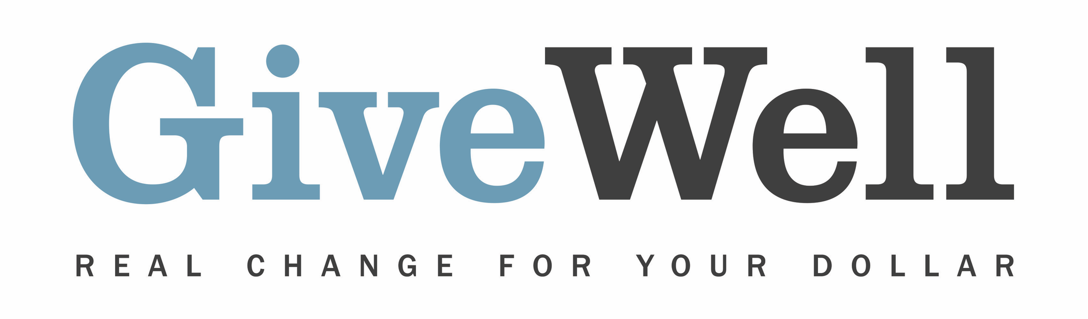
Dear (RECIPIENT'S NAME) ,
(YOUR NAME) has made a donation of $(DONATION AMOUNT) in your name designated for the support of Development Media International (DMI).

DMI produces radio and television broadcasts in developing countries that encourage people to adopt improved health practices. DMI's program may be highly cost-effective. DMI has shown a commitment to monitoring the quality of its programs.

DMI is one of GiveWell’s standout charities. GiveWell is a nonprofit dedicated to finding outstanding giving opportunities. Thousands of hours have gone into finding and analyzing GiveWell's recommended charities. For more information on these charities, including DMI, and GiveWell’s work, please visit us online at www.givewell.org

Thank you for your support!

Sincerely,
GiveWell Staff
www.givewell.org

