 | America SCORES  National Evaluation Report  2005-06 | 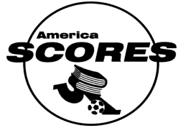

America SCORES is a national not-for-profit organization whose mission statement is “America SCORES empowers students in urban communities using soccer, writing, creative expression, and service-learning. With teamwork as the unifying value, America SCORES inspires youth to lead healthy lifestyles, be engaged students, and become agents of change in their communities.” America SCORES provides after-school programs for youth in elementary schools that include playing soccer, writing poetry, and participating in community service. The America SCORES philosophy is that by implementing programs that provide basic developmental “supports and opportunities” while promoting physical activity, health education, literacy, social skills, and character development, urban children develop life skills that will last throughout their lives.

Currently, America SCORES is implemented in 14 cities across the country. Program sites are primarily staffed by Executive Directors and directors of the soccer and writing components. Teachers from collaborating public schools are hired and trained to serve as soccer and writing coaches. Children participate in weekly soccer practices and games (for two to seven hours of physical activity per week) and in periodic soccer clinics or related events. The program also uses a health education curriculum to encourage healthy choices and lifestyles. Another central component of America SCORES is literacy; sessions are provided twice a week for 60 to 90 minutes each and focus on creative writing (in poetry form) and expository writing (“Writing for the Community”). In addition, children have the opportunity, at least once per academic year, to participate in public performances of their work, including Poetry Slams and other special events. An additional aspect of America SCORES is promoting character development through community service. In conjunction with their expository writing sessions, participants plan and participate in volunteer service projects in their communities. Integral to all these components of SCORES programming is a focus on team building, cooperation, good sportsmanship, and leadership.

The primary targeted outcomes of America SCORES include the following:

- Improved performance in language arts;
- Improved (or maintained) levels of physical fitness;
- Increased cooperation and teamwork;
- Increased self-confidence; and
- Increased community awareness and responsibility.

Other intended outcomes include developing more positive attitudes toward language arts (creative and expository writing), improved peer relationships (including increased conflict resolution skills), increased social support, and improved self-concept or positive identity.

In August 2005, America SCORES contracted with Philliber Research Associates to conduct a national evaluation of the program as it was currently being implemented in 12 sites: the San Francisco Bay Area, Chicago, Cleveland, Dallas, Denver, Los Angeles, Milwaukee, New England (Boston), New York, St. Louis, Seattle, and Washington, D.C. During the same period, staff at Philliber Research Associates, in close collaboration with America SCORES staff, conducted a review of program logic models, previous evaluation efforts undertaken at both the national and individual site levels, and other program documentation to develop an evaluation plan with strategies to meet the evaluation needs, within the available resources, of SCORES. The evaluation utilized the following data collection strategies to measure progress toward the program’s intended outcomes:

- Pre/Post Creative Writing Assessments, rating participants’ poetry-writing skills in the dimensions of creativity, voice, mechanics and structure, and use of descriptive language. Seven sites administered both pre (fall) and post (spring) assessments.

- Pre/Post Expository Writing Assessments, measuring participants’ expository writing skills in the areas of insight and ideas, clarity, voice, mechanics and structure, and use of descriptive language. Four sites administered these assessments during the spring semester.

- Pre/Post Fitness Assessments, consisting of a six-minute running test to measure endurance and BMI assessments, measuring participants’ fitness levels through their body mass indices. Ten sites administered both pre (fall) and post (spring) running tests and submitted heights and weights for their participants.²

- Youth Pre/Post Questionnaires measuring youth attitudes and behaviors in the areas of physical activity, health knowledge, attitudes toward writing, self efficacy, peer relationships, social support, positive identity, community citizenship, and conflict resolution. Eleven SCORES sites administered both pre (fall) and post (spring) surveys. ²

- Pre/Post Coaches’ Assessment of Players, completed by soccer coaches, measuring changes in self-confidence, soccer skills, peer relationships, and sportsmanship and teamwork. Three sites completed both pre (fall) and post (spring) assessments.

- Parent/Guardian Surveys, completed at special program events, documenting parent/guardian perceptions of SCORES’ benefits for their children. These surveys were administered at eight sites.

The following report presents a “snapshot” of SCORES participants, followed by evaluation findings organized by outcome area.

The Youth Served by America SCORES: A Snapshot
According to attendance records submitted by the 12 SCORES sites included in the evaluation, approximately 4,500 children and youth participated in the program during the 2005-06 academic year. Of these, basic demographic characteristics were available for 1,339 participants.
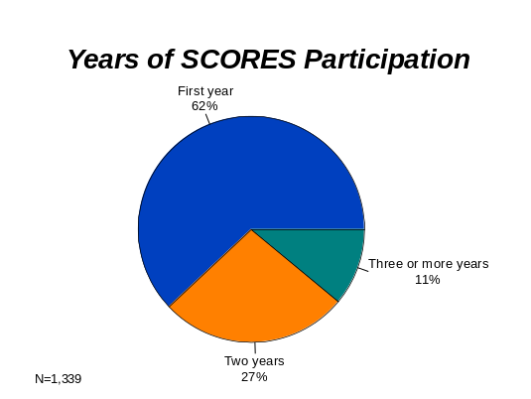

Of these participants:

- The majority (62%) were in their first year of SCORES participation;

- Half were boys and half were girls;

- Sixty-four percent were nine or 10 years of age; the average age was 9.6 years; and

- Nearly half (47%) were Hispanic or Latino/Latina; 29% were Black or African American; and the rest were from other racial/ethnic backgrounds.
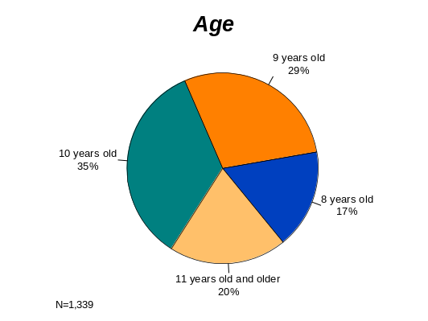

In addition, as indicated in a previous evaluation report, approximately 80% to 95% of SCORES participants were eligible for free or reduced price school lunch because their family income was below the poverty line.

Site Participation: Participants attended SCORES programming in 12 different cities. Attendance records suggest the following SCORES sites served 500 or more children and youth during the 2005-06 program year: Cleveland, D.C., Bay Area, New England, and Denver. Those serving 300 to 450 during the year included Seattle and New York City. Sites that served 100 to 200 participants per year include Chicago, Dallas, Milwaukee, St. Louis, and L.A.

Participation in Physical Activity: On fall surveys, SCORES participants reported relatively high levels of physical activity (outside of SCORES), but only about one-third reported participating in any other organized sports or exercise programs.
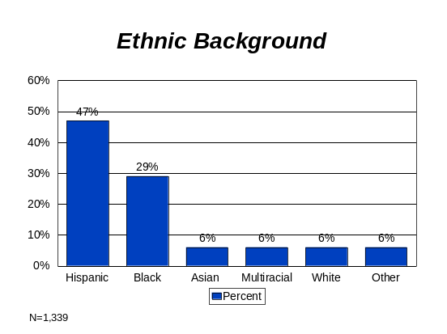

Reading Levels and Attitudes Toward Writing: The young people in SCORES also reported reading books, stories or poems on their own, fairly frequently (with half indicating they read from these sources at least three days a week). Finally, participants also held positive attitudes toward writing. Nearly 60% agreed, “Writing is VERY important for my future and I work hard to improve!” The majority reported they liked writing poetry and stories “a lot.”

Overall, these data suggest that SCORES serves a diverse population of young people (mostly children of color), with a good balance of girls and boys. Youth survey results suggest that this was the only organized sports program in which the majority of the young people participated.

The following sections present evaluation data by outcome area, beginning with improved performance in language arts.

Outcome One: Improved Performance in Language Arts

SCORES’ joint focus on language arts and soccer is one programming aspect that makes SCORES unique among other youth development and after-school programs. The literacy component is offered two afternoons each week. Writing Coaches work with participants on structured lessons that focus on creative writing (poetry) during the fall and on expository writing (related to community awareness and service) in the spring. At the end of the poetry curriculum, children and youth participate in Poetry Slams to showcase their work for family and friends.

Several evaluation strategies were used to measure improvement in language arts, including pre/post creating writing (poetry) assessments, pre/post expository writing (community letter) assessments, and questions about literacy on coach and parent/guardian surveys. Taken together, results of these measures suggest that SCORES participants show significant gains in writing abilities during program participation. These gains are detailed below.

Results of Pre/Post Creative Writing Assessments
Summary of Poetry Scoring Guidelines
Rubric Scoring Area | Scores of 7 to 8 represented…
Creativity/ideas | Very original/multiple creative ideas; fresh ideas and details; shows insight
Voice | Writing is personal and shows engagement with subject; writing is compelling and engaging
Mechanics/structure | Organized, well-written; has a basic poetry structure (line breaks); has “rhythm”
Use of adjectives and adverbs | Imaginative use of adjectives and adverbs; unusual, fresh adjectives and adverbs
Use of metaphor and simile | Rich, creative use of metaphors or similes
Use of other poetic devices | Rich, creative use of two or more poetic devices

To measure changes in poetry writing abilities, SCORES writing coaches at six sites asked participants to write six-line poems on “found objects” from nature, brought in for each class by the coaches. These objects included tree leaves, potted plants, pieces of fruit, and rocks.

Coaches submitted their participants’ poems to the evaluation team who, in turn, distributed groups of poems to the Writing Directors at different sites for scoring. Assessment rubrics were designed to score six creative writing components, using scales of 0 to 8 in which 0= “No attempt/refused to participate,” and scores of 7 to 8 represented “excellent” poem qualities as described in the table above.

One hundred and fifty-two young people completed poems near the beginning and end of the program year, approximately six months apart. From fall to spring, there were increases in average rubric scores for the following areas:
1) Creativity/ideas;
2) Voice;
3) Mechanics/structure;
4) Use of adjectives and adverbs; and
5) Use of other poetic devices.
The increases in Creativity, Voice, and Use of Other Poetic Devices are statistically significant.
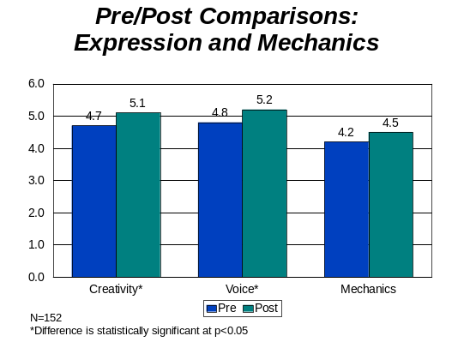
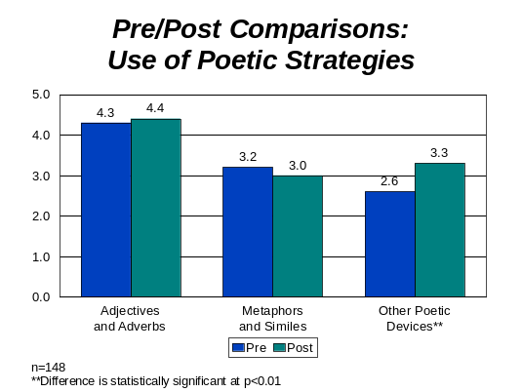

The following are examples of poems written by SCORES participants.

The Plant  Precious emerald  Leaves  Tropical violet flower  In the  Center  Spike of a  Porcupine  Color of a freshly brewed  Tea. | Leaves  Leaves grow in summer in the beautiful breeze.  Leaves are like pillows you sleep on.  Leaves make me feel soft and fuzzy  Like being in the happiest place ever.  It is like being in heaven.  Leaves make me feel good. | The Tree  In the woods. In the spring all day long.  I see the tree.  In the shadows in the night all the time.  I see the tree so gold.  In the dark it stands alone,  In the dark at night I see the tree.

Results of Pre/Post Expository Writing Assessments

A similar approach was used to measure changes in participants’ expository writing abilities. SCORES writing coaches at four sites asked participants to write a short letter (to a fictional family moving into homes next door to participants) describing their neighborhoods. Specifically, participants were asked to describe two things they liked the most about their neighborhoods and two things they would like to change.

As with participants’ poems, neighborhood letters were submitted by each of the four sites to the evaluation team who distributed them to the Writing Directors at different sites for scoring. Rubrics were used to score five expository writing components, and, like poetry rubrics, employed scales of 0 to 8 in which 0= “No attempt/refused to participate,” and scores of 7 to 8 represented “excellent” writing qualities.
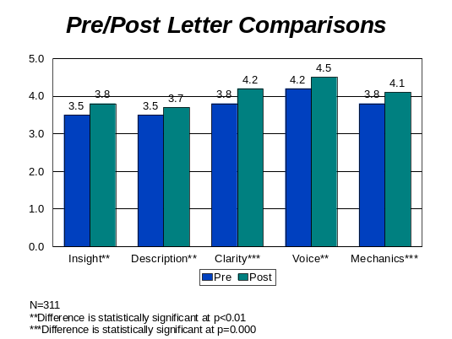

Three hundred and eleven youth completed letters for both pre- and post-assessments. Letters were completed approximately two months apart. As shown in the graph to the right, there were statistically significant increases in average rubric scores for all areas assessed; these include:
1) Insight and ideas;
2) Description;
3) Clarity;
4) Voice; and
5) Mechanics/structure.

The following are examples of participants’ letters.

Dear Brooks Family,  I am so happy that you moved in the community. I like that my community is clean. My community is a happy place to live in. What I want changed is the teens who spray paint on walls and grown ups have to say stop. What I want changed is the kids batting balls to the roof. I am happy that you moved in the community because I can play with your kids.  Sincerely,  Jacob | Dear Brooks Family,  I live in Roxbury and I like it a lot. I am happy that you live in my neighborhood too. There is a lot of nice stuff here. For example, I love the Roxbury Park, the restaurant, and the stores. But something that I would change is the killing and the gangs. There is a big gang that you need to be careful of. Anyway, it is nice to have you near.  Sincerely,  Alicia
Dear Brooks Family,  My name is Vivian. I live in the house next to you. Our community has a beautiful park across the street. People are sweet and nice. But something I wish I could change is the littering everywhere. I also wish that the park would have more stuff to play on.  Love,  Vivian | Dear Brooks Family,  Our community is a great place. The two things I like about our community is our park because it is where we can have fun. And another thing I like about my community is my friends because they’re so much fun to play with. What I would like is a Boys’ and Girls’ Club and more houses.  Sincerely,  Michael

Other Results

Survey results from parents/guardians and SCORES coaches provide additional evidence of positive outcomes in language arts. Writing coaches commented on increased participant motivation, interest, eagerness, and enthusiasm for writing. Two writing coaches noted that English Language Learning students gained more proficiency in English and became more outgoing.

Almost all parents and guardians who completed surveys agreed that their children enjoyed writing poetry and stories. A number of them commented on greater creativity, higher levels of personal expression, and “more meaningful” writing among the young people in SCORES. Writing coaches also noted increased willingness to take risks, particularly in sharing work and creativity; and improved abilities to focus, follow instructions, listen, and “work hard.”

The majority of parents/guardians reported that the amount of time their children spent reading had increased since they began participating in SCORES. About half reported their children spent one or two hours per week reading poems, stories or books outside of school and SCORES, while the other half indicated their children spent three or more hours engaging in these types of reading. A number of parents had noticed improvements in their children’s levels of reading comprehension. Comments include the following:
My son has learned how to write a poem, and he loves it. Also, his teacher says his writing skills have sky-rocketed since last year.

My daughter is learning the importance of reading and writing in everything we do in life.

She loves to write poetry now and does it at home on the computer.

His reading and writing skills have improved and he is more interested in doing his homework.

-- Parents/guardians of SCORES Participants

- My son is learning to pay more attention and understand much, much better what he’s reading.
- I could not get him to read. Now he does it on his own.
- My daughter learned it is better to read more to learn more.
- She thinks it is very important to read because the more she reads the more she learns.

A number of parents/guardians also noted their children were developing their vocabulary, improving their penmanship, improving their abilities to construct paragraphs, and building confidence in their writing abilities through SCORES participation. One parent said that her daughter was “learning to think more before writing down her thoughts,” while another commented, “She is learning to generate ideas on a topic and to organize her ideas.”
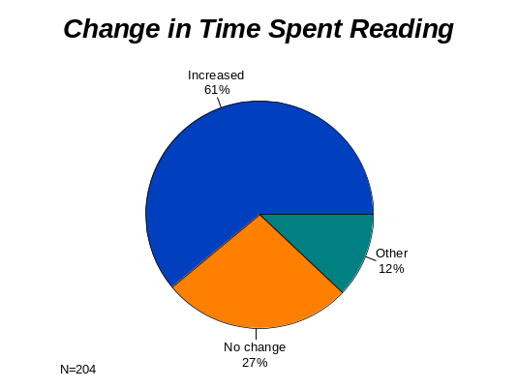

More than 90% of the parents/guardians surveyed believed SCORES was helping their children learn more about poetry and creative writing. Numerous parents commented specifically that SCORES was helping their children develop imagination, creativity, and the ability to express themselves or speak in front of a group, leading some participants to become less shy and more outgoing. Comments about creativity and self-expression include the following:

  - My children express themselves better.
We learned how to express our feelings without hurting others.

-- SCORES participant
- My son has learned how to be creative and put thoughts into words.
- My daughter’s stories show much more imagination and creativity.
- The program has caused my son to open up and express himself.
- My son used to be shy to perform. Now he’s not, and he knows he can do anything he puts his mind to.
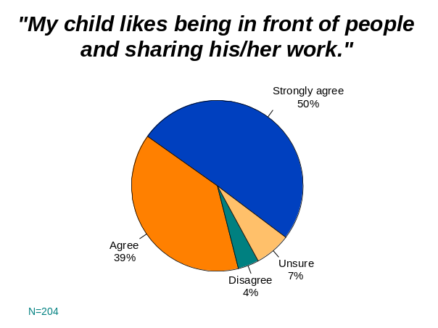
- This program is bringing my daughter out of her shell. She’s able to speak in front of a crowd without being nervous.

As previously mentioned, parents and guardians completed surveys while attending special program events, including Poetry Slams. Participants’ willingness to take risks in sharing their creative work was evident in parent/guardian comments about how their children had encouraged them to attend their Poetry Slam performances. Parents shared the following comments from and about their children:
- My son is excited to be a part of this poetry reading.
- My daughter told me the Poetry Slam would be a powerful expression of the spoken word.
- My daughter was excited that her poem was selected to be performed. She was excited to be on the stage.
- My son told me that he was going to do his own poem. He said that we had to go, that it was very important.
- “Mommy,” he said with great emotion, “I’m inviting you to this great event.” He is very happy to get to participate in these events.

Language Arts Summary

Assessments of poetry and community description letters written by SCORES participants suggest that the creative and expository writing abilities of these youth improved in a number of areas during the course of program participation. Poems showed an overall improvement in creativity/ideas, voice, and the use of poetic devices, while community letters improved in the areas of insight and ideas, description, clarity, voice, and mechanics/structure. The improvement in expository writing is particularly noteworthy because the pre/post community letters were completed over a relatively short time period (about two months).

Additionally, parents/guardians reported their children spent more time reading, and nearly all agreed their children were learning about creative writing. Comments from both parents and writing coaches provide evidence that SCORES gives participants the opportunity to develop imagination, creativity, and self-expression.

Outcome Two: Improved Levels of Physical Fitness

When asked what their children liked most about participating in SCORES, many parents/guardians reported they liked playing soccer and playing sports competitively the most. For many participants, SCORES provided their only opportunity to be in an organized sports program. Results of this evaluation suggest that this enthusiasm for soccer and competition, and the two to seven additional hours of physical activity per week that young people gained through SCORES, contributed to positive outcomes in physical fitness. This includes improved performance on a six-minute running test and a drop in the number of girls who were overweight or at risk of being overweight.
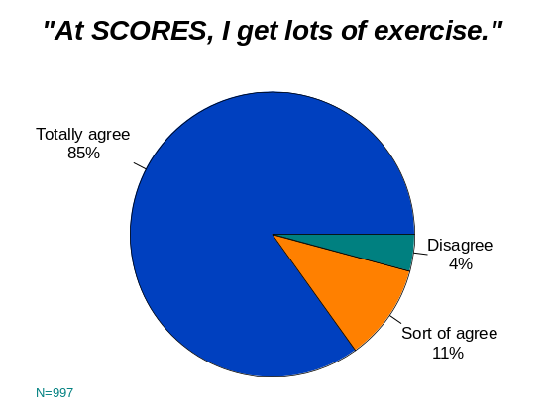

Physical Fitness Measures

In order to measure changes in physical fitness, all SCORES sites were asked to administer a six-minute running test (modeled after the Cooper 12-minute run, a standard fitness measure used with college soccer players) and to gather participants’ heights and weights for Body Mass Index (BMI) calculations. For the running test, participants ran laps around soccer fields, tracks, or gymnasiums (depending upon available facilities at each site) for six minutes; if they were unable to run or jog for this period of time, they were allowed to walk. SCORES coaches counted the number of laps (to the nearest quarter of a lap) that each participant was able to run at the beginning of the program year and again at the end. SCORES personnel also recorded the heights and weights of their participating youth, using physicians’ scales at each site (in late October and mid to late May). Evaluators then calculated BMI-for-Age statistics, based on a standard BMI formula that was adjusted for each child’s age and gender according to guidelines distributed by the Centers for Disease Control. For both sets of fitness measures, the goal was to measure change from pre- to post-assessment rather than to compare results for SCORES participants to national norms.
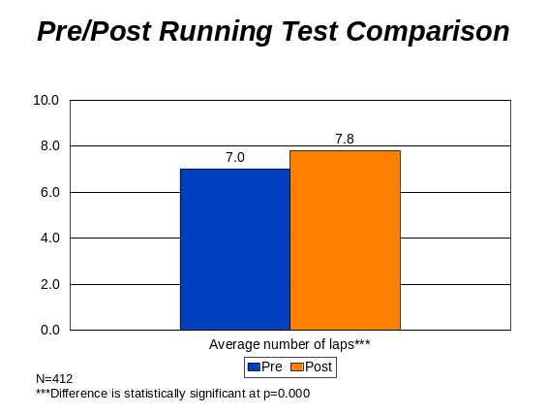

Pre/Post Results: Six-Minute Running Test

Four hundred and twelve youth participated in both fall and spring running tests. As shown in the table below:

- There was a 11% decrease from pre- to post-assessment in the number of youth who ran less than six laps in six minutes.

- There was a statistically significant increase in the average number of laps that youth were able to run at the time of the post-assessment; the average increased by nearly one full lap.

Comparison of Pre/Post Results: Six-Minute Running Test
 | Pre | Post | Change
Number of laps  1.00-5.99  6.00-10.99  11.00-15.99  16.00-20.99  21.00 or more | 51%  37%  9%  1%  2% | 40%  43%  13%  1%  3% | -11%  +6%  +4%  --  +1%
Average number of laps | 7.0 | 7.8 | +0.8***
N=412
***Difference is statistically significant at p=.000

These results suggest that, overall, youth developed better physical endurance in the approximately six-month period between the fall and spring tests.

Pre/Post Results: BMI-for-Age Assessments
My daughter is losing weight by participating in SCORES.

My son is more active than before.

-- Parents/guardians of SCORES participants

I’ve learned that I can run faster . . . You’ll lose a lot of weight if you play soccer.

-- SCORES participant

Body Mass Index assessments were completed in both the fall and the spring for 126 girls and 128 boys participating in SCORES. BMI-for-Age guidelines classify children and youth in the 1st through 4th percentiles as underweight; those in the 85th through 94th percentiles as at risk of being overweight; and those in the 95th percentiles and above as overweight. According to these guidelines, 51% of the total sample of SCORES participants was at or above the 85th percentile at the time of the fall assessments; this suggests that about half the youth were overweight (28%) or at risk of being overweight (23%). At the time of the spring assessments, the percentage at or above the 85th percentile had fallen by 2%.

The percentage of girls in the pre/post BMI sample who scored between the 85th and 95th percentiles on fall assessments was 25%; by spring, this percentage had fallen to 22%. The number of girls at and above the 95th percentile fell by 2% from fall to spring. Altogether, the number of girls who were classified as overweight or at risk of being overweight fell by 5% during the six-month period between assessments.

Comparisons of Girls’ BMI-for-Age Assessments
 | Pre-BMI | Post-BMI | Change
25th percentile and under | 9% | 7% | -2%
Between 25th and 50th percentile | 14% | 18% | +4%
Between 50th and 75th percentile | 19% | 21% | +2%
Between 75th and 85th percentile | 10% | 11% | +1%
Between 85th and 95th percentile | 25% | 22% | -3%
95th percentile and over | 23% | 21% | -2%
n=126

As shown in the table below, among boys, there was a 2% decrease in the number who were classified as overweight (in the 95th percentile and above) from fall to spring; however, there was a 1% increase in the number of those classified as being at risk of being overweight.

Comparisons of Boys’ BMI-for-Age Assessments
 | Pre BMI | Post BMI | Change
25th percentile and under | 6% | 7% | +1%
Between 25th and 50th percentile | 6% | 9% | +3%
Between 50th and 75th percentile | 24% | 16% | -8%
Between 75th and 85th percentile | 9% | 14% | +5%
Between 85th and 95th percentile | 21% | 22% | +1%
95th percentile and over | 34% | 32% | -2%
n=128

Altogether, BMI-for-Age results suggest that the number of girls in SCORES who were overweight or at risk of being overweight fell by 5%.
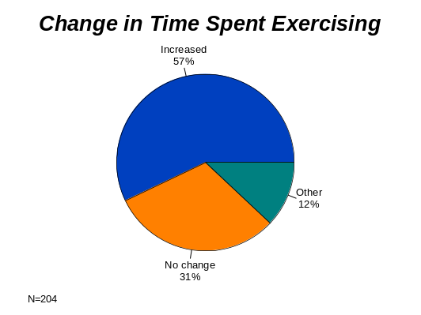
Other Results

As previously mentioned, positive outcomes in physical fitness are linked to the opportunities for increased physical activity provided by SCORES. In addition to the two to seven additional hours of exercise participants received during SCORES programming, survey results also suggest that many participants exercised more on their own as well. More than half of the parents/guardians who completed surveys reported the amount of time their children spent exercising each week had increased since they had started participating in SCORES. Results of Youth Pre/Post-Questionnaires also suggest a slight increase in the number of days participants exercised during the week (outside of SCORES and PE class).

Finally, some parents/guardians (about 10% of those surveyed) also reported that their children’s eating habits had become healthier during their SCORES participation. Their comments include the following:

- My son likes to eat healthier foods, like Quaker Oats. He never liked it before.
- My son eats for energy, so he says he plays better.
- My daughter eats more nutritional foods, like fruits and vegetables.
- My son eats more nutritionally now and drinks more water.
- She drinks more water and eats more fruit.
- He eats less junk food.

Physical Fitness Summary

Overall, evaluation results suggest there were positive increases in time spent exercising and in physical fitness among SCORES participants with fall and spring assessment results; these include:

- An increase in physical fitness/endurance as measured by participants’ abilities to run/walk laps during a six-minute period.

- A decrease in the percentage of girls who were classified as overweight or at risk of being overweight according to BMI-for-Age guidelines.

Finally, some parents/guardians indicated their children were eating healthier, for example, by eating more nutritional food or drinking more water. These results are noteworthy in view of rising rates of obesity among children and youth in the U.S., and because the demographic groups served by SCORES tend to be at high risk for obesity.

Outcome Three: Improved Cooperation and Teamwork

The organized sports component of SCORES presents natural opportunities to help youth learn to cooperate and work together as a team. Indeed, as reported by parents/guardians, the opportunity to meet and play with friends is what their children liked best about SCORES.

What Participants Liked Best about SCORES
(From Parent/Guardian Surveys)
My son gets to meet and play with more new friends.

My daughter likes her coaches and her team.

My son likes being part of a team. He likes the friendship and being with other children his age.

My daughter likes being around kids and working together. She likes the teamwork and great sportsmanship.

My son likes companionship and good exercise. He likes participating and being with his friends.

Surprisingly, Coaches’ Pre/Post Players’ Assessments and Youth Pre/Post Questionnaires showed little change in these areas. However, more qualitative data from Participant Focus Groups, Parent/Guardian Surveys, and Coaches’ Surveys suggest that children and youth made important gains in cooperation, teamwork, and peer relationships during their SCORES participation.

Parents and guardians reported very favorable impressions of the relationships their children had with their peers at SCORES.

- Nearly all agreed that their children cared about their SCORES teammates.

- Nearly all also agreed that their children got along with their peers at SCORES.

Positive Relationships with Peers: Parent/Guardian Responses
 | Strongly disagree | Disagree | Agree | Strongly Agree | Unsure
My child cares about the kids on his/her team (in the SCORES program). | 1% | -- | 22% | 75% | 2%
My child gets along with other kids in SCORES. | 1% | 2% | 25% | 72% | --
N=204

During focus groups, participants frequently commented that they “learned to get along” and “not to fight.” On Youth Questionnaires, from fall to spring, there was a 5% increase in the percentage who agreed that they could “help other kids stay out of a fight,” and a 4% increase in the percentage who agreed that they could “talk out problems with other kids,” suggesting a modest increase in conflict resolution skills.

Parents/guardians believed their children learned “how to play sports as a team” and “how to share with other kids,” in addition to learning about respect for others, good sportsmanship, and how to communicate with others.

- My daughter is learning more about teamwork.
- My son has learned how to play with people even if he loses.
- My daughter has more friends; she is no longer shy.

What Participants Learned
(From Youth Focus Groups)
I learned to get along and not fight with teammates.

I met other people and learn about their cultures.

I learned that everyone has a role on the team.

I learned to encourage others.

When we lost, we didn’t get mad at the goalie.

I learned to be kind.

We learned that when teammates are hurt, we should help them.

We learned to laugh with people, not at them.

- My son feels like he can be part of a team that wins together or loses together.
- My son is learning how to respect others and how to work as team.
- She has learned to share more with other children.
- My children are learning to be better team players and are learning how to communicate on the field.

Although there was little change on soccer coaches’ Fall/Spring assessments of participants’ abilities to get along with one another and in their sportsmanship, both soccer and writing coaches noted on surveys that participants improved in social skills and peer relationships during the course of their SCORES participation. In fact, more than half of the soccer coaches and about one-quarter of the writing coaches mentioned teamwork and cooperation as the most important improvements they had observed among SCORES participants. Coaches commented specifically on new friendships, greater youth support for one another, better skills at overcoming conflicts, and an increased sense of belonging, caring, and respect.

What Participants Learned About Teamwork
(From Coach Surveys)
I think the group became more of a team this year. They helped each other more and were kinder to each other.

Teamwork, teamwork, teamwork! My girls supported each other and encouraged each other to excel, especially in positions in which they appeared to have a gift or knack for performing.

The greatest improvements were in team chemistry. At the first girls seemed like they were running aimlessly with no real concept of a team effort. After the season got underway, they became aware of each other’s strengths and weaknesses and were ably to effectively utilize the knowledge of both in the game. They not only scored more, and played better, but they were actually more socially responsive to one another.

-- SCORES Soccer Coaches

- The girls have bonded with each other and feel like they have a strong connection. They interacted more with each other inside school.
- They gained friendships from their teamwork.
- The students in grades three through five really came together to cheer one another on in both writing and soccer.

Cooperation and Teamwork Summary

Survey and focus group results provide evidence that SCORES participants made improvements in cooperation and teamwork during their time in the program. Coaches gave examples of improved teamwork during soccer play. Children and youth, parents, and coaches also commented that participants developed more positive peer relationships, which included higher levels of respect and kindness toward one another.

Outcome Four: Increased Competencies and Self-Confidence

One component of a high-quality youth development program is successfully providing skill-building opportunities that are challenging and engaging. During focus groups, SCORES participants described the program as “fun,” “fantastic,” “cool,” and “incredible.” SCORES presents a unique opportunity for children to engage in meaningful opportunities for building skills in both soccer and language arts. Evaluation results strongly suggest that these skill-building opportunities lead to increased competencies and self-confidence in the young people who participate in SCORES. Progress in this area is also made possible by opportunities to perform and share their creative work in front of a group, and also by the supportive and caring relationships participants develop with the adults in the program.

Skill Improvements
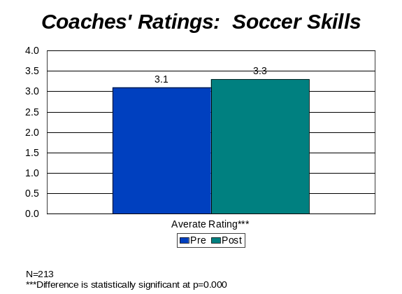

On fall and spring Coaches’ Assessments of Players, soccer coaches rated the soccer skills of individual players using a four-point scale in which:
4= Participant excels at multiple skills required to play soccer;
3=Participant exhibits sound performance in some of skills required to play soccer;
2=Participant has some physical coordination but still has difficulty with many of the skills required for soccer; and
1=Participant lacks physical coordination and has difficulty with most skills required for soccer.

As shown in the upper graph to the right, coaches’ average rating of participants’ soccer skills increased from 3.1 to 3.3, suggesting an overall increase in physical coordination and soccer skills. This change is statistically significant.
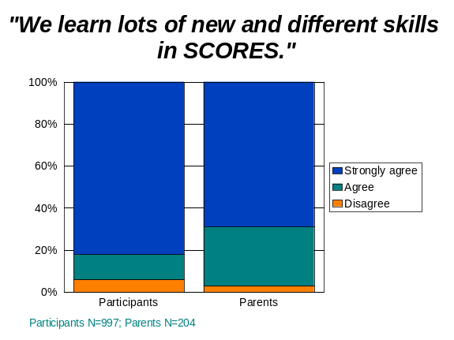

On surveys, soccer coaches commented on improved abilities in passing, playing specific positions, and ball handling. Participants believed they had made improvements in dribbling, shooting or kicking, making goals, being a goalie, and playing defense. One young man commented, “We learn a lot of new tricks,” while another added, “In third grade, I wasn’t so good at soccer. Now I’ve improved.“ Other comments include:

- In soccer, the skills get trickier. You have to be tough and do the best you can.
- Never quit; if you try to quit, others pressure you not to.
Finally, both SCORES participants and their parents/guardians overwhelmingly agreed that the young people learned “lots of new and different skills” through the program. In addition to improved writing and soccer skills, parents and participants mentioned improvements in penmanship and skills related to self-expression and peer relationships.

Improvements in Self-Confidence

Soccer Coaches’ Assessments of Players included a four-point scale measuring participants’ self-confidence. On this scale:
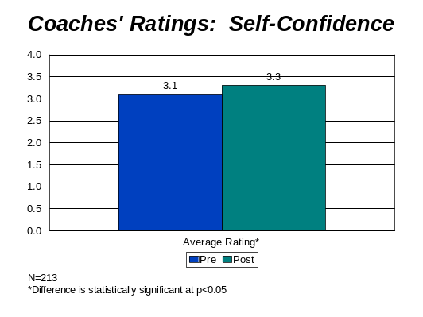

4=Participant is always assertive and confident in almost all activities;
3=Participant is usually assertive and confident in most activities;
2=Participant is sometimes nervous when trying new activities, or is unsteady with ball contact; and
1=Participant is afraid of trying new activities, or is afraid of contact with the ball.

As shown in the graph to the right, average ratings of players’ self-confidence showed a statistically significant increase from fall to spring.

Writing coaches also believed participants made gains in self-confidence, self-esteem, overcoming shyness, and in a sense of pride in their work and capabilities:

- The most improvement I’ve seen in my students is their high self-esteem.
- When we started working together, most students were shy, but toward the end of the first semester they were very confident and loved to write.

These findings are confirmed by parents/guardians who overwhelmingly agreed that participating in SCORES was helping their children feel better about themselves, including in the areas of self-esteem and self-confidence. Their comments include the following:

- This program helps my son in a big way, especially to be more confident. His self-esteem is a lot better.
- My children feel more independent, more sure about themselves, and more interested in getting involved.
- My son is more confident about speaking in front of a crowd.
- I feel my children are more outgoing with others and more confident in what they do.
- SCORES gives my daughter confidence in herself.

Finally, on youth spring surveys, nearly all participants agreed with the following statements measuring self-efficacy: “I know I will get better at sports or exercise if I keep practicing,” and “I know I can learn lots of new things if I keep trying.”

Participant Ratings of Self-Efficacy: Spring Surveys
 | Strongly  Agree | Agree | Disagree | Strongly Disagree
I know I will get better at sports or exercise if I keep practicing. | 83% | 15% | 1% | 1%
I know I can learn lots of new things if I keep trying. | 81% | 17% | 1% | 1%
N=1,062

Positive Relationships with Adults
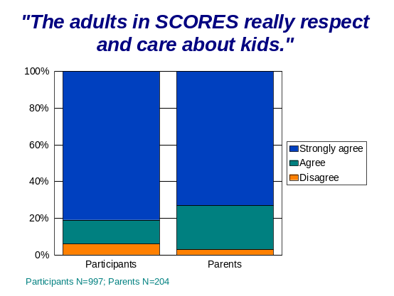
As discussed above, SCORES provides opportunities for developing skills in a context that helps children and youth build self-confidence and self-efficacy. An important program component that links skill building with improved self-confidence is the opportunity participants have to build caring and supportive relationships with the adults in the program. In quality youth programs, these positive relationships enable young people to experience the guidance and support they need to develop a range of skill competencies. On evaluation surveys, both young people and their parents/guardians strongly agreed that the adults in SCORES “really respect and care about kids.”

Focus group comments suggest that youth believe their coaches are helpful, fun, and effective, providing good role models for participants:

- My writing and soccer coaches are fun and focused. We learn a lot from them.

- Our coaches are awesome, wonderful, and helpful. I’ve been happy to have someone help me out.
I think SCORES is a great program for kids. The teachers do a wonderful job. During the times that I’ve gone on field trips with them, the adults are always attentive with the kids and it makes me feel that they are in good hands.

-- Parent of a SCORES participant

- Coaches explain things you might not know how to do and they do [soccer] demonstrations.

- Our coaches whistle at us, not because they’re mad, but because they’re trying to improve our skills.

- The coaches are our heroes. They’re like family to all of us.

In addition, on spring surveys, participants agreed that their soccer and writing coaches challenged and encouraged them to try new things and to do their best.

Participants’ Relationships with SCORES Coaches: Spring Surveys
 | I totally DISAGREE! | I sort of disagree | I sort of agree | I totally AGREE!
My soccer coach encourages me to try new things even if at first I make mistakes. | 3% | 3% | 12% | 82%
My writing coach encourages me to try new things even if at first I make mistakes. | 3% | 4% | 15% | 78%
My soccer coach encourages and challenges me to do my best. | 3% | 3% | 13% | 81%
My writing coach encourages and challenges me to do my best. | 4% | 3% | 16% | 77%
N=997

Competencies and Self-Confidence Summary

Evaluation results provide evidence that SCORES is an engaging and challenging program for children and youth that provides opportunities for developing greater competencies in soccer, language arts, and other skill areas. Opportunities for skill building, coupled with the positive relationships participants develop with the adults in the program, lead to improved self-confidence and self-efficacy, enabling young people to believe that they can achieve.

From the America SCORES website (http://www.americascores.org).
It should be noted that, due to administrative/logistical requirements, pre-assessments and pre-questionnaires were administered in mid to late October, after most SCORES sites had been implementing the program for more than a month. Thus, it may be more accurate to call these measures “fall” assessments or questionnaires.
Seven of these events were Poetry Slams; one was a “College Kicks” program, which included a soccer clinic and tour at a local community college.
These participants completed Youth Pre-Questionnaires in October 2005.
See “America SCORES National Evaluation Report, 2002-03,” completed in collaboration with the Organizational Effectiveness Consulting Group (OECG).
Writing Directors were trained in using evaluation rubrics for scoring poems during conference calls conducted by the evaluation team. Writing Directors did not score poems from youth at their own sites, and they were unaware of which site their group of poems represented.
Again, Writing Directors were trained in using evaluation rubrics for scoring neighborhood letters during conference calls conducted by the evaluation team, and they did not score letters from youth at their own sites.
These results are particularly striking in view of the dramatic increases in rates of childhood obesity in the U.S. over the past 40 years. Between 1963 and 2004, obesity rates quadrupled for children ages six to 11 years, from 4% to 19%. See the CDC publication “QuickStats: Prevalence of overweight among children and teenagers.” Available online at http://www.cdc.gov/mmwr.
For information on the Cooper 12 and the appropriateness of using six-minute periods for testing children, see http://www.topendsports.com/testing.
See http://www.cdc.gov/nccdphp/dnpa/bmi/childrens_bmi.
These percentages are higher than national statistics which suggest that 19% of U.S. children ages 6 to 11 are overweight (obese), with another 15% being at risk of obesity. The higher percentages are likely related to demographic characteristics of SCORES participants; data from the National Health and Nutrition Examination Survey show that low-income children, and children who are African American or Hispanic, have higher rates of obesity than others.
Participants tended to be rated highly on pre-assessments in these areas, averaging 3.5 out of 4.0 for “ability to get along with others” and 3.6 for “sportsmanship – ability to be a team player.” On post-assessments, these ratings slipped slightly to 3.4 and 3.5, respectively, which are still positive ratings.
See, for example, Finding out what matters for youth: Testing key links in a community action framework for youth development, (2002), by Michelle Gambone, Adena Klem, and James Connell, published by Youth Development Strategies, Inc.
See the Community Network for Youth Development (CNYD) website at http://www.cnyd.org/framework.

