FINAL PAPER

Who Leaks from the Bucket?

Attrition and its impact on baseline test scores at KIPP Gaston College Preparatory

(DRAFT)

Brent Maddin

May 21, 2007

Submitted to:

Professor Richard Murnane

Teaching Fellow Pia Caronongan

Introduction

Washington Post educational reporter Jay Matthews has dubbed the approach of the KIPP network of charter schools as, “the most interesting and successful attempt so far to raise the achievement of low-income, minority children” (Mathews, 2006). Taken at face value, KIPP’s achievement results on standardized tests are impressive. Their average entering fifth-grader scores in the 28th percentile nationally on norm-referenced reading and mathematics assessments, but by eight-grade, they average in the 74th percentile (KIPP, 2004). By the end of fifth-grade, approximately 40 percent of KIPP schools outperform their respective districts on state reading exams, and just over 60 percent do so in math. By eighth grade, 100 percent of KIPP schools outperform their districts in both subjects (Mathews, 2006).
KIPP’s impressive record is not without controversy; critics accuse KIPP of skimming the highest achieving students from the traditional public schools (Carnoy, Jacobsen, Mishel, & Rothstein, 2005). For example, at a KIPP school in the Bronx, the incoming fourth-grade math scores exceeded the district average and average incoming reading scores bested all of New York City (Tough, 2006). In addition to attracting higher-performing students, critics also speculate that lower-achieving students leave KIPP schools in disproportionately higher numbers. Because much of KIPP’s success comes from their ability to dramatically move an incoming fifth-grade cohort upward through the national percentile ranks by eight-grade, it is plausible that some of this movement could be a function of the lowest achieving students leaving the schools. In fact, because results are aggregated at the cohort level, it would be possible for average cohort achievement to improve over time, even if students were doing no better—as long as the lowest performing students continued to leave the group. Unfortunately, there are no data to confirm or reject this speculation.
For this paper I will focus on one of the 52 KIPP schools—KIPP Gaston College Preparatory (GCP) in North Carolina. Founded in 2001, GCP is one of the oldest KIPP schools. It opened with only fifth graders in school year 2001 (SY2001) and has added a single grade level each year since. GCP now offers grades 5-10 and plans to add eleventh-grade in SY2007 and twelfth-grade in SY2008. In the six years since its founding, GCP students have posted impressive results on the End Of Grade (EOG) tests, and the school has been named as one of the top 10 highest performing middle schools in the state of North Carolina (Gaston College Preparatory, 2006). Because of its relatively long history and high achievement, GCP is an appealing site to study attrition.
In this paper I endeavor to explore the topic of attrition at GCP. First, I look to explore the demographics of who leaves and when they exit. Second, I will attempt to answer whether KIPP skims the highest performing fourth graders from the district schools and whether the students who score lowest on their fourth-grade reading and math exams leave GCP at disproportionately higher rates. Before answering these questions, I will first highlight the literature on attrition in charter schools in order to contextualize any findings from this study. In the second section I will describe the analytical approach used to arrive at the findings reported in Section III. In the final section I will summarize the results, propose recommendations for GCP and suggest future research.

Section I: Literature Review

In any discussion of charter schools, it is important to keep two things in mind: first, charter laws vary widely from state to state making cross-state comparisons difficult; and second, that the variation among charter schools, even within states, is dramatic. For example, some charter schools are founded to help curb high school dropout rates among teenage mothers; others, like KIPP, are college preparatory middle schools. Clearly, schools with such dramatically different missions serving dramatically different populations will be difficult to compare on essentially any outcome. Despite these obvious differences, charters schools are often grouped together for the sake of analysis, and this grouping might explain why findings are often inconsistent across states or studies.
Although very little research has been done specifically on charter school attrition, a number of large studies have touched on the issue. Amy Stewart Wells and researchers at the Rand Corporation find that charters open for at least five years have attrition rates of around 25% (Bracey, 2005). Using a statewide data set of all charter schools in Arizona, researchers from the Goldwater Institute (2001) analyzed differences in value-added individual student achievement over three years to determine that, “there is no evidence of charters creaming the best students, or of the worst performing students being the ones who leave” (Solmon, Paark, & Garcia, 2001, p. 24). This evidence clearly contradicts that found by Carnoy et. al. highlighted in the introduction. It is also contrary to the findings from a large study of all Texas charter schools, in which researchers, using a large set of panel data, found that about 40% of all charter school students eventually leave their charter schools; and that the probability of exit is negatively associated with both school quality and the student’s academic performance in the charter school (Hanushek, Kain, Rivkin, & Branch, 2005). Hanushek et. al. (2005) also find much higher attrition rates during the first few years after a charter is founded. In summary, the literature suggests two inconsistencies: variable rates of charter attrition (ranging from 25%-40%) and mixed findings with respect to whether high or low performing students are more likely to leave.

Section II: Analytical Approach

A. Research Questions

Part of the reason for disparities in the literature may result from the extreme variation within the charter sector. Because KIPP schools are unique on the charter landscape with respect to their high profile, reputation for high achievement, and intense focus on academics, one might expect they would naturally attract higher-achieving students and more likely retain those who could handle the rigorous academic schedule. These suppositions frame the two research questions for this study:
RQ1: Who leaves Gaston College Preparatory and when in their school career does this happen?

RQ2: How do the fourth-grade reading and mathematics cohort averages change as students leave the cohort?

B. Data Set

The majority of the students who have attended GCP (448 of 635) are still currently enrolled at the school. These students, and any who have withdrawn since SY2004 existed in the school’s digital attendance records. These records served as the foundation for the data set and contained dozens of covariates including basic demographic data, mother’s level of education and number of books in the home. Unfortunately, any student who withdrew from GCP prior to SY2004 does not appear in these records and had to be entered by hand.
Information on students not appearing in the digital file was found in hardcopies of attendance records, printouts of student test scores issued by the state of North Carolina, and student cumulative folders. Each of these sources was used to construct a list of students attending the school prior to SY2004. These lists were merged to ensure that all students who had withdrawn from the school had been entered into the database.
For the purposes of this paper I will only be using a select set of variables in the data set. These include enrollment date, withdrawal date, cohort year, entering fourth-grade reading and math scores on state assessments, and dummy variables for gender, race, and whether the student entered in the fifth-grade or not.

C. Analyses

The analyses for this paper are entirely descriptive. I begin by presenting current school demographics and then shift focus to those who have left. For most of these descriptive analyses I include the entire sample of students who have exited (n=187), which includes students who enrolled as fifth graders and students who transferred to GCP after this initial year. When doing any cohort-level analyses, I use only the students who enrolled as fifth graders and consequently the number of students who have withdrawn is somewhat smaller (n=132).
To ease interpretation and comparison of test scores, I transformed all raw scores into z-scores for each cohort. To do this, I subtracted the cohort mean from each score and then divided by the standard deviation. I did this separately for math and reading tests. By standardizing the scores, the distribution for each cohort on both tests has a mean of zero and a standard deviation of 1.0. This will allows me to quickly discern the relative impact of attrition on test scores.

Section III: Findings

A. Descriptive statistics of those who leave

Before considering who leaves, it is first important to get a sense of who currently attends and has ever attended Gaston College Preparatory. As shown in Table 1, the school currently enrolls about 450 students in grades 5-10. The vast majority of the school is Black (87%) with a small minority of White students (11%). There are fewer males than one would expect (43%). These descriptive statistics remain relatively consistent when we consider all of the students who have ever attended the school (n=635), thus suggesting that attrition doesn’t seem to be driven by one particular demographic type.

Table 1. Description of the total student body and current enrollment in grades fifth through tenth.
 | Students currently enrolled at GCP |  |  | Students ever enrolled at GCP
Characteristic | Totals | Percent |  | Totals | Percent
All Students | 448 | 100 |  | 635 | 100
Male | 194 | 43.3 |  | 301 | 47.4
Black | 388 | 86.6 |  | 556 | 87.6
White | 50 | 11.2 |  | 67 | 10.6
Mixed Race | 7 | 1.6 |  | 7 | 1.1
American Indian | 2 | 0.5 |  | 2 | 0.3
Hispanic | 0 | 0.0 |  | 2 | 0.3
Asian | 1 | 0.2 |  | 1 | 0.2

All told, 187 students (29.4%) have left GCP since the school opened in 2001. As shown in Table 2, the percentage of attrition within major demographic groups ranges from 22.2% to 37.4% (White and Black males respectively). The high rate of Black male attrition helps explain why there is such gender imbalance at the school.

Table 2. Student attrition by race and gender (n=187).
Student Characteristic | Total Number of Students  Who Withdrew | Percentage of Each Group  Who Withdrew
Male | 107 | 35.6
Female | 80 | 24.0
Student of Color | 170 | 29.9
White Student | 17 | 25.4
White Male | 8 | 22.2
Male of Color | 99 | 37.4
White Female | 9 | 29.0
Female of Color | 71 | 23.4
Note: Because there are so few students who are of other races, these data are reported for White students and a “composite” of students of color.

Of the 187 students who have left, 132 entered as fifth-graders (70.6%) and serve as the population of withdrawn students we will consider from this point forward. Most of the attrition (~60%) occurs in the first year and a half (~550 days) after a student enrolls at GCP. Figure 1 depicts this high amount of early attrition. Given KIPP’s high expectations, longer school day and tight discipline it seems plausible that students may enroll and quickly realize that the school is not a good fit for them. To this end, 16 of the 132 who left (12%) withdrew within the first month of school and nearly a third of all fifth graders students who left (32%) exited within six months of starting.
In addition to highlighting early exit, Figure 1 also displays a pattern for those who leave after the first few months. There are spikes in attrition at the end of fifth, sixth, and seventh-grades, with the largest exodus occurring at the end of fifth grade. Two factors may contribute to these spikes. First, because the local middle schools begin in sixth grade, the end of fifth-grade is a natural point of transition and any exit from GCP would be less upsetting at this time. Although smaller, we also see spikes at the ends of sixth and seventh-grade, perhaps because leaving during the summer makes for an easier transition than during the middle of the year. Just to the right of the fifth and sixth grade spikes, there is another cluster of students who exit. These are likely students who withdrew over the summer, but were not officially dropped until the beginning of the next school year. Interestingly, there does not appear to be a spike at the end of eighth-grade, however, a small number of students withdraw at the beginning of ninth grade.
Overall, as one might predict, attrition appears to decrease the longer students attend the school. This could be because the students who are likely to leave have already exited. Alternatively, at higher grade levels, there are fewer observations, and therefore less attrition might simply be a function of this small number. Once the school matures and several cohorts have gone through each grade level, it will be possible to determine if fewer cohorts are driving the decreased attrition at higher grade levels.

Figure 1. Number of students withdrawing based on the number of days they have been at the school. This plot includes only students who start as fifth-graders and withdraw (n=132).
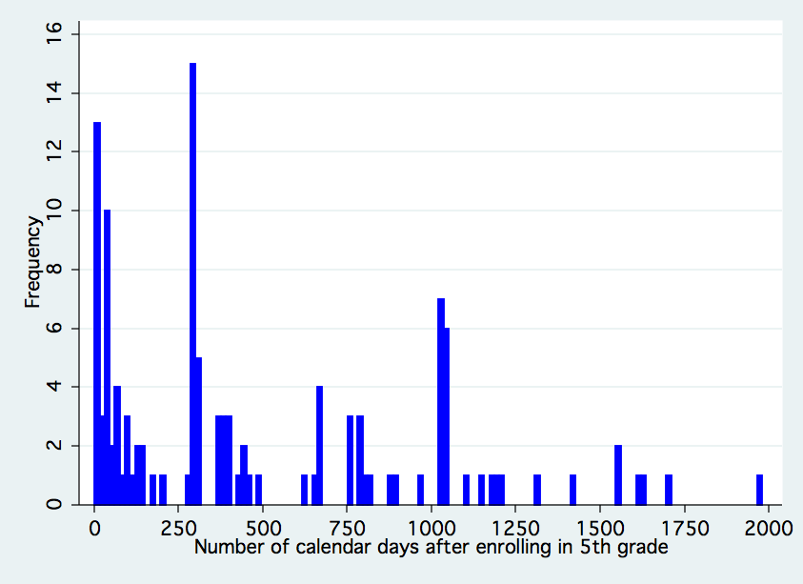
End of 5th Grade
End of 7th Grade
End of 6th Grade
Beginning of 9th Grade
Note: The horizontal axis is scaled in days, and represents the raw number of calendar days between the date of enrollment in fifth-grade and the date of withdrawal.

A more nuanced way to examine Figure 1 would be to show the attrition in each year by cohort. Table 3 shows the total number of students who withdraw after having been at the school for a fixed amount of time, disaggregated by cohort. It appears that cohorts from the earliest years of the school’s existence have the highest levels of attrition. This supports findings by Hanushek et. al. (2005), who also find greater levels of attrition during the “start-up” phase of charter schools. Potentially students come to GCP without having a clear sense of what the school is about. They would therefore be more likely to exit than students in later cohorts who have a much better sense of the school based on its reputation.

Table 3. Attrition for each fifth-grade cohort by year, n=122.
 | 2001 Cohort | 2002 Cohort | 2003 Cohort | 2004 Cohort | 2005 Cohort | 2006 Cohort | Total Withdrawn / Year
Year 1 | 20  (23.8%) | 8  (15.7%) | 9  (12.9%) | 14  (17.7%) | 7  (7.9%) | 6  (7.3%) | 64
Year 2 | 7  (8.3%) | 3  (5.9%) | 6  (8.6%) | 3  (3.8%) | 1  (1.1%) |  | 20
Year 3 | 8  (9.5%) | 4  (7.8%) | 10  (14.3%) | 2  (2.5%) |  |  | 24
Year 4 | 2  (2.4%) | 4  (7.8%) | 1  (1.4%) |  |  |  | 7
Year 5 | 4  (4.8%) | 1  (2.0%) |  |  |  |  | 5
Year 6 | 2  (2.4%) |  |  |  |  |  | 2
Total Withdrawn / Cohort | 43  (51.2%) | 20  (39.2%) | 26  (37.1%) | 19  (25.3%) | 8  (15.7%) | 6  (11.0%) | 122  (29.5%)

Figure 2 graphically displays the trends observed in Table 3. As shown, the 2001 cohort has the greatest attrition after the first year and continues to have the most attrition at any point in time there forward. Interestingly, the 2002, 2003, and 2004 cohorts have attrition rates that vary over time such that each of has the second most attrition at some point in the first three years. The two most recent cohorts (2005 and 2006) have essentially identical attrition rates in the first year and are much less than any of the preceding cohorts.
Figure 2. Percent of each original fifth-grade cohort remaining at GCP over time, n=132.
Percent of Original 5th Grade Cohort Remaining
High school
(a natural transition point)

B. Changes in baseline test scores overtime

As Paul Tough (2006) intimated in his story featuring the KIPP school in the Bronx, students might be coming in with increasingly higher tests scores over time. It is possible test this idea at GCP by examining the shape of the test score distributions for each cohort. The box plots in Figures 3 and 4 show the distribution of fourth-grade scores for each cohort. The score distributions seem to be widest for the 2001 cohort and then have slightly less variation for later cohorts. Figure 3 also highlights the statewide change in reading scores during SY2003, when the North Carolina switched to a scale that was approximately 100 points higher than it was previously. Acknowledging that the y-scaling is expanded due to this issue, average reading scores do not systematically increase like the average math scores in Figure 4. Therefore, it seems as if Tough’s assertion about test scores in the Bronx may hold true for GCP math scores, but not for reading scores.
Figure 3. Box plots representing the distribution of fourth-grade reading scores for each cohort at KIPP GCP.
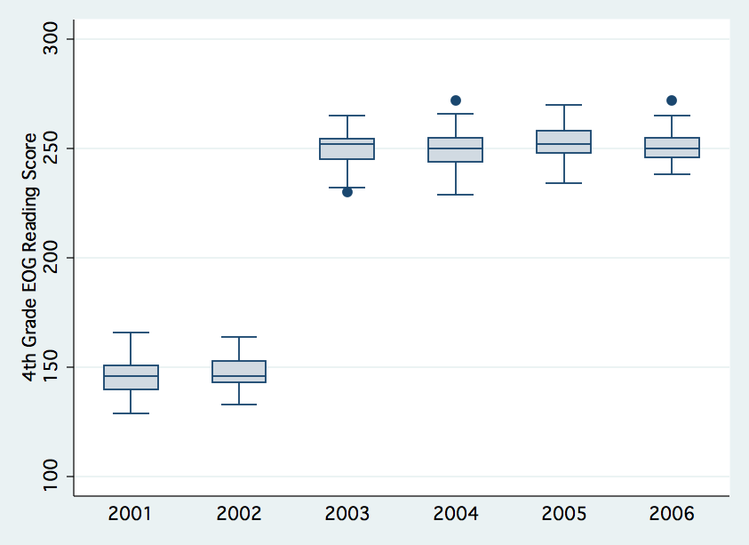

Figure 4. Box plots representing the distribution of fourth-grade math scores for each cohort at KIPP GCP.
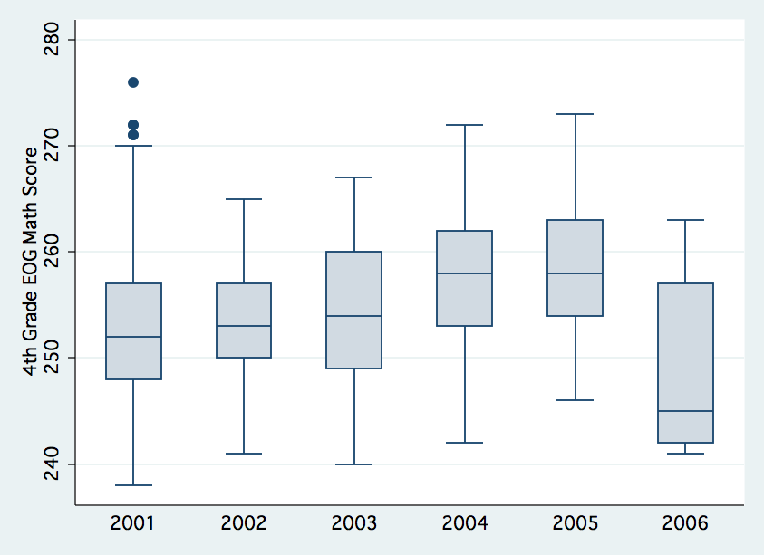
* Note data are not available for the 2006 cohort.
Not only might KIPP be attracting increasingly higher scoring students over time, but they might also be taking the best students from the traditional public schools. As seen in Table 4, GCP appears to be attracting students who have scored slightly higher on the fourth-grade reading test than the district average, with the exception of the first cohort. In mathematics, for the first three years, GCP attracted students who performed slightly worse than the district average, however this trend reverses for the latest cohorts. Comparative data for the 2006 cohort is not yet available, but having it may help determine if there is a trend in GCP attracting the best students from the traditional public schools. In summary, GCP appears to be attracting students who do slightly better than the district averages—especially in the more recent cohorts. This is important for this study on attrition because one might expect higher achieving students to be less likely to leave the school.

Table 4. Comparison of fourth-grade reading and math scores for students who enroll at KIPP GCP and all students who attend local traditional public elementary schools (for each cohort, GCP n = ~65 and district n=~575).

 |  | Reading |  |  |  | Math
Cohort |  | GCP  Average | Weighted District Average | Difference |  | GCP  Average | Weighted District Average | Difference
2001 |  | 145.66 | 147.77 | -2.11 |  | 253.35 | 253.67 | -0.32
2002 |  | 147.88 | 147.85 | 0.03 |  | 253.47 | 253.62 | -0.15
2003 |  | 249.82 | 248.69 | 1.13 |  | 254.51 | 255.79 | -1.28
2004 |  | 249.64 | 249.10 | 0.54 |  | 257.10 | 255.58 | 1.52
2005 |  | 251.98 | 250.69 | 1.29 |  | 258.64 | 256.52 | 2.12
2006 |  | 250.70 | . | . |  | . | . | .
The standard deviation for reading was around 8.0 and the standard deviation for math was around 6.7. District schools include all of the elementary schools in Northampton County, Weldon City Schools, and Roanoke Rapids City Schools (9 schools total).

C. Impact of attrition on baseline test scores

As reported, KIPP students make large test score gains between entering in fifth-grade and the end of their eighth-grade year. By examining how the average incoming four-grade reading and math test scores change when dropping the scores for those students who withdraw, it is possible to estimate whether attrition is dramatically influencing the increase in cohort averages over time. If the KIPP critics are correct and the lowest achieving students (as measured by their incoming test scores) are more likely to leave, then we would expect to see an increase in the average test score for each cohort when accounting for attrition. Alternatively, if the students with the highest incoming test scores leave, the cohort’s average score would decrease. It could also be the case that attrition is random with respect to entering test scores and no significant changes in the mean test score will be observed.
As shown in Table 5, with only one exception, the mean test score for each cohort on both fourth-grade tests was higher after accounting for attrition. This suggests that exiting students have, on average, lower baseline test scores than those who stay and thus their leaving inflates the average cohort test score. It is important to note that the size of the increase varies dramatically and depends on both the cohort and subject. For example, the 2001 cohort has relatively high values for both reading and math, suggesting that even more students who scored below the mean on the baseline tests left this cohort than in subsequent groups. Considering the higher attrition rate for this cohort, these findings should not be surprising. Graphical versions of these changes in baseline scores as a function of attrition can be seen as kernel density plots in Figures 5 and 6 and as histograms in Appendix Figures A3 and A4. The plots show that as students with lower forth-grade scores leave the distributions become more skewed to the right.

Table 5. Impact of attrition on the fourth-grade test scores expressed as changes in national percentile rank (n=398 for reading, 341 for math).
Cohort | Change in Average Cohort National Percentile Rank for 4th-Grade Reading after Attrition | Change in Average Cohort National Percentile Rank for 4th-Grade Math after Attrition
2001 | +24 | +13
2002 | +12 | +3
2003 | +3 | +8
2004 | +15 | +16
2005 | -1 | +2
2006 | +1 | .
Weighted Average | +7 | +8
Notes: (1) These differences in percentile ranks were calculated by taking the differences in z-scores (expressed in standard deviation units) and then converting them to national percentile ranks. For example, there was a 0.24 standard deviation increase as a result of attrition in the 2001 readings scores. This translates into a +24 increase in national Percentile Rank. (2) There are no reported math scores for the 2006 cohort because those results were not available yet from the state of NC. (3) The weighted average calculated above only accounts for the numbers of students in each cohort and does not factor in the amount of time each cohort has been in existence.

Figure 5. Kernel density diagrams showing the impact of attrition on the distribution of raw fourth-grade reading scores for each cohort. For each side-by-side pair, the plot on the left displays the raw fourth-grade scores for all entering fifth-graders for each cohort and the plot on the right shows the distribution of the same set of scores after attrition.
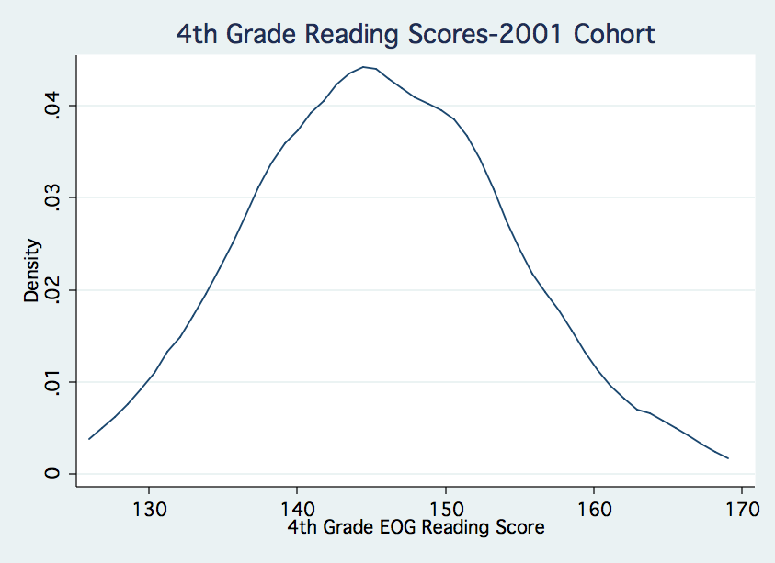 | 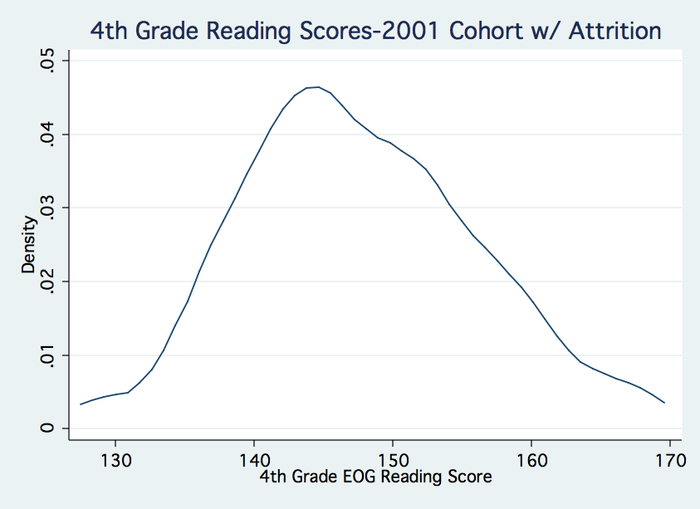
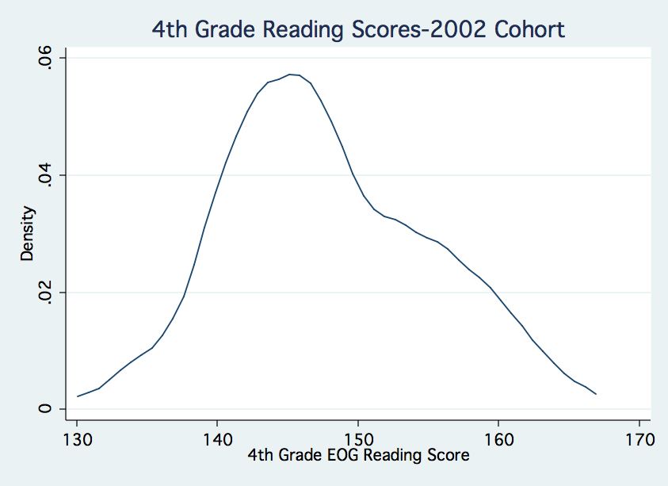 | 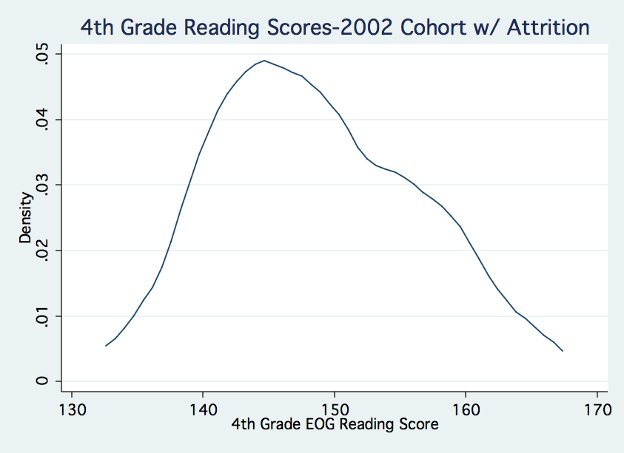
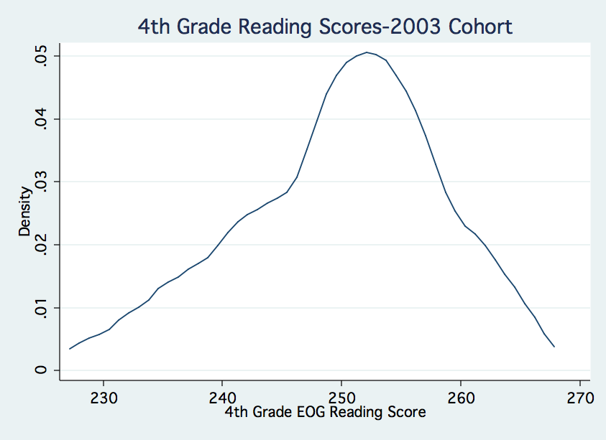 | 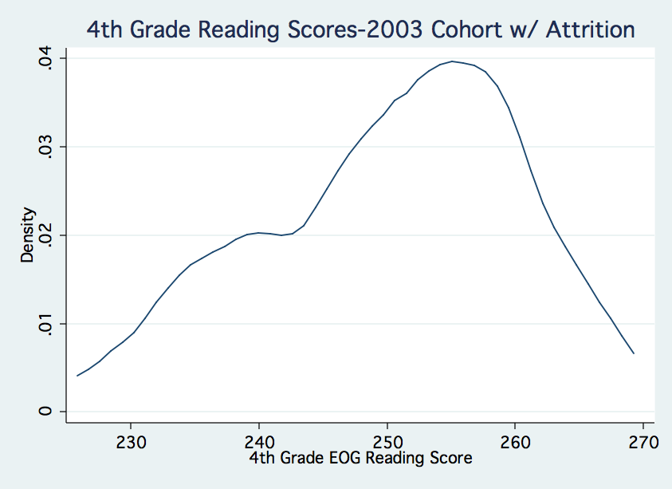

Figure 5. Continued…
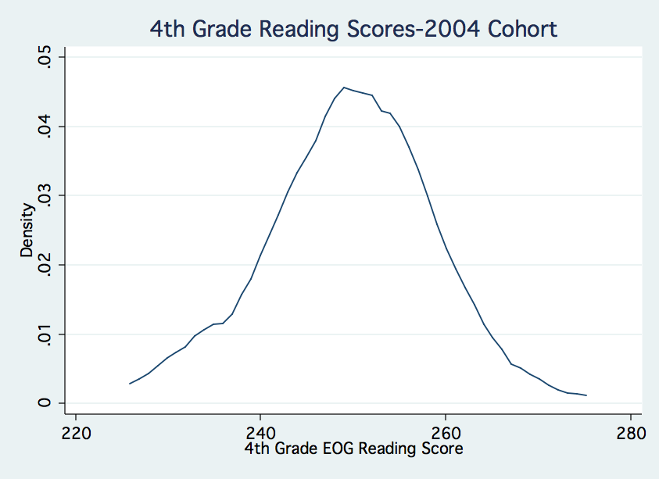 | 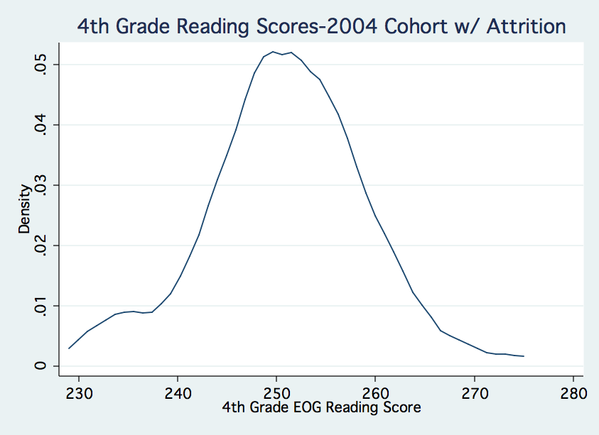
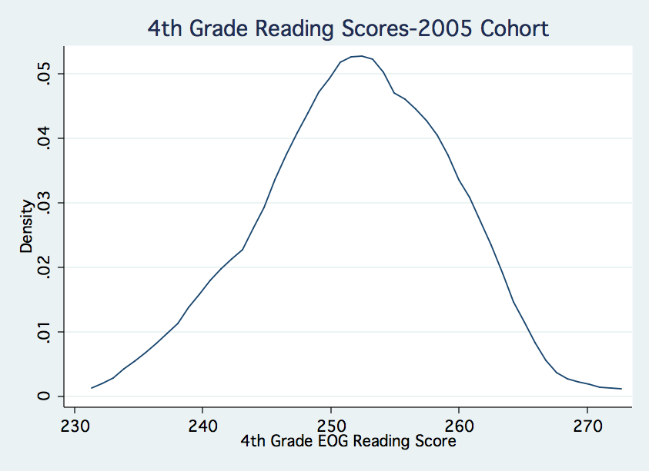 | 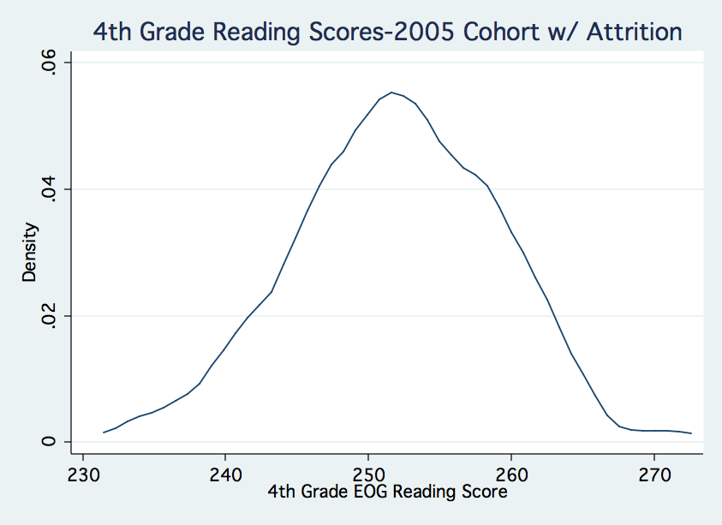
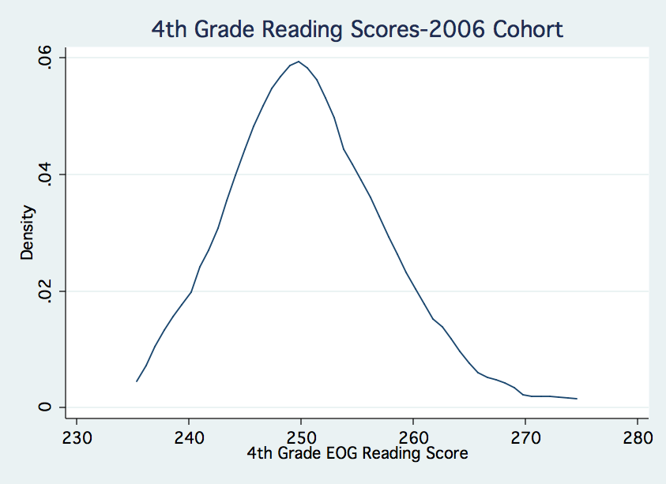 | 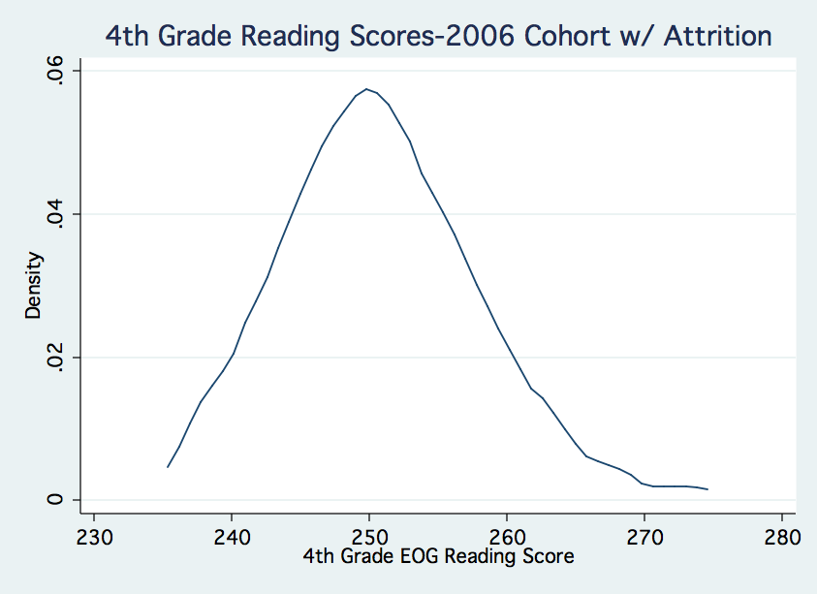

Figure 6. Kernel density diagrams showing the impact of attrition on the distribution of raw fourth-grade math scores for each cohort. For each side-by-side pair, the plot on the left displays the raw fourth-grade scores for all entering fifth-graders and the plot on the right shows the distribution of the same set of scores after attrition.
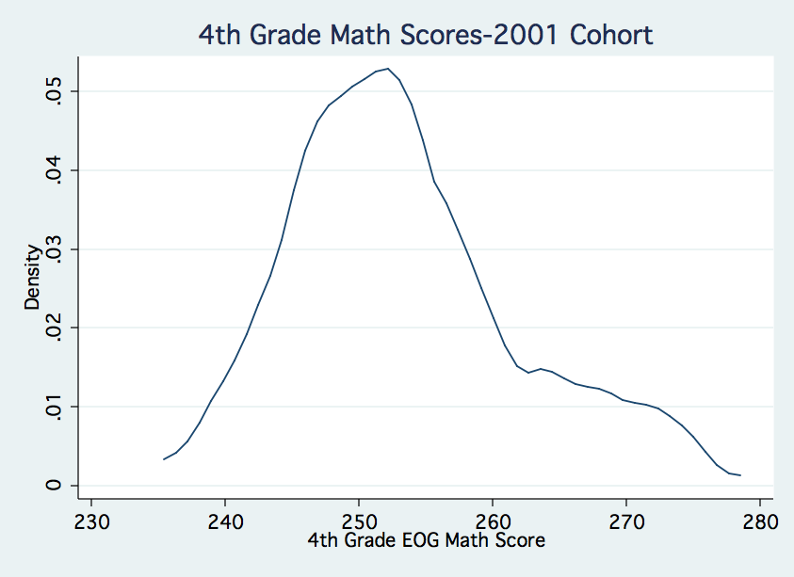 |  | 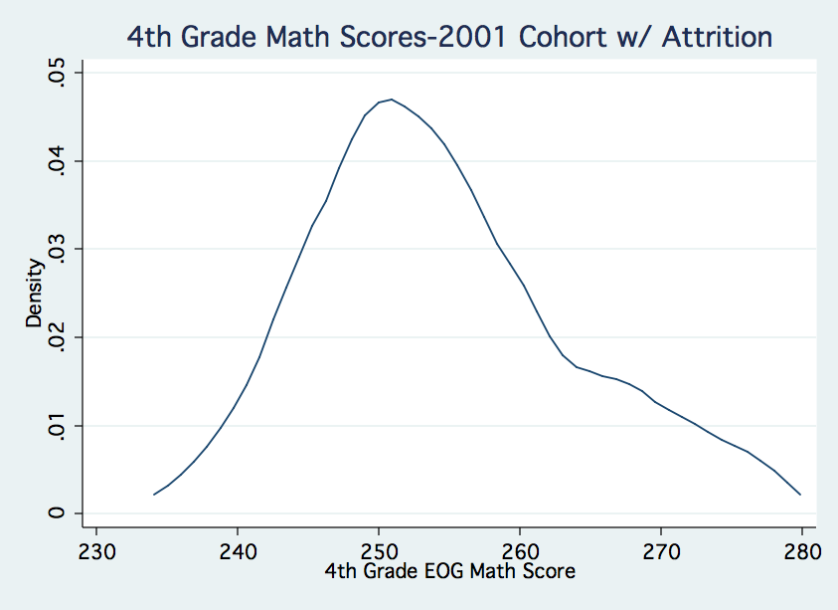
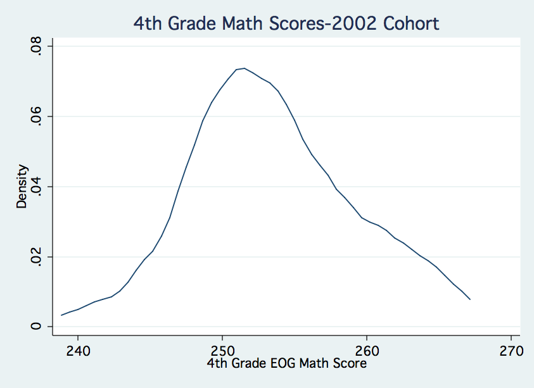 |  | 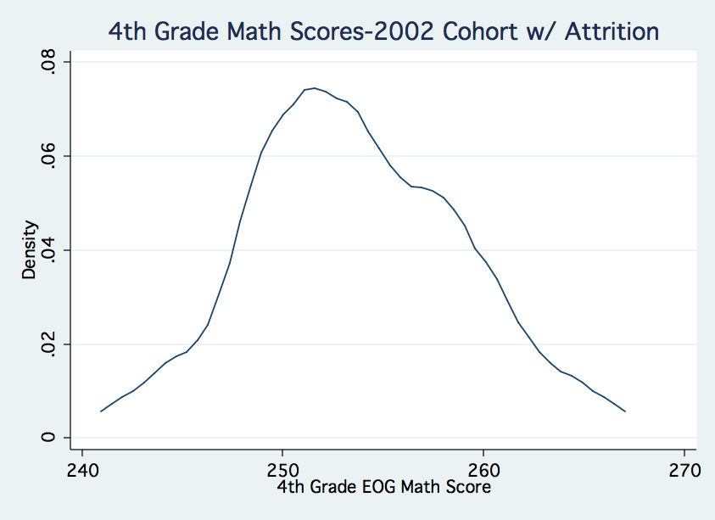
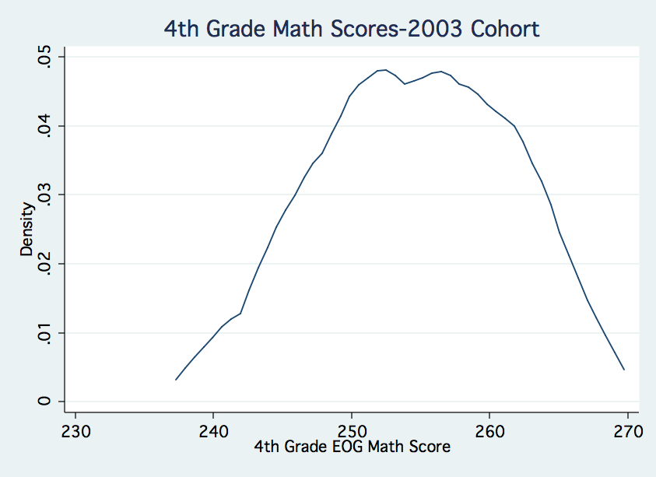 |  | 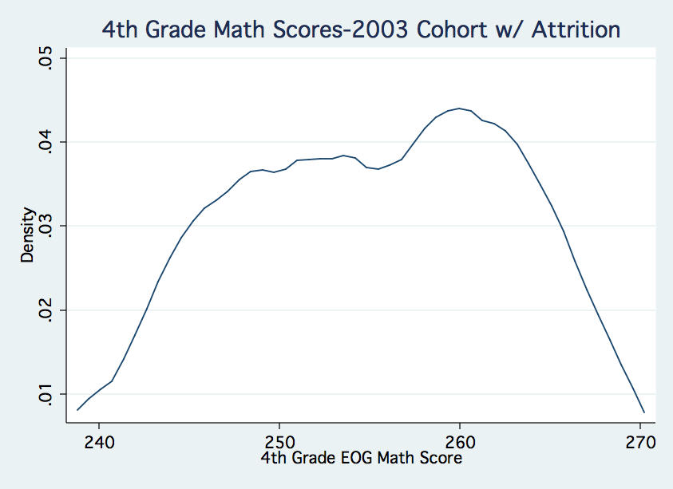

Figure 6. Continued…
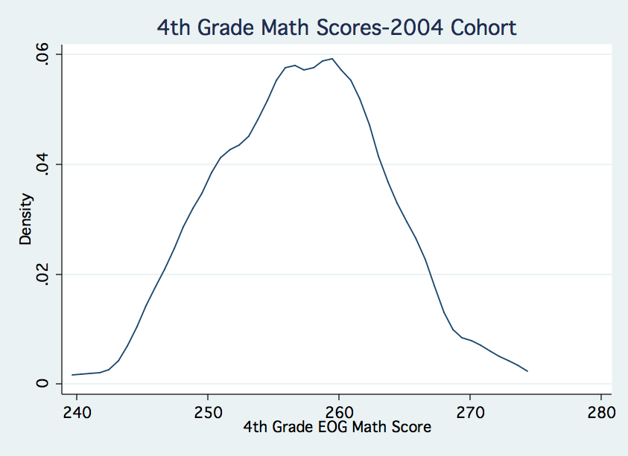 |  | 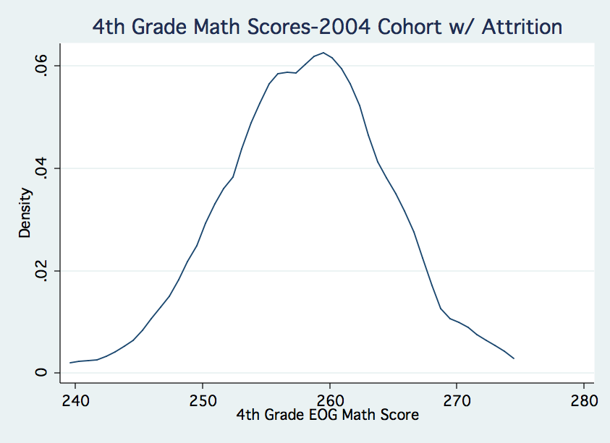
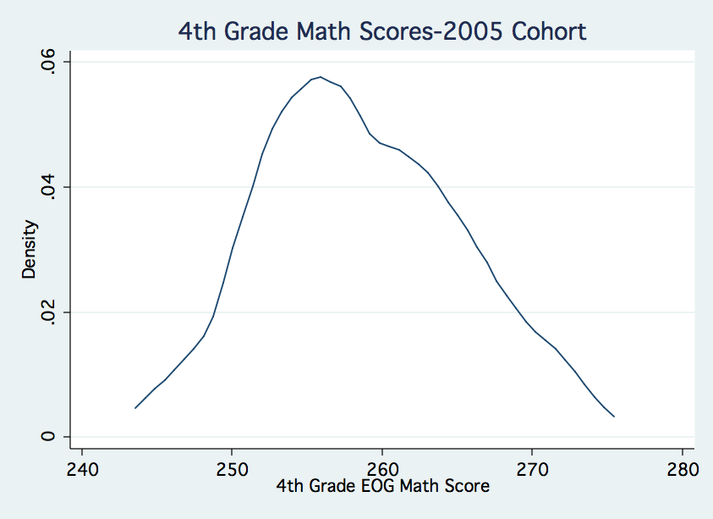 | 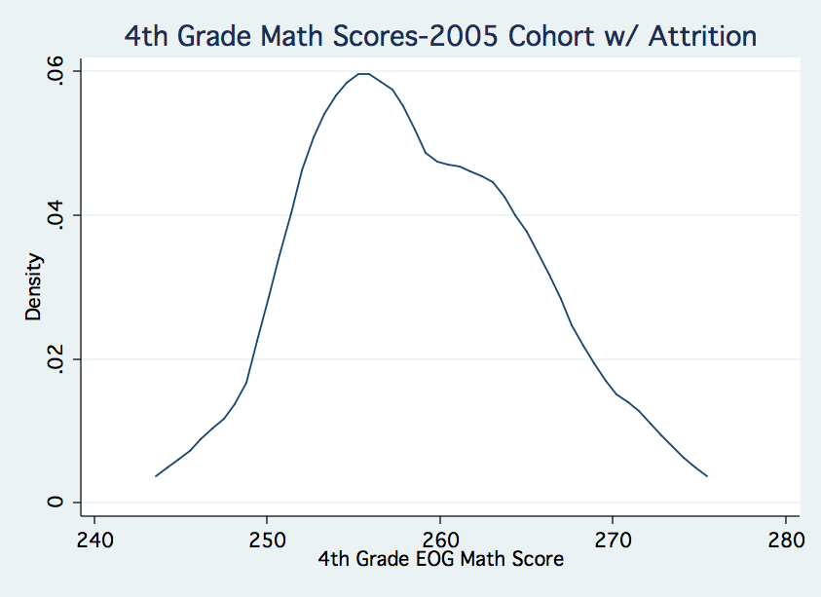
Note: Data for the 2006 fourth-grade math scores are not yet available.
C. Threats to validity

The largest threat to validity for this study is selection bias resulting from missing baseline test scores. While these missing values do not influence the descriptive statistics in part A, or the score comparisons in Part B, they may have serious implications for the test score changes in part C if those with missing values also have fundamentally different baseline scores than those who are not missing values.
There appear to be three likely reasons that students would have missing scores: (1) having incomplete cumulative folders because they were at the school for only a very short time, (2) transferring from another state and, (3) entering from home school or private school. Of these three, it seems that the first might not bias the results in any systematic way, however, entering from out of state, home school or private school may. Because the local public schools perform so poorly relative to state averages, students coming from other systems would likely have higher scores and if they were more likely to exit, differences in cohort mean scores after attrition would be lower.
As shown in Table 6, those with missing scores are about as likely to stay as they are to exit. Of the students who enrolled in fifth-grade, 57 (13%) were missing baseline reading scores and 39 (10%) were missing baseline math scores. While the overall number of missing test scores are important, it is only those students who exit that would disrupt the standardized cohort average. Those who left the school and had missing test scores numbered 27 (7%) and 20 (6%) for reading and math respectively and are just more than half of the total number of missing scores. Although these overall numbers are small (especially when compared to attrition rates in many other studies), this sample is also very small and a series of sensitivity analyses should be conducted to test whether the missing scores dramatically influence the findings in Part C. These analyses would include imputing the cohort mean for all missing test scores, imputing the cohort maximum, imputing the cohort minimum and setting all missing scores to zero.

Table 6. Description of missing scores across cohorts and tests.
Cohort | Total # of 5th Graders | Total # with 4th Grade Reading Scores | Missing Reading Scores | Missing Reading Scores and Withdrew | Total Number with 4th Grade Reading Scores | Missing Math Scores | Missing Math Scores and Withdrew
2001 | 84 | 77 | 7 | 3 | 77 | 7 | 4
2002 | 51 | 49 | 2 | 0 | 49 | 2 | 0
2003 | 70 | 56 | 14 | 7 | 59 | 11 | 6
2004 | 79 | 69 | 10 | 5 | 69 | 10 | 5
2005 | 89 | 80 | 9 | 5 | 80 | 9 | 5
2006 | 82 | 67 | 15 | 7 | . | . | .
Totals | 455 | 398 | 57 | 27 | 334 | 39 | 20

Section IV: Summary of Results, School Policy Recommendations, and Future Studies

A. Summary of Results

On average, attrition increases the number of students in each cohort with higher baseline test scores. If we assume that higher baseline test scores are associated with higher future performance on similar assessments, then it seems that attrition may increase cohort averages. If KIPP students move from the 28th to the 74th national percentile between fifth and eight grades, based on the maximum value from Table 5, at most, 24 of those 46 percentile ranks (more than half the gain) may result from attrition. This number, however, is likely an overestimate of attrition’s impact. As shown in Table 5, attrition more likely accounts for increases of about 7 of the 46 (15%) percentile ranks. Even this estimate ranges widely among cohorts. All told, it seems that attrition may play a small, but not insignificant, roll in accounting for increases in cohort-level achievement gains overtime. It also appears that attrition has a more substantial impact on test scores early in GCP’s history than on scores associated with more recent cohorts.

B. School Policy Recommendations

If GCP is interested in minimizing attrition, a few school-specific policy recommendations come from this study. First, because nearly 40% of all attrition occurs within the first six months of a student enrolling, it seems that more could be done to better educate potential applicants so they know if the school is a good fit before entering. As described, attrition during the fifth-grade year has dropped substantially in the last two years and it could be that the school’s reputation is more established or that they have proactively taken steps to increase applicant awareness.
A second policy recommendation would be to focus retention efforts on particular subsets of students. Although the school enrolls fewer male students on average, a higher percentage of these students also leave. These factors combine to create a gender imbalance with males comprising 43% of the current student body. If the school were to focus retention efforts on one particular group of students, it seems logical to concentrate on Black males because, as a group, more than 37% will ultimately exit.
If the school were committed to serving the most underserved, a final recommendation would be to target student recruitment in an attempt to create an incoming fifth-grade cohort that more closely resembles the 2001 cohort. This group of students came in with some of the lowest fourth-grade scores, but also had a dramatically greater attrition rate. It seems that there is a relationship between attrition and incoming achievement levels and that by recruiting lower performing students may also mean increasing attrition. Because funding may be linked to attrition rates, this could set up an incentive to recruit students who are higher performing. By sharing the findings of this study with funders concerned about attrition, KIPP may be more able to advance their mission of providing a quality education to the most educationally underserved because the funders may have a great appreciation for the risks associated with recruiting students with lower baseline tests scores.

C. Follow-up Research

In addition the sensitivity analyses discussed in Section III, there is also other further study that would be interesting to conduct.
- Each cohort’s average baseline test scores can be influenced in two primary ways. Attrition, as discussed in this paper, impacts these scores but so would students enrolling into a cohort after the fifth-grade year. It would be interesting to know how the fourth-grade scores for these students compare to the original cohort mean.
- It would be important to know if a relationship exists between why a student leaves and how they scored on the baseline tests. I have qualitative data from the principal on why each student left. Examples include: moving, struggling academically, behavior issues, and retention at the end of the year.
- Additionally, because I have student-level test score data for all students who remain at GCP, it will be possible to show how performance changes over time. I can use the fourth-grade scores (and even third grade scores in many cases) to set a pre-KIPP achievement level and then look for increases in performance in light of the KIPP treatment.
- Finally, GCP is just one of 52 schools in the KIPP nation. It would be interesting to replicate this study in other KIPP schools in attempt to make these findings more generalizable.
Appendix Exhibit A1. Background on key individuals and dates in the KIPP expansion.

Key Players
- Mike Feinberg: 1992 Teach For America Houston Corps Member. Co-founder and original principal of KIPP Houston that was founded in 1994. Feinberg currently helps run the KIPP network.
- Dave Levin: 1992 Teach For America Houston Corps Member. Co-founder and original principal of KIPP New York that was founded in 1995. Levin currently helps run the KIPP network.
- Scott Hamilton: Former managing director of the Pisces Foundation—an education-related philanthropy in San Francisco. He originally negotiated the partnership between KIPP and the Pisces Foundation. He currently helps run the KIPP network.
- Donald and Doris Fisher: Donated millions in 1999 to create the KIPP network. The Fishers are the founders of Gap Inc. and with revenues from their stores established the Pisces Foundation
- KIPP Students: 95% African American or Hispanic, 80% low SES. Upon enrollment they are typically several grade levels behind their higher-income peers. The admission to the school is based on a random lottery. To attend the school, students and their parents must sign a contract stating that they will work hard. Although students often struggle early on, very few students leave the schools. Many KIPP schools have waiting lists of hundreds of students.

Timeline

SY1992: Feinberg & Levin meet at Teach For America summer training institute

SY1992-1994: Feinberg & Levin teach in separate inner-city Houston schools
SY1994-1995: Feinberg & Levin start KIPP as a 1-room school for 50, 5th grade students
SY1995: Feinberg formally opens KIPP Houston on separate site; Levin opens KIPP New York

SY1998: KIPP Houston becomes a state charter school, becomes a 5-8 school
SY1999: KIPP New York becomes district charter school, becomes a 5-8 school
SY1999: KIPP is featured on TV news magazine 60-Minutes and garners national attention
SY1999: Feinberg and Levin partner with the Pisces Foundation to create the KIPP network
SY1999-2006: KIPP network grows to include 45 schools (7 more open Summer 2006)

KIPP Results
KIPP students typically perform extremely well on state mandated tests. In 1994, 98% of the original 5th grade class passed the Texas TAAS test (Leschly, 2002, p. 5). In fact, from 1995-1999 nearly 100% of the students passed that test. Students at the New York school did equally well. In both 1998 and 1999, KIPP New York was selected as the top performing middle school in the Bronx (Leschly, 2002, p. 12). For a detailed list of KIPP’s academic accomplishments, please see www.kipp.org

This background information was collected from several different sources (Headden, 2006; KIPP, 2006; Leschly, 2002; Mathews, 2006)
Appendix Table A1. All KIPP Schools as of Spring 2007, sorted by year established.
School | State | City | Year Established
KIPP Academy Middle School | TX | Houston | 1995
KIPP Academy New York | NY | Bronx - New York | 1995
KIPP 3D Academy | TX | Houston | 2001
KIPP DC: KEY Academy | DC | Washington | 2001
KIPP Gaston College Preparatory | NC | Gaston | 2001
KIPP Austin College Prep | TX | Austin | 2002
KIPP Bridge College Preparatory | CA | Oakland | 2002
KIPP Delta College Preparatory School | AR | Helena | 2002
KIPP DIAMOND Academy | TN | Memphis | 2002
KIPP Reach College Preparatory | OK | Oklahoma City | 2002
KIPP Sunshine Peak Academy | CO | Denver | 2002
KIPP Ujima Village Academy | MD | Baltimore | 2002
TEAM Academy, a KIPP school | NJ | Newark | 2002
KIPP Academy of Opportunity | CA | Los Angeles | 2003
KIPP Adelante Preparatory Academy | CA | San Diego | 2003
KIPP Ascend Charter School | IL | Chicago | 2003
KIPP Aspire Academy | TX | San Antonio | 2003
KIPP Bayview Academy | CA | San Francisco | 2003
KIPP LA Prep | CA | Los Angeles | 2003
KIPP Philadelphia Charter School | PA | Philadelphia | 2003
KIPP Sankofa Charter School | NY | Buffalo | 2003
KIPP SF Bay Academy | CA | San Francisco | 2003
KIPP South Fulton Academy | GA | Atlanta | 2003
KIPP STAR College Prep Charter School | NY | New York | 2003
KIPP Summit Academy | CA | San Lorenzo | 2003
KIPP TRUTH Academy | TX | Dallas | 2003
KIPP WAYS Academy | GA | Atlanta | 2003
Freedom Academy, a KIPP school | NJ | Camden | 2004
KIPP Academy Fresno | CA | Fresno | 2004
KIPP Academy Lynn | MA | Lynn | 2004
KIPP Heartwood Academy | CA | San Jose | 2004
KIPP Houston High School | TX | Houston | 2004
KIPP Indianapolis College Preparatory | IN | Indianapolis | 2004
KIPP SHINE Prep | TX | Houston | 2004
KIPP Academy Nashville | TN | Nashville | 2005
KIPP AMP Academy | NY | Brooklyn - New York | 2005
KIPP DC: AIM Academy | DC | Washington | 2005
KIPP Harbor Academy | MD | Edgewater | 2005
KIPP Infinity Charter School | NY | New York | 2005
KIPP Pride High School | NC | Gaston | 2005
KIPP TECH VALLEY | NY | Albany | 2005
KIPP Tulsa College Preparatory | OK | Tulsa | 2005
Cole College Prep | CO | Denver | 2005
New Orleans West College Prep (NOW) | TX | Houston | 2005
KIPP Believe College Prep | LA | New Orleans | 2006
KIPP DC: WILL Academy | DC | Washington | 2006
KIPP DREAM Prep | TX | Houston | 2006
KIPP LEAD College Prep Charter School | IN | Gary (Chicago area) | 2006
KIPP Liberation College Prep | TX | Houston | 2006
KIPP Spirit College Prep | TX | Houston | 2006
Rise Academy, a KIPP school | NJ | Newark | 2006
McDonogh 15 | LA | New Orleans | 2006
Appendix Figure A1. Number of students withdrawing based on the number of days they have been at the school disaggregated by 5th grade cohorts. This plot includes only students who start as fifth-graders and withdraw (n=132).
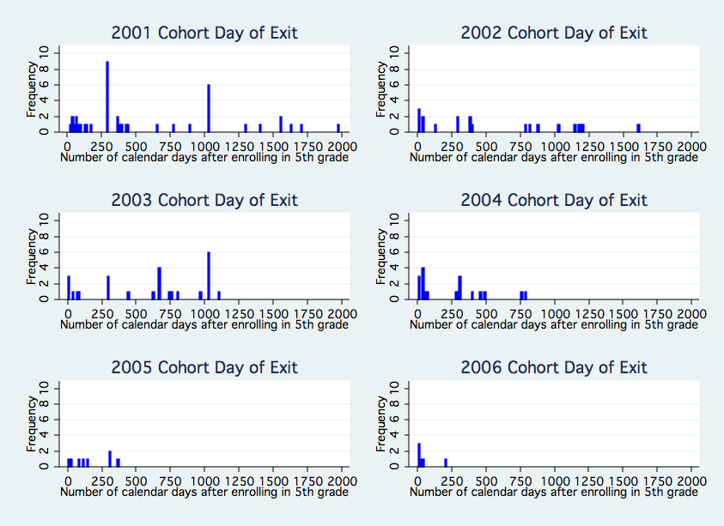
Appendix Figure A2. Histograms showing the impact of attrition on the distribution of raw fourth-grade reading scores for each cohort. The lighter and darker bars taken together represent the distribution at for the entire original fifth-grade cohort. The darker bars represent the distribution of the same distribution of scores after attrition.

Appendix Figure A3. Histograms showing the impact of attrition on the distribution of raw fourth-grade math scores for each cohort. The lighter and darker bars taken together represent the distribution at for the entire original fifth-grade cohort. The darker bars represent the distribution of the same distribution of scores after attrition.

2006 Cohort Data
Not Currently Available

Table A2. Average raw fourth-grade test scores and standard deviations for reading and math at GCP for each cohort.
 |  |  | Reading |  |  | Math
Cohort | n |  | Average | Standard Deviation |  | Average | Standard Deviation
2001 | 77 |  | 145.66 | 8.32 |  | 253.35 | 8.48
2002 | 49 |  | 147.88 | 7.03 |  | 253.47 | 5.53
2003 | 56 |  | 249.82 | 8.39 |  | 254.51 | 6.77
2004 | 69 |  | 249.64 | 8.75 |  | 257.10 | 6.11
2005 | 80 |  | 251.98 | 7.13 |  | 258.64 | 6.49
2006 | 67 |  | 250.70 | 6.84 |  | . | .
Note: There were 59 instead of 56 reported scores for the 2003, fifth-grade math test. Also, math scores were not available for the 2006 cohort.
Works Cited

For an overview of KIPP, please see Appendix Exhibit A1.
For a complete list of all 52 KIPP schools, their locations, and when they were founded, please see Appendix Table A1.
It should be noted that students with lower incoming test scores were more likely to leave charter schools, but those who remained had lower test score increases on future tests when compared to those students who left the charter school (Solmon, Paark, & Garcia, 2001, p. 22)
In the last six years KIPP has been featured on 60 Minutes (twice), the Oprah Winfrey Show, and in every major newspaper in the country.
The fourth-grade scores are from the North Carolina End-of-Grade (EOG) tests. These are criterion-referenced tests given in May of each year in grades 3 through 8. For more information, please see: http://www.dpi.state.nc.us/accountability/testing/shared/achievelevel/eog
It would also be interesting to examine attrition of students who qualify for federally subsidized lunch (a proxy for socioeconomic status), however, there were so many records missing for this variable that these analyses were not possible.
As the simple subtraction suggests, 55 students who ultimately withdrew from GCP transferred to the school after the initial fifth-grade year.
To see Figure 1 disaggregated by cohort year, please see Figure A1 in the Appendix.
For a more descriptive table of statistics that reflect these box plots, please see Appendix Table A5.
The systematic increase in math scores could also be reflective of a larger state trend where every school was doing better on this exam. Further analyses should be conducted to determine if this is the case.
Again, there were no math scores for the 2006 cohort, hence the difference in total number of fifth graders for each subject.
Exact amount could not be determined
SY = School Year

