Pratham (http://www.pratham.org/)

GiveWell staff made two visits to Pratham Programs. Simon Knutsson, Natalie Stone, Elie Hassenfeld, and Holden Karnofsky visted Pratham on September 15, 2010. Simon and Holden visited again on October 12, 2010. Notes from both visits follow.

Visit #1

We were guided by Ms. Rakhi Tandel, Supervisor, and Mr. Altaf Vajir Sayyad, Supervisor Training Monitor. We visited several Pratham programs:

Library program (Pratham description)

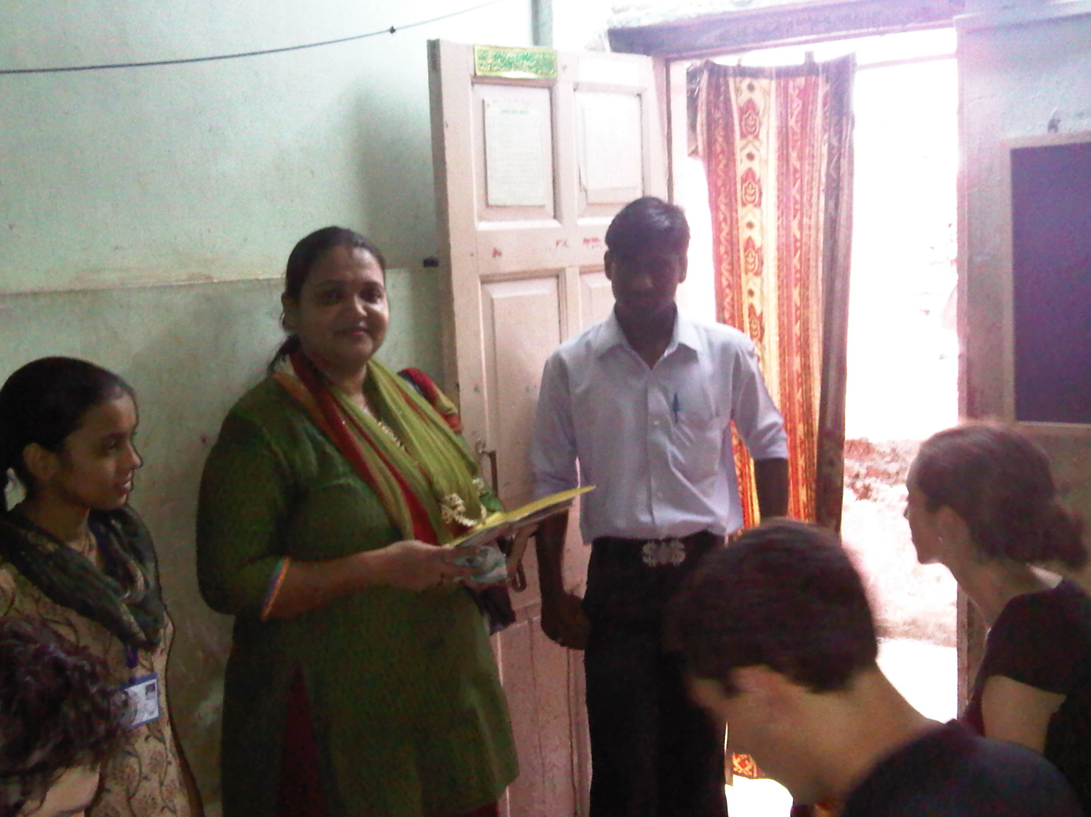
Our first visit was to the library program, where our guide seemed to ask the librarian (at the left of the picture) to show us how she carried out her work, and she handed out books to children.

We examined the books; none that we saw were in English, and most appeared to be non-academic.

Staff showed us a table summarizing how many children were enrolled at each grade level, and showed us a room (pictured) whose primary use is for testing children.

Preschool (Balwadi) (Pratham description)

We visited a Pratham-run preschool (Balwadi). Our guide told us that 23 of the community’s children attend this program, while 37 go to “private” preschools.

Children were uniformed, well-behaved, and spirited as the teacher led them in a prayer and then in some other exercises.

Scholarship programs (Pratham description) and Read India program (Pratham description)

From Pratham: There is a scholarship Exam held by the state government in the month of February every year for grade 4 and 7. It tests children’s competencies in Math, language, English and General knowledge. Children appearing on the merit list are given a small scholarship. Pratham gives extra classes so that they are able to get some extra help to pass the exam. Read Mumbai is a learning enhancement program that works towards giving basic language, math and English skills to children between standard 1 and 5.

We visited multiple classes in a government building, where students were taking outside-of-school lessons on various topics. Because these classes were on government property, pictures were not permitted.

Children were attentive and well-behaved as teachers conducted lessons. All of the classes we saw seemed relatively small to us - 15-20 students with one teacher, in rooms that had plenty of space.

In general, we couldn’t follow much of the specifics of the lessons. In one room, we saw a blackboard with a translation from the English alphabet into numbers (A=1, B=2, etc.) and students working on exercises that involved pairing letters with their corresponding numbers.

When we walked into the Read India program, two classes of students jumped up to welcome us.

The Read India program was quiet instruction taking place. Nearby, another program that involved young children shouting and chanting constantly. The Read India kids stayed focused on their lesson even though there was noise next to them.

Math and English classes in Pratham building

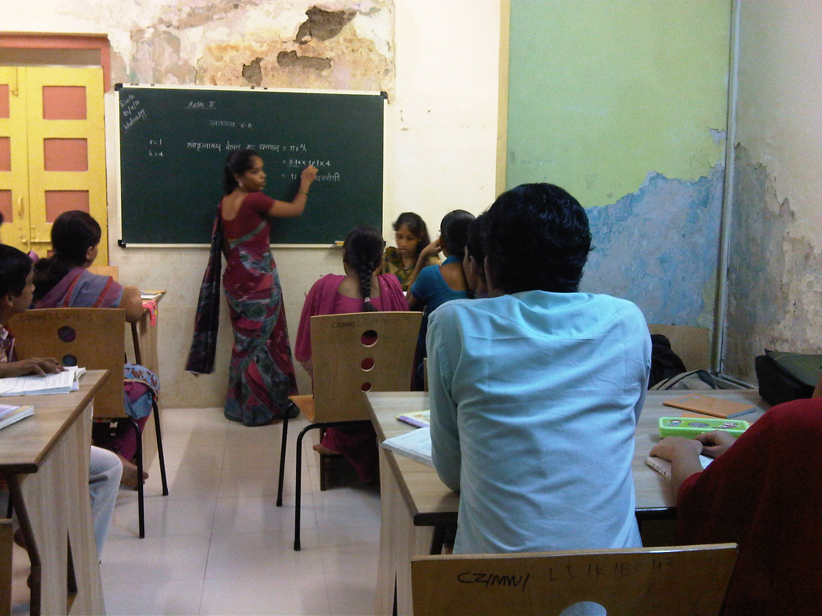
We went to a Pratham center (pictured above), where we saw a level 10 math class for kids who had dropped out of school, as well as two English classes. Again, students were very attentive; the rooms were small and most or all seats were in use. We had a couple of practice conversations with the students in one very introductory English course; they knew some basic phrases (”What is your name?”, “Where are you from?”, “How is your family?”) and pronounced them well.

The teacher was copying English phrases out of a textbook and pronouncing them with the class. The lesson appeared to be on the future tense and phrases included “They will reach here in the next month”, “They are not going to ask you anything”, “We shall make your tongue right again” and “The teacher will teach you a lesson.”

Computer class

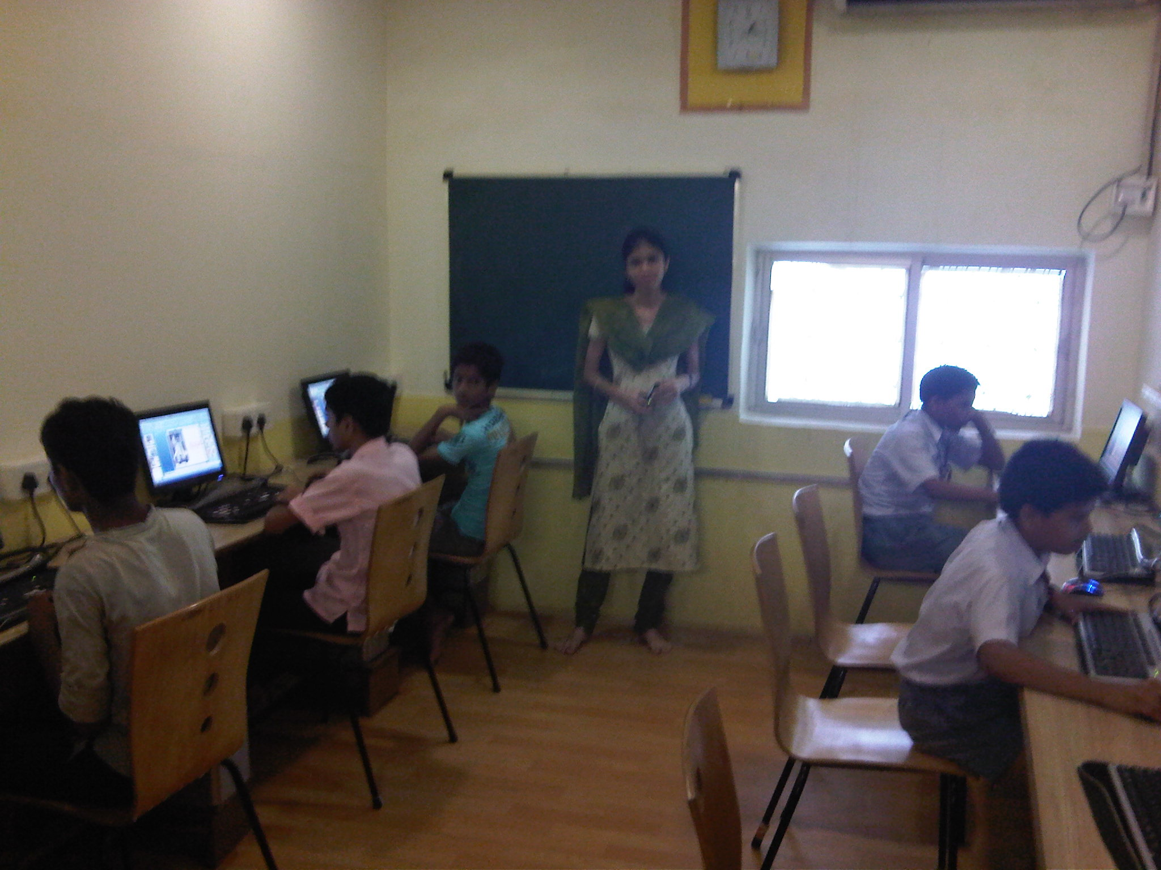

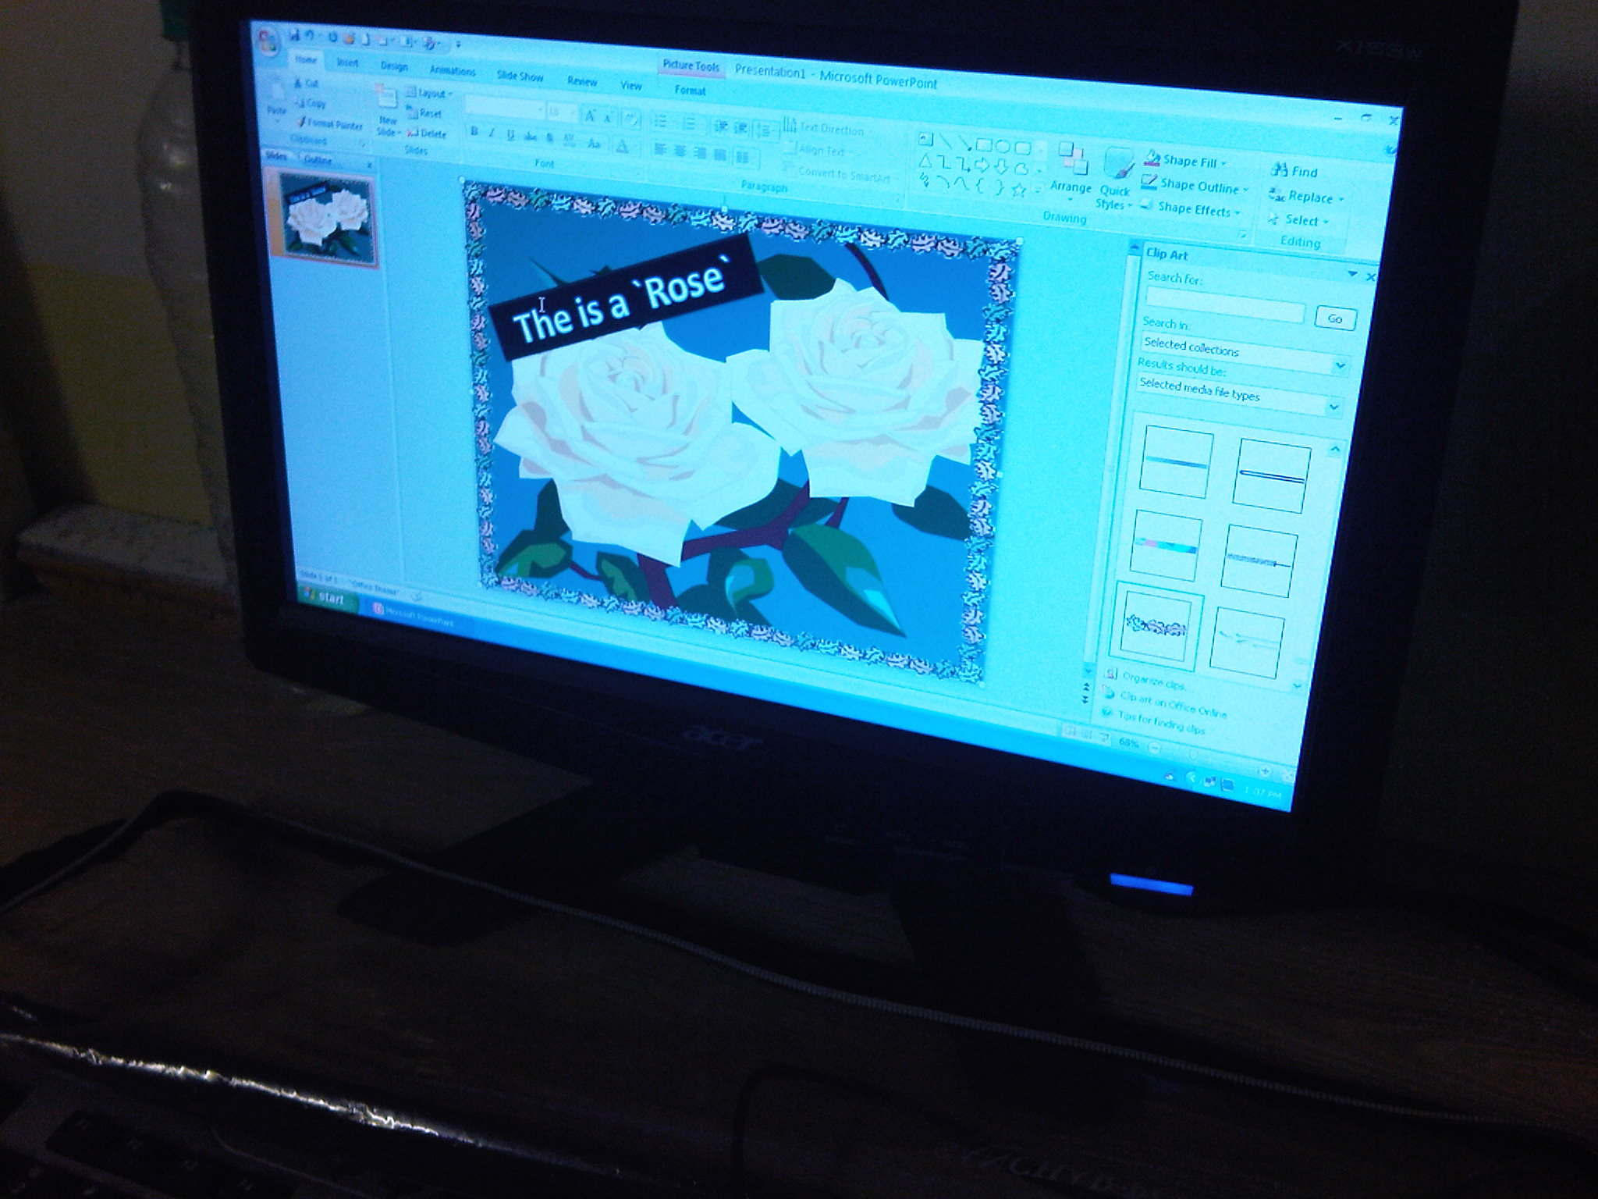
Finally, we visited a computer class, where children were doing exercises in PowerPoint, including labeling items in English and replicating a diagram multiple times. This was the only air-conditioned room in the building (because of the computers, we were told). This was also the only class we saw where fewer than half the seats were in use. We were told that the courses cost parents 300-1500 INR for 3 months, and that most parents in the community are not sufficiently informed about the courses (Pratham representatives go door to door spreading information).

Visit #2

- This visit was near a slum in Mumbai near Andheri
- We visited a balwadi (pre-school):
  - It took place in the teacher's living room. The teacher is local; we were told that Pratham does not take volunteers from outside, as they would leave and have no understanding of the community.
  - The Pratham representative stated that the teacher is handicapped (she can't get up and walk around) and that one of the benefits of the program is providing her employment.
  - The Pratham representative told us that a preschool teacher needs to have the qualification to have finished 10th class. She also said teachers get 4 days training every month. Natasha says Pratham finds teachers mainly by connections, e.g. there is a “Pratham person” in the community who knows whom would be good teaching candidates. There are approximately 250 balwadi teachers across the 4 zones in Mumbai (North, South, East, and West).
- Next was a visit to a library. The children were sitting quietly and reading.
- Next was a school readiness program for children who hadn't gone to balwadi or anganwadi. The program starts 3 months before school starts. The children we saw were 5-6 years old and learning about colors. They were not as attentive as the children we'd seen in other Pratham programs. We saw some other classrooms with children but no teachers in them. Apparently these were classrooms for government (not Pratham-run) classes; teachers had given kids work and walked out while they were working on it.
- Next was a scholarship program. Natasha said that in grades 4 and 7, students have opportunities for financial aid. The session we visited was for grades 3-4, and that the program provides extra lessons outside the regular curriculum to increase chances of scholarships so that more students have the chance to get scholarships. She said in Maharashtra, 91 students got into scholarship programs, a great achievement for Pratham.
- Next we visited an anganwadi (government day care). The children sang Twinkle Twinkle Little Star in English. They were in a much larger space than in the balwadi we had seen earlier. 14 children were present. We asked about differences between the anganwadi and the balwadi, which was very nearby and which we had seen earlier.
  - Balwadi is ages 3 and up; anganwadi is ages 2 and up.
  - Anganwadi teachers get more pay: 2000 INR/month vs. 1000 INR/mo for balwadi teachers.
  - Anganwadi teachers are required to have bachelor's degrees.
  - Neither anganwadi nor balwadi charges fees for attendance.
  - We asked why there was a balwadi so close (a few minutes' walk) to the anganwadi, which seemed to have enough space for more children. We were told that anganwadi provides free food and tends to be more about the food than the education - no intensive focus on English and numbers as there is in the Pratham balwadi (which does not provide free food).

Notes from our conversations with staff

- Pratham's process uses a lot of input from surveys. Generally, communities are surveyed to determine what programs Pratham should conduct; that, plus the cooperation of the government, is the main determinant of what programs Pratham will run in an area.
- At the beginning of the school readiness program, parents are surveyed about what they're expecting from the program; afterwards, Pratham shows them their children's progress. Rapport with parents is important to Pratham.
- New balwadi teachers are given an intensive 8-day training just before balwadi begins. The teacher managers train them, and check up on them over time to see how things are going in the classrooms. Pratham doesn't fire teachers; instead it gives them extra training and help when necessary.
- The Trainer Monitors (TMs) are managed by center coordinators. The center coordinators report to zone managers. Zone managers report to the head of Pratham Mumbai, who in turn reports to the Pratham CEO.
- We were told that Maharashtra is a cooperative and helpful government compared to those of, for example, Karnataka or Kerala. In those provinces education is so developed that they feel little need for Pratham's programming.
- The Pratham representative we met with works with donors and media.

