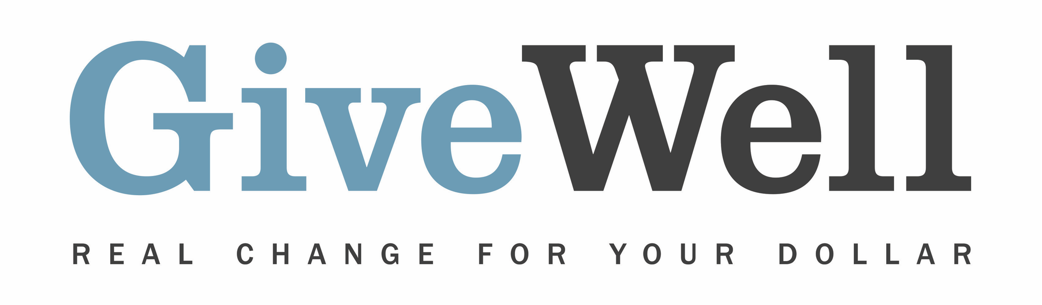
Dear (RECIPIENT'S NAME) ,
(YOUR NAME) has made a donation of $(DONATION AMOUNT) in your name designated for the support of Malaria Consortium’s seasonal malaria chemoprevention program

Malaria Consortium works on preventing, controlling, and treating malaria and other communicable diseases in Africa and Asia. GiveWell, a nonprofit dedicated to finding outstanding giving opportunities, recommends Malaria Consortium's seasonal malaria chemoprevention (SMC) program, which aims to distribute preventive anti-malarial drugs to very young children to prevent illness and death from malaria, one of the leading causes of child deaths in Africa. Our recommendation is only for Malaria Consortium’s SMC program.

Malaria Consortium’s SMC program is recommended by GiveWell. Thousands of hours have gone into finding and analyzing GiveWell's recommended charities. They are evidence-backed, thoroughly vetted, and underfunded. For more information on these charities, including Malaria Consortium’s SMC program, and GiveWell’s work, please visit us online at www.givewell.org.

Thank you for your support!

Sincerely,
GiveWell Staff
www.givewell.org

