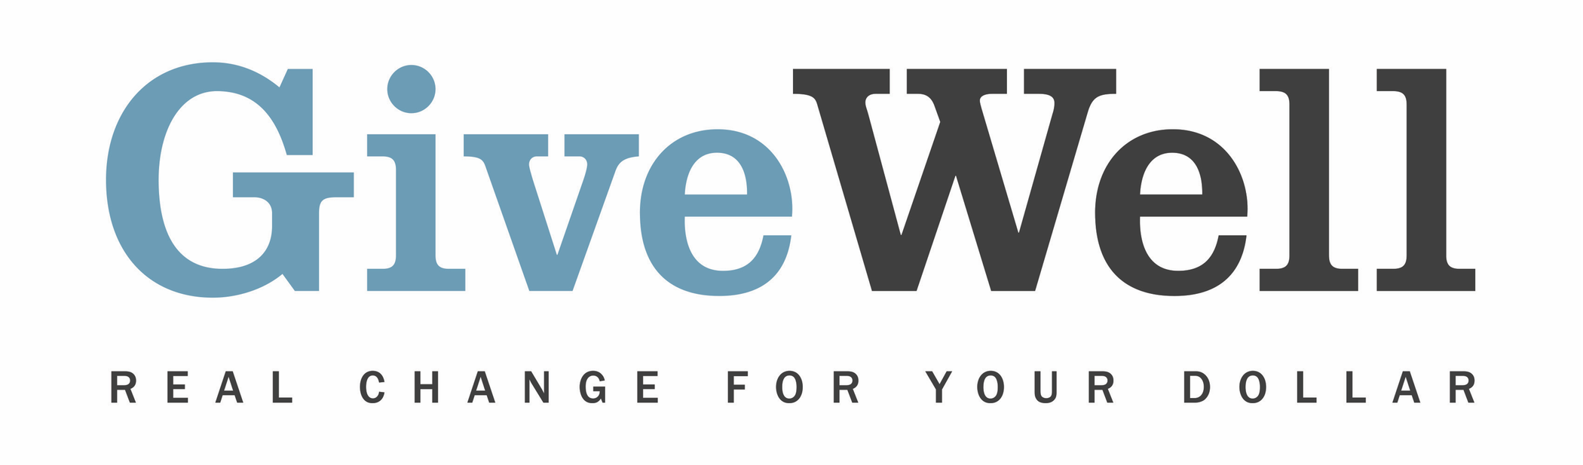
Dear (RECIPIENT'S NAME) ,
(YOUR NAME) has made a donation of $(DONATION AMOUNT) in your name designated for the support of the Iodine Global Network (IGN).

Iodine deficiency, which remains common in the developing world, harms cognitive development. Fortifying salt with iodine successfully alleviates this problem. IGN aims to reduce iodine deficiency globally by advocating for national salt iodization programs, tracking progress on iodization, and providing global and country-specific guidance on related programmatic and scientific issues.

IGN is one of GiveWell’s standout charities. GiveWell is a nonprofit dedicated to finding outstanding giving opportunities. Thousands of hours have gone into finding and analyzing GiveWell's recommended charities. For more information on these charities, including IGN, and GiveWell’s work, please visit us online at www.givewell.org.

Thank you for your support!

Sincerely,
GiveWell Staff
www.givewell.org

