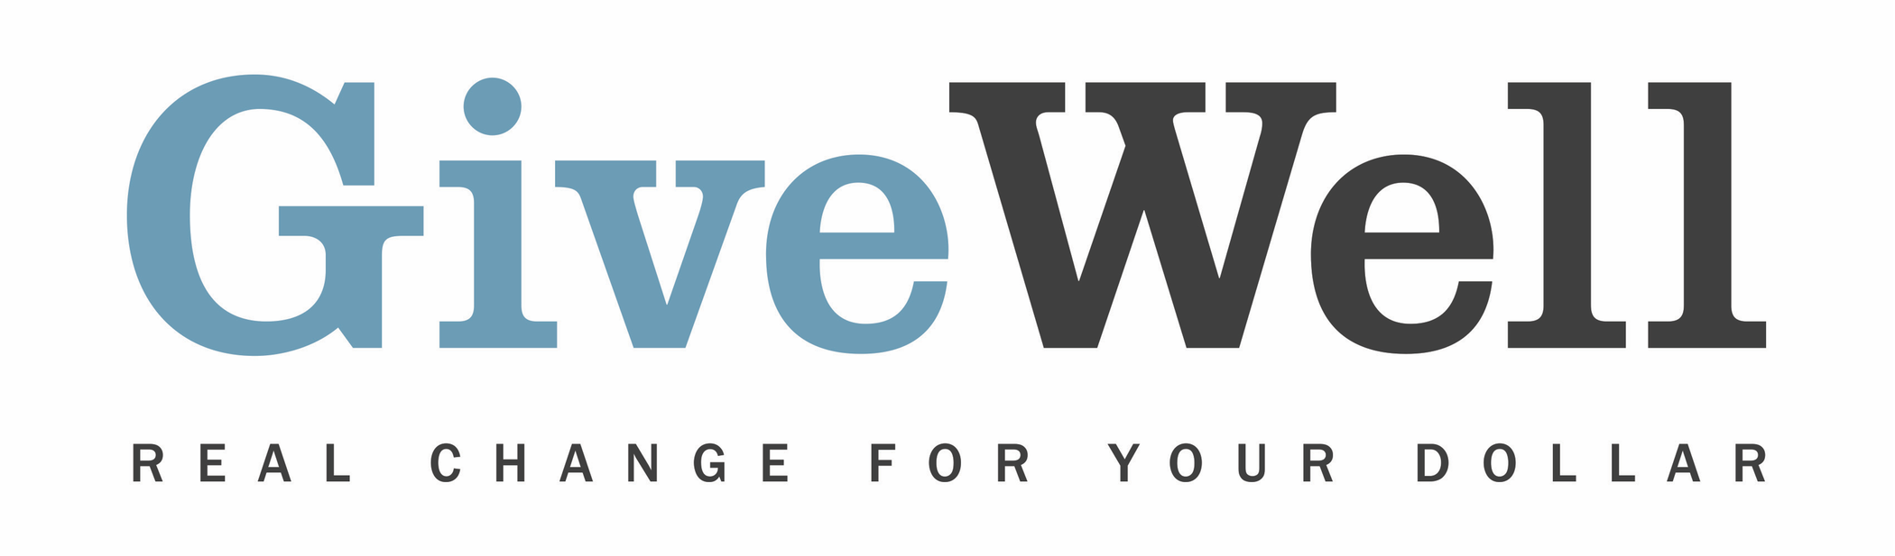
Dear (RECIPIENT'S NAME) ,
(YOUR NAME) has made a donation of $(DONATION AMOUNT) in your name designated for the support of GiveDirectly.

GiveDirectly provides cash grants to poor households in Kenya and Uganda. Directly transferring money to poor individuals allows them to purchase whatever they believe will help them most. GiveWell believes that GiveDirectly effectively distributes cash to extremely low-income individuals.

GiveDirectly is recommended by GiveWell, a nonprofit dedicated to finding outstanding giving opportunities. Thousands of hours have gone into finding and analyzing GiveWell's recommended charities. They are evidence-backed, thoroughly vetted, and underfunded. For more information on these charities, including GiveDirectly, and GiveWell’s work, please visit us online at www.givewell.org.

Thank you for your support!

Sincerely,
GiveWell Staff
www.givewell.org

