MONITORING DATA ANALYSIS

In order to evaluate the efficacy of the deworming protocol and process, independent monitors visited a randomly selected sample of schools and anganwadis over five days – one day before deworming for preparation monitoring, on Deworming Day, on Mop-Up Day, and two days post-deworming allocated for coverage validation.

A multi-stage sampling strategy was used to select the 990 schools (1.1% of 90,488 schools in Rajasthan) targeted for monitoring. From each of the 33 districts in Rajasthan, 2 blocks were selected by simple random sampling. In each of these 66 blocks, 15 schools were randomly selected for a total of 990 schools.

One monitor was assigned to each of these blocks. From the list of 15 schools in a block, the monitor could visit any 3 schools before Deworming Day for Preparation Monitoring, another 2 schools on Deworming Day, 2 more schools on Mop-Up Day, and 4 more schools over the two Coverage Validation days. The remaining 4 schools served as a buffer in case a particular school could not be visited. Hence, the actual sample size was 726 schools (0.8% of all schools).

Out of the total sample of 726 schools, monitors were able to survey ___ schools comprising 186 schools for Preparation Monitoring, 136 on Deworming Day, 132 on Mop-Up Day, and ___ on Coverage Validation days.

In addition, anganwadis were also monitored over the course of these five days. As there was no pre-assigned master list of anganwadi centres (AWCs), monitors visited AWCs situated nearest to the monitored schools. Each monitor was tasked with visiting 2 AWCs for Preparation Monitoring, another 2 on Deworming Day, 2 more on Mop-Up Day, and 4 more over the two Coverage Validation days.

Monitors managed to visit 131 AWCs for Preparation Monitoring, 109 on Deworming Day, 107 on Mop-Up Day, and ___ on Coverage Validation days.

PREPARATION MONITORING – SCHOOLS

For checking preparations for deworming program, monitors visited schools and anganwadis in the week prior to Deworming Day (15 October 2012). The preparation monitoring visits occurred from 11-13 October. The following analysis is based on the status of 186 schools in this time period.

SCHOOL DETAILS:

- As good hygiene practices include using latrines instead of open defecation, it’s vital that schools and AWCs provide functional toilet facilities for both boys and girls. Monitors reported that functional toilets for boys existed in 57.1% of schools and for girls in 57.8% of schools.
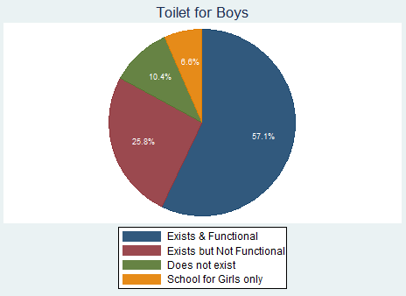

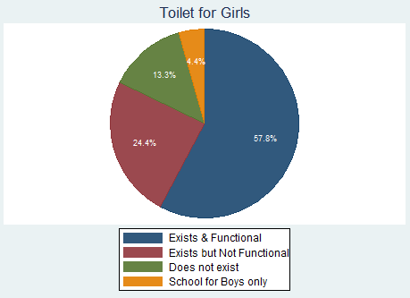

- Monitors also checked if water and soap were available for washing hands. Both were available in 62.4% of schools.
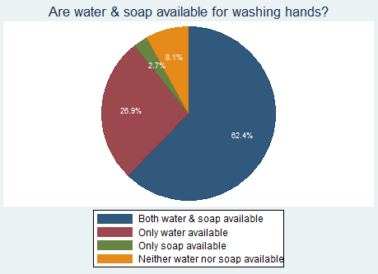

- Average enrollment in schools visited for preparation monitoring is 153.

CLASS SELECTION:

- Each monitor selected one class to visit according to a random selection table. The following figure shows the distribution of classes selected for monitoring. For a few schools, data on which class was monitored was not available; these are specified as “MISSING.”
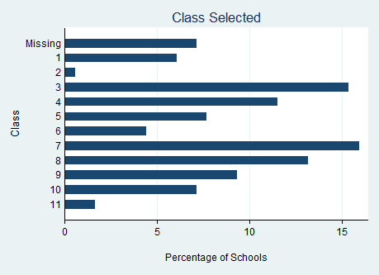

DEWORMING TRAINING AND GENERAL AWARENESS:
- 91.7% of school principals, 90.3% of class-teachers, and 62.6% of children interviewed in the selected classes were aware that Deworming Day in Rajasthan was October 15, 2012.

- 77.9% children reported that they learned about deworming through their school, 1.7% through radio, 2.9% through TV, 12.8% through posters, 4.1% through friends/relatives, and 3.5% through newspapers. This indicates that the school system is the main source of information.

- 90.3% of principals report that they or another school teacher attended official training for Deworming Day. 85.5% of these principals also reported training other teachers in their school. In the selected classes, 51.4% of interviewed teachers reported attending official training, 40.6% received training from other teachers in their school, and 8% did not receive any training.

- Teachers were asked a few questions about worm prevalence to test their general awareness and the effectiveness of training. 33.7% of teachers responded correctly to the question “Which worms can enter through skin”.
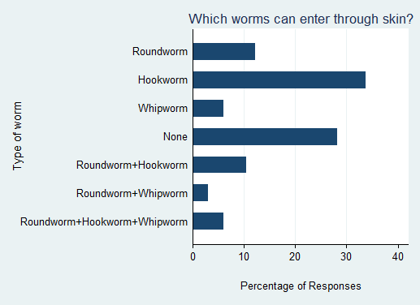
- 32.3% of teachers were aware that worm infection spread through contaminated food, contaminated water, as well as walking barefoot in a worm infested area.
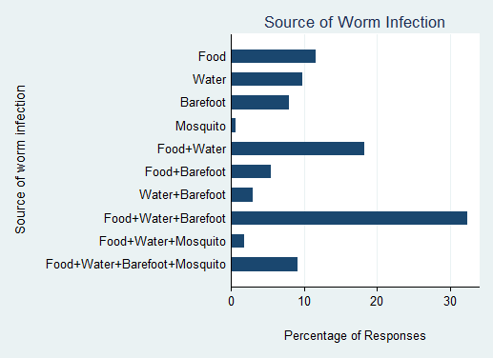
- On being asked about how children could avoid worm infection, 29.5% of teachers were able to respond with all of the following: using latrines instead of open defecation, washing hands before eating, wearing shoes outside the house, drinking clean water & washing vegetables before consumption.
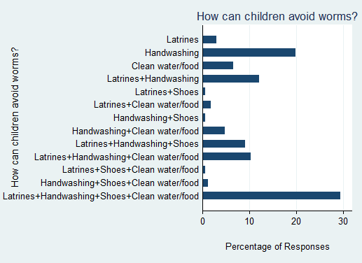
- On being asked if it was safe to give deworming medicine to children who may not have worms, teachers’ responses were split. 49.4% correctly considered the medicine as safe to be given to all children while 46.3% did not. The rest did not know for certain if the medicine was safe.
INFORMATIONAL MATERIAL & DEWORMING DRUGS:

- 81.4% of schools reported receiving both the Deworming Day poster and Global Handwashing Day poster. 10.4% of schools received only the Deworming Day poster. 3.3% of schools received neither poster.
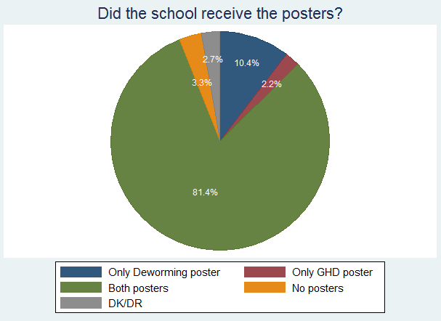

- The Deworming Day poster was clearly visible in 59.8% of schools, partly visible (torn, obscured by other posters, etc.) in 8.7% of schools, and not visible in 31.5% of schools.

- 94% of schools reported receiving the training booklet.

- 95% of schools reported receiving the deworming tablets. The average number of tablets received is 179. However, among schools that reported the exact number of tablets received, 7.7% of schools claim to have received fewer tablets than the number of students enrolled.

- Monitors checked the place where deworming drugs were stored and reported if the location satisfied the following attributes: cool (not in direct sunlight), dry (not in a damp location), secure (access restricted to school principal & teachers), and tidy (in clean packaging). The following figure shows the percentage of schools satisfying each of these attributes. This information is condensed in the next figure which shows how many of these four attributes are satisfied by schools. 27% of schools had kept the drugs in a location that satisfied all attributes.
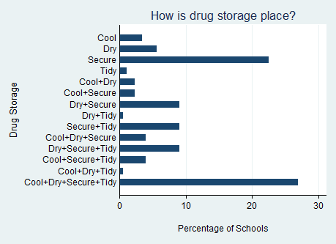

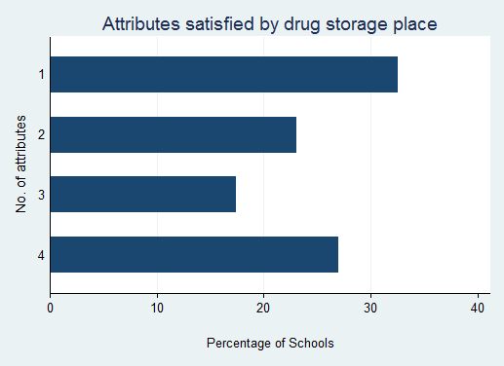

SUMMARY FORMS:

- 93.9% of schools received the summary form. 96.5% of school principals reported that they completely understood how to fill the form. A further 2.3% claimed to understand it partly.

- 80% of principals were aware that the last date for submitting the summary form was October 19, 2012.

PREPARATION MONITORING – ANGANWADIS

The preparation monitoring analysis is based on data received from 131 anganwadis.

ANGANWADI DETAILS:

- Monitors reported that functional toilets existed in only 30.1% of anganwadis. In 19.5% of anganwadi centres, a toilet facility existed but was not functional.
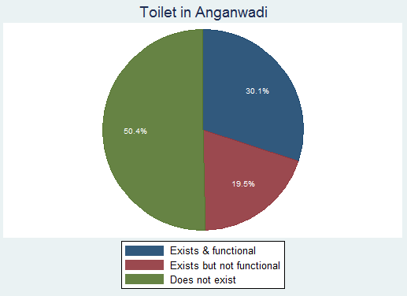

- Monitors checked if water and soap were available for washing hands. Both were available in 53.2% of anganwadis, only water in 28.6% of anganwadis, and neither in 14.3% of anganwadis.
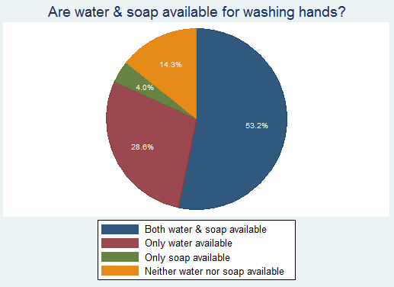

- Average enrollment in anganwadis visited for preparation monitoring is 57.

DEWORMING TRAINING AND GENERAL AWARENESS:
- 79.7% of anganwadi workers (AWWs) were aware that Deworming Day in Rajasthan was October 15, 2012.

- 55.3% of AWWs report that they attended official training for Deworming Day, 20.3% received training from other teachers, and 24.4% did not receive any training. 82.4% of AWWs who attended official training also report that they trained others who worked in their anganwadi.

- AWWs were asked a few questions about worm prevalence to test their general awareness and the effectiveness of training. 26.6% responded correctly to the question “Which worms can enter through skin”.
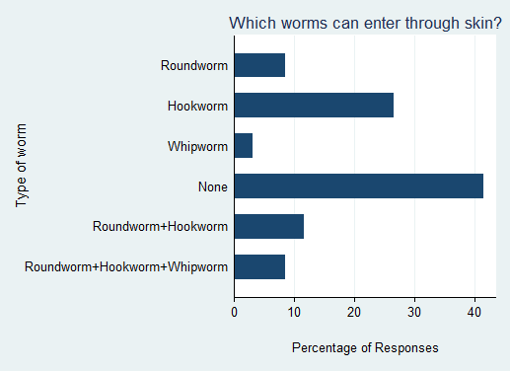
- 26.8% of AWWs were aware that worm infection spread through contaminated food, contaminated water, as well as walking barefoot in a worm infested area.
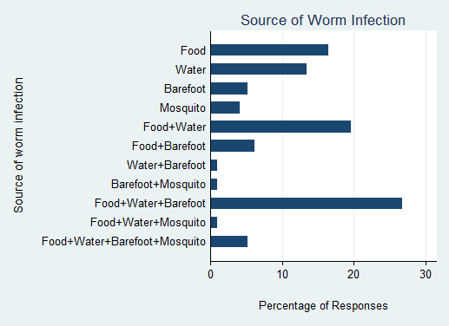
- On being asked about how children could avoid worm infection, 20.2% of AWWs were able to respond with all of the following: using latrines instead of open defecation, washing hands before eating, wearing shoes outside the house, drinking clean water & washing vegetables before consumption.
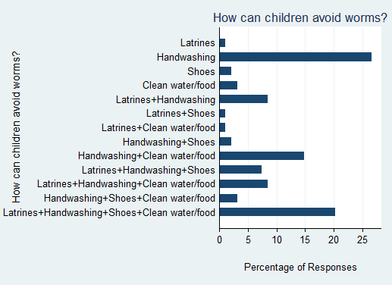
- On being asked if it was safe to give deworming medicine to children who may not have worms, AWWs’ responses were split. 43.8% correctly considered the medicine as safe to be given to all children while 41.7% did not. The rest did not know for certain if the medicine was safe.
INFORMATIONAL MATERIAL & DEWORMING DRUGS:
- The Deworming Day poster was clearly visible in 26.4% of anganwadis, partly visible (torn, obscured by other posters, etc.) in 6.2% of anganwadis, and not visible in 67.4% of anganwadis.

- 38.7% of anganwadi workers received both deworming and GHD pamphlets, 11.3% received only one of the pamphlets, and 42.7% received neither.
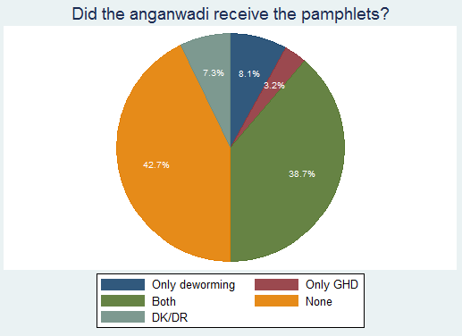

- 48% of anganwadi workers reported receiving the training booklet while 48.8% did not receive it. The rest did not know if they had received it for certain.

- 55.1% of anganwadis reported receiving the deworming syrup. The average number of syrup bottles received is 72. However, among anganwadis that reported the exact number of bottles received, 17.1% of anganwadi workers reported receiving fewer syrup bottles than the number of children enrolled. This may be due to total enrollment including children below the age of 2 years while syrup bottle allocation is determined on the basis of number of children aged 2-6 years.

- Monitors checked the place where deworming syrup bottles were stored and reported if the location satisfied the following attributes: cool (not in direct sunlight), dry (not in a damp location), secure (access restricted to anganwadi workers), and tidy (in clean packaging). The following figure shows the percentage of anganwadis satisfying each of these attributes. This information is condensed in the next figure which shows how many of these four attributes are satisfied by anganwadis. 23.6% of anganwadis had kept the drugs in a location that satisfied all attributes.
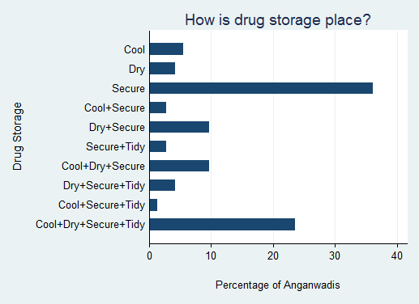

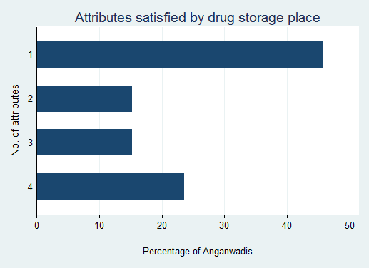

SUMMARY FORMS:
- 57.9% of AWWs received the summary form. 84.9% reported that they completely understood how to fill the form, 5.5% understood it partly, and 9.6% did not understand the form at all.

- 79.7% of AWWs were aware that the filled summary form was to be submitted to their Supervisor.

DEWORMING DAY – SCHOOLS

Deworming Day in Rajasthan was held on 15th October 2012. As the majority of targeted children are dewormed on this day itself, monitoring the process on this day is vital. The monitoring analysis for Deworming Day is based on data received from 136 schools.

SCHOOL DETAILS:

- 38.2% of schools in the dataset are Primary Schools (up to Class 5), 25% Middle Schools/Upper Primary Schools (up to Class 8), 19.1% High Schools/Secondary Schools (up to class 10), and 9.6% Senior Secondary Schools (up to Class 12). For 8.1% of schools, data on school type is not available. This disaggregation is shown in the following figure.
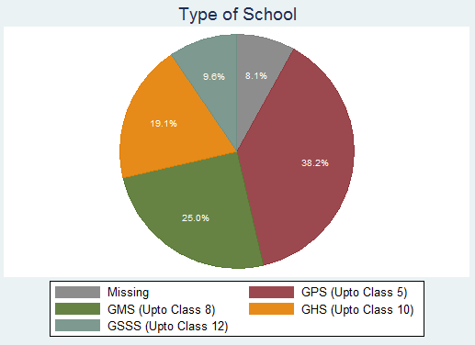

- A functional toilet for boys existed in 66.9% of schools whereas a functional toilet for girls existed in 67.9% of schools.
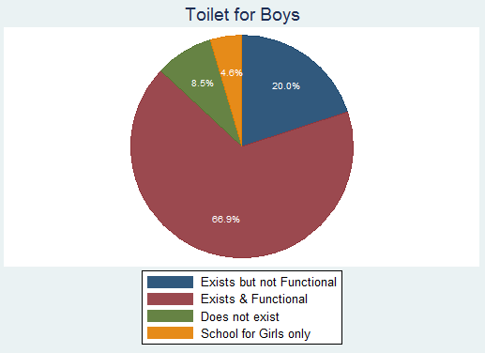
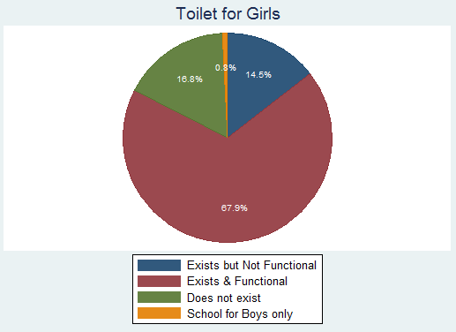
- Monitors checked if water and soap were available for washing hands in the school. Both were available in 82.3% of schools.
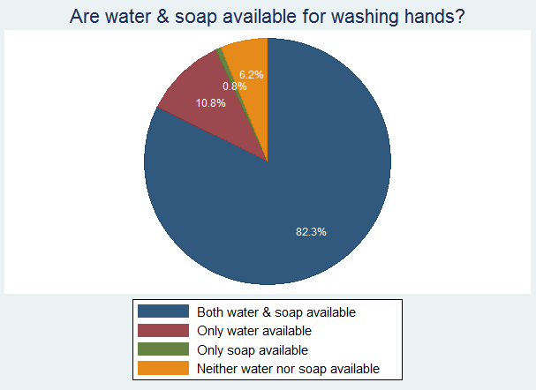

- The average enrollment in these schools was 141 and the average attendance on Deworming Day was 93.
CLASS SELECTION:

- Each monitor selected 1 class to visit on Deworming Day according to a random selection table. The following figure shows the distribution of classes selected for monitoring. For a few schools, data on which class was monitored was not available; these are specified as “MISSING.”
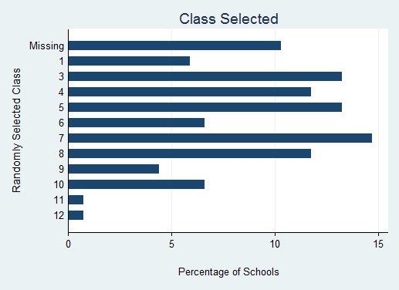

DEWORMING TRAINING AND GENERAL AWARENESS:
- 96.3% of school principals were aware that the day of monitoring visit was Deworming Day.

- 92.6% of school principals reported that they or another teacher from their school attended the official training for Deworming Day. 92% of these teachers also trained other teachers in their school.

- Class teachers were asked a few questions about worms and deworming to test their knowledge and the effectiveness of training. 93.7% of teachers were aware that worms are found in the intestine.

- Teachers were also asked about the sources of infection by worms – walking barefoot, eating contaminated food, contact with infected people, mosquito bites, and others (including not washing hands, lack of hygiene, open defecation, drinking contaminated water, dirty nails, and constipation).
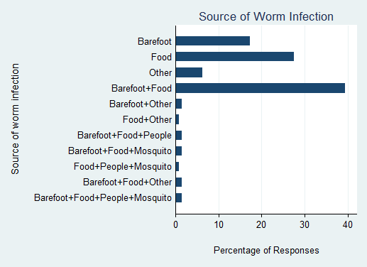

- Teachers were asked various reasons why worms were harmful. Among the responses stating the consequences of worm infection, 55.9% mentioned shortage of blood, 66.9% anaemia & malnourishment, 56.7% adverse impact on child’s growth, 39.4% adverse impact on child’s learning capabilities, and 32.3% stated that long-term infection could lead to more serious health problems later.

- On being asked about ways to prevent or cure worm infection, 46.4% of teachers stated that awareness, good hygiene, as well as deworming medicine were important.
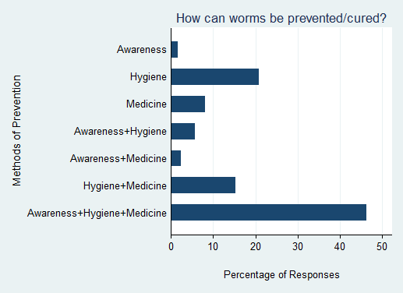

- On being asked about why schools were optimal for the deworming program, 76.8% of responses mentioned the ability to reach a large number of children, 40.8% mentioned the vulnerability of the school-age population, and 61.6% mentioned the ability of the teacher to inform children about the importance of deworming.

- Teachers were asked about their response in case of a child suffering from adverse effects after taking the deworming tablet.
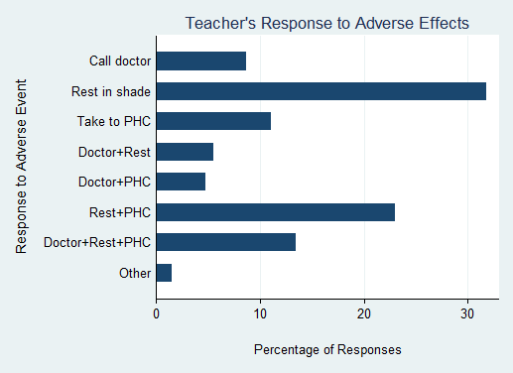
INFORMATIONAL MATERIAL & DEWORMING DRUGS:

- The Deworming Day/GHD poster was clearly visible in 76.9% of schools, partly visible (torn, obscured by other posters, etc.) in 4.5% of schools, and not visible in 18.6% of schools.

- 78.9% of school principals reported that they received information about distribution of drugs through the official deworming/GHD training, 14.3% through a teacher who had attended the training, 2.3% through another school, and 2.3% through other sources. Only 2.3% of schools claimed to have not received any information.
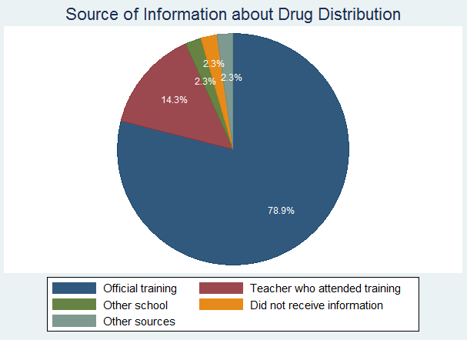

- 97% of school principals reported that they had received the deworming tablets by Deworming Day.

- 98.5% of school principals reported that they had received sufficient deworming tablets for all their enrolled students.

- Monitors observed the drug storage location to check if it was cool, dry, secure, and tidy. All these attributes were satisfied by 25.6% of schools.
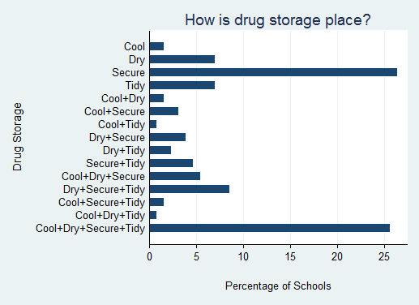
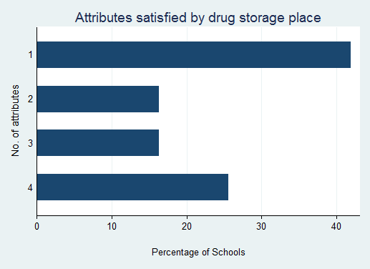
- In 66.7% of schools, the remaining tablets were kept by the teacher in a secure place for next time. In 26.8% of schools, the tablets were returned to the principal.
SUMMARY FORMS:

- 92.4% of principals claimed that they completely understood how to fill the School Summary Form and 2.3% understood it partly. 3.8% of principals stated that they did not understand the form.

- 84.1% of principals were aware that the last date for submitting the School Summary Form was Oct 19, 2012.

ADMINISTRATION OF DEWORMING TABLETS:

- In 93.1% of schools, the principal claimed that deworming was taking place or going to take place in their school on that day. Monitors could observe the deworming process in 83.3% of schools. In 94.3% of such schools where deworming was ongoing, monitors reported that deworming activity was proceeding in an orderly manner.

- Prior to administering the deworming medicine to children, teachers need to ensure that certain processes are followed. In 96.4% of schools, monitors observed the teacher providing health education to the children. In 90.7% of such schools, the health education segment included instructions to not give deworming tablets to sick children.

- As the medicine is only to be taken after meals, children should have eaten their tiffin or mid-day meal. Monitors observed this to be the case in 97.3% of schools.

- As unclean hands are a primary source of worm transmission, hands should be washed before taking the medicine. Teachers and children washed their hands with soap in 88.2% of monitored classes, washed with only water in 6.4%, and did not wash their hands at all in 2.7% of classes.

- Adequate potable water was available for the children in 75.9% of schools, water is not available in 13.9% of schools, and potable water was available but not in adequate quantity in 10.2% of schools.

- Monitors observed that children were chewing the tablet before swallowing in 97.1% of schools. Doing this mitigates the risk of choking or throwing up the tablet.

- In all schools, the class-teacher or principal was administering the tablet to each child.

- In 97.1% of classes visited, the monitor observed the teacher ticking each child’s name in the attendance register after giving him/her the deworming tablet. In 96.1% of classes, the monitor reported that all dewormed children’s names had been ticked.

- 92.9% of teachers interviewed claimed that they did not give the tablet to any sick children. In 93.2% of schools, the monitor did not observe any sick child taking the tablet. No adverse reactions to taking the tablet were reported in 93.2% of schools. In a few reported cases, the monitor observed some children suffering from nausea/vomiting.

- In 94.2% of schools, the monitor did not observe any child taking more than one tablet.

- In 94.3% of schools, the monitor did not observe any tablets being spoilt during administration. Among schools where any tablets were spoilt, the monitor observed that in 57.1% of classes, spoilt tablets were thrown away while in 42.9%, spoilt tablets were kept securely in another place.

CHILD INTERVIEWS:

- In the selected class, the monitor interviewed one child chosen by the random selection table. The monitors were able to interview 130 children in all. The age distribution of interviewed children is shown in the figure below. 94.6% of the interviewed children reported that they walked to school, 3.9% cycled, and the rest took other modes of transport.
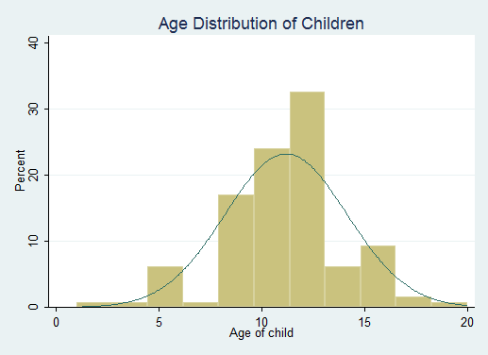

- 63.9% of children knew about deworming before Deworming Day whereas 27.7% found out on that day. All responding children learned about deworming at school, as opposed to other sources such as banners, the media and friends & relatives. 51.5% reported that their parents knew about deworming as well.

- 99.2% of children reported feeling fine when they came to school on Deworming Day.

- 86.2% of interviewed children had a tick in front of their name in the register. 89% of responding children reported receiving a tablet on Deworming Day. 96.4% of children were aware that the tablet given to them was for deworming. 94.6% ate the tablet after chewing, whereas 5.4% ate the tablet without chewing it, and no children reported throwing it away.

DEWORMING DAY – ANGANWADIS

The monitoring analysis for Deworming Day is based on data received from 109 anganwadis.

ANGANWADI DETAILS:

- A functional toilet existed in 47.4% of anganwadis whereas there was no toilet facility in 50.9% of anganwadis.
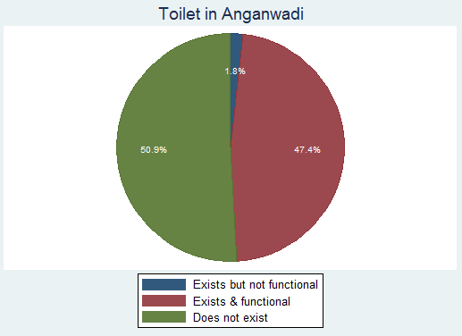
- Monitors checked if water and soap were available for washing hands in the anganwadi. Both were available in 70.9% of anganwadis.
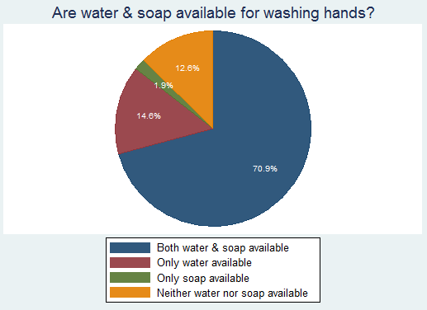

- The average enrollment in these anganwadis was 69 and the average attendance on Deworming Day was 27.
DEWORMING TRAINING AND GENERAL AWARENESS:

- 91.4% of AWWs were aware that the day of monitoring visit was Deworming Day.

- 88.6% of AWWs reported that they attended the official training for Deworming Day. 85.7% of these AWWs also trained other workers in their anganwadi.

- AWWs were asked a few questions about worms and deworming to test their knowledge and the effectiveness of training. 77.3% of AWWs were aware that worms are found in the intestine.

- AWWs were also asked about the sources of infection by worms – walking barefoot, eating contaminated food, contact with infected people, mosquito bites, and others (including not open defecation, drinking contaminated water, and dirty nails).
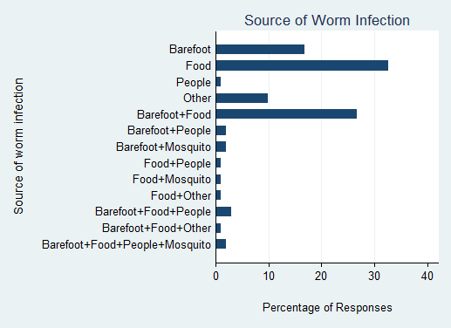

- AWWS were asked various reasons why worms were harmful. Among the responses stating the consequences of worm infection, 54.6% mentioned shortage of blood, 58.8% anaemia & malnourishment, 54.6% adverse impact on child’s growth, 19.6% adverse impact on child’s learning capabilities, and 20.6% stated that long-term infection could lead to more serious health problems later.

- On being asked about ways to prevent or cure worm infection, 25.3% of AWWs stated that awareness, good hygiene, as well as deworming medicine were important.
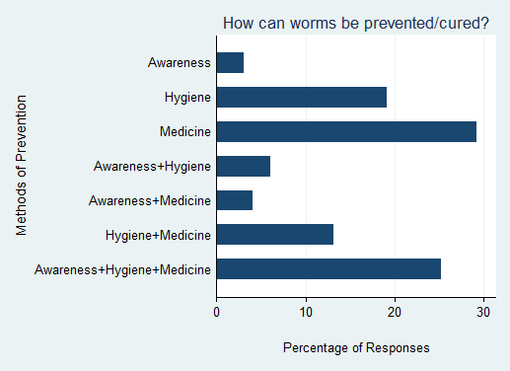

- AWWs were asked about their response in case of a child suffering from adverse effects after taking the deworming syrup.
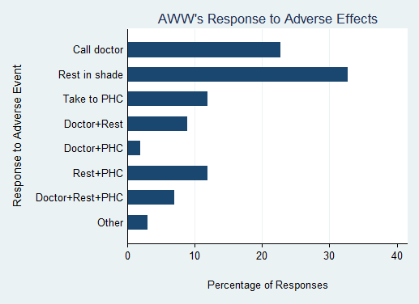
INFORMATIONAL MATERIAL & DEWORMING DRUGS:

- The Deworming Day/GHD poster was clearly visible in 38.8% of anganwadis, partly visible (torn, obscured by other posters, etc.) in 12.6% of anganwadis, and not visible in 48.6% of anganwadis.

- 97.1% of AWWs reported that they had received the deworming syrup bottles by Deworming Day.

- 93.1% of AWWs reported that they had received sufficient syrup bottles for all their enrolled children.

- Monitors observed the drug storage location to check if it was cool, dry, secure, and tidy. All these attributes were satisfied by 18.2% of anganwadis.
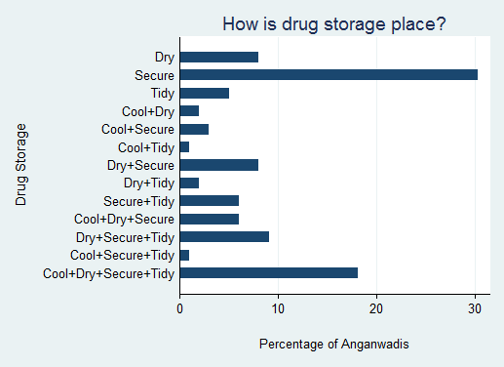
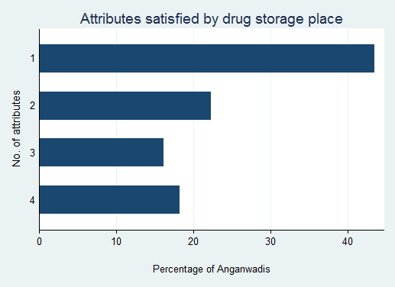
- In 81.7% of anganwadis, the remaining syrup bottles were kept by the AWW in a secure place for next time.
SUMMARY FORMS:

- 74.5% of AWWs claimed that they completely understood how to fill the Summary Form, 7.8% understood it partly, and 15.7% of AWWs stated that they did not understand the form.

- 73% of AWWs were aware that the Summary Form was to be submitted at the next sector meeting between Oct 21-25, 2012.

- 86.9% of AWWs were aware that the Summary Form was to be submitted to their Supervisor.

ADMINISTRATION OF DEWORMING TABLETS:

- In 92.2% of anganwadis, the AWW claimed that deworming was taking place or going to take place in their anganwadi on that day. Monitors could observe the deworming process in 68.9% of anganwadis. In 84.5% of such anganwadis where deworming was ongoing, monitors reported that deworming activity was proceeding in an orderly manner.

- Prior to administering the deworming medicine to children, AWWs need to ensure that certain processes are followed. In 80.9% of anganwadis, monitors observed the AWW providing health education to the children. In 81.8% of such anganwadis, the health education segment included instructions to not give deworming tablets to sick children.

- As the medicine is only to be taken after meals, children should have eaten their tiffin or mid-day meal. Monitors observed this to be the case in 95.7% of anganwadis. In a few cases, children reported that they had eaten at home before coming to the anganwadi centre.

- Before giving the deworming syrup, monitors observed that the AWW and children washed their hands with soap in 80.9% of anganwadis, washed with only water in 11.2%, and did not wash their hands at all in 7.9% of anganwadis.

- Adequate potable water was available for the children in 70.8% of anganwadis, water was not available in 19.1% of anganwadis, and potable water was available but not in adequate quantity in 9% of anganwadis.

- In 95.5% of anganwadis, the AWW was administering the syrup to each child. In a few rare cases, another adult was administering the syrup.

- In 90% of anganwadis, the monitor observed the AWW ticking each child’s name in the attendance register after giving him/her the deworming syrup. In 92.2% of anganwadis, the monitor reported that all dewormed children’s names had been ticked after the process was over.

- 95% of AWWs interviewed claimed that they did not give the syrup to any sick children. In 90% of anganwadis, the monitor did not observe any sick child taking the syrup. No adverse reactions to taking the syrup were reported in 91% of anganwadis. In a few reported cases, the monitor observed some children suffering from nausea/vomiting.

- In 94.4% of anganwadis, the monitor did not observe any child taking more than one tablet.

- In 94.3% of anganwadis, the monitor did not observe any syrup bottles being spoilt during administration.

MOP-UP DAY – SCHOOLS

Mop-Up Day in Rajasthan was held on 18th October 2012. Any children that could not be given medicine on Deworming Day (due to being sick or absent from school) could be dewormed on Mop-Up Day. Monitors were able to visit 132 schools on this day to observe the deworming process.

SCHOOL DETAILS:

- 34.8% of schools in the dataset are Primary Schools (up to Class 5), 25% Middle Schools/Upper Primary Schools (up to Class 8), 22% High Schools/Secondary Schools (up to class 10), and 4.5% Senior Secondary Schools (up to Class 12). For 12.9% of schools, data on school type is not available.
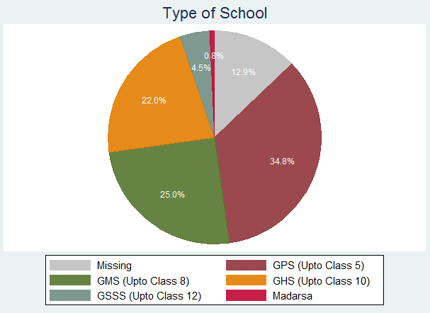

- A functional toilet for boys existed in 59.2% of schools whereas a functional toilet for girls existed in 68% of schools.
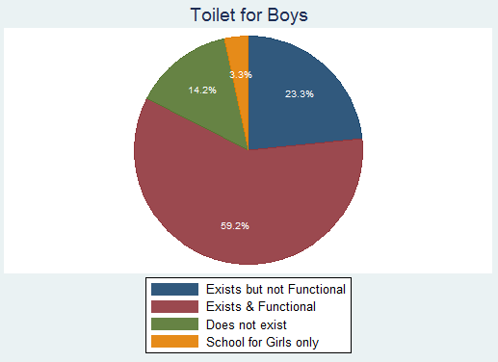
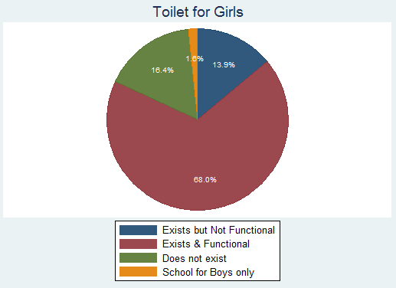
- Monitors checked if water and soap were available for washing hands in the school. Both were available in 76.6% of schools.
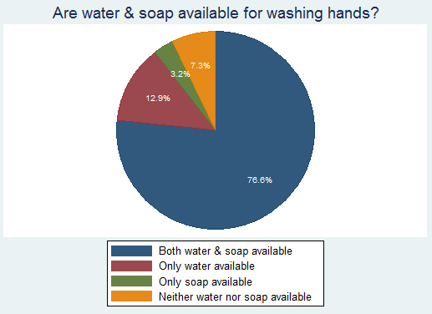

- The average enrollment in these schools was 129 and the average attendance on Mop-Up Day was 103.

CLASS SELECTION:

- Each monitor selected 1 class to visit on Mop-Up Day according to a random selection table. The following figure shows the distribution of classes selected for monitoring. For a few schools, data on which class was monitored was not available; these are specified as “MISSING.”
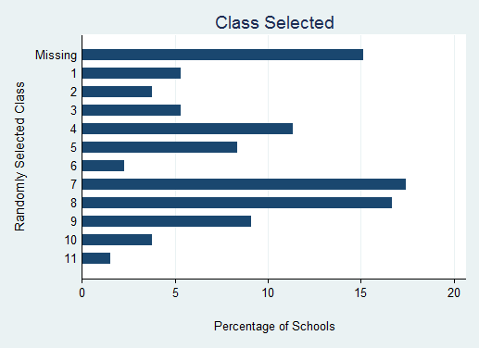

DEWORMING TRAINING AND GENERAL AWARENESS:
- 89.4% of school principals were aware that the day of monitoring visit was Mop-Up Day.

- 88.2% of school principals reported that they or another teacher from their school attended the official training for deworming. 85.7% of these teachers also trained other teachers in their school.

- Class teachers were asked a few questions about worms and deworming to test their knowledge and the effectiveness of training. 95% of teachers were aware that worms are found in the intestine.

- Teachers were also asked about the sources of infection by worms – walking barefoot, eating contaminated food, contact with infected people, mosquito bites, and others (including lack of hygiene, open defecation, drinking contaminated water, dirty hands, and constipation).
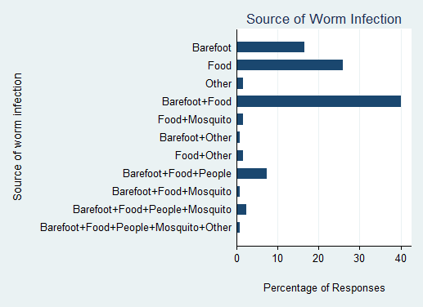

- Teachers were asked various reasons why worms were harmful. Among the responses stating the consequences of worm infection, 59% mentioned shortage of blood, 67.5% anaemia & malnourishment, 62.4% adverse impact on child’s growth, 39.3% adverse impact on child’s learning capabilities, and 29.9% stated that long-term infection could lead to more serious health problems later.

- On being asked about ways to prevent or cure worm infection, 46.7% of teachers stated that awareness, good hygiene, as well as deworming medicine were important.
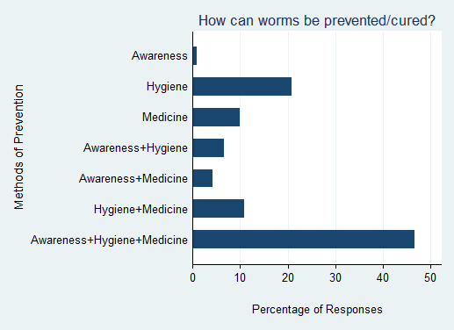

- On being asked about why schools were optimal for the deworming program, 72.5% of responses mentioned the ability to reach a large number of children, 37.5% mentioned the vulnerability of the school-age population, and 53.3% mentioned the ability of the teacher to inform children about the importance of deworming.

- Teachers were asked about their response in case of a child suffering from adverse effects after taking the deworming tablet.
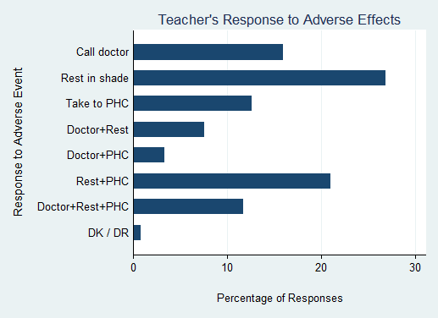

INFORMATIONAL MATERIAL & DEWORMING DRUGS:

- The Deworming/GHD poster was clearly visible in 74% of schools, partly visible (torn, obscured by other posters, etc.) in 6.3% of schools, and not visible in 19.7% of schools.

- 77% of school principals reported that they received information about distribution of drugs through the official deworming/GHD training, 17.5% through a teacher who had attended the training, 5.6% of schools claimed to have not received any information.
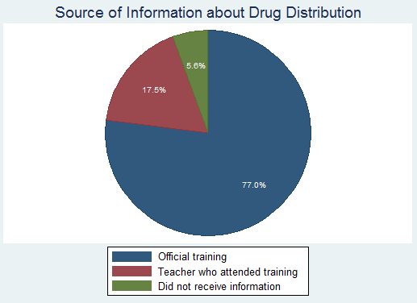

- 99.2% of school principals reported that they had received sufficient deworming tablets for all their enrolled students.

- In 66.4% of schools, the remaining tablets were kept by the teacher in a secure place for next time. In 26.7% of schools, the tablets were returned to the principal.
SUMMARY FORMS:

- 95.8% of principals claimed that they completely understood how to fill the School Summary Form.

- 70.7% of schools had filled the Summary Form by Mop-Up Day.

- 76.5% of schools had noted the number of tablets received in the Summary Form.

- 87.4% of school principals were aware of the last date for submitting the School Summary Form.

ADMINISTRATION OF DEWORMING TABLETS:

- Monitors could observe the deworming process in 70.5% of schools. In 89% of such schools where deworming was ongoing, monitors reported that deworming activity was proceeding in an orderly manner.

- In 90.4% of schools, monitors observed the teacher providing health education to the children. In 88.2% of such schools, the health education segment included instructions to not give deworming tablets to sick children.

- As the medicine is only to be taken after meals, children should have eaten their tiffin or mid-day meal. Monitors observed this to be the case in all schools for which data is reported.

- Teachers and children washed their hands with soap in 88.1% of monitored classes, washed with only water in 7.9%, and did not wash their hands at all in 4% of classes.

- Adequate potable water was available for the children in 68.6% of schools, water was not available in 18.6% of schools, and potable water was available but not in adequate quantity in 12.8% of schools.

- Monitors observed that children were chewing the tablet before swallowing in 94.7% of schools where deworming was happening.

- In 97.9% of schools, the class-teacher or principal was administering the tablet to each child.

- In 84.2% of classes visited, the monitor observed the teacher double-ticking each child’s name in the attendance register after giving him/her the deworming tablet. In 88.9% of classes, the monitor reported that all dewormed children’s names had been ticked after the process was complete.

- 95.8% of teachers interviewed claimed that they did not give the tablet to any sick children. In 95.9% of schools, the monitor did not observe any sick child taking the tablet. No adverse reactions to taking the tablet were reported in 85.7% of schools.

- In 94.8% of schools, the monitor did not observe any child taking more than one tablet.

- In 80.2% of schools, the monitor did not observe any tablets being spoilt during administration. Among schools where any tablets were spoilt, the monitor observed that in 27.8% of classes, spoilt tablets were thrown away while in 50% of schools, the spoilt tablets were kept securely in another place.

CHILD INTERVIEWS:

- In the selected class, the monitor interviewed one child chosen by the random selection table. The monitors were able to interview 121 children in all. The age distribution of interviewed children is shown in the figure below. 94.2% of the interviewed children reported that they walked to school, 5% cycled, and the rest took the bus.
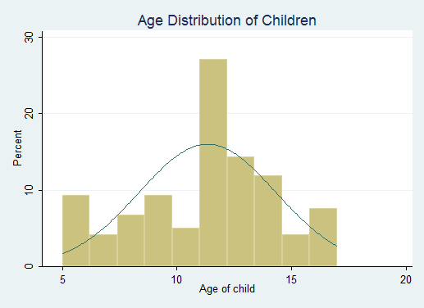

- 74% of children knew about deworming before Deworming Day, 15.1% found out on Deworming Day, 1.7% between Deworming day & Mop-Up Day, 1.7% on Mop-Up Day, whereas the rest did not respond.
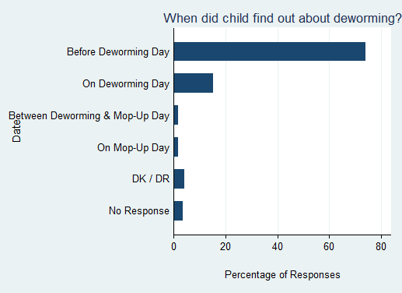

- Children learned about deworming from multiple sources – 99.1% at school, 13.5% through posters, 0.9% through friends/relatives, and 1.8% through the newspaper. 57.1% of children reported that their parents knew about deworming as well.

- 94.2% of children reported feeling fine when they came to school on Deworming Day, while 4.2% did not receive the tablet.

- 92.6% of interviewed children had a tick or double-tick in front of their name in the register.

- 91.7% of interviewed children were present on Deworming Day. 5% of interviewed children were present on Deworming Day but their name was not ticked in register. In half of such cases, the child actually did not receive the tablet due to deworming not happening in school, whereas for the rest, the child’s name was not ticked despite receiving a tablet on Deworming day.

- 80.2% of children reported receiving a tablet on Deworming Day, 14% on Mop-Up Day, 1.7% between the two dates, whereas 4.1% did not receive the tablet.
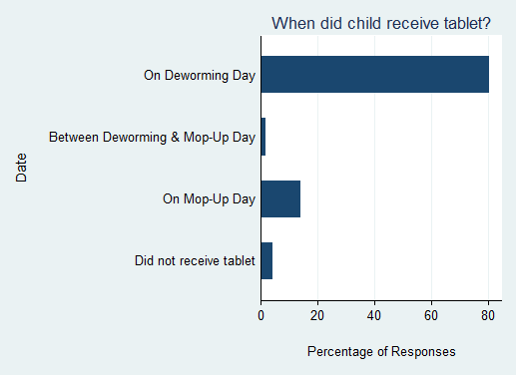

- 94.9% of children were aware that the tablet given to them was for deworming.

- 93.2% ate the tablet after chewing, whereas 5.1% ate the tablet without chewing it, and no children reported throwing it away.

MOP-UP DAY – ANGANWADIS

The monitoring analysis for Mop-Up Day is based on data received from 107 anganwadis.

ANGANWADI DETAILS:

- A functional toilet existed in 23.3% of anganwadis whereas there was no toilet facility in 62.1% of anganwadis.
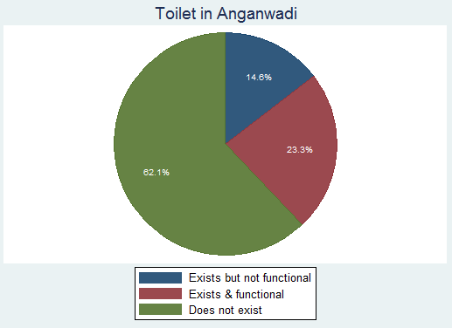
- Monitors checked if water and soap were available for washing hands in the anganwadi. Both were available in 59.2% of anganwadis.
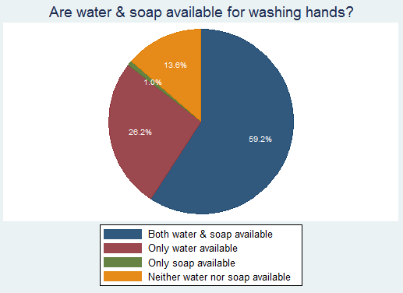

- The average enrollment in these anganwadis was 63 and the average attendance on Deworming Day was 23.
DEWORMING TRAINING AND GENERAL AWARENESS:

- 87.8% of AWWs were aware that the day of monitoring visit was Deworming Day.

- 87.3% of AWWs reported that they attended the official training for Deworming Day. 77.3% of these AWWs also trained other workers in their anganwadi.

- AWWs were asked a few questions about worms and deworming to test their knowledge and the effectiveness of training. 84.5% of AWWs were aware that worms are found in the intestine.

- AWWs were also asked about the sources of infection by worms – walking barefoot, eating contaminated food, contact with infected people, mosquito bites, and others (including lack of cleanliness, eating mud, etc).
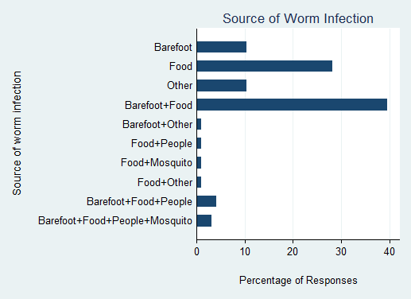

- AWWS were asked various reasons why worms were harmful. Among the responses stating the consequences of worm infection, 50.5% mentioned shortage of blood, 64.2% anaemia & malnourishment, 53.7% adverse impact on child’s growth, 23.2% adverse impact on child’s learning capabilities, and 22.1% stated that long-term infection could lead to more serious health problems later.

- On being asked about ways to prevent or cure worm infection, 27.5% of AWWs stated that awareness, good hygiene, as well as deworming medicine were important.
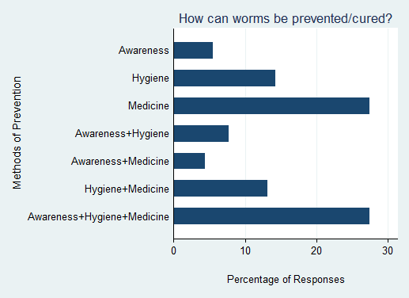

- AWWs were asked about their response in case of a child suffering from adverse effects after taking the deworming syrup.
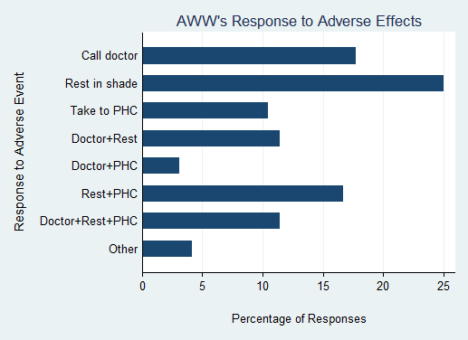
INFORMATIONAL MATERIAL & DEWORMING DRUGS:

- The Deworming/GHD poster was clearly visible in 26% of anganwadis, partly visible (torn, obscured by other posters, etc.) in 7.7% of anganwadis, and not visible in 66.3% of anganwadis.

- 96% of AWWs reported that they had received the deworming syrup bottles by Mop-Up Day.

- 93.7% of AWWs reported that they had received sufficient syrup bottles for all their enrolled children.

SUMMARY FORMS:

- 66% of AWWs claimed that they completely understood how to fill the Summary Form, 14% understood it partly, and 20% of AWWs stated that they did not understand the form.

- 48.5% of AWWs had filled the Summary Form. 47.5% had noted the number of syrup bottles received.

- 72.6% of AWWs were aware that the Summary Form was to be submitted at the next sector meeting between Oct 21-25, 2012.

- 42% of AWWs responded that they would submit the Summary Form to their CDPO while 23.5% would submit it to their Supervisor.

ADMINISTRATION OF DEWORMING TABLETS:

- Monitors could observe the deworming process in 57.3% of anganwadis. In 84.2% of such anganwadis where deworming was ongoing, monitors reported that deworming activity was proceeding in an orderly manner.

- In 79.8% of anganwadis, monitors observed the AWW providing health education to the children. In 90.9% of such anganwadis, the health education segment included instructions to not give deworming tablets to sick children.

- As the medicine is only to be taken after meals, children should have eaten their tiffin or mid-day meal. Monitors observed this to be the case in 95% of anganwadis. In a few cases, children reported that they had eaten at home before coming to the anganwadi centre.

- Before giving the deworming syrup, monitors observed that the AWW and children washed their hands with soap in 68.7% of anganwadis, washed with only water in 13.7%, and did not wash their hands at all in 17.9% of anganwadis.

- Adequate potable water was available for the children in 68.7% of anganwadis, water was not available in 7.5% of anganwadis, and potable water was available but not in adequate quantity in 23.7% of anganwadis.

- In 92.2% of anganwadis, the AWW was administering the syrup to each child. In a few rare cases, another adult was administering the syrup.

- In 33.3% of anganwadis, the monitor observed the AWW double-ticking each child’s name in the attendance register after giving him/her the deworming syrup. In 86.1% of anganwadis, the monitor reported that all dewormed children’s names had been ticked atleast once after the process was over.

- 95.8% of AWWs interviewed claimed that they did not give the syrup to any sick children. In 93.5% of anganwadis, the monitor did not observe any sick child taking the syrup. No adverse reactions to taking the syrup were reported in 96.1% of anganwadis.

- In 93.4% of anganwadis, the monitor did not observe any syrup bottles being spoilt during administration. In case there were any spoilt bottles, they were thrown away.

- 82.5% of AWWs stored the remaining syrup bottles in a secure location.

COVERAGE VALIDATION – SCHOOLS
The analysis is based on monitoring data received from about 241 schools over the two coverage validation days. The dates for coverage validation in the state of Rajasthan were not fixed. However monitors were asked to pick to two days during which they could visit schools after mop-up day.
SCHOOL DETAILS
- 37 % of the schools were reported to be Primary Schools (upto class 5), 22 % of the schools were Middle Schools, and 22 % were High schools. About 6 % of the schools were Secondary Schools. No data was available for 13 % of the schools. This disaggregation is shown in the figure below.

SUMMARY FORM & ATTENDANCE REGISTER
- The school summary form was available for the monitor to check in 213 (87 %) of the schools, also 213 (87% of all 246) schools had completed the summary form.

- The class attendance register was available to check by the monitors to check in almost all schools.
Monitors were expected to visit 3 classes (selected according to a random selection table) in each school. From each of these classes, monitors noted class size and number of children dewormed from the class attendance register as well as the school summary form. The median class size is 14 according to the attendance register and 16 according to the school summary form. The median number of children dewormed is 12 according to the attendance register and 14 according to the school summary form.

- Data from both the attendance register and the school summary form is available for 87% of classes. For classes visited on these days, the estimate for number of children dewormed does not tally. The aggregate number of children dewormed as reported in the summary forms is lower than the number according to the attendance registers.
CHILD INTERVIEWS
- 44 % of all the children interviewed were in primary classes, 39 % were in upper primary classes whereas 17 % were in secondary and high school classes. This indicates that monitoring process focused on interviewing mainly young children.

- 656 children were interviewed on coverage validation days. However not all children responded to each question in the survey.
- 94 % (615 out of 656) of all responding children said that they walked to school, while 3 (18 out of 656) % cycled.
- Most of the children claimed that they were given a tablet to eat in school in the past few days.
- 40 % of the responding children reported received the tablet on Deworming day, 99 % percent of the children received the tablet by Mop-up day. The details are shown in the figure below.

- Over 90 % of the children were aware that the tablet given to them was for deworming.
- 94 % of the children ate the tablet that was given to them. The small number of children who did not eat the tablet stated that they threw away the tablet as they did not want to eat.
- When asked about the color of the tablet they were given in school, only 94 % stated that it was white. The rest did not remember the color or respond to the question.
- 87 % of the children reported that the tablet tasted sweet, a strong indication that they were given the correct tablet.

- Who gave the child the tablet? As specified by the Deworming program, training, 98 % of the children received the tablet by the class teacher.

COVERAGE VALIDATION – ANGANWADIS

- In the state of Rajasthan in the year, 202 Anganwadis were visited by monitors over the course of two days. There were no fixed dates for carrying out this procedure but a window of one week was given to the monitors after the mop-up day. October 18, 2012.

SUMMARY FORMS & ATTENDANCE REGISTER
- In 34 % of the cases the Anganwadi worker had a copy of the summary form available, in case of attendance registers, the monitors found that in 84 % of the cases the attendance register was available.
- It was observed that in 64 % of the cases the summary form was filled and in rest of the cases it was partially filled, not filled or not received. It was found that in 51 % of the cases the summary form tallied with the number of ticks in the attendance register.

PARENT INTERVIEW
•In cases of 75 % of the parents interviewed mentioned that their children came to the Anganwadi every day.

- In 87 % of the cases, the children knew that the syrup was given to them for deworming and in rest of the cases; the children thought it was being given for other diseases or any other illness other than Deworming.

- As we can see from the figure above, in 97 % of the cases it was the AWC worker who gave the child the Deworming syrup. In the rest of the cases it was given by the Supervisor or ASHA or AWC worker.
- It was also found that in 73 % of the cases the child always ate the food that was provided to him at the Anganwadi.

What did the child do with the syrup given?

- It was found that in 95 % of the cases, the child drank the Deworming syrup that was given to him or her. In the other cases, it was found that the child vomited it, doesn’t remember if he or she was actually given the syrup or did nothing at all with the syrup administered.

KEY LEARNINGS

- Interviews with teachers & anganwadi workers indicate that they were aware of worm prevalence but could be better informed regarding the specific sources and impact of worm infection. As most reported attending training, the training sessions seem to be effective in increasing general awareness and stressing the importance of deworming treatments. An effort could be made to create greater understanding of the germ environment and poor hygienic conditions contributing to re-infection.

- Preparation monitoring is a useful tool to gauge readiness for the deworming process. Most schools and anganwadis were aware of the date of Deworming Day.

- While most schools had received drugs and IEC material by the date of preparation monitoring visits, many anganwadis had not. Most anganwadis received the drugs by Deworming Day but did not have the deworming/GHD poster displayed. Ensuring greater visibility of IEC material is vital for improving awareness of the deworming program among the targeted communities.

- Due process was followed during most deworming activities. Most teachers and AWWs followed training instructions regarding tablet administration and ensure that students eat beforehand, wash their hands, and chew before swallowing.

- The drugs (tablets and syrup bottles) should ideally be stored in a cool, dry, clean, and secure location to prevent spoilage. However, only 1 in 4 schools/anganwadis met all four attributes.

- According to the monitors’ interviews with school principals, most school principals and AWWs were aware of the last date for submitting the form. As delay in form submission by schools leads to a long time lag between completion of deworming program and estimation of coverage, it’s imperative to ensure that schools are aware of submission date.

- The protocol of ticking each dewormed child’s name in the attendance register once on Deworming Day and twice on Mop-Up Day is not followed by some teachers and AWWs. This makes it difficult to distinguish between children dewormed on Deworming Day and Mop-Up Day.

- .Deworming figures in the summary form should ideally be based on number of ticks in the class register, but some schools may be relying on rough estimates by class teachers.

- Coverage validation exercise is a good way to gauge the overall picture in terms of number of children dewormed both in schools and Anganwadis and consistency of data. In monitoring the focus has somehow been on children in younger classes and children, it could be made more effective by being more uniform in terms of classes of children included.

- A closer look at the monitoring data indicates that the monitors often do not fill the entire form due to various reasons which reduces the sample size. In the analysis in this report, non-response is not included while calculating percentages. Hence, the percentage figure for a particular question is not from the set of all monitored schools, but only the set of responses to that question. In future training session, it’s important to assert that the entire form must be filled by each monitor. Including detailed instructions, skip patterns, end signs, as well as simplifying the forms may help. The training provided to monitors can be improved by including a session on role-playing to allow monitors to anticipate and deal with different types of responses in the field.

