MONITORING DATA ANALYSIS

In order to evaluate the efficacy of the deworming protocol and process, independent monitors visited a randomly selected sample of schools over four days – Deworming Day, Mop-Up Day, and two days post-deworming allocated for coverage validation.

A multi-stage sampling strategy was used to select the 1216 schools (1.75% of 69,299 schools in Bihar) targeted for monitoring. From each of the 38 districts in Bihar, 2 blocks were selected by simple random sampling, for a total of 76 blocks. 2 clusters were randomly selected from each of the 76 blocks, excluding clusters with fewer than 8 schools. In each of these 152 clusters, 8 schools were randomly selected for a total of 1216 schools.

Each monitor was assigned a block comprising 16 schools to be monitored. From this list of 16 schools, the monitor could visit any 4 schools on Deworming Day, another 4 on Mop-Up Day, and 8 more schools over the two Coverage Validation days.

Out of the total sample of 1216 schools, monitors were able to survey 1196 schools comprising 302 schools on Deworming Day, 296 on Mop-Up Day, and 598 on Coverage Validation days.

DEWORMING DAY

Deworming Day in Bihar was held on 10th September 2012. As the majority of targeted children are dewormed on this day itself, monitoring the process on this day is vital. The monitoring analysis for Deworming Day is based on data received from 302 schools.

SCHOOL DETAILS:

- 58.9% of schools in the dataset are Primary Schools (up to Class 5), 35.4% Middle Schools/Upper Primary Schools (up to Class 8), 0.3% High Schools/Secondary Schools (up to class 10), and 0% Senior Secondary Schools (up to Class 12). For 5.3% of schools, data on school type is not available. This disaggregation is shown in Figure 1.

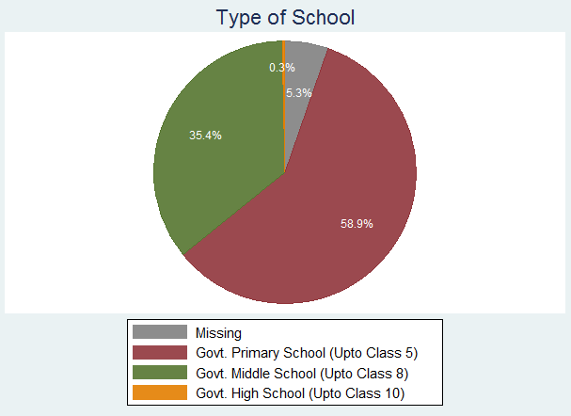
Figure 1: School Type Visited on Deworming Day

CLASS SELECTION:

- Each monitor selected 1 class to visit on Deworming Day according to a random selection table. Figure 2 shows the distribution of classes selected for monitoring. For a few schools, data on which class was monitored was not available; these are specified as “MISSING.” The distribution of classes selected is not uniform as monitors seem to have received a higher number of Primary Schools in their sample than Middle Schools or Secondary Schools.

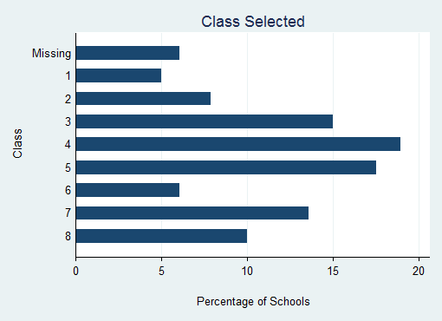
Figure 2: Distribution of Classes Selected for Observation

DEWORMING TRAINING AND GENERAL AWARENESS:
- 79.3% of school principals reported that they or another teacher from their school attended the official training for Deworming Day. 90.3% of these teachers also trained other teachers in their school.

- Class teachers were asked a few questions about worms and deworming to test their knowledge and the effectiveness of training. 88.2% of teachers were aware that worms are found in the intestine. Figures 3 and 4 show teachers’ responses to questions about worm transmission and how it can be prevented.

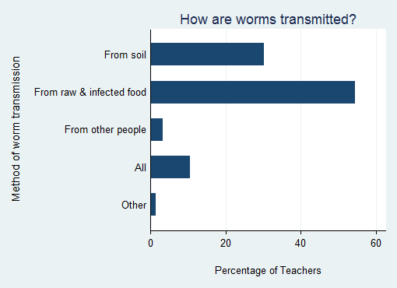
Figure 3: Sources of Worm Transmission – Teachers’ Responses
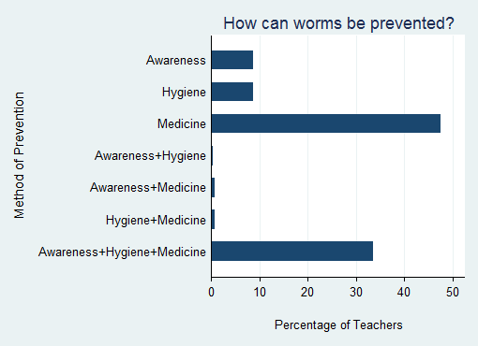
Figure 4: Methods of Worm Prevention – Teachers’ Responses

INFORMATIONAL MATERIAL & DEWORMING DRUGS:

- The Deworming Day poster was clearly visible in 68.9% of schools, partly visible (torn, obscured by other posters, etc.) in 27.8% of schools, and not visible in 3.3% of schools.

- 92.4% of school principals reported that they received information about delivery of drugs through their Cluster Resource Centre. Only 2.4% of schools claimed to have not received any information.

- 95.8% of school principals reported that they had received the deworming tablets by Deworming Day.

- 93.4% of schools reported that they received sufficient deworming tablets for all their registered students.

- Monitors checked the drug storage location and found that most schools had kept the medicine in a cool/dry place to avoid spoilage. The drug storage location was observed to be cool (not in direct sunlight) in 38.9% of schools, dry in 31.7% of schools, and secure in 14% of schools. All three attributes were found to be true in only 2.6% of schools, though this seems to be an artifact of selective reporting by monitors (only selecting single option instead of multiple). Figure 5 is based on monitors’ observations of the drug storage location.

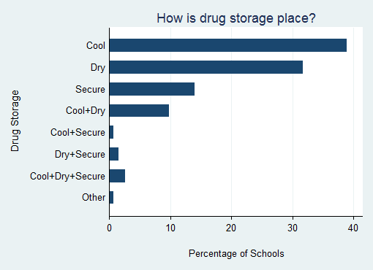
Figure 5: Attributes of Drug Storage Location

SUMMARY FORMS:

- 81% of principals claimed that they completely understood how to fill the School Summary Form and 1.8% understood it partly. The remaining 17.2% of the schools stated that they did not understand the form.

- Monitors observed that enrollment and attendance details in the School Summary Form had been filled by Deworming Day in 67.3 % of schools. In these schools, average enrollment was noted as 274 and average attendance on deworming day as 190.

- Only 62% of school principals were aware of the last date for submitting the School Summary Form.

ADMINISTRATION OF DEWORMING TABLETS:

- In 95.6% of schools, the principal claimed that deworming was taking place in their school on that day. Monitors could observe the deworming process in 90% of schools. In 97.8% of such schools where deworming was ongoing, monitors reported that deworming activity was proceeding in an orderly manner.

- Prior to administering the deworming medicine to children, teachers need to ensure that certain processes are followed. In 88.8% of schools, monitors observed the teacher providing health education to the children.

- As the medicine is only to be taken after meals, children should have eaten their tiffin or mid-day meal. Monitors observed this to be the case in 97.5% of schools. As unclean hands are a primary source of worm transmission, teachers and children need to wash their hands before taking the medicine. This was observed in 97.5% of schools.

- Monitors observed that children were chewing the tablet before swallowing in 96.3% of schools. Doing this mitigates the risk of choking or throwing up the tablet.

- In 97.8% of schools, teachers administered a tablet to each child. In a few rare cases, another adult or a student was administering the medicine.

- In 93.9% of classes visited, the monitor observed the teacher ticking each child’s name in the attendance register after giving him/her the deworming tablet.

- 95% of teachers claimed that they did not give the tablet to any sick children. In 89.1% of schools, the monitor did not observe any sick children taking the tablet. No adverse reactions to taking the tablet were reported in 98.2% of schools.

- In 97.8% of schools, monitors report that they did not observe any child taking more than one tablet.

CHILD INTERVIEWS:

- In the selected class, the monitor interviewed one child chosen by the random selection table. The monitors were able to interview 279 children in all. The age distribution of interviewed children is shown in Figure 6 below. 94.6% of the interviewed children reported that they walked to school, 4.7% cycled, and the rest took the bus or other modes of transport.

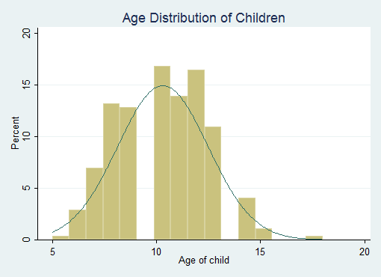
Figure 6: Age Distribution of Interviewed Children

- 42.2% of children knew about deworming before Deworming Day whereas 51.7% found out on that day. Most children (95.2%) learned about deworming at school, as opposed to other sources such as banners, the media and friends and relatives.

- 88.6% of children reported feeling fine when they came to school on Deworming Day.

- 99.3% of responding children reported receiving a tablet on Deworming Day. 97.4% ate the tablet, and very few children threw it away. 97.1% of children were aware that the tablet was for deworming.

MOP-UP DAY

Mop-Up Day in Bihar was held on 15th September 2012. Any children that could not be given medicine on Deworming Day (due to being sick or absent from school) could be dewormed on Mop-Up Day. Monitors were able to visit 296 schools on this day to observe the deworming process.

SCHOOL DETAILS:

- 53% of schools in the dataset are Primary Schools (up to Class 5), 35.1% Middle Schools/Upper Primary Schools (up to Class 8), 1.4% High Schools/Secondary Schools (up to class 10), and 0% Senior Secondary Schools (up to Class 12). For 10.5% of schools, data on school type is not available. This disaggregation is shown in Figure 7.

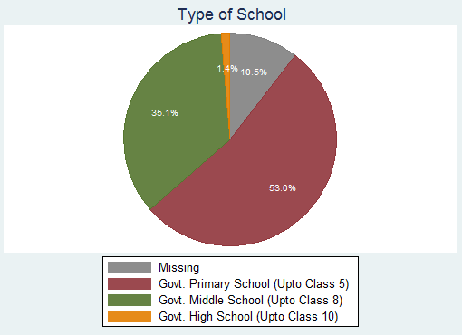
Figure 7: School Type Visited on Mop-Up Day

CLASS SELECTION:

- Each monitor selected one class to visit on Mop-Up Day according to a random selection table. Figure 8 shows the distribution of classes selected for monitoring. Schools for which no data is available on which class was monitored are specified as “MISSING”.

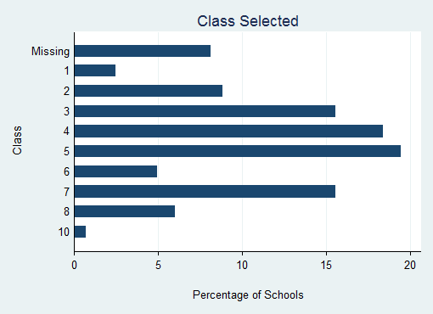
Figure 8: Distribution of Classes Selected for Observation

DEWORMING TRAINING AND GENERAL AWARENESS:

- 75.2% of school principals reported that they or another teacher from their school attended the official training for deworming day. 93.9% of these teachers also trained other teachers in their school.

- Class teachers were asked a few questions about worms and deworming to test their knowledge and the effectiveness of training. 85.3% of teachers were aware that worms are found in the intestine. Figures 9 and 10 show teachers’ responses to questions about worm transmission and how it can be prevented.

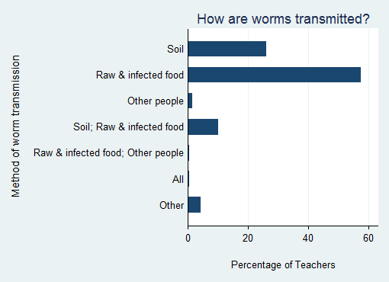
Figure 9: Sources of Worm Transmission – Teachers’ Responses
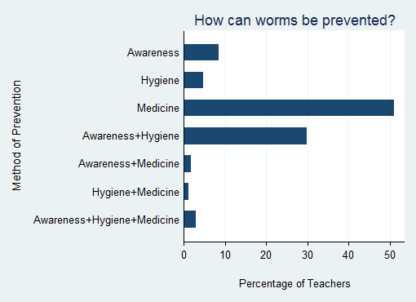
Figure 10: Methods of Worm Prevention – Teachers’ Responses

INFORMATIONAL MATERIAL & DEWORMING DRUGS:

- The Deworming poster was visible in 65.4% of schools. This indicates that schools attempt to raise awareness about the program primarily before Deworming Day. The continued visibility of posters is essential to inform children who may have missed Deworming Day that they can get the tablet on Mop-Up Day.

- 93.7% of school principals reported receiving information about delivery of drugs through the Cluster Resource Centre. Only 0.7% of schools claim to have received no information.

- 90% of schools reported that they received sufficient deworming tablets for all their registered students. 73.7% had noted the number of tablets received in the Summary Form.

SUMMARY FORMS:

- 77.6% of principals claimed that they completely understood how to fill the School Summary Form and 1.1% understood it partly.

- 70.9% of schools had completed the School Summary Form by Mop-Up Day. In schools where the Summary Form had been completed, average enrollment was noted as 260 and average attendance on deworming day as 186.

- Only 62.4% of school principals were aware of the last date for submitting the School Summary Form.

ADMINISTRATION OF DEWORMING TABLETS:

- 86.3% of school principals were aware that the day of monitoring visit, 15th September, was Bihar Mop-Up Day. Monitors observed deworming taking place in 81.8% of schools. Some schools covered all their students on Deworming Day or the few days between Deworming and Mop-Up Day. Hence, there was no deworming on the day of monitoring visit. The deworming process was reported to be orderly in almost all schools.

- Before the deworming tablet was administered, monitors observed the teacher providing health education to children in 84.3% of schools. Children had eaten their mid-day meal or tiffin in 95.6% of schools. Teachers and children washed their hands in 97% of schools.

- Monitors observed that children were chewing the tablet before swallowing in 95.5% of schools.

- In 96.6% of schools, the teacher was administering the tablet to each child. In a few rare cases, another adult or child was administering the medicine or the children took the medicine home.

- In 72.6% of classes visited, the monitor observed the teacher double-ticking each child’s name in the attendance register after giving him/her the deworming tablet. In other schools, the teacher was not ticking names or only single-ticking which would make it difficult to distinguish between children dewormed on Deworming Day and those dewormed later. Monitors reported that all dewormed children’s names were ticked at least once in 83.6% of schools.

- In 93.7% of schools, the monitor did not observe any sick children taking the tablet. No adverse reactions to taking the tablet were reported in 97.8% of schools.

- In 96% of schools, monitors report that they did not observe any child take more than one tablet.

CHILD INTERVIEWS:

- In the selected class, the monitor interviewed one child chosen by the random selection table. The monitors were able to interview 280 children in all. The age distribution of interviewed children is shown in Figure 11 below. Most of the interviewed children reported that they walked to school.

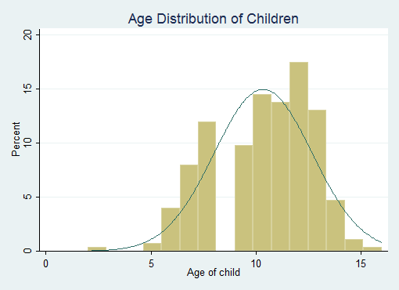
Figure 11: Age Distribution of Interviewed Children

- Nearly all responding children had been dewormed by Mop-Up Day. 57.4% of children reported receiving the tablet on Deworming Day, 26.4% on Mop-Up Day, and 14.3% between the two dates.

- Figure 12 shows when the child first came to know out about the deworming program. 97.4% children report learning about deworming at school.

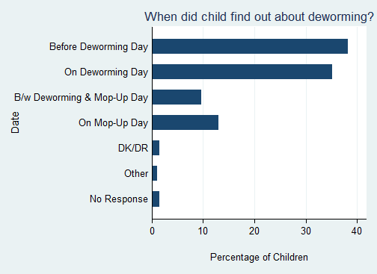
Figure 12: When did child find out about deworming?

- 67.3% of children claimed that at least one of their parents was aware of Deworming Day.

- 93% of children reported feeling fine on the day that they received the deworming medicine.

- 97.4% of children ate the tablet given to them while a few children threw it away. 95.3% stated that they were aware that the tablet was for deworming.

COVERAGE VALIDATION

The analysis is based on monitoring data received from 598 schools over two coverage validation days.

SCHOOL DETAILS:

- 57% of schools were reported to be Primary Schools (up to Class 5), 36% Middle Schools/Upper Primary Schools (up to Class 8), 0.5% High Schools/Secondary Schools (up to class 10), and 0% Senior Secondary Schools (up to Class 12). For 6.7% of schools, data on school type is not available. This disaggregation is shown in Figure 13.

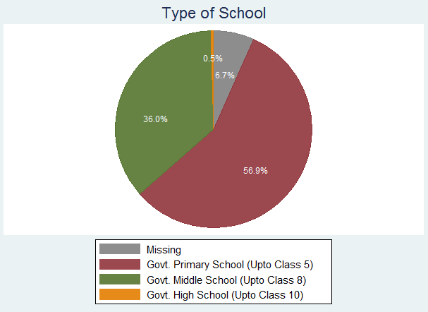
Figure 13: School Type Visited on Coverage Validation Days

SUMMARY FORM & ATTENDANCE REGISTER:

- The school summary form was available for the monitor to check in 412 (68.9%) schools. 387 schools (64.7% of all 598 schools) had completed the summary form.

- The class attendance register was available for the monitor to check in almost all schools.

- Monitors were expected to visit 3 classes (selected according to a random selection table) in each school. From each of these classes, monitors noted class size and number of children dewormed according to the class attendance register as well as the school summary form. The median class size is 41 according to the attendance register and 42 according to the school summary form. The median number of children dewormed is 35 according to the attendance register and 38 according to the school summary form.

- Data from both the attendance register and the school summary form is available for 64% of classes (1148 out of 1794). For 8.8% of classes (101 out of 1148) the estimate for number of children dewormed does not tally. The aggregate number of children dewormed as reported in the summary forms is higher than the number according to the attendance registers.

CHILD INTERVIEWS:

- 71.7% of school children interviewed were in primary classes, 28% in upper primary classes, and 0.2% in secondary classes. This indicates that the monitoring process is mainly focused on interviewing younger children. This is expected as there are few secondary and no senior secondary schools in the monitored sample. Figures 14 and 15 show the class-wise distribution of school children.

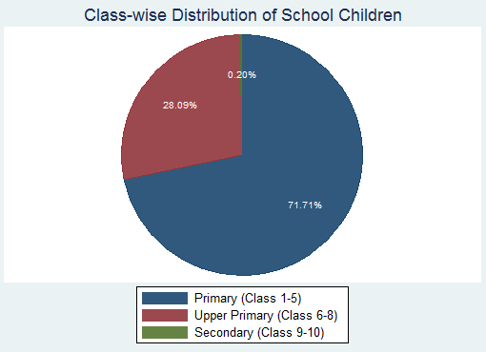
Figure 14: Type of Classes Selected for Observation
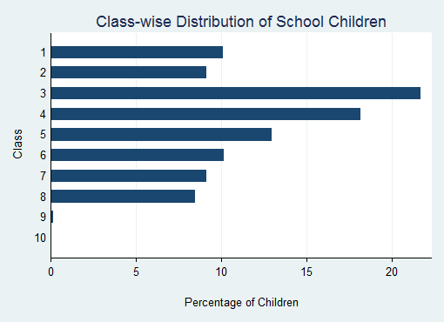
Figure 15: Distribution of Classes Selected for Observation

- 1442 children were interviewed during coverage validation days. However, not all children responded to each question in the survey.

- 93.9% (1341 out of 1428) of responding children stated that they walked to school while 5.9% (84) cycled.

- 97.9% (1408 out of 1438) children claimed that they were given a tablet to eat in school in the past few days.

- Over 52% of responding children reported receiving the tablet on Deworming Day (10th September). 93.3% of children had received the tablet by Mop-Up Day (15th September). The details are shown in Figure 16.

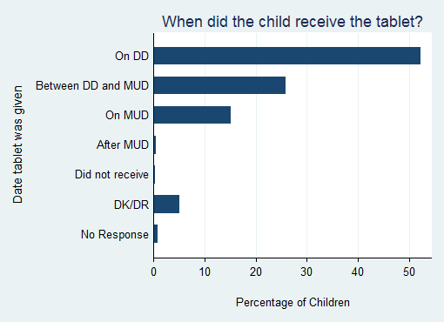
Figure 16: When did child receive deworming tablet?

- 95.5% of children were aware that the tablet was given for deworming.

- 97.5% of children reported that they ate the tablet given to them. The small number of children who did not consume the tablet stated that they threw away the tablet as they did not want to eat it.

- When asked about the colour of the tablet they were given in school, only 66.8% of children reported that it was white, whereas 25.3% reported another colour. The rest did not remember the colour or did not respond to the question.

- 86.8% reported that the tablet tasted sweet, a strong indication that they received the correct tablet, as shown in Figure 17.

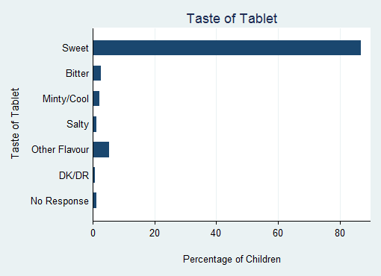
Figure 17: Taste of Tablet – Children’s Responses

- Over 80% of children reported that the tablet was given by their class teacher. As specified by the deworming program training, 97.3% received it either from the class teacher or principal/head teacher, as shown by Figure 18.

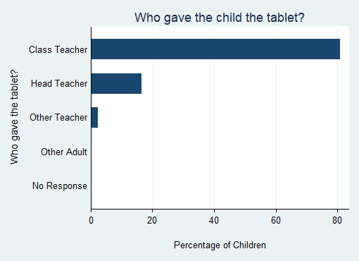
Figure 18: Who gave the child the tablet?

KEY LEARNINGS

- Teacher interviews indicate that training was effective in increasing awareness of risk factors for worm transmission to some extent and stressing the importance of deworming treatments. However, when asked about methods of worm prevention, less than 10% of teachers acknowledged hygiene as a factor. An effort could be made to create greater understanding of the germ environment and poor hygienic conditions contributing to re-infection.

- Due process was followed during most deworming activities. Most teachers follow instructions regarding tablet administration and ensure that students eat beforehand, wash their hands, and chew before swallowing.

- According to the monitors’ interviews with school principals, only 62% of school principals were aware of the last date for submitting the form. As delay in form submission by schools leads to a long time lag between completion of deworming program and estimation of coverage, it’s imperative to ensure that schools are aware of submission date.

- There is a mismatch for some schools between estimates of dewormed children from the summary form and the attendance register. If the monitoring data is accurate, this implies that coverage estimates according to the summary form are inflated or class teachers are not consistently following the instructions to tick each child’s name/roll number in the register. Deworming figures in the summary form should ideally be based on number of ticks in the class register, but some schools may be relying on rough estimates by class teachers.

- Additionally, the protocol of ticking each dewormed child’s name in the attendance register once on Deworming Day and twice on Mop-Up Day is not followed by some teachers. This makes it difficult to distinguish between children dewormed on Deworming Day and Mop-Up Day.

- The sampling strategy for schools to be monitored may be reviewed in future to ensure a more balanced dataset of schools stratified on geography as well as school type. The latter will allow more schools with senior classes to be included in the monitoring dataset.

- The monitoring process itself can be improved by simplifying the forms in future rounds. The forms should also include instructions to monitors regarding when not to prompt with options to a question in case it biases the response, as well as when to do physical checks of IEC material, drugs, forms, etc. The training provided to monitors can be improved by including a session on role-playing to allow monitors to anticipate and deal with different types of responses in the field.

As there are 598 schools in the monitored sample, data should be available for 1794 classes (i.e. 598 x 3). However, due to various constraints or misunderstanding of the 3-class selection process, data was received from a smaller subset of classes. Data from the attendance register on class strength and children dewormed could be obtained for 79.8% of classes (1432 out of 1794). The same data from the school summary form could only be obtained for 64.1% classes (1151 out of 1794). In most cases, the school summary form was not available even though schools are instructed to retain a filled copy. In some cases, the data appears to be clearly wrongly filled by the monitor and has been ignored for the purposes of this analysis.

