ORGANIZATIONAL BACKGROUND

- OICI Mission and Strategy

  - Mission

The mission of OICI is "to improve lives of disadvantaged people in developing countries through training and sustainable organizational development.”

OIC International (OICI) is a non-profit organization headquartered in the United States. Since 1970, OICI has been improving the quality of life of low-income, disadvantaged individuals through the provision of skills training, business development, health education and food security programs in the developing world.
OICI has a team of over 300 skilled management, technical and field staff with expertise in Agriculture, Food Security, Water and Sanitation, Vocational Training & Job Creation, Microenterprise Development, Microfinance, Health and Nutrition and HIV/AIDS.

The range of OICI program interventions covers:

- Skills Development :
OICI develops its skills training programs based on local needs as indicated by labor supply and demand in the host countries and communities.

- Conflict Management & Rehabilitation
OICI programs assist those individuals most affected by conflict and war to help them rebuild their lives and their communities.

- Food Security & Agriculture
OICI programs assist in increasing the productivity, income and quality of life for farmers and farming communities.

- Health, Nutrition & HIV/AIDS
OICI programs increase access to health infrastructure, improve nutrition and provide critical education in areas related to reproductive health, family planning and HIV/AIDS.

- Sustainable Livelihoods & Community Development
OICI programs assist individuals and their communities in developing financial assets and a broad array of other knowledge and skills for sustainable long-term improved well-being.

- Microenterprise Development
OICI programs provide training and guidance to assist the unemployed, small entrepreneurs and women-led businesses in starting or expanding their businesses for greater productivity and increased profits.

- Microfinance Initiatives
Depending on local needs OICI programs may include microfinance activities to provide small and micro-business men and women the credit facilities that they are unable to obtain elsewhere. Oftentimes their disqualification elsewhere was due to the lack of collateral.

- Local Capacity Building
Overall, OIC programs engage in a variety of venues – as described above – to assist in the development of local leadership, management and technical skills that will enable the poor to achieve sustainable long-term improved well-being.

- International Development Career Training
Newly included among its services since 2004 has been OICI’s Building Global Bridges program that provides college youth with the training and hands-on experience needed to prepare them for career opportunities in International Development. This is a pilot program funded by the U.S. Department of Labor. OICI collaborates with several local universities in the Philadelphia area to recruit interested students and college graduates for this ten (10)-week intensive training during the Fall and Spring terms.

- Strategy for Accomplishing Mission

OICI's strategy for achieving its long-term sustainability objective is to provide a comprehensive package of multi-dimensional assistance to its affiliates. It aims at ensuring that OIC affiliates are equipped with the necessary tools for effective program leadership, management and operations. It also reviews these tools on an on-going basis for better adaptation to changing needs. As a result, OICI has consistently demonstrated its ability to transform itself and reorient its programs and services in response to new constraints and opportunities. Its performance history reflects both the courage and the capacity to rethink and reorganize itself.

Complementing its strategy has been OICI’s specific and effective service delivery procedures that were well tested and documented. These procedures have been validated for their effectiveness in supporting learning and adaptation, and have established an excellent reputation among peers and development institutions. They account for OICI’s track record in developing the viable economic, business and livelihood skills of the disadvantaged including vocational technical students seeking jobs, unemployed workers, micro-enterprise founders or managers, farmers and others.

Key Elements of OICI Methodology

Basic Philosophy. OICI believes in:

- Self-help: We believe in empowering individuals, institutions and communities through the transfer of knowledge and skills.
- Capacity building: OICI's programs equip their beneficiaries with the life, job and business skills that enable them to become productive members of their communities.
- Social enterprise: All of OICI's programs are designed with the goal of sustainability and are market driven to ensure that they both meet community needs and are based on fiscal responsibility.
- Partnership: OICI believes that development is a communal effort and that only through effective cooperation will the needs of the developing world be met. In this spirit, OICI has a proud history of welcoming international and national partners in all its work.

Long-term Sustainability. The development process of each OIC program focuses on achieving its status as an independent, self-reliant and capable local skills training institution. This objective requires a multi-year process of institutional development to assist each of the OIC in establishing its long-term managerial, operational and financial viability. The end-of-project evaluation of an OICI-USAID Matching Grant in the past stated:
“During the five-year grant period, OICI did through the provision of training and technical assistance assist in bringing the Tanzania and Ghana programs from limited service delivery capacity and virtual one grant dependency, to the point where both programs developed and implemented sustainability plans”.

Empowering Affiliate OICs. OICI's program development and support services aim at developing the institutional strength of the affiliates. These services focus on developing a capable local OIC Board and staff, the implementation of effective program management and control systems, the adoption of appropriate training curricula and techniques, and the strengthening of local resource development capacity. The same end-of-project Matching Grant evaluation also indicated:
“The main success achieved in strengthening organizational sustainability of NGO partners lie in OICI’s having built capacity at field program level…to add or expand business support services responsive to market needs and to deliver them to a variety of clients or institutions”.

In line with its empowerment objective, OICI introduced to its affiliates the Social Enterprise methodology for achieving organizational mission and financial sustainability. This method aims at creating a mission-led and market-driven organization that is effective in its service delivery while sustaining its financial viability through sound business practice.

In summary, OICI’s key strength as a U.S. PVO is the establishment of effective and sustainable indigenous non-formal skills training and human service institutions. Its assistance enables each affiliate OIC to manage, operate and finance program activities through the local Board and staff and appropriate partnerships with local communities, governments, donors and other PVOs and NGOs. In some situations and on contractual terms with donors - OICI would provide at first the core leadership and management while pursuing the same objective of assisting in the creation of long-term local capacity.

Global Network of OIC Affiliates

Affiliates of OICI were established and are operating in the following countries in FY 2005. OICI assigned its representatives one each to six (6) of the countries marked with asterisks. Affiliates in these countries received grants in FY 2005 from one or more donor sources through OICI that also had the accountability for ensuring proper program management, technical support and program results.

    - Cameroon
    - Chad
    - Côte d'Ivoire*
    - Ethiopia*
    - Ghana*
    - The Gambia
    - Guinea*
    - Lesotho
    - Liberia
    - Mali*
    - Niger
    - Nigeria*
    - Philippines
    - Poland
    - Sierra Leone
    - Tanzania
    - Togo*
    - Zimbabwe

Contributions of Local and Other Sources

OICI and affiliate programs obtain support from local communities, host governments, multilateral and bilateral donors, and a wide range of foundations and non-governmental institutions (NGOs). In several program countries, host governments have consistently been a major contributor to the local OIC institutions. Their contributions range from in-kind donations such as land, buildings, training facilities and seconded personnel, to budget subventions and concessions such as duty-free privilege and tax-exempt status to the OIC programs.

The FY 2006 independent audit report series provides detailed information on the financial status and operations of OICI and the reported affiliates for the year under review. ■

KEY FUNDED PROGRAMS
FY 2006

October 1, 2005 – September 30, 2006

ENHANCEMENT OF HOUSEHOLD AGRICULTURE, NUTRITION, RISK REDUCTION AND COMMUNITY EMPOWERMENT PROGRAM (ENHANCE)

GHANA, FY 2006

A. Program Overview

The enhancement of household agriculture, nutrition, risk reduction and community empowerment program (ENHANCE) - June 2004 to September 2008 – completed its second year of implementation as of September 30, 2006. It serves nine (9) selected vulnerable districts in the Northern Region of Ghana and provides care, support and economic opportunities to PLWHAs and OVCs in four (4) selected districts in the Southern Region.

The goal of ENHANCE is to reduce food and livelihood insecurity in the targeted vulnerable districts in Ghana by the end of program funding for 130,000 direct and indirect beneficiaries in 250 communities. Its objectives are:
- To enhance livelihood capacity and community resiliency of households in nine vulnerable districts in the Northern Region; and
- To enhance human capabilities through improved health and nutrition in all the districts identified above in both the Northern and Southern Regions of Ghana. The Southern Regions are served by the HOPE program that is an integral part of ENHANCE.

The services of ENHANCE focus on achieving:
  - Improved sustainable food production among 3,250 farm households.
  - Reduction of post-harvest handling and storage losses for the same 3,250 households.
  - Strengthening income generating capacities of 3,500 women.
  - Improved care and support for 8,965 PLWHA and 7,385 OVCs members.

B. Program Results

The following sections present the progress to date and program results obtained by the end of FY 2006 in both the Northern and the Southern Region of Ghana. In the north the program aims at the enhancement of household agriculture, nutrition, risk reduction and community empowerment. In the south it provides care, support and economic opportunities development to HIV/AIDS orphans and vulnerable children and people living with HIV/AIDS. During FY 2006, most planned targets had been realized, as reflected by the statistics and indicators of achievements.

1. Agriculture
- Training in sustainable crop production systems including facilitation to procure agricultural inputs

Training
The 750 farm households targeted for FY06 were all mobilized for training in sustainable crop production systems that consisted of 7 training modules, as well as for access to agricultural inputs. This objective was achieved as all 750 farm households were trained in the 7 specified modules in topics ranging from Land Preparation through Participatory Farm Budgeting and Resource Allocation. Additionally, the farm households received training in record keeping as well as how to improve techniques in production for better yields.

The LOA target for this activity is 3,250 farm households. By the end of FY06, the 750 target farm households trained in FY 2005 and the 750 mobilized in FY06 had completed all the assigned agriculture training modules. The cumulative number of farmers trained now stands at 1,572 representing 48.4% of the LOA target of 3,250 farm households.

In addition to the farm households that were mobilized and provided with training, about 72 other farmers (non OICI group members) took part regularly in agriculture training sessions organized for farmers at the community level.

Field days
Farmers’ field days are essential activities of the agricultural component of ENHANCE to enable ‘peer learning’ and ‘hands-on’ training experiences. During the period under review, three field days were organized for a cross section of 239 farmers. They were given practical training in the correct use of approved chemical fertilizer (NPK and Sulphate of ammonia) for increased yields.

Access to Inputs
All 750 farmers mobilized in FY06 and those farmers of the FY05 group that repaid 100% of their input credit were targeted for input support from ENHANCE for maize and soybean production in FY06. Following some additional and thorough assessment of eligibility, the farmers finally selected for actual support included 522 new farm households (mobilized in FY06) and 497 old one (mobilized in FY05), bringing the total of such beneficiaries in FY06 to 1,019. This cumulative total represents about 67% of combined FY05 and FY06 targets, and 54.5% of the life-of-activities (LOA) target of 3,250 farm households.

Fig. 1

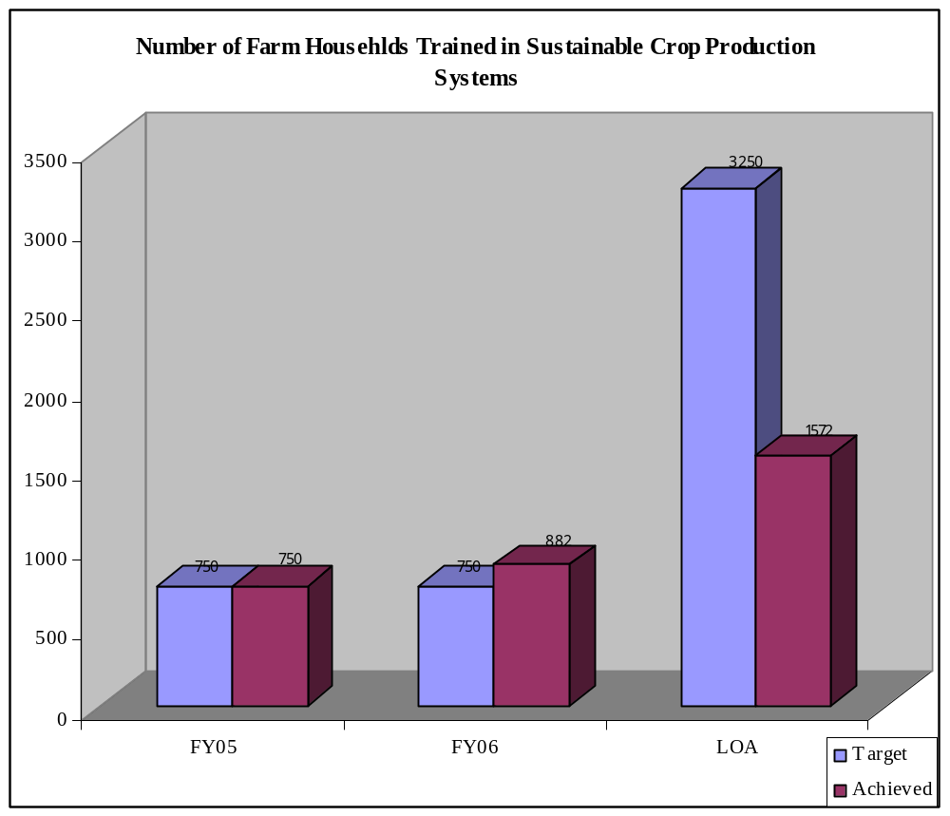

Yield Assessments
Yield assessments from farmers’ fields are made at the beginning of each fiscal year to cover the preceding year. Thus, at the beginning of FY06, yield assessments were conducted on fields of farmers who received inputs during the preceding year (FY05). An average of about 10 sacks of maize (1 MT) per acre was recorded. Beyond the average, sixteen (16) sacks of maize (1.6 MT) were recorded from one acre of the field of one farmer at Gbintiri, in the East Mamprusi district. The results of the assessment showed an increase in yields (from baseline figure of 0.89MT) following the distribution of improved inputs to farmers. Currently yield studies are being conducted on farms that benefited from the FY06 package of input credit.

Micro-irrigation
OICI is implementing this component with Enterprise Works (EW) that is providing the irrigation hardware and training associated with its installation and utilization. It
adopted the EW “Soka” treadle pump technology for use by small-scale farmers to pump and distribute water to their fields. OICI and EW organized a “training of trainers” on pump installation, use, maintenance and repairs of the “Soka” pump during the period under review. Fourteen (14) participants from among OICI Community Development Officers (CDOs), Ministry of Food and Agriculture (MOFA) staff and local farmers took part in the training. A practical session was held at one of the demonstration sites (Manguli dam site in the Tamale Rural district) at which 36 other farm households were taken through the “Soka” pump installation, use, maintenance and repairs.

Three hundred (300) farm households were the target for training in micro-irrigation technology for FY06 with the LOA target being 900 farm households. Owing to land tenure issues as well as late start up of field activities (delay in the conduct of the baseline study and hence missing out on the first dry season opportunity) the plan to train the first 300 households in FY05 was deferred to FY06.

An attempt was made to train 600 households (i.e. 300 of FY05 and 300 of FY06) in FY06. However, by the end of FY 2006, only 410 farm households were actually recruited and provided with training in micro-irrigation technology. The actual achievement, therefore, stands at 68% of the FY06 target (of 300) though in cumulative terms (FY05 and FY06); it reflects a cumulative shortfall for catching up in FY07. Current achievement stands at 45.5% of the LOA target of 900.

Establishment of Micro-irrigation Demonstration plots
OICI is adopting the experiential, “doing by learning”, method to teach farmers micro-irrigation technologies. The rationale behind the establishment of the demonstration plots is to engender hands-on training. Twelve (12) micro-irrigation demonstration plots are to be established by the end of the third year of program implementation. Each plot comprises ½ to 1 acre plot provided by the farmers, duly fenced and all participating farmers take care of it. Equipment supplied by OICI for training includes a treadle pump (Soka) and its accessories. The proceeds from the sale of produce from the plots are shared equally by all the participating farmers.

The target for FY06 was four (4) demonstration plots. During the period under review, 6 demonstration plots were actually set up in 6 communities in the Savelugu/Nanton and Tamale Rural districts. The number of micro-irrigation demonstration plots established exceeds, therefore, the target for FY06 and is 50% of the LOA target of 12 demonstration plots. Plans are far advanced to establish the remaining 6 demo plots in FY07. This will enable the program to achieve its LOA target of 12 demo plot on time.

Animal Traction
To boost production and yields of farmers, 10 pairs of bulls were trained under the bullock traction activity. This involved OICI client farmers from Tolon/Kunbungu District who own the animals and came forward willingly for the training.

- Training of farmers in improved livestock management

Training
The LOA target is 840 clients. The targets for FY05 and FY06 were 264 respectively for each year, bringing the two-year cumulative number to 528 clients.

To date, all the original 1,572 farmers mobilized for agriculture production training have all completed basic training in livestock housing, livestock health and livestock production. Current training, however, is being focused on the 528 target farmers mentioned above. These 528 currently undergo the complete set of livestock management training modules (details of animal health, housing, feeding, reproduction and care) and will all receive live animal loans as part of the animal placement /passing on gift package of the OICI/Heifer Animal Project.

Twenty four (24) Community Livestock Workers (CLWs) were targeted for training in FY05 and the same number (24) for FY06. However, due to late program start up, the program missed its FY05 target. Recruitment accelerated in FY06 during which 44 CLWs had been selected and trained, achieving 91.7% of the initial combined target of 48 for FY05 and FY06, and 36.6% of the LOA target of 120 CLWs. The CLWs received training in animal production, animal health, and the management and care of animals. In so doing they are expected to promote the Heifer “Passing on the Gift” principles, serve as animal first aid specialists at the community level, and look after the basic animal health care needs in their communities. At graduation, the CLWs received livestock health kits including first aid boxes for basic animal health treatments.

Direct distribution of livestock to households
Heifer Project International-Ghana (HPI) is currently supporting OICI in implementing the livestock promotion intervention. Under this intervention, HPI uses the ‘passing-on’ the gift methodology that entails the procurement, conditioning in quarantine and distribution of appropriate improved livestock to trained farmers. The passing-on chain will run through the LOA.

The target number of animals for distribution in FY06 is 300 sheep, 300 goats and 1,980 poultry. The same numbers were also scheduled for distribution in FY05. However, construction of the livestock-holding pen and animal housing at community level delayed prevented distribution activities in FY05. In total the animals for distribution in FY05 and FY 06 are 600 sheep, 600 goats and 3,960 poultry or a total of 4,160.

Actual distribution of animals began in March 2006 and, to date, 1,816 animals (810 sheep, 410 goats and 596 poultry) have been distributed to farmers. The number of animals passed on to farmers represents 94% of FY06 target of 1,920 animals and 31.5% of the LOA target of 5,760. Each farmer got one male and four females of either sheep or goats depending on their choice. Those who chose poultry received ten hens and one cock each.

- Training in Post-Harvest Loss Reduction

Training

OICI trains farm households in the harvesting and post-harvest handling of grains and legumes in selected communities in the Northern region. The training in post-harvest loss reduction is saving farm households between 20 to 25% of their harvested and stored grains and legumes that would otherwise have been lost to pests and diseases. This intervention has also increased the number of months of availability of stored grains and legumes at the household level.

For FY06, the program targeted 750 farmers/households for training in post-harvest loss reduction. One thousand five hundred and seventy two (1,572) farm households had initially been mobilized in FY05 to meet the goal in FY05 and FY06. None of these were trained at that time due to the late start-up of fieldwork that was also the result of delay in the conduct of the baseline survey.

Actual training in post-harvest handling, loss reduction and safe storage technologies for grains, tubers and vegetables commenced in October 2006 for both the targeted groups of FY05 and FY06, or a total of 1,500 farm households. To date 1,572 farm households are being trained using four standard modules in post harvest handling and loss reduction, including:

Introduction to the Post Harvest System;

Causes of seed/grain spoilage;

Grain Treatment with Actellic 25 EC; and
- Post harvest system for perishables such as onion, tomato and yams

Crop Loss Assessment
To ensure effective program impacts on the beneficiaries, OICI conducts annual assessment of post-harvest loss of grains in the mud silos to determine the “Percentage of crop loss during storage” by beneficiaries. This assessment enables OICI to ascertain to what extent post-harvest loss techniques are being adopted by farm households and their level of losses during storage, especially for those using OICI promoted technologies.

CDOs from OICI collected data between January 2006 and June 2006, the major storage period. Preliminary analysis of the data indicated a reduction in grain loss from the baseline figure of about 20% to an average of less than 5% within the first year of post-harvest loss reduction training and improved storage strategy. The results of this assessment are very significant and can contribute to a prolonged number of months of food availability for farm households in the target area.

Construction of Household and Community Storage Facilities
The household storage facility promoted by OICI is the Ministry of Food and Agriculture (MoFA) recommended mud silo OICI which improves the storage of grains and legumes With a lifespan of about 10-15 years, these mud silos are capable of storing and maintaining the quality of grain over longer periods than the indigenous storage structures normally employed by most farm households in the region.

The target number of mud silos to be constructed by OICI for FY06 was 500. The number for the preceding year was also 500. After constructing 243 mud silos in FY05, the activity was halted owing to shortage of water in target areas. A deficit of 257 silos was carried forward into FY06 target giving 757 outstanding mud silos at the start of FY 2006.

At the close of FY06, a total of 775 mud silos had been constructed. In addition to the 243 of FY05, the number of mud silos built since FY05 is 1,018 or 40.72% of the LOA target of 2,500, an indication that the program is on target with this activity.

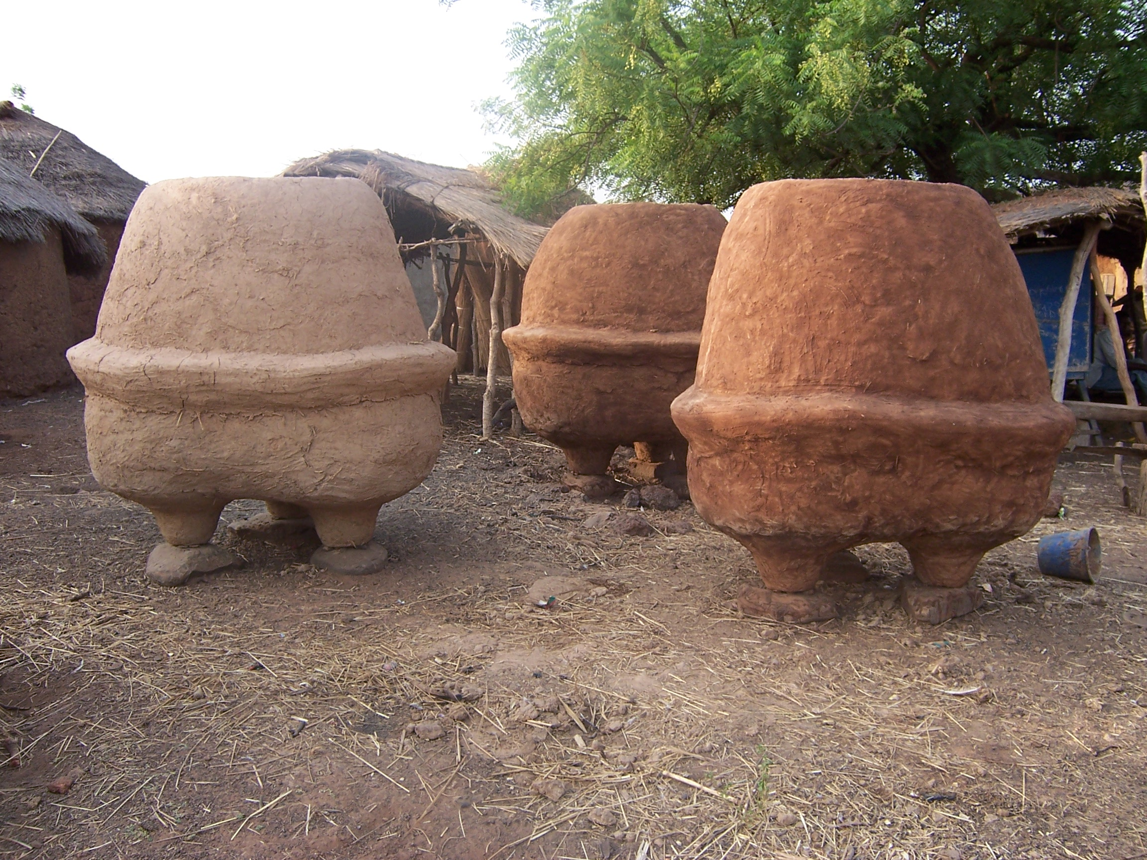

Newly built mud silos at Kpasablo in the Karaga District

Community Storage facility
Two (2) community storage structures were constructed at Galwei (Gusheigu district) and Kpataribogu (Karaga district) in FY06. This is 100% achievement of FY 2006 target of constructing 2 community storage structures.

Training of Farmer-Volunteers in (Mud Silo) Storage Structure Construction Techniques
As part of an exit strategy and a mechanism to institutionalize the continuous construction and repair of mud silos in OICI-assisted and other farming communities, OICI instituted a system of selecting and attaching volunteer-trainees to the hired master-builders in all communities where mud silos are being constructed.

OICI has trained a total of eighty-one (81) farmer-volunteers on how to build and maintain grain and legume storage structures. This represents 81% of the FY06 target of 100 volunteers to be trained in household grain storage structure construction. In FY05, 16% of the annual target of 100 volunteer trainees was achieved. The shortfall was due to the fact that only few communities were covered in FY05 as a result of the water shortage in many of the target communities. Cumulatively 97 volunteer trainees have been trained in the silo construction (24.3% of the combined target of 200 for FY05 and FY06). The shortfall will be consciously taken care of in FY 2007.

Farm Marketing and Business Management
OICI has been promoting the concept of “farming as a business” to its target clients in the Northern region. Training conducted is intended to help the farmers to plan and allocate available resources judiciously among the various enterprises they are engaged in and to help them determine appropriate time for selling their harvested crops for higher returns. To date, all the recruited 1,572 farm households had received training in farm marketing and business management as against the target of 750 for each year since FY05. This represents 104.8% achievement relative to the combined target of 1,500 for FY05 and FY06, and 48.4% of the LOA target of 3,250.

Inventory Credit (ICP) and Inventory Storage Service (ISSP) Programs
OICI established the Inventory Credit mechanism to provide bridge funding for farmers who, strapped for cash at harvest time, are forced sell their grain and legumes at low prices. The Inventory Storage Service program on the other hand, provides safe storage facilities for farmers who simply need a safe place to store their produce (at a fee) until they are ready to sell.

Several target households participated in the OICI grain Inventory Credit Program and Inventory Storage Service Programs. The total number of beneficiary farmers who participated in the ICP/ISSP was 424, (169.9% of FY06 target). During the FY 06 storage period, the total quantity of grains stored was 185 metric tons. This figure was 148% of the FY06 target of 125 metric tons. The over-achievement of the annual target made up for a shortfall in the quantity of grain stored during the FY05 storage period. The shortfall was due to late commencement of the ICP/ISSP and poor grain harvest during the FY05 harvesting period.

Cumulatively, 539 farm households (115 for FY05 and 424 for FY06) have participated in the ICP/ISS under the ENHANCE program, representing 43.1% of the LOA target of 1,250.

Vulnerability Surveillance and Response System (VSRS)
The VSRS is an innovative intervention in the ENHANCE program to ensure food security and improved health and nutrition for the selected communities. It is a community-based early warning system that ensures that basic but vital indicators are tracked periodically for planning and prompt corrective response. For the VSRS to be effective and accurate and to provide information that will satisfy the needs of the major stakeholders (GHS and MOFA) and other development workers and donors, Geographic Information System technology was adopted. The Management Information System (MIS) and Geographic Information System (GIS) have two integral modules that were created using the parameters specified in the questionnaire design as a baseline. The GIS part of the module was created using ArcView 3.2 software and Microsoft Access software for the MIS

The DAP targeted VSRS for 12 communities for each fiscal year totaling 60 for the LOA. This target was exceeded by over two hundred percent since it is established in four districts representing 138 communities which will be tracked throughout the LOA of the program. The final system and some thematic maps and reports generated were presented to OICI senior management and Patrick Fosu-Siaw, Alfred Osei and Regina Dennis of USAID Ghana Mission. It is anticipated that the data will be updated quarterly and a quarterly report presented to GHS, MOFA and stakeholders with subsequent distribution to the communities served.

2. Micro-Enterprise Development and Business Management Training

- Training
The OICI women’s Micro-Enterprise Development (MED) program seeks to promote skills that will enable women to diversify their livelihood and increase their income and access to and control of food and other resources. Women-clients assisted by OICI continue to report success stories of having more money now and higher purchasing power than before (to purchase soup ingredients for their households, and to pay for their children’s school fees and uniforms).

The LOA target for MED business management skills and marketing is 3,500 women. At the beginning of FY06, 1,463 women who had been mobilized in FYO5 to be trained in FY05 and FY06 continued to receive training. The number mobilized and trained is 100.9% of FY05 and FY06 cumulative target of 1,450 and 41.8% of the LOA target. At the end of FY06, all these women had received training in ten (10) training modules including but not limited to group formation and dynamics, marketing, costing, packaging, sourcing credit, credit management.

Having given technical skills training in FY05 to 975 women out of the 1,463 women mobilized for MED, in rice processing, cassava processing, and beekeeping, in FY06, 248 women benefited from technical skills training in groundnut oil processing. Training in soybean processing was not carried out as the most appropriate technology for rural communities had not yet been identified. With the identification of an appropriate technology, technical skills training in soybean processing for FY06 beneficiaries would be done in the first quarter of FY07. The number trained in technical skills in FY06 represents 35.4% of FY06 target of 700. Cumulatively, 1,222 women clients have been given technical skills training representing 84.3% of the FY05 and FY06 target of 1,450 and 40% of the LOA target of 3,500.

- Provision of Equipment
Following the provision of technical training, appropriate equipment is provided for use by the women. Four cassava graters and accessories have been procured and distributed to four cassava processing groups in the West Gonja district. Two rice-processing groups also received two rice processing machines and accessories. All 6 groups were made to construct their own working sheds as part of the groups’ contribution towards the set up of the processing facility. This is to ensure ownership and sustainability of the program.

One hundred (100) beehives, 40 bee suites, 40 Wellington boots, 40 hats (bee veils) and 40 hand gloves were distributed to five beekeeping groups in five communities. The equipment would enable the women put into practice the training they received in beekeeping and also to increase their incomes from the sale of the bee products.

3. Maternal Child Health and Nutrition (MCH/Nutrition)
OICI has implemented the MCH/N program in collaboration with Counterpart International (CPI) in four districts in Northern Region (NR) classified by the World Food Program as the most vulnerable to food insecurity. These are Savelugu/Nanton, Tolon-Kumbungu West and Central Gonja districts. Owing to lack of access to health and sanitation facilities, poor nutrition, sanitation and hygiene practices, and lack of nutrition and health counseling for caretakers food utilization is inhibited in most of these areas. OICI activities in maternal and child health and nutrition serve to improve food utilization through advancing nutrition, health, and sanitation behaviors and treating parasitic infections and micronutrient deficiencies. The four districts were selected because of the level of high chronic and underweight malnutrition in the districts as documented in recent UNICEF and UNDP Vulnerability Analysis Mapping (VAM) Reports.

- Behavior Change Communication (BCC) for women
The targeted number of men, women, adolescent girls and boys to participate in health and nutrition educational BCC sessions is 1,000 for FY06. By the end of the year, BCC campaigns were carried out for all 1,000 BCC participants (100% of FY06 target). In addition to the target participants attending the BCC session about 506 other non-program community members have participated in at least one BCC session. In FY05, 763 participated in the BCC key messages training. Cumulatively, 1,763 BCC training participants (excluding non-targeted clients) have participated in BCC sessions since FY05. The number represents 100.7% of FY05 and FY06 target of 1,750 and 37.1% of the LOA target of 4,750.

- Incentive Take-Home Ration
To encourage participation in the program and promote adoption of improved practices, an incentive take-home ration is distributed to all households represented at the BCC sessions. The ration basket consists of soy-fortified bulgur wheat (SFBW) and vegetable oil. The other essential reason why the food ration is given is to mitigate the acute food shortage in the communities and decrease its effect on children (stunting and underweight), pregnant women (low birth weight babies and anaemia) and lactating mothers (anaemia).

Mothers with children less than 3 years (0 to 36 months) and pregnant women were targets of the BCC sessions monthly and were given a take home ration each month. During the period, 613.14 MT of food were distributed (95.8% of FY06 target of 640 MT) comprising 574.25 MT of SFBW and 38.89 MT of vegetable oil. In all 1,000 lactating mothers and pregnant women received at least one food ration from the program.

- Growth Monitoring and Promotion (GMP)
A critical component of the MCH/nutrition component is the Growth Monitoring and Promotion (GMP), used as a tool to prevent malnutrition. Children under age 3 (0 to 36 months) are weighed monthly and their weight tracked on a growth chart, which is kept by the child’s caretaker. During FY06, about 1,003 children, 0 to 36 months, benefited from GMP exercise on monthly basis. Apart from counseling mothers and caretakers during GMP sessions, OICI PCNs and PHFs also collected anthropometric data (weights and heights/lengths) of all children 0 to 36 months enrolled into the MCH/Nutrition component.

- Height-for-age index (% Children 0 to 36 months Stunted)
The height-for-age index is an indicator of linear growth retardation (stunting). At the commencement of the ENHANCE Program, the target area (Savelugu/Nanton, Tolon/Kumbungu, Central Gonja and West Gonja districts) had stunting levels of 40% for children under 5 years. Results of analysis of child anthropometrical data for the period April to June 2006 (diagram below) show a steady decrease from the high stunting level of 40% to 21.5% in June 2006. The stunting level as of June 2006 has been found to be below OICI’s LOA target of 25%. This is an indication that the ENHANCE program is on course with the implementation of strategies to reduce chronic malnutrition in the target area.

- Weight-for-age index (% Children 0 to 36 months Underweight)
The weight-for-age index (underweight) is a composite index for height-for-age (stunting) and weight-for-height (wasting). It takes into account both acute and chronic malnutrition. Children whose weight for age is below -2SD from the median of the reference population are classified as underweight. Results from the analysis show that 32.5% of the children were underweight in April. This decreased to 30.5% in May and further declined to 28.3% in June 2006. Even though the underweight trend shows a decline during the quarter, the underweight levels are still far below the LOA target of 15. However with the nature of reduction from the baseline value of 30% to 28.3% in June 2006, the program can achieve the LOA target by September 2009, given that the mothers would continue to adopt the best health practices being promoted by the program.

- Training of CHAs
As part of the community empowerment process in improved health and nutrition practices, 51 women (selected from each OICI MCH/Nutrition group) were trained as Community Health Agents (CHAs). They received training in health and nutrition. The CHAs were taken through basic theoretical and practical aspects of community health and nutrition practices. This training was carried out at the Rev. Leon Sullivan Food Security Center where the mothers were accommodated for four days during the training.
- De-worming
To improve the health status of the communities through the reduction of malnutrition among children, lactating mothers and other community members, all beneficiary community members were de-wormed with a broad spectrum of anti-helminthe; Mebendazole USP 500mg to prevent and control intestinal worm infestation. Apart from pregnant women and children under one year, every willing community member was de-wormed with a single dose of Mebendazole 500mg in all 37 target communities. In all, 11,249 children and adults (men and women) were de-wormed.

4. Water & Sanitation

- Training
OICI has, in the past, adequately trained communities through WATSAN committees in the control of the worm. Communities that have been trained by OICI boast of 100% absence of the disease and reported cases in trained communities are the result of movement of infected people from non-assisted areas.

The FY06 target for water and sanitation committees was 40. Since 83 committees had been formed late in FY05 to cater for FY05 and FY06 targets, those 83 continued to be trained in water and sanitation and hygiene practices. Topics covered included “Guinea Worm infection and prevention”; “Diarrhea infection and prevention”; “Malaria infection and prevention”; “Bilharzia infection and prevention”; “Personal hygiene and health”; “Domestic refuse/waste disposal”; “Disposal of Domestic waste water”; and “Excreta Disposal system-latrine use and maintenance”. At the close of the review period, all committees had received training in all modules for onward transmission to the community members.

- Borehole Drilling
Access to all year round potable and availability of potable water has an immediate and positive impact on household food security by improving health and reducing incidence of water borne and diarrheal diseases.

There was a carry forward of FY05 outstanding boreholes (12) into FY06 as a result of unsuccessful trials in FY05. This number was added to the 20 boreholes targeted for FY06 giving a total of 36. A total of thirty one (31) test holes have so far been drilled in selected communities and out of this number twelve (24) have so far been declared wet holes. All the twenty four (24) boreholes are currently providing safe water to over 9,600 people in 24 communities. Cumulatively (FY05 and FY06) 49 test holes have been drilled out of which 34 recorded wet holes (75.5% of the combined FY05 and FY06 targets of 45 boreholes; and 42.5% of the LOA target of 80 boreholes). The shortfall in achieving the FY05 and FY06 cumulated target of 45 boreholes was due to early onset of the rains and the high prevalence of dry wells in some of the selected communities. The contractor has provided an undertaking to continue with the siting and drilling very early in the next borehole-drilling season in order to clear the backlog before the start of the FY07 drilling campaign.

Screening of Video Drama on Guinea Worm Infection and Prevention
OICI continued to show the Guinea Worm Eradication video it developed in two local languages (Dagbani and Gonja) during the implementation of the last DAP. The dissemination was made through the Ministry of Information mobile video units. The Guinea worm eradication activities were also carried out in collaboration with the Government’s Guinea Worm Eradication Program in the Northern region. The video drama on “the causes, economic effects and prevention of guinea worm infection” were screened in 24 OICI target communities in Tolon/Kumbungu, Central Gonja and West Gonja districts. A total of 5,460 audience/viewers viewed the videos. Majority of community members who have viewed the video have been observed to change their attitudes in water handling and usage. Indeed, where there are no boreholes, the video has created greater impacts where the people insist on filtering their water before using it in order to prevent the dreaded Guinea worm disease.

- Improved Care and Support for People Living With HIV/AIDS (PLWHA) and Orphans and Vulnerable Children (OVC)

The goal of the HIV/AIDS orphan and vulnerable children and PLWHA care support and economic opportunities enhancement program (HOPE) is to improve care and support and economic opportunities to PLWHA and OVC in high prevalence regions of Ghana namely Ashanti, Eastern, Greater Accra and Western regions.

- Capacity building and training of 2000 PLWHA and OVC care and support providers

Activity 1: Development of psychosocial counseling training manual
This activity was a joint one between CRS, SHARP and OICI. The development of the manual has been completed, validated and tested. It was used to train the PLWHA Association members, Queen Mothers, Community Health Workers (CHW), GHAFTRAM members (traditional healers), OIC Ghana Counselors and Orphanage care givers in psychosocial counseling. The manual will be used in subsequent years to conduct all training in psychosocial counseling and will be revised when necessary.

Activity 2: Development of basic home-care guides for CHW, Queen Mothers, PLWHA Association Members Orphanage care givers and community home-care providers
CRS and OICI are collaborating on the development of a pictorial home-based care guide on the “dos” and “don’ts” of home care for PLWHA. Fortunately, AED/GSCP is funding the development of the guide which is almost ready to be tested. When completed, the manual will be used to train community care givers and family members who need to provide the service.

Activity 3: Training of CHW, PLWHA Association members, Queen Mothers, traditional Healers and OIC vocational school Counselors in psychosocial counseling and home-based care.
The target set for the training of all these groups was 440 for FY06. However, the target was exceeded by 10% to 525 persons. This has been possible due to the “rolling” training which is undertaken during the monthly meetings of the PLWHA. Using the psychosocial counseling training manual, PLWHA were taken through various modules during their monthly training for the whole year. This is a cost-effective way of meeting the target of 250 PLWHA who needed to be trained for the year. It also allowed them to absorb small amounts of information at a time and allows them to apply the little they have learnt. Four hundred and two 402 (160%) PLWHA were trained this year through the monthly rolling training. These were PLWHA who attended training regularly every month throughout the year. During the same period 55 (110%) CHW, 21 (40%) Queen Mothers, 34 (70%) Traditional Healers, 31 Orphanage care givers and OIC Ghana Counselors, received residential training. Some of the topics treated included: overcoming self stigmatization, management of common symptoms of HIV, nutrition. living positively, developing a memory book, basic facts on HIV and AIDS and universal precautions among others.

Semi-annual surveys were conducted to assess the knowledge levels of the targeted beneficiaries. As at the end of this fiscal year 80% as against the targeted 60% of beneficiaries knew what good nutritional practices are, and could mention at least two types of opportunistic infections and their home remedies

Activity 4: Income generating Activities (IGA)
The need to establish viable income generating activities has become even more necessary than before as the PLWHA association members are to be graduated off the food rationing program after two years. It is important that a sustainable alternative is found to enable them continue having healthy and nutritious diets. For the period under reporting six (150%) as against the four income-generating activities were established. Four community farms were established by 4 implementing partners, 2 in the Eastern region and 1each in Ashanti and Greater Accra regions. The community farm project has been very successful. Through the establishment of community farms, the Queen mothers in the Upper Manya Krobo District who have OVC under their care were able to supplement their household food supply with corn and cassava from their community farms. In the Ashanti region, proceeds from the sale of maize and cassava are being used to supplement the cost of drugs needed by the PLWHA of the Anidaso Ni Nkabom Kuo.

- Train 1,500 OVC in vocational skill, entrepreneurship and business development at OICG and other selected skills training centers through OVC scholarship program

Activity: Skills training and counseling for OVC
During the year 300 (100%) OVC were enrolled for vocational training. These children will be completing the training in the next fiscal year. However, with the 271 who were enrolled the previous year, 229 (80%) of them completed this year. Some of the children dropped out of training because of a variety of reasons including sickness and disinterest. In addition to the formal training, individual and group counseling and sessions on life-skills are also given to them.

A great deal of effort is being made to raise funds from other sources to purchase tools for the students especially as the program is emphasizing self-employment and business development. Some collaborating District Assemblies have donated tools to some OVC pursuing vocational training in their districts. The Shama Ahanta East Metropolitan Assembly has taken on some scholarship beneficiaries from OIC Takoradi vocational school for job attachment. A number of the graduates have now started earning and supplementing household incomes. The exposure given to the young people during training has made them more confident individuals. One young lady who graduated this year in office skills has been employed as a secretary by Animwa Hospital – the hospital which houses the Anidaso Ni Nkabom Kuo.

Only 25% as against a target of 80% of OVC graduates have been placed in jobs due to the prevalent scarcity of opportunities in the country. Some of the master crafts men and women employ the children after training, but formal employment opportunities are limited. This is why the program emphasizes self-employment. The OVC also receive education in HIV prevention. As such they are administered a questionnaire annually to assess their level of knowledge in HIV and AIDS. For this year 88% of them as against the target of 70% were able to describe at least two ways to prevent HIV infection.

- Nutrient Dense take-home food rations for 5,600 PLWHA households and 3,785 OVC households

Activity: Distribution of monthly food rations
In order to harmonize the size of our food ration to that of Catholic Relief Services, OICI was directed by the USAID Mission Office to reduce the ration size from the current 20kgs each WSB and SFSG and 1 gallon vegetable oil to 10kgs of WSB, 5kgs of SFSG and 2 liters of oil with effect from October 1, 2006.

The targets set for food ration recipients for FY06 were 1,000 each of PLWHA and OVC households. However, the number of PLWHA and OVC reached with food rations during the year were 1,160 (120%) and 946 (90%) respectively. Thus, every month on the average, these numbers of target beneficiaries are reached with food. This figure translates into 10,530 household members benefiting from the food rations monthly. Not all the children, their parents or guardians turn up for the monthly food ration. This is often attributed to lack of money for transportation. The total tonnage of food distributed for the year was 1,100.22MT as against 1,056MT

During the distribution of food rations, beneficiaries are given education on nutrition, HIV and AIDS. Counseling services are also given during this time.

- Best Practices

Due to the positive results of the HOPE program so far, OICI was awarded funding from the Ghana AIDS Commission M-SHAP Program to replicate the HOPE program on a small-scale in 2 districts in the Northern region of the country thus expanding the outreach of the program to a new region.

To supplement and strengthen the program, OICI engaged in private fund raising and increased its collaboration with District Assemblies. During the year, the Ejisu-Juaben and Sekyere East District Assemblies donated 4 sewing machines to 4 OVC enrolled in vocational training within the districts. Churches, private institutions and individuals have donated cash and in-kind towards the HOPE program. Among these institutions were Kingsway International Christian Center, Akosombo Textiles Ltd, GIHOC Distilleries, and Eyaqueen Interior Decorators. The values of in-kind donations from Akosombo Textiles and Eyaqueen were 10,700,000 Cedis and 30,444,200 Cedis respectively. The cash donations enabled the purchase tools for the scholarship beneficiaries while the in-kind donations were distributed to the OVC and PLWHA beneficiaries.

C. Monitoring, Evaluation, Audits and Studies

- Update on Monitoring and Evaluation System Set-up
OICI has finally developed a comprehensive Monitoring and Evaluation systems for its ENHANCE program. The M&E took into account the findings of the baseline survey and lessons learned from the implementation of the previous systems. Key stakeholders are actively involved in the monitoring and evaluation processes including data collection, data processing and the sharing of information on project activities and recommendations from the USAID. A series of training sessions in the new M&E system also took place for all stakeholders to gain familiarity with the details of how it operates.

- ENHANCE Management Information System Development
OICI is also in the process of developing a comprehensive Management Information Systems (MIS) for its ENHANCE program. The new MIS will hold all data collected from the field for storage, processing and retrieval. The MIS development followed the completion of the M&E system. The MIS takes into consideration data integrity and reliability. Users’ access is defined and limited according to one’s job responsibilities in order in order to protect system integrity.

- Studies
Various studies took place in FY06 including one on post harvest losses. OICI Community Development Officers (CDOs) collected data from December through 2005 to June 2006. OICI engaged a consultant to assist in analyzing the data and preparing the final report.

Yield assessment studies were conducted on two of OICI’s targeted crops (maize and soybeans), and a household survey also took place to study the impacts attributable to the two-year implementation of ENHANCE.

D. Monetization Sales Impact

The importation and monetization of wheat was not a disincentive to local production nor marketing. Wheat is not produced at all in Ghana and bread, which is a derivative of wheat, is a mainstay for the entire population.

FOOD AND LIVELIHOOD SECURITY IN PITA AND TELIMELE, GUINEA
THE FLSPT PROJECT

GUINEA, FY 2006

A. Program Overview
OIC International is implementing a development relief initiative in Guinea - the Food and Livelihood Security in Pita and Telimele (FLSPT) program - which addresses the exceedingly acute levels of food insecurity in two of the poorest prefectures in the country. Pita and Telimele are respectively located in Middle and Lower Guinea, where neither government nor NGO efforts were able to reduce or mitigate the widespread vulnerability of at-risk populations. The recurrent vulnerability is linked to several factors: (i) decreasing levels of food production due to intensive population density and land scarcity, (ii) over-cultivation of hillsides and accelerating land degradation, (iii) lack of effective technological options, (iv) pervasive incidence of malnutrition and easily prevented hygiene-related diseases that impede human productive capacity, and (v) the unabated spread of HIV/AIDS which has been linked to transporters, out-migration of young men and women to urban centers, and the military.
The stated objectives of the project capture the multidimensional and interrelated nature of the food security problem and can be inferred from its strategic objectives relative to households in Pita and Telemele:
- To reduce chronic vulnerability through sustainable increase in food access.
- To improve human capacity in reducing vulnerability through improved health and nutritional practices.
Toward the above objectives, the goal of FLSPT is to reduce vulnerability and enhance resilience for approximately 12,000 food insecure households in the intervention area over the five-year life of the project. This includes 15,600 FFW beneficiaries and thousands of indirect beneficiaries. The total number of direct and indirect beneficiaries is projected as 180,000.
As FY06 ended, FLSPT has completed its second year of implementation. There are three more years left to fully appraise the stated project goal of improving the quality of life in six (6) sub-prefectures of Pita and Telimele. OIC International is pleased to report positive findings in FY 2006. Specifically, a fairly significant number of indicators exceeded targets, even though delays in monetization proceeds for FY05 had obligated OIC International to carry forward activities from FY05 and merge them with its FY06 implementation plan.

B. Program Results
- Capacity Building
This section reports on the level of training for permanent project staff and project supervisory and consultative components.
  - National and Local Board Capacity Building
The National Board of Directors is composed of five (5) permanent members who meet every three months. The two steering committees (local board) comprised of eleven (11) participants, meet every month or according to a specific need or issue to be addressed. Although formal meetings are not carried out each month for the steering committees as planned, there is a significant amount of informal participation carried out by these oversight groups through specially appointed tasks, such as participation in the new FLSPT new member identification, new staff recruitment, interview processes for prospective FLSPT employees and program development. To be operational in the field, training has been organized by OICI to build their capacity in terms of role and commitment to manage the FLSPT project and mobilize resources for sustainability. These members are particularly useful in providing a vital link with GOG representatives and village-level participants on a regular basis.
  - Training of Trainers
A monitoring and evaluation (M&E) training workshop was organized for FLSPT project staff and field staff, managers. Other workshops organized by local NGOs with OICI staff participation include: democracy and good governance, communication, preparation of local pesticide, sustainable soil fertility management, GPS utilization, soil analysis, level curb drawing in hillside, vegetable gardening development for new staff orientation, training in sustainable agriculture (composting, crop rotation, variety introduction and test), livestock development, natural resource management and land tenure arrangements.
In health agents capacity building, seven (7) OICI health agents, fifty-five (55) GOG health agencies field agents and eighty one (81) village health promoters received training in positive deviance/health behaviour, maternity training (exclusively for village birth attendants), communication for behavioural change and VIH/SIDA sensitivity (for community peer educators), nutrition and micronutrient supplement training, nutrition and postpartum supplements using Vitamin A, health model for pregnant women, counselling as a means of communication and hemocue (blood test).
  - Training of Adult Farmers
FLSPT project field agents responded consistently to local needs and a growing demand for technical support in improved agricultural productivity. An estimated 2,268 farmers (including 1,202 women) grouped into 121 farmer associations benefited from such assistance. The six project health field agents reached an estimated 2,210 direct beneficiaries living in nineteen districts of the six (6) sub-prefectures covered by FLSPT.
    - Achievements in non-formal adult training in sustainable agriculture were recorded for small farm holder associations and host organizations. The farmer associations are composed of vulnerable men, women, and youth. Within each group, the field agent facilitated the democratic selection of farmer leaders who assisted OICI field agents in mobilizing and organizing farmer participation and monitoring the adoption of sustainable agricultural and natural resource management practices.
    - Among the 115 farmer associations trained by nine (9) extension field agents in grassroots development initiatives, 73 out of 121 are functional. This exceeds the 45 farmer associations planned for FY05 and FY06. This is due to the recruitment of new staff based on a recruitment requirement that each extension field agent must recruit and train at least ten (10) farmer associations.
    - All 115 farmer associations signed an agreement with OICI, enabling them to benefit from foreign-to-local and local-to-local technical assistance and other supports such as the provision of improved healthy seeds and access to hand tools. It is worth noting that in FY06, project field agents provided training and support that gained recognition at the prefecture level, exposing to the 73 farmer associations that are functional. This invariably lends a hand to sustainability and assists the associations in organizing themselves into unions at sub-prefecture levels and preparing them to join the larger farmer federation at the regional level.
  - Training in health and nutrition
Project field health agents conducted health and nutrition training for village health workers including fifty seven (57) “maman lumiere”, thirty eight (38) village health promoters and nineteen (19) local birth attendants. They also trained women in exclusive breastfeeding, SRO preparation, malnourished child nutritional rehabilitation, and basic hygiene for adults (men and women). Seventy-six peer educators conducted outreach in 1,197 households with HIV/AIDS awareness messages. To reinforce program ownership at the sub-prefecture level, village health committees (VHCs) were elected to work alongside OICI health field agents.
  - Training in Income Generation
The main purpose of this intervention is to increase food availability and income for women who are mostly involved in vegetable gardening and fruit marketing. Within this program component, FLSPT used outside expertise from FarmServe Africa volunteers to enhance productivity. Specifically, 473 women benefited from training in food processing and conservation, including preservation by drying potatoes, tomatoes, mangoes, papaya, and onion. These different products are found in Pita, Timbi Touny and Doghol Touma markets where the supply of fresh products is relatively scarce.
Cereal Banks for Income-generating Activity and for Food Availability in Lean Period
OICI promoted cereal banks in FSLPT intervention zones by providing loans to farmer groups. Forty-five (45) cereal banks were established and managed by elected cereal bank committees with a gender lense (75% are women). The popularity of cereal banks initiatives amongst certain community members is predicated on the basic marketing principle of withholding quantity supplied when prices are low and selling when prices are high. The immediate and medium term effect is access to food for its members when prices are below the market price. Within a relatively short period, all forty five (45) cereal banks repaid the loan and made significant interests for their members.
- Food security
Given that food security is an important measure of well-being, food availability refers to the level of food production at the household level. The inability of households to access enough food for a productive healthy life is an important indication of their level of poverty. Factors such as farming practices, post-harvest losses management, the level of rainfall, soil fertility, land tenure and the availability of agricultural inputs influence the level of food production. In FY06, FLSPT employed nine (9) full-time agricultural extension agents who lived and worked alongside project beneficiaries. These agents taught beneficiaries by doing and also acquired an intimate understanding of farmers’ problems.
  - Farming Practices and Food Production
The food security targets were not generally achieved in FY 2006 for rice because the harvest period is due between November and December. The yield of rice will be reported in the first quarter of FY 2007. However, there was an increased yield for corn from 0.8 ton per hectare to 1 ton per hectare. This increase is attributable to the introduction of improved healthy seeds from research centers and the preparation and use of organic fertilizers by beneficiaries. Land area cultivated under project auspices in FY 2006 was 113.09 hectares of land compared to 150 hectares targeted. This covers the land area used for vegetable gardening, cereals production (rice, and corn, home gardens (tapades), and soil conservation along hillsides.
    - FSLPT provided farmers with loans to purchase seeds and 30 farmers also received loans to purchase 120 small ruminants and 180 chickens. It also provided seed inputs by providing an amount of 90,002,500 GF (about $ 23,000) as loans to farmer groups to develop their vegetable gardening. Gardening seeds include: tomatoes, cabbage, pepper, Irish potatoes, and watermelon and groundnut seeds grown for farmer resource mobilization.
    - Improved seed production by farmers include: low land rice (250 kg of CK 90), up land rice (300 kg of CK 2008), 100 kg of yellow maize QPM, and 45 kg of red beans. The production of rice seeds is driven by collective farmers; the production of maize and peas is driven by individual farmers. This approach allowed farmers to produce their own improved seeds and if the introduced seeds were adopted by other farmers, ten (10) innovative individual farmers were selected and awarded loans to produce improved seeds and to diffuse the technology.
    - The project supported small ruminant development in the targeted areas within the meaning of the Government of Guinea’s current Letter de Politique de Developpement de l’Elevage (LPDE 2). While men raise cattle, small animals (sheep, goat, chickens) activities are traditionally undertaken by women in Pita and Telimele.
    - As part of its gender strategy, OICI targeted 30 women (possibly some mixed groups) by providing loans for them to purchase 120 sheep and goats and 180 chickens. It is expected that this activity will provide women with a means of livelihood diversity and serve as a source of animal manure for their home gardens (tapades) and other vegetable growing activities.
  - Vegetable Gardening
The prefecture of Pita, specifically the sub-prefecture of Timbi Touny is more suitable for the development of vegetable gardening than Telimele. This is due to the existence of more low land, favourable temperatures and access to local and national markets. Vegetable gardening in the off-season is an extension of the traditional “tapade” (home garden) system where women manage the garden as a complement to daily meals. In developing this activity, an increasing number of women sell vegetables in their farms or at the weekly markets and gain access to healthy food choices, given that most citizens of isolated districts in Guinea only have access to local markets on a weekly basis.
    - Vegetable gardening was promoted by the project in most of FLSPT areas for increased household income and improved nutrition. The intervention included training in improved vegetable production, marketing technique and the provision of loans to purchase hybrid seeds such as high quality okra, carrots, cabbage, eggplants, tomatoes and potatoes.
    - To enhance soil fertility for vegetable gardening development, 462 farmers produced 500 kg of organic fertilizer to enhance 25 hectares of land. Techniques used included compost preparation and animal manures handling.
    - One-hundred and thirty-four (134) women home gardens (tapades) were significantly improved by enhancing the fertility of the soil, introduction of improved citrus, natural coffee, banana, pineapple, nutritional salt blocs to fatten animals and facilitate the night parking, and by the establishment of live fences around gardens.
    - OICI has provided technical and material support for women with home-based gardens to 1,300 households. The package of assistance has not been as extensive as the cereal and tuber farming; however, the project took advantage of the existing women’s groups already carrying out this activity. OICI field agents living in these areas promoted the increased use of mulching, composting, crop rotation and staking animals within the tapade for zero grazing and collection of organic manure.
- Demonstration Plots
Eighty-three (83) demonstration plots were established to introduce new varieties of high yield improved cereal including rice (CK21 and Nerica) and corn (K 91), hybrid legumes such as tomatoes, cabbage, pepper, lettuce, water melon and Irish potatoes (in Doghol, Ley Miro), and sustainable agricultural practices including in-line planting, crop rotation, safe use of animal manure, compost preparation and use as basal and top soil fertilizer.
- Livestock Village Health Promoters
To support women initiatives, OICI has worked closely with local GOG animal husbandry service offices to help the women understand and improve small ruminant health, nutrition and land management.
  - OIC International, the local GOG animal husbandry service, and farmer management committees identified 12 community veterinary service providers, “auxiliaires de l’élevage,” who have had training and actually performed in rural area intervention sustainability.
  - OICI provided the community veterinary service providers with a loan to buy a veterinary health kit, vaccines and a bicycle to facilitate their work in rural areas. Twelve community veterinary service providers worked successfully in all six (6) sub-prefectures. The initial training took two weeks and covered the diagnosis and treatment of common, local animal diseases, de-worming and human relation skills. The training materials were based on technical manuals developed by the Government of Guinea (GOG).
  - Upon graduation, twelve veterinary service providers were awarded certificates to practice in Pita and Telimele prefectures. The certificate also allows them to purchase drugs from CAVET at discount rates of 5% for de-worming medications and 10% for vaccines.
  - OICI extension field agents have trained breeders in making 234 homemade salt blocks. By sucking on these blocks, which weigh about 5 kg each and are made of cement, salt and calcium phosphate, cows and small ruminants satisfy their biological need for salt. This activity permits breeders to organize the night parking for animal manure collection.
- Land Tenure Arrangements
A food security survey in December 2004 clearly showed that land tenure presents a constraint to the increase of agricultural production among potential project beneficiaries. The landless farmers lacked the mechanisms to secure long-term rights regarding land use, meaning that they could be driven to seek short-term solutions to food security that went against the norms of environmental sustainability.
To resolve the land title problem, FLSPT staff helped beneficiaries obtain titles that assured long-term possession of arable land. The arrangements resulted in 139 land tenure contracts comprised of forty five (45) silos, forty two (42) improved wells, thirty one (31) for vegetable gardening development and twenty one (21) for community forest areas. The approach was simple. After the purchase of land by individuals or by farmer groups, with the support of OICI field agents, transfer agreements were signed by heads of local authorities (the president of the district and the president of CRD) and two witnesses from the local community (usually youths). In some areas agreements were written in the local languages (Pular or Soussou) or in Arabic.
- Post-harvest Loss Reduction
In Pita and Telimele prefectures, post-harvest food losses due to pests and spoilage contributed significantly to the food insecurity of households. To overcome this problem, FSLPT introduced improved post-harvest storage methods such as the construction and management of 45 community storage units for farmer training and cereal banks. Most rural households store grain in the attic (mirador) of a house constructed of clay bricks with a grass roof supporting a wood frame. The main grain crop is commonly stored in the attic of the head of household who determines how much is sold during the year to cover expenses for clothing, ceremonies, health, and education. The houses are easily accessible to rodents, reptiles, and insects which feed on locally produced grains such as fonio, rice, and corn. Potato and manioc are also susceptible to insects such as termites and weevils.
Besides training households to improve traditional storage methods, the project introduced techniques that eliminated openings for insects and rodents, while reducing temperatures and offering cross ventilation of air in the ceiling areas. As part of the training package associated with this activity, FSLPT integrated local knowledge, such as the application of wood ashes, dried pepper, dried orange rings, tobacco, garlic, and other plant products to prevent insect infestation inside the storage silo. Neem tree leaves were also used to repel storage-related insects. Without these preventive steps, these pest inhibitors would have been mixed in stored grains and bagged in 50kg sacks. Chemical pesticides were not used by project-assisted farmers. Also, most women enhanced food shortage by joining the 20 cereal banks established with loans granted by the project. To avoid future land tenure conflicts, OICI has facilitated land tenure arrangements between land owners and the farmer associations through the construction of 45 community storage units (Silos).
- Sustainable natural resource management
In FY06, FLSPT established 54 nurseries to improve soil fertility; planted 56.76 hectares of community forests (around 90,819 forest tree and fruit tree plants), and vegetable barriers along hillsides to reduce soil erosion and degradation. The project assisted farmers to reduce soil erosion and land degradation on hillside areas by promoting the planting of vetiver (Vetiveria zizanioides), a leguminous tree in contour lines to act as live barriers on about 20 hectares. An estimated 2,550 beneficiaries were involved in these activities (nurseries, soils improvement and community forest) and were compensated through the food-for-work component of the project.
The arboriculture project component assisted communities to develop tree nurseries for sale to the farmers for out-planting. Tree planting can be viewed as an means to an end in itself in terms of maintaining appropriate levels of bio-diversity, and its contributions towards sustainable agriculture production; particularly, in the context of the importance of Guinea as the watershed in West Africa. To ensure the financial viability of the nurseries, tree species were diversified based on predetermined community preferences in order to make seedling--raising demand driven to the extent possible.
During this reporting year OICI received five volunteers from OICI’s Farmer-to-Farmer program (FarmServe Africa) from the U.S. Within the framework of technology transfer, the volunteers conducted training and exchange of experience with local OIC staff and farmers in soil erosion control, soil fertility enhancement, soil analysis, and integrated pest management
- Road and Bridge Building
The roads and bridges project component built 48.5 km of rural roads and ten (10) bridges in collaboration with SPGR. The planned targets for FY06 were 60 km of roads and 16 bridges. For the sustainability of this program, OICI, in collaboration with the SPGR constituted and trained 25 CVEP road maintenance committees which are fully equipped with hand tools and are fully operational in the field.
- Health and nutrition
- Child and Mother Health Promotion
Six (6) OICI health field agents and a health coordinator recruited and trained 57 local volunteers from communities to act as village health promoters (VHPs). These village agents received orientation in IEC techniques such as motivational interviewing, household-level counselling, use of animation materials, and techniques of conducting educational sessions for small groups. Each VHP has been assigned a number of households which he or she is visiting monthly to conduct educational activities on hygiene, sanitation, water transport, food storage and treatment techniques, and the link between hygiene and health. To support and reinforce the activities of the VHPs, a series of motivational meetings and recognition sessions were held during the year to recognize the results of VHP activities from which a total of 57 village health promoters received food for work (FFW).
FSLPT focused on the well-being of children and encouraged households to improve knowledge, practice, and decision-making in the following areas: female nutrition in pre- and post-natal stages; breastfeeding and weaning; the prevention and treatment of diarrhea; and other illnesses common to children. The program developed an effective partnership with Helen Keller International to provide training to OICI health field agents, GOG health field agents and VHPs in Pita and Telimele.
To reverse stunting in children through affordable and nourishing local meals, FSLPT field health agents employed the health model approach called “Maman Lumiere,” because of the primary role and important responsibility mothers play in influencing the health of household members. In FY06, nine (9) out of the 57 “Mamans Lumieres” identified and trained animated six (6) FAR-E. A total of 57 Maman Lumiere benefited from food for work to motivate them to participate actively in the program.
For the sustainability of the program, 35 health committees have been established by the community via the six OICI health field agents and received orientation in their role as the group responsible for the management of the heath program at the community levels. After two weeks of participation showed a significant change in the growth pattern (weight) of malnourished children, the heads of the households were convinced that preventive health measures are cost-effective compared to treatment. This has also been an excellent strategy to gain villagers’ trust and confidence.
- Supplementary Feeding
Supplementary feeding of vulnerable and at-risk women (pregnant and lactating women and women with at-risk children under 36 months) complemented the health and nutrition component. The project provided supplementary rations to 2,550 vulnerable women in FY 2006. Growth monitoring (measures of weight-for-height and height-for-age) was conducted during the health sessions and compared against the baseline. Daily growth monitoring was performed by VHPs and verified by FSLPT field agents. 2,512 children were provided with de-worming medication (mebendazole and/albendazole) and vaccinated as they enrolled in the program. With regards to diarrhea, 537 children out of 861 registered as diarrhea patients received SRO and their mothers were trained on how to prepare oral rehydration salts (ORS) and further sensitized on hygiene and sanitation.
- Provision of Potable Water
OICI supervised the construction of 42 wells in Telimele and Pita and provided educational training to 42 water management committees. These wells are serving 12,600 beneficiaries. The project provided educational training in methods of disinfecting water for cooking and drinking as part of the Maman Lumière/Hearth component. The field agents together with the VHPs provided communities with cost-effective ways of disinfecting water such as boiling and filtration. In Pita, the intervention was slightly different. There was an extra effort on raising awareness to target those in the 15 year and over age group. They were advised on the importance of hand washing especially after defecating and before meals.
- Demonstration Latrines at Public Places
The project constructed twelve (12) pilot latrines at 12 selected public places including FARN-E and outreach centers (G places). Because the resources budgeted for latrines in the proposal were underestimated, the less expensive latrine model popularized by UNICEF in rural areas was used to build these 12 latrines.

- HIV/AIDS Awareness
During the year, 57 peer educators and community awareness workers were trained in the area of HIV/AIDS prevention. These community awareness workers, together with the field health agents succeeded in reaching 1,197 households with awareness messages on HIV/AIDS prevention and distributed 1,500 packets of condom. Table 1 shows that the number of community awareness workers trained exceeded the targeted number with an achievement rate of 276.9%. However, the number of households reached with the awareness message did not exceed the expected target.
- Monitoring and evaluation, visits and studies
The monitoring plan currently in use by the project covers the following areas: objectives of the Title II program, the funded activities, beneficiaries reached, monitoring indicators, data collection, and reporting procedures. The operational methodology enabled OICI to meet three requirements: (1) assessing progress made toward achieving intermediate results in each activity on the basis of findings, and revising implementation activities; (2) enable potential donors and USAID to assess the performance of OICI and the relevance of their (potential) support for the lives of ordinary people in Guinea, and (3) enable the USAID mission in assessing the extent to which OICI development activities are contributing to its strategic objectives and intermediate results.
Monitoring visits were critical in updating program management on progress in the field and the adaptation of appropriate technology. Staffs with monitoring responsibilities were properly trained. A carefully monitoring program had been developed and implemented. A few highlights include:
- Workshop on monitoring and evaluation were conducted as part of new employee orientation with the purpose of helping them understand how what they do or fail to do can affect the big picture and program outcomes.
- Management staff including the two coordinators for health and agricultural production, and the two extension agricultural supervisors, continuously monitored field activities on a weekly basis.
- In agricultural production, 42 community farm leaders are supporting the program for sustainability, by monitoring diffusion and adoption practices in the project periphery.
Extensive exchange visits with other development organizations for mutual learning purposes and studies by OIC staff through workshops and seminars took place in FY06.
- The agricultural coordinators and the motoring and evaluation coordinator visited two USAID funded PVOs (Africare and ADRA) to learn from them their approach in terms of post-harvest loss reduction and their reporting system.
- The health coordinator visited Africare Dinguiraye to exchange experience in FARN-G and E implementations.
- The health coordinator attended three workshops organized by the GOG Ministry of Health/ Immunization in Mamou, child nutritional statute in Kindia, and nutritional policy in Conakry. In these workshops, the coordinator presented the result of the FLSPT project over the two years.
- OICI organized farmer exchanges in vegetable gardening and compost preparation for 24 farmers of which eleven (11) were women. During the visit, farmers learnt from each other about land preparation, seed suppliers, resource mobilization, gender issues in management committees and elections.
- The program in Pita was visited by elected officials from six sub-prefectures in Pita (Brouwal Tappa, Sangareya and Ninguelande) and Telimele (Koba, Daramaky and Santou). The goal of their visit was to ask OICI to expand its activities in their sub-prefectures.
- The monitoring and evaluation coordinator attended a training information session in Epi organized by Helen Keller International in Conakry.
- Two natives “ressortissants” of Donghol and four from Doghol visited the program in Pita to propose collaboration with the OICI road and bridges building program. They pledged to assist their communities by providing transportation for local materials and mobilizing residents.
- Four (4) local NGOs visited the program to propose services in the following areas: literacy, HIV/AIDs awareness, and training-of-trainers in multiples areas.
- Helen Keller International, an implementation partner of OICI based in Conakry and working in nutrition (Vitamin A supplement), visited the OICI program in Pita twice to discuss how to fortify existing collaborative efforts.
- Two (2) heads of the GOG National Forest Direction visited OICI in Pita to work with OICI staff to better involve their representatives at the prefecture and sub-prefecture levels in OICI natural resource management program activities.
- During this year OICI has received five volunteers form FarmServe Africa from the U.S. who performed training in foreign-to-local technology transfer in soil erosion control, soil fertility enhancement, soil analysis, and integrated pest management.

FarmServe Africa

RFA M/OP-03-846
John Ogonowski Farmer-to-Farmer (FtF) Program
Cooperative Agreement #: EDH-A-00-03-00021-00
10/1/05 - 9/30/08

FY 2006

A. Program Overview

- Program goals and objectives
The Farmer-to-Farmer program of OIC International (FarmServe Africa) recruits US volunteers with a broad range of agriculture expertise to work with farmers, agricultural support systems, and agribusinesses in target African countries. FtF volunteers contribute to the improvement of farm and agribusiness operations, such as fruit and vegetable growing, food processing and packaging, and commercial marketing. Overall, the program supports agricultural extension and facilitates capacity building of farmer organizations, associations, and small and medium scale commercial farmers and businesses in Africa, with an end-goal of increasing revenues and economic growth. In operational terms, the objectives of FarmServe Africa are as follows:

- To increase productivity among target farmers of high-value agricultural produce, non-traditional agricultural and natural products;
- To increase private sector trade for selected agriculture and natural resource products through agribusiness development and improved marketing;
- To increase the diversity of professional agriculturists providing technical assistance in developing countries.

  - Scope of Operations
FSA/FtF operates in four (4) West African countries: Ghana, Guinea, Mali and Nigeria. Needs assessment is conducted yearly across more than fifteen (15) host organizations per country. Volunteers are then recruited from all over the USA to fulfill the needs of technical assistance. OICI’s role also includes that of a “matchmaker” finding the skills sets that meet the needs in program countries. Historically Black Colleges and Universities (HBCU) subcontractors have been the key supporters of OICI in the recruitment of volunteers. Each of the program countries has a Country Coordinator who oversees all local activities and reports to the FtF Program Director at OICI headquarters.

- US and host countries partners
Key US-based institutional partners include:
  - Alcorn State University (HBCU) - contractor
  - North Carolina Agricultural and Technical State University (HBCU)—contractor
  - Southern University System (HBCU)—contractor
  - Sustainable Agriculture Network (SANET)
  - Returned Peace Corps Volunteers Association

Program countries-based partners consist of a wide range of interested and supportive members from over fifteen (15) local host organizations on the average in each country. They include officers and specialists from government ministries, national and international NGOs, extension services, commercial businesses and farming cooperatives in addition to a number of farmers.

- Summary of major targets and achievements
Major targets of the program include:
- 300 volunteers over LOP
- 4,200 total volunteer days donated over LOP
- $1,800,000 value of volunteers donated time.
- Host organization revenues increased by at least 15%.

Cumulative program achievements from inception point to the potential of FarmServe attaining its goals by end-of-project:
- 100 volunteer persons served
- 140 volunteer assignments implemented
- 2,900 volunteer days served
- Volunteer time donated to date: over $800,000
- Cumulative host contributions: $120,000

- Result highlights of FY06

During FY06 OICI increased its number of volunteers by 241% and its number of assignments by 206% in comparison to the preceding year. We continued to improve, expand and increase program impact through a combination of organizational development, targeted marketing and recruitment, relationship building, quality assurance and improved orientation/preparation provided to each departing volunteer. In the second half of the year, OICI focused on the assessment of product sectors, focus areas and overall program design.

We also explored new topic areas, such as avian influenza and aquaculture, with positive results in both areas, as well as new or improved relationships with Volunteers for Economic Growth Alliance (VEGA), Food and Agriculture Organization (FAO), West African Cotton Improvement Program (WACIP), Small Enterprise Education and Promotion (SEEP) Network, and the USAID Mission Economic Growth Agriculture and Trade sections of all four (4) FSA/FTF countries.

The commitment from our partners at Historically Black Colleges and Universities (HBCUs) has increased, and the number of volunteers recruited by them has grown by more than 500%. Of the volunteers placed this fiscal year, HBCUs account for thirty-four percent (34%) of the total. The number of volunteers placed per university surpassed the total number of volunteers placed in all preceding years of FSA/FtF. Relationship building was pivotal to the increase in awareness of the FSA/FtF program this year at all HBCUs, and strong and enthusiastic relationships with VEGA and USAID Washington were also improved and strengthened.

With the increased number of volunteers and cost-savings strategies such as volunteers doing double assignments, we have reduced the volunteer program cost per day from $1,174 to a $465 average, a 60% reduction in volunteer cost per day from FY2005 to FY2006.

Efforts have been made to identify synergies between the various Africa-based USAID programs implemented by OICI and others. Working with host organizations, we reached over 19,000 agriculturalists directly through training or consulting. Indirect agriculturalist beneficiaries are estimated to be over 162,000 people as a result of our training and intervention.

B. Program Results

- US Activities and Accomplishments.

We spent the first half of this fiscal year focused on standardization and reporting processes related to the recruitment, placement, and “delivering” of volunteers to their respective countries. The year’s second half focused on evaluating existing product sectors, project strategy and program design. By standardizing processes and documenting those standards, we have saved time and thus money; cost savings will continue through FY07, as we seek ways to compensate for the increased funds given to field offices. We also focused on program quality, by increasing communication with Africa staff and partners, increasing efforts to prepare volunteers for their respective assignments, and by learning from our volunteers and hosts about opportunities for improvement.

With respect to recruitment, we continued with targeting mailing lists and list servers that cater to members of the sustainable agriculture and food marketing industries across the US. This method has paid off. When asked how they heard about us, at least one third of our volunteer candidates give us the name of a person, place or mailing list we have never heard of, nor recruited from. This proves that those who receive our recruitment pieces are forwarding it to their friends and colleagues. In addition, we attended the annual conference for Pennsylvania Association for Sustainable Agriculture, where we promoted the program through a booth and by providing evening presentations on the program. This event has yielded over forty new leads, which have materialized into a dozen or so volunteer assignments.

We developed a standard approach to the program, which focused on not just finding partners, volunteers, farmer and host beneficiaries, but spending a concerted and strategic effort to find the right mix of the above, those who best represented the ideals of the program, and who would bring about the biggest impact. We spent this year evaluating existing hosts, and identifying those who do not meet the goals of the program. We also began the process of surveying each country for agribusinesses, registered cooperatives, associations and farmers.

With an increased emphasis on business and economic impact in this program, coming from US Congress and USAID Washington, there is more incentive than ever to work with farmers and businesses who have the capability of not only change but of thinking “entrepreneurially”. The current program underscores the importance of finding partners and hosts that are commercial agricultural businesses, and we are taking the initiative to move the program in this direction. Starting in July 2006, we began researching and surveying each country’s network for commercialized farming businesses, which includes farmers/producer/cooperatives, processors, buyers, vendors and exporters. This work will continue and has been built into our FY07 Work Plan..

With respect to our partners at the Historically Black Colleges and Universities, the FarmServe Africa Director visited four of the original six partners in person in November 2005 to bolster enthusiasm and commitment to the OICI-HBCU partnership. It also gave the Director an opportunity to address upfront any issues, complaints, or constraints to the implementation of the program, and the opportunity to collect ideas. Together, we drafted Teaming Agreements. Three Agreements were signed in FY06; all three will be renewed for good performance in FY07. We are working with: Alcorn State University, North Carolina Agricultural and Technical State University (NCA&T), and Southern University System (SUS).

In FY06 the FSA Director increased the emphasis on outreach and relationship building with organizations that have similar functions and goals. In 2006 we signed a Teaming Agreement with Volunteers for Economic Growth (VEGA); FSA Director sits on the Leader Steering Committee, and OICI’s President and CEO sits on VEGA’s Board of Directors. Both have attended numerous meetings both in Washington, D.C. and by teleconference. By giving the project more exposure, and by building linkages with other economy-oriented volunteer programs, FarmServe gives the USAID Farmer-to-Farmer program more exposure and helps to further emphasize the importance of economic growth to development work in agriculture. There is a lot of potential with VEGA, and we look forward to collaborating more in FY07.

- FtF Ghana activities and accomplishments

  - FtF Ghana Quantitative Results
In FY06 twenty-nine (29) assignments were successfully performed by twenty-three (23) volunteer consultants in the FarmServe Africa Ghana program. A total of 2,611 direct beneficiaries (1,144 male and 1,467 female) and 17,344 indirect beneficiaries have benefited from the program’s services.

Cumulatively since program inception in FY04, out of the 34 volunteer consultants placed, 67.6% were male and 32.4% female. 67.6% of the volunteer consultants’ assistance was in the area of Technology Transfer, 24.3% in Business/Enterprise Development, 5.4% in Organizational Development and 2.7% in Environmental Conservation. It is important to note that 32.5% of the commodity chain activities have been in the area of Processing, 32.4% in Farm Production by Farmers; 21.6% in Marketing; and 13.5% on Information and Input Support.

In regards to the focus area of the Ghana program, 51.4% of the assignments focused on Agribusiness, Processing and Marketing, 16.2% on Horticulture, 13.5% on Natural Resources Management, 13.5% on Non-Traditional Agricultural Products and 5.4% on Producer Organizational Development. Increases in incremental net income across all hosts adopting volunteer consultants’ recommendations amounted to $25,879. Increased gross value of hosts sales amounted to $76,094. Increases in hosts’ revenues amounted to $11,623. The host institutions were made up of Non-Governmental Organizations (NGO’S), Public Sector (Government) Technical Agencies and Cooperatives & Associations.

Distribution of volunteer consultants for FSA Ghana

Year | No of Volunteers | No of assignments Completed. | Male  Beneficiaries | Female  beneficiaries | Total direct  beneficiaries | Estimated Indirect  Beneficiaries
2004 | 2 | 2 | 70 | 16 | 86 | 490
2005 | 9 | 11 | 295 | 667 | 962 | 3,635
2006 | 23 | 29 | 1,144 | 1,467 | 2,611 | 17,344
Total | 34 | 42 | 1,509 | 2,150 | 3,659 | 21,469

- FtF Ghana Qualitative Results
By design, FtF Ghana focuses on strengthening the country’s non-traditional agricultural products sector as it carries higher profit per unit than traditional products such as maize or common vegetable crops like tomatoes. We define non-traditional, therefore, as products not normally produced en masse in Ghana, and specifically those that are already being produced but which have the potential for commercialized production and larger scale marketing based on need. In some instances, the product exists mostly in imported varieties, when it can be produced locally.

FarmServe Ghana volunteer consultants in FY06 completed 29 assignments in the program’s Non-Traditional Products focus area. The volunteer consultants collectively addressed the goal of productivity and profitability by teaching valuable skills that directly help in increasing either productivity or profitability or both at the same time.

- A Weed Control/Striga assignment was to generate a positive economic effect by increasing yields and decreasing labor. The increase in yields is expected to result from the decrease in the amount of Striga in the fields and the increase in soil fertility due to the use of compost. A total number of 125 direct beneficiaries and 625 indirect beneficiaries benefited from the assignment.

- Vegetable Processing and Packaging assignments enabled farmers to reduce their post-harvest loss and increase food available for their consumption or sale through low-cost food drying, processing and packaging, putting the farmers in a strategic marketing position for pricing their commodities. The farmers’ incomes increased as a result of the higher prices they got for the processed vegetables. 248 males and 338 females directly benefited, while 1,680 people indirectly benefited from the assignments.

- Several Soil Enhancement and Loss Reduction assignments resulted in production of healthier plants, decreased labor (from irrigating and applying fertilizers) and an ultimate increase in profit. These assignments also led to safe nitrogen-building in soils by farmers with the implementation of the new knowledge transferred, skills obtained by the hosts, and new attitudes observed. A broad concern over agrochemical use was emphasized, as well as an interest in alternative agriculture practices. 141 individuals (78 males and 63 females) directly benefited from the technical assistance/training. The 12 direct beneficiaries will train at least 2,520 of their clients (12 staff with 7 groups of 30 farmers per group) with 645 additional indirect beneficiaries. An anticipated additional future impact of the assignments includes an increase in the number of farmers and surrounding villages actively practicing organic agriculture.

- Strategic Farm Animal Management for Productivity and Profitability assignments taught trainers and farmers how to incorporate animals into the farm management and business plan and maximize their presence to the economic and productivity enhancement of the farm. Noted impacts were a dramatic increase and improvement in livestock record keeping in Tamale; decreased mortality rate among newborn lambs, kids and calves; improved animal health and therefore less mortality among yearlings and older animals; less culling due to injury and health problems; increase use of routine vaccinations on farms; increase in confinement housing for livestock and more farms installing improved water systems for their livestock. Assignments resulted in 55 direct beneficiaries.

- Natural and Medicinal Products assignments taught farmers a variety of value added skills for natural pomade and soap-making, traditional herbs, bee products and herbal tea processing using inexpensive, locally available materials, such as coconut oil. These assignments taught a cooperative of natural healers and plant growers how to address production issues of value added non-traditional herbs, establish a more business-like reputation and market to a broader audience than their local villages, enabling them to compete with Chinese medicine shops by providing comparable products. Beekeeper trainees now carry out good honey harvesting, honey extraction, honey comb processing into wax and transformation of bees-wax into value added products such as candles and body cream. Training also enabled farmers to implement quality assurance procedures in handling herbal teas, resulting in the consumer’s increased perceived product value due to diversified and differentiated competition among beneficiaries, supply chain management and teamwork in addressing product distribution issues. More than 216 people (79 male and 137 female) directly benefited from these assignments, with 1,080 indirect beneficiaries.

- Management Development and Business Planning assignments provided local NGOs and farmers a heightened awareness for the importance of business in farming and provided enhanced business management training to the hosts through Training-of-Trainers, which will increase productivity and profitability of the organizations. Results were the creation of business plans for the NGOs, an improved business atmosphere (a vision and mission statement were drafted and posted after the trainings) and increased knowledge of the processes and concepts of business planning for the farmer members, enabling them to respond to farmers’ request for business management skills and support trained trainers. A total number of 90 people (52 male and 38 female) directly benefited from the assignment, with 2,242 indirect beneficiaries.

- Several Loss Reduction assignments resulted in the development of an effective post harvest loss reduction system. The Training-of-Trainers approach allowed mushroom farmers to branch out and teach their member farmers the cutting edge methods of producing mushrooms. Based on the implementation of recommendations in the previous assignment (FY05), production has increased by over 50%, and there has been a reduction in contamination rate that has dropped to accepted levels of 5% in commercial production in western countries. A total number of 128 people (43 male and 85 female) directly benefited from these assignments, with 152 indirect beneficiaries.

- A Bamboo Furniture Processing assignment resulted in the adoption of new bamboo furniture designs, management concepts and furniture assembly by the host organization. Eight male and three female beneficiaries received the training. The Ejisu-Juaben District Assembly has entered into a contractual agreement with the association to produce 500 pieces of bamboo furniture (school desk) for the district. The total cost of the 500 pieces is estimated at $5,556 with production beginning in November 2006.

- Income Generating Activities assignments resulted in the introduction of viable income generation activities (fruit and vegetables preservation) for clients of the host organizations and nutrition talks leading to improved health, both in the farming communities and in AIDS patients near Kumasi. Ultimate results include increased food security (leading to improved nutrition, less wasted food crops and less money spent on packaged foods) and higher income generation potential. There were more than 267 direct beneficiaries (47 males and 220 females) participating in technical assistance/training. 1335 individuals are likely to benefit from the assignment as indirect beneficiaries.

- An Enhancing Marketing Opportunities for Agricultural Producers and Small-Scale Agro-Processors assignment had 258 people (137 male and 121 female) trained to enhance their capabilities in marketing opportunities for agricultural producers and small-scale agro-processors.

- OICI Ghana hosted the FSA/FtF workshop on M&E in Accra, Ghana for the staff of OICI’s FtF Anglophone countries (Ghana and Nigeria). The facilitator of the workshop was Dr. Alfred Tambe, M&E Specialist at OICI-HQ, USA.

  - FtF Guinea Activities and Accomplishments

    - FtF Guinea Quantitative Results
In FY06 eight (8) assignments were successfully performed by six volunteer consultants in the FarmServe Africa Guinea program. The target was to host 16 volunteer consultants to provide Natural Resources Management and Farms Production Improvement trainings. In accordance with host partners and volunteers’ availability, 13 volunteers’ scopes of work were submitted and eight implemented, with two volunteers completing two assignments.

Assignments were in the areas of Soil Fertility Enhancement, Soil and Water Conservation, Horticulture Development, High Value Agricultural Products, Post Harvest Losses Reduction, Forest Development, Small Ruminants and Poultry Production Development and Entrepreneurship Training. Implementation activities involved 47 farmer associations and one public vocational school for a total of 156 volunteer days. 683 received directly the first hand training; and it is expected that at least 3,506 will benefit indirectly from these assignments.

Distribution of Volunteer Consultants for FSA Guinea
Year | No of Volunteers | No of assignments Completed. | Male  Beneficiaries | Female  beneficiaries | Total direct  beneficiaries | Estimated Indirect  Beneficiaries
2004 | 0 | 0 | 0 | 0 | 0 | 0
2005 | 1 | 4 | 305 | 490 | 795 | 1,869
2006 | 6 | 8 | 230 | 462 | 692 | 3,506
Total | 7 | 12 | 535 | 952 | 1,487 | 5,375

FSA Guinea’s performance in FY06 was negatively affected by two workers’ general strikes in March and in June 2006, which paralyzed in-country activities and delayed volunteer placement in the periods following the social unrests. Results were also low due to of the transition of FarmServe Guinea Coordinators during the year.

A major constraint to recruitment of volunteers for Guinea has been the language barrier. Guinea is a French-speaking country, and it is difficult to find francophone Americans. Even a basic knowledge of French is not sufficient to teach and connect with host organizations and training audiences. Even with interpreters, which OICI-Guinea has represented among its staff, the training sessions are still not as effective as they could be. Fortunately, as more people are learning of FSA and with good recruitment tools such as the Returned Peace Corps Network, the program is receiving more French-speaking volunteer applications than ever before.

According to informally tracked Natural Resource Management (NRM) indicators, the new focus area of NRM has resulted in nearly 2,000 hectares of land under improved methods of production (anti-erosion, soil-building methods), and over 275 compost piles being built as soil fertilizer. Over 1,500 farmers have learned how to conduct soil testing/assessment, which will result in 700 hectares of land being managed with new soil testing techniques.

- FtF Guinea Qualitative Results
The Natural Resource Management sector is important in Guinea because it is a country with numerous NRM issues plaguing the country and its agricultural sector, particularly in the Fouta region. Guinea has a critical need for soil regeneration since most of the soils are eroded and degraded as a result of the hillside landscapes of the country; hillside farming is performed without terracing, an ancient technology in many other countries. This impacts production volumes and the general economic viability of the region.

Volunteer consultants taught valuable skills to increase the productivity in-country natural resources, allowing the host organizations and beneficiaries to ultimately increase profitability. Given, however, a transition of focus areas at the USAID Guinea mission, we will be adapting ourselves to the changing priorities, the increased emphasis on economic growth at USAID Washington and developing a new country strategy for Guinea.

FarmServe Guinea volunteers consultants in FY06 completed a variety of assignments in the program’s Natural Resource Management focus area.

- Several Soils assignments resulted in training of volunteers and trainers in productive methods of bed/soil preparation, compost building and use, seed propagation and garden planning. Soil testing kits were donated by the University of Nebraska and are being used to encourage soil fertility.

- A Biointensive and Diversified Market Gardening assignment resulted in vegetable gardeners’ increased knowledge of soil enhancement with the adaptation of cultural techniques to prevent soil fertility deterioration. Beneficiaries were three farmer associations and seven direct participants (six males and one female). It is expected at least 1,000 rural peasants will benefit from the training.

- Two Vegetable Processing for Off-Season Reduction of Hunger assignments resulted in the transfer of valuable post-harvest loss reduction skills, resulting in increased food availability for consumption or sale in the off-season to create a profitable year-round income-generating activity.

- A Natural Resource Management assignment resulted in the direct training of seven OICI agents and farm groups’ representatives (five males and two females). Training replication will expectedly involve almost 1,000 persons.

- A Sustainable Business Management and Organizational Development assignment resulted in 30 individuals receiving direct training on entrepreneurship at the Center for Environment Training and Development (CEED). It is expected that 30 new students each year will attend the entrepreneurship course as secondary beneficiaries.

- An NRM Curriculum Development Course assignment resulted in the development of a Natural Resources Management training module for use by the Ministry of Technical Training’s Environmental School to assess and address the school’s NRM needs. A follow-up assignment will be carried out in FY07 to deliver the training module and train the trainers.

  - FtF Mali Activities and Accomplishments
By design, the FtF program of OICI in Mali focuses on the strengthening of the country’s Small Farm Horticulture. This focus selection was based on statistics showing the high number of small-scale farmers producing vegetable and horticulture crops. OICI further decided to concentrate on the high-value, high profit horticultural products

- FtF Mali Quantitative Results
In FY06 twelve (12) assignments were successfully performed by eleven (11) volunteer consultants in the FarmServe Africa Mali program in the areas of Horticulture, Natural Resource Management, Chemicals Use and Farm Safety, Fish Farming and Soil Fertility. Their assignments yielded the following results: 958 direct beneficiaries (532 female, 423 male); 892 beneficiaries receiving training (367 female, 545 male); 40 assisted cooperative and association hosts; 30 trained individual private farmers; 44 assisted nonprofit, public interest NGOs; 42 assisted private and public education institutions; six trained rural financial institutions; 21 assisted public sector technical agencies were assisted and 33 trained private enterprises hosts. More than 110,000 indirect beneficiaries will benefit from the program assistance. These results were obtained through various activities including training sessions, population sensitizing via TV and radio, meetings and exchanges of experiences.

Distribution of Volunteer Consultants for FSA Mali

Year | No of Vol. | No of assign. Completed. | Male  Beneficiaries | Female  beneficiaries | Total direct  beneficiaries | Estimated Indirect  Beneficiaries
2004 | 2 | 2 | 1 | 50 | 51 | 1,378
2005 | 3 | 5 | 11 | 287 | 298 | 2,328
2006 | 10 | 12 | 423 | 532 | 955 | 113,000
Total | 15 | 19 | 435 | 869 | 1,304 | 116,706

- FtF Mali Qualitative Results
In FY06 FSA Mali suffered a number of constraints including the scarcity of francophone volunteer candidates and insufficient funds. A major solution was USAID approval of a revised budget that expanded OIC-Mali’s FSA budget from about $7,000 to over $14,000. This budget increase enables FSA Mali to eventually increase the number of volunteers it would host, which was fourteen (14) for FY06.

FarmServe Mali volunteer consultants in FY06 completed fully their assignments in the program’s Small Farm Horticulture focus area.

- A Better Production Techniques assignment enabled the participating women farmers to increase their income from market gardening operations, through the improvement of the quality and a 15% increase in the quantity of their market garden products such as onion, tomato and aubergine.

- An Alternatives to Chemical Pesticides for Health and Profits assignment resulted in decreased health risks and increase of income when alternative inputs/natural pesticides are used. A one-day workshop was conducted for an audience of over one hundred people, which included several members of USAID-Mali mission, and the international and national NGO community. The volunteer demonstrated the risks and proper usage of chemicals, and suggested possible options.

- An Agroforestry/Integrating Trees for Soil Improvement assignment resulted in the enabling of farmers in understanding the benefits and usages for certain trees and plants that can add nutrients to the soil and then be used for composting or for fuel. The volunteer donated 100,000 seeds of improved species of trees to the host NGO, thanks to his employer, an NGO named Trees for the Future.

- A Post-Harvest Sesame Improved Processing assignment resulted in a general assessment of means and practices used by rural populations in post-production techniques to save time and labor.

- Other FSA Mali assignments included Natural Resource Management, Environmental Protection, Horticulture, Small Enterprise Development, Enterprise Development, Environmental Management, Microfinance, and a Fish Farming Feasibility Study.

  - FtF Nigeria Activities and Accomplishments
On the basis of identified needs, the FtF program of OICI in Nigeria focuses on strengthening Producers Organizational Development. The Producer Organizational Development sector is important in Nigeria because Nigeria is the most populous country in all of Africa; yet, most products one finds in Nigerian stores are imported. This is due to lack of infrastructure and organization on the part of existing cooperatives of commercialized farmers. OICI helps those cooperatives to legitimatize their activities for increased growth. Consistent volumes and quality, a previous weakness is now being addressed to provide the various product sectors with dependable product.

- FtF Nigeria Quantitative Results
In FY06 a total of twenty-six (26) volunteer assignment scopes of work were completed. Fourteen (14) volunteer consultants completed seventeen (17) assignments with nine (9) host organizations across three Nigerian states and in the Federal capital territory of Abuja. As of September 30, 2006, a total of 4,049 direct beneficiaries made up of 1,992 male and 2,057 female have benefited from the program; 28,343 indirect beneficiaries are estimated to have benefited through the Training-of-Trainers programs being practiced by most of the FSA program’s host organizations as a method of sustaining the program.

Since the inception of the FSA program to date (FY04–FY06), twenty four (24) volunteer consultants have been placed by the FSA Nigeria Program and thirty (30) volunteer assignments have been completed; a total of 5,333 direct beneficiaries (2,624 males and 2,709 females) have benefited directly from the program. In addition, a total of 37,331 beneficiaries are estimated to have benefited indirectly from the Program. The volunteer assignments were in the areas of Marketing, Cooperative Development and Record Keeping, Honey Production and Processing/Value Added Bee Products, Organic Gardening, Bamboo Production, Mushroom Production, Food Processing, Medicinal Herbs Production and Avian Influenza Containment.

Distribution of Volunteer Consultants for FSA Nigeria
Year | No of Vol. | No of assign. Completed. | Male  Beneficiaries | Female  beneficiaries | Total direct  beneficiaries | Estimated Indirect  Beneficiaries
2004 | 1 | 1 | 65 | 24 | 89 | 623
2005 | 9 | 12 | 441 | 364 | 805 | 5,651
2006 | 14 | 17 | 1,992 | 2,053 | 4,045 | 28,315
Total | 24 | 30 | 2,624 | 2,705 | 5,329 | 37,303

Of the 14 volunteer consultants placed in Nigeria for FY06, ten (10) were male and four (4) were female. Most of the volunteer assignments were in Technology Transfer, Organizational Development, Food Processing or Marketing. FSA Nigeria host organizations consist of government extension institutions known as Agricultural Development Programmes (ADPs), Non-Governmental Organizations (NGOs) and Cooperatives Associations.

- FtF Nigeria Qualitative Results

- Four (4) volunteer assignments with Imo State Agricultural Development Programme (IMOADP) were completed in FY06 in the areas of Agricultural Business/Marketing; Value Added Bee Products, Honey Production and Processing; and Cooperative Development and Records Keeping. 1,495 beneficiaries (611 males and 844 females) benefited directly from the program, while an estimated number of 10,465 beneficiaries are indirectly benefiting from the program through a well-established Training-of-Trainers (TOT) program. About 80% of the 387 people who were trained in value added bee products have established bee-hives, and their incomes have increased by about 40%.

- Ebonyi State Agricultural Development Programme (EBADP) received four (4) volunteer consultants in FY06. A total of 1,324 beneficiaries (632 male, 692 female) benefited directly from the program, with 9,268 indirect beneficiaries across the State. 25% of the assignments focused on Value-Added Bee Products and Honey Production, 25% on Bamboo Production, with 50% on Processing and Marketing. The State did not receive a volunteer on bamboo processing but received a medicinal plants production volunteer instead, which the people welcomed with a lot of excitement. At present, over 700 beneficiaries have benefited from the use of solar driers. On value added bee products, more than 90% of the beneficiaries have constructed and mounted their bee-hives. Income of the beneficiaries on value added bee products have increased by about 45%

- Two Marketing assignments were completed with the Abia State Agricultural Development Programme (ABIDEP). A total of 136 beneficiaries (66 male and 70 female) directly benefited from the program, while an estimated number of 952 people are indirectly benefiting from the program through a well-established Training-of-Trainers (TOT) program in Abia state ADP. Abia State is one of the states that conferred OICI with a Meritorious Award of Excellence in recognition of OICI’s improvement in the quality of life of the people in Abia State in December 2005.

- The volunteer consultant hosted by OICI JOBS-Nigeria Calabar introduced new techniques of composting, soil science, exotic vegetable gardening, horticulture and market gardening to 108 urban women and youth. She went further to develop a three-year plan for the OICI-JOBS Youth-in-Agriculture Program. Women cooperatives who benefited from the program are now reporting 30% increased vegetable production.

- Following the confirmation of highly pathogenic H5N1 avian influenza in domestic birds in Nigeria in February 2006, an urgent appeal for help to fight the disease was sent from USAID Nigeria. OICI’s FSA quickly recruited and dispatched to Nigeria Dr. Henzler, DVM, Program Manager of Epizootiology and a veteran in Avian Influenza containment. Within 25 days in Nigeria, he trained 650 veterinary doctors, poultry workers, and livestock officers on the containment, prevention, eradication and recovery of Avian Influenza. This assignment was not originally included in the focus area, but there was such an urgent need that we had to intervene. The training is continuing, using Dr. Henzler’s modules. A total of 6,550 stakeholders in the poultry industry are expected to benefit indirectly from the A.I. Emergency Response and Intervention program.

- Cooperative Development and Records Keeping assignments were completed for Concern Universal (CU) and Sustainable Practices in Agriculture for Critical Environment (SPACE) for more than four cooperative groups in more than four communities, as well as for staff of ABGREMO organization (CU’s partner NGO), who will be responsible for sustaining the program. A total of 92 direct and 644 indirect beneficiaries benefited from these assignments.

- Two volunteer assignments on Medicinal Plants Production and Marketing were completed with Betem Mushroom Cooperative organizations. A total of 240 beneficiaries (114 male and 126 female) benefited directly from the assignments, while an estimated target of 1,680 beneficiaries are benefiting indirectly from the program.

Constraints to organize and fulfill FSA Nigeria assignments in FY06 were many and included political unrest in the north; unrest related to the oil-producing Niger Delta region; two plane crashes that resulted in the grounding of the entire fleet of Nigerian flights for a brief period; and finally, the outbreak of Avian Influenza and the unknowns related to the extent of its outbreak. However, the latter problem provided an opportunity, for OICI’s FtF to recruit from its network and place very quickly a poultry disease expert in Nigeria within 48 hours of the request.

USAID and the Cross River State Government have currently contracted OICI to carry out a Tourism Program to complement the tourism boost already existing in the state. The project is jointly implemented by OICI and the CRS Tourism Bureau. The OICI Nigeria Country Director involved the FarmServe Program as a part of the implementation of the project. We have undertaken a preliminary mission for the Tourism assessment, and we are currently developing a detailed Tourism Development Work plan. FarmServe is expected to play a vital role in this project through the provision of volunteers to address various focus areas, such as bee-keeping and honey production, processing and packaging, dairy products and processing, food processing, cooperative development, and records keeping, food and fruits preservation, packaging and marketing.

Estimated value of host organizations’ contributions towards the cost of hotel accommodation only for hosting the FSA volunteer consultants during the fiscal year is more than three million, two hundred and thirty four thousand, four hundred and eighty eight naira (N3,234,488.00) equivalent to twenty four thousand, eight hundred and eighty USD ($24,880.80).
Success Story:
Responding to Avian Influenza (AI) Crisis

“I can't tell you how much help Dr. David Henzler has been to our efforts in Nigeria in light of the current situation with Avian Influenza (AI). I want to extend our personal thanks to your organization for responding in such a rapid and professional manner. We have had an incredible sense of partnership working with Jacqueline* in Kano and Kennedy** in Kano and here in Abuja. Their hospitality, expertise and contacts in the region as well as their ability to understand the seriousness of the situation have been excellent. We are grateful for your very excellent work and continued support as we make our way through this very serious problem.”
Michael Satin, USAID-Nigeria, Economic Growth

* Jacqueline Hardware is the Country Representative of OICI in Nigeria
** E. Kennedy serves as OICI’s Nigeria FtF Country Coordinator

INSTITUTIONAL CAPACITY BUILDING PROGRAM

USAID/FFP Grant AFP-A00-01-000-17-00
June 2004 to September 2008

FY 2006

A. Program Overview

The current OIC International Institutional Capacity Building (ICB) Program was approved in the fourth quarter of FY 2004 (July 15, 2004), with June 1, 2004 as the program commencement date.

The overall goal of OICI’s ICB program is to strengthen the technical and managerial capacities of its core staff and institutional partners, particularly in Africa, in order to enable them to conduct better needs assessments for designing P.L. 480 Title II development relief programs. These are expected to integrate direct food distribution into agricultural and health and nutrition programs for needy persons in communities that are vulnerable to man-made and/or natural shocks.

The expected people level impact is the reduction in household food insecurity by ensuring food availability, food access, and food utilization all year around among program beneficiary households. Program beneficiaries are being trained to acquire improved skills, practices and technologies for food production, food processing and storage, as well as rural micro enterprise development skills. The direct beneficiaries and their communities are also trained to adopt and practice personal hygiene and good nutrition, particularly for children under the age of 5 years.

OICI’s approach to the above development goals under its ICB program is two-fold: (i) To achieve responsive and efficient program management; and (ii) To support technical excellence and innovation through collaborative efforts with other food aid cooperating sponsors. This two-pronged approach is spelled out in the two Strategic Objectives (SOs) of the ICB proposal.

B. Program Results

Performance of the ICB program during the FY06 reporting period has been remarkable. Overall, program management has improved as a result of the several technical skills training workshops provided to OICI staff in the field and at headquarters, aimed at sharpening their skills in program design and implementation generally, as well as in logistics, commodity management and loss reporting.

- Strategic Objective 1: Responsive and efficient program management achieved

  - Intermediate Result 1.1:
Higher scale of efficiencies achieved through collaboration with other PVO’s and program integration.

Progress to date: OICI has sustained its collaborative relationships with several PVOs for mutual advantage.

- In Guinea, OICI collaborates with ADRA and Africare for joint commodity monetization, with Africare as the lead agent. OICI also collaborates with Helen Keller International on improving M& E systems and on Vitamin A supplementation activities. In Ghana, ADRA and CRS are the implementation partners, with CRS as the lead agent.

- Also in Guinea, periodic country- level monetization coordination meetings are held to discuss commodity monetization processes and issues related to program implementation. There have also been reciprocal visits by ADRA, Africare, and OICI to partners’ project sites. In this collaborative spirit, the OICI Health Coordinator visited Africare’s health program activities in Guinea, to exchange views on how to implement OICI health programs better. In addition, the OICI Agriculture Coordinator and the M&E Officer observed ADRA’s agricultural credit and extension service activities, to learn methods that would help to improve OICI agricultural credit system and agricultural extension service methods.

- Another sharing of experiences occurred during two training workshops held in Guinea. The first was on Supply Chain Management and the second week was on Monetization. Ten OICI technical staff from Guinea, Ghana, Togo, and la Cote d’Ivoire participated, and ten additional participants from Africare/Guinea, ADRA/Guinea, World Vision/Kenya and World Vision/US participated.

- In Ghana, collaboration between OICI and CRS resulted in the development of common monitoring and evaluation indicators for MCH and HIV/AIDS. Counterpart International is the principal collaborator and sub-grantee of OICI/Ghana for MCH interventions and Heifer International is the partner for the enhancement of animal husbandry activities.

- On program integration, FarmServe Africa volunteers continue to provide advice on agricultural practices to OICI Title II programs in Ghana and Guinea. Both countries have significantly benefited from several volunteer assignments during this reporting period.

  - Intermediate Result 1.2:
OICI capacities in key technical areas strengthened.

Progress to date: Technical skills and capacities of OICI staff continue to be improved to ensure more efficient management of its Title II programs. The training workshops referred to above have increased the capacity of staff to implement existing projects and to get more involved in monetization sales and commodity management and logistics – which was hitherto performed for them by other PVOs. .

- With ICB funding, a workshop was facilitated by TANGO, provided training to fourteen management-level staff in development-relief and the USAID food security framework. Training of staff in supply chain management included the development of a commodity tracking system for the countries in which OICI currently operates Title II programs. This has provided OICI with the capacity to track and manage its Title II commodities. One OICI Country Representative and one Program Manager in the field participated in the Food Aid Managers Course.

- Monitoring and Evaluation capabilities have been greatly increased during this reporting period-- an M&E specialist was hired at headquarters and for Ghana. In Ghana and in Guinea, the M&E system was redesigned, and training workshops in M&E qualitative and quantitative tools have been provided.

  - Intermediate Result 1.3:
OICI human resources for food security program management strengthened

Progress to date: As mentioned above, the training workshops have improved staff capacity in needs assessments, program design, commodity management, and the conduct of monetization sales. Field staffs have now improved their skills in development and implementation of developmental-relief programs. To further strengthen program design, monitoring and evaluation, OICI has recruited an M&E specialist at headquarters.

- Strategic Objective 2: Technical excellence and innovation supported

- Intermediate Result 2.1:
Promising tools, methods, and best practices identified and disseminated; headquarters and field-level technical information exchange facilitated.

Progress to date: OICI has now upgraded its website. Arrangements are being made for the translation of the best practice manuals developed in English in the areas of agricultural extension, water and sanitation, post-harvest crop management and animal husbandry into French, and those developed in French into English. Both the English and French Versions will put on the intranet for the use of OICI field technical officers as resource materials. They will also be shared with the Title II PVO community.

The manuals include:

- Community Animation and Training  - Financial and Business Management  - Water and Sanitation  - Micro Enterprise Development  - Agriculture  - Maternal and Child Health/Nutrition  - Marketing  - Animal Husbandry: Poultry (manuals viii – xvi are in French) | - Rabbit Production  - Pig Production  - Small Ruminants  - Animal Nutrition  - Animal Extension  - Animal Traction  - Grasscutter raising  - Crop Production

  - Intermediate Result 2.2:
Participation in food aid community discussions and decision-making enhanced.

Progress to date: OICI benefited greatly from its participation in FANTA discussions held with P.L.480 Title II PVOs. OICI also participated in the International Food Aid Conference hosted by USDA and USAID in Kansas City, and benefited greatly from discussions on the future of food aid.

- Expanding capabilities agency-wide
The mid-term evaluation of the ICB program was conducted by an independent consultant from TANGO during the reporting year. The evaluation concluded that the ICB program has efficiently and effectively strengthened OICI, particularly with respect to rebuilding of capacity in the field and at the headquarters for higher technical quality programming. The same evaluation also pointed to a few areas that would require attention by OICI in order to sustain, deepen and expand its capabilities agency-wide. These areas include:

- Continuation of Systematic Capacity Building
The mid-term review recommended that OICI continue to build its capacity in food security and vulnerability programming, including disaster preparedness and program implementation, and particularly within conflict-prone areas which are the types of countries likely to stand in need of developmental food relief programs. It further recommended that attention be given to orientation training and training in specific technical areas for staff, with professional development of staff and mentoring being integral parts of the training strategy. Recommended areas of further training that OICI would like to pursue in the remaining period of the life of this ICB program, and possibly into a follow-on proposal include:
  - Holistic food security framework and its application;
  - Detailed MYAP and other project design process, including problem analysis based on food security assessments;
  - Participatory extension methodologies;
  - Monitoring & Evaluation refresher training;
  - Technical training related to the publication of key programming manuals.

- Further strengthening of the Food Security Unit by adding key staff.
The mid-term review recommended the filling of the following job positions:
  - Assistant Director of food security--to concentrate on commodity management, commodity accounting, contracts, the monetization process, and the food aid tracking process. It is envisaged that this will free up the Director of Food Security to spend more time on program quality issues, and more time for liaison with USAID/FFP, OICI country offices for new responsive program proposals development;
  - Health/HIV/AIDS/Nutrition/Sanitation Coordinator/Director or Technical Advisor, which is very important in view of the growing prominence of needs in this sector in development realities in developing countries; and
  - Grants Development Officer—to lead the process of grant and proposal development and documentation
- Development of a Food Security Framework leading to OICI Food Security programming
As a result of the mid-term review, OICI began taking steps towards developing an organizational cohesive and holistic food security framework. The latter will provide the springboard for OICI to formulate a programming approach capable of fully embracing and addressing the contextual basic causes of food insecurity. Such approach must be so coordinated that it will also reflect OICI’s core values, mission and its basic guiding principle of helping people to help themselves.

- Build on monitoring and evaluation progress
Even though OICI has made good strides in building monitoring and evaluation capacity at the country office and headquarters levels, primarily by hiring new M&E experts, OICI accepts the review recommendation to continue to build monitoring and evaluation capacity within field offices to promote program learning and reporting on food security indicators. This will be done in coordination with USAID, FANTA and others regarding appropriate practices with respect to baselines and the selection of meaningful indicators.

- Develop Sustainability Mechanisms in the DAPs
Given the near certainty of OICI P.L. 480 Title II activities in Ghana and Guinea not going beyond the life of the current DAPs that will end in FY09, OICI would need to put in place adaptable exit strategies with the proper sustainable mechanisms to sustain field efforts beyond the LOPs of the DAPS.

- Establishing strategic coalitions with PVOs in order to develop new Food Security programs in USAID priority countries and elsewhere
The mid-term review highlighted the strategic advisability for OICI to form alliances with PVOs having similar developmental thrust in order to establish consortia capable of developing strong proposals, drawing on their comparative sectoral strengths, sharing of resources, and geographical targeting within countries, if required, and thus providing economies of scale and synergy in program design

JOBS AND BUSINESS DEVELOPMENT INITIATIVES (JOBS)

USAID Grant 620-A-00-04-000022-00
December 2003 – June 2007

NIGERIA, FY 2006

A. Program Overview

- Program objectives and duration
The Jobs and Business Development Services Initiative (JOBS Nigeria), was designed as a two-year pilot project from December 2003 through December 2005, operational in Kano and Cross River states of Nigeria. The goal of this project is to promote broad-based economic growth in Nigeria by providing sustainable employment-generation and micro enterprise development services to disadvantaged, at-risk youth.

The strategic objectives of this initiative are:
- To create access to practical micro enterprise development services;
- To develop access to viable employment-generation services;
- To strengthen the financial and operational sustainability of job creation and placement services.

In December 2005, JOBS received a no-cost extension through March 31st, 2006 to increase project impact and to meet its goal of reaching 19,005 at-risk, disadvantaged youth and women. Following the completion of the first phase of the project (December 15th, 2003 – March 31st, 2006), USAID Nigeria provided OIC International with the opportunity to submit a cost extension proposal for phase two of JOBS that was subsequently approved for another one-year covering the period: April 1st, 2006 to March 31st, 2007.

This annual report covers the last six months of phase one of JOBS, from October 1st, 2005 to March 31st, 2006 and the first six months of its phase two covering the period: April 1st, 2006 to September 30th, 2006. The data presented below are provided within the context of the new and improved Results Framework and Performance Monitoring Plan (PMP) created with the assistance of the MEMS project in April 2006 for phase two of JOBS.

- Program salient features
The uniqueness and greatest contributive factors of JOBS can be summarized in three succinct statements:
  - ‘JOBS’ offers career guidance and counseling services to its beneficiaries that enable them to make informed decisions about their careers.
  - ‘JOBS’ works collaboratively with employers of labors and government to bridge the gap between the supply and demand of the labor market skills in an effort to ascertain what (technical/job) skills are required to meet the needs of the market.

  - ‘JOBS’ is not only training for job placement but is actively engaged in seeking jobs for its beneficiaries; we not only train people how to establish businesses but we links beneficiaries to micro-credit/start-up capital and provide technical assistance and support through our Business Development Services in the establishment of new businesses or the expansion of existing businesses.

B. Program Results

Performance Overview & General Description of the FY06 Activities

The 2006 fiscal year of JOBS was both an exciting, rewarding and challenging time for the project. During the year, the project witnessed the successful ending of the first phase of the project. OICI staff in Nigeria and headquarters took steps to design and commence project activities for JOBS phase two following USAID approval. During this period significant strides were made and a high momentum achieved in reaching key program targets that were previously slow to actualize (i.e. accessing micro-credit assistance for JOBS beneficiaries).

During the year, JOBS facilitated the disbursement of almost 60 Million Naira in micro-credit assistance; provided training to 4,218 youth; and facilitated increased access to employment generation (formal job placement and job creation) opportunities to 3,284 beneficiaries of JOBS.

JOBS also deepened its relationship with the Cross River State government and formally established a partnership to support the growth and development of the tourism and agricultural sectors. In both Kano and Calabar—the two project locations—important collaborative partnerships were forged and/or strengthened with several key USAID Nigeria implementing partners that include: (1) the Society for Family Health (SFH) in Kano and Calabar; (2) the Community Participation for Action in the Social Sector (COMPASS) project in Kano; (3): the GHAIN project in Kano and Calabar; (4) and Sustainable Practices in Agriculture for Critical Environment (SPACE) project in Calabar.

- Intermediate Result: JOBS Objective of Increased Employment Generation

  - Performance Indicator: Job creation index comprises the number of beneficiaries that have been placed into jobs in excess of two weeks with an income higher than the states minimum wage (Naira 5,500/month); and those who have been self-employed for more than three-months.

  - Status: As of September 30th, 2006 a total of 3,284 youth has accessed employment opportunities during the fiscal year 2006.

- Job Placements: During the 2006 fiscal year, a total of 1,863 youth were placed into formal jobs in both Kano and Calabar; 645 youth were formally placed into jobs during the October 1st, 2005 – March 31st, 2006 period; and 1,218 youth were placed into jobs during the April 1st, 2006 – September 30th, 2006 period.

Jobs Created: During the fiscal year 2006, a total of 1,421 beneficiaries of JOBS firmly established themselves as self-employed resulting from businesses that were newly created or expanded from JOBS’s technical assistance/support. During the October 1st, 2005 – March 31st, 2006 period, 810 had established/expanded businesses beyond the required three (3) month period and during the April 1st – September 30th, 2006 period 611 new entrepreneurs had been operating new or expanded businesses in excess of three (3) months.

  - Intermediate Result: Increased number of micro enterprises in targeted areas

    - Performance Indicator: Number of businesses established/expanded by assisted beneficiaries and /or job seekers

    - Status: As of September 30th, 2006 a total of 1,403 businesses were established or expanded through the assistance of JOBS. 995 took place during the October 1st, 2005 – March 31st, 2006 period; 408 took place between April 1st and September 30th, 2006.

- Intermediate Result: Increased access to employment generation training

  - Performance Indicator: Number of beneficiaries trained (disaggregated by types of training)

  - Status: As of September 30th, 2006 a total of 10,239 youth received employment generation training. Employment generation training includes job placement training, micro-enterprise (entrepreneurship) training, apprenticeship (short-term vocational skills) training, computer training and mentorship attachments.

    - Job placement counseling and training Services: During the 2006 fiscal year, a combined total of 4,428 youth were provided with job placement counseling and training services. During the October 1st, 2005 – March 31st, 2006 period a total of 2,985 youth benefited from job placement counseling and training services. During the April 1st – September 30th, 2006 a total of 1,443 youth benefited from job placement training.

    - Microenterprise/Entrepreneurship Training: During the fiscal year 2006, a total of 4,218 youth and women participated and successfully graduated from JOBS’s microenterprise/ basic business management training. During the October 1st, 2005 – March 31st, 2006 period 2,706 successfully graduated from microenterprise training; and during the April 1st – September 30th, 2006 period, 1,512 beneficiaries successfully graduated from JOBS’s microenterprise training.

    - Apprenticeship Training: During the fiscal year 2006, a total of 1,518 youth and women benefited from short-term technical skills (apprenticeship) training. During the October 1st, 2005 – March 31st, 2006 period 851 benefited from technical skills training; and during the April 1st – September 30th, 2006 period 667 beneficiaries benefited from short-term technical skills (apprenticeship) training.

    - Mentorship Attachments: During the fiscal year 2006, a total of 75 youth benefited from mentorship attachments to industry professionals based in Kano and Calabar.

- Intermediate Result: Increased access to microenterprise training

  - Performance Indicator: Number of beneficiaries counseled

  - Status: As of September 30th, 2006 (under the revised PMP for JOBS phase two) a total of 4,425 job seekers that visited the JOBS Centers in Kano and Calabar were provided with career counseling and orientation services during the April 1st – September 30th, 2006 period.

- Intermediate Result: Increased access to microfinance

  - Performance Indicator: Number of beneficiaries accessing Microenterprise loans

  - Status: As of September 30th, 2006 a total of 2,337 beneficiaries successfully accessed micro-credit assistance.

    - During the 2006 fiscal period, a total of 2,337 youth and women successfully accessed micro-credit assistance from JOBS’s four (4) micro-finance partners which include: the Women’s Development Initiative (WDI); the Nigerian Agricultural Cooperative and Rural Development Bank (NACRDB), the Justice Peace and Development Commission (JDPC), and GRADO.
    - During the October 1st, 2005 – March 31st, 2006 period, 1,389 project beneficiaries successfully accessed loans from NACRDB.
    - During the April 1st – September 30th, 2006 period 948 beneficiaries accessed micro-credit assistance from NACRDB, JDPC and GRADO.

- Intermediate Result: Loans mobilized and approved

  - Performance Indicator: Aggregate value of loans mobilized during the fiscal year 2006

  - Status: As of September 30th, 2006 Naira 59,219,979 or $455,538 USD in micro-credit loans was mobilized during the 2006 fiscal year.

The total value of loans approved and mobilized during the period: October 1st, 2005 – March 31st, 2006 is Naira 29,984,980 ($230,653 USD) for 1,389 beneficiaries; and from April 1st - September 30th, 2006 for 948 beneficiaries, the total value of loans mobilized was Naira 29,234,999 ($224,885 USD) from NACRDB, JDPC, WDI and GRADO.

- Intermediate Result: Increased access to business development services

  - Performance Indicator: Number of enterprise benefiting from business development services (BDS)

  - Status: As of September 30th, 2006 a total of 2,059 enterprises benefited from business development services.

During the 2006 fiscal year a total of 2,059 enterprises benefited from JOBS’s business advisory services. During the October 1st, 2005 – March 31st, 2006 period, 366 enterprises benefited from BDS; and during April 1st – September 30th, 2006 period, business advisory assistance and support was provided to 1,693 new businesses or expanded micro-businesses.

- Intermediate Result: Increased access to business development services

  - Performance Indicator: Increase in income levels of assisted beneficiaries

  - Status: As of September 30th, 2006 the percent increase in the income level of JOBS clients was

During the first two quarters of the 2006 fiscal year (October 1st, 2005 – March 31st, 2006) 35% increase in income levels was recorded for beneficiaries who successfully established new/expanded businesses. During the second half of the 2006 fiscal year (April 1st – June 30th, 2006) an increase of 20% was recorded for beneficiaries that had set up new/expanded businesses during this period.

- Intermediate Result: Increased sustainability of employment generation support services

  - Performance Indicator: Increased income generated by employment generation centers.

  - Status: As of September 30th, 2006 a total of 2,995,584 Naira or $23,043 was generated as earned income and cost recovery by the JOBS project centers in Kano and Calabar.

JOBS Nigeria’s social enterprise activities consist of the following (i) Sale of application forms;(ii) Computer appreciation training, in Kano; (iii) Business Center with internet browsing, in Kano; (iv) Micro enterprise development training fees in Kano and Calabar; and Business development services.

Social enterprise activities from October 1st, 2005 – September 30th, 2006

Social Enterprise Services | JOBS Kano Center | JOBS Calabar Center | Total
- Application forms | Nil | 40,500 | 40,500
- Microenterprise Development training | Nil | 1,137,000 | 1,137,000
- Business Development Services | 44,500 | Nil | 44,500
- Computer training | 377,900 | Nil | 377,900
- Business Center/Internet services | 156,005 | Nil | 156,005
Total in Naira | 578,405 | 1,177,500 | 1,755,905
Total in USD | 4,449.26 | 9,057.69 | 13,506.95

Exchange Rate: 130 Naira to $1.00 USD

SELECTED PERFORMANCE DATA

JOBS Nigeria Program, FY 2006

Performance Data Part A: October 1st 2005 to March 31st 2006 (Grant: 620-A-00-04-000022-00)

Intermediate Result 1: Number of clients able to start and efficiently manage income-generating microenterprises
Performance indicator | Project targets for two-year life-of-project  (15/12/03-14/12/05) | Actual: Project start-up to end of March 2006  (15/12/03-31/3/06) | Actual for the period: October 1, 2005 to March 31, 2006
1.1 Number of clients receiving entrepreneurship development and business management training. | 5,275  Microenterprise/  job creation beneficiaries | 6,206  Cumulative  _______________  Kano:5,115; Calabar:1091 | 2,706
1.2 Number of job creation trainees placed in mentorship programs. | 225  Microenterprise/  job creation beneficiaries | 525  Cumulative  _______________  Kano:250; Calabar:275 | 75
1.3 Number of trainees benefiting from microenterprise  start-up capital funds. | 1,250  Microenterprise/  job creation beneficiaries | 1,508  Cumulative  _______________  Kano: 1,148; Calabar: 360 | 1,389
1.4 Percent increase in level of increase of income of clients. | 20%  Microenterprise/  job creation beneficiaries | 35% average  (Kano only) | 35%

Intermediate Result 2: Number of clients able to access self- employment and job-placement opportunities

Performance indicator | Project targets for two-year life-of-project  (15/12/03-14/12/05) | Actual: Project start-up to March 31, 2006  (15/12/03-31/3/06) | Actual for the period: October 1, 2005 to March 31, 2006
2.1 Number of graduates receiving job placement, counseling and training services. | 10,025  All microenterprise and job placement services, and computer training beneficiaries | 12,935  Cumulative  _________________  Kano:9,838; Calabar:3,097 | 2,985
2.2 Number of graduates accessing and retaining employment opportunities. | 2,005  Job placement beneficiaries | 1,805  Cumulative  _________________  Kano:1750; Calabar:55 | 1,455
2.3 Number of job placement trainees placed in apprenticeship program. | 225  Job placement beneficiaries | 2,901  Cumulative  _________________  Kano: 2,726; Calabar: 175 | 851
2.4 Increase in income level above state minimum wage.  Note: Cross River State Minimum Wage: N5,500/month; Kano State Minimum Wage: N5,000/month | 20% | 36% average  Kano: average N1,800 above State minimum wage;  Calabar: average monthly income is 7,000 per/month; N2,000 above the state’s minimum wage | 36%
Intermediate Result 3: Job development centers operational as viable social enterprise ventures

Performance indicator | Project targets for two-year life-of-project  (15/12/03-14/12/05) | Actual: Project start-up to March 31, 2006  (15/12/03-31/3/06) | Actual for the period: October 1, 2005 to March 31, 2006
3.1 Increase in level of earned income and cost recovery by project centers. | $250,000 | $25,284/$250,000 of length-of-project target achieved in financial resources (cost recovery fees: N2,037,213) and 9 percent ($23,627/ $250,000) in non-financial resources (office facility and office renovation value in expenses deferred: N3,043,400). | $9,536

Performance Part B to follow

Performance Data Part B: JOBS Nigeria FY 2006
April 1st 2006 to September 30th, 2006 (Grant: 620-A-00-04-000022-00)

 | JOBS Phase II Targets: April 1st, 2006 – March 2007 | Target for: April 1st - Sept. 30th, 2006 | Actual: April 1st – Sept. 30th, 2006 | Explanation for variance or why not reported during this year
Project Objective: Improved livelihoods in selected Areas
Indicator 1 :Job Creation Index | 2,900 | 1,450 | 1,829
Common indicator: 1: Job placement over two (2) weeks who have income not lower than the prevailing state minimum wage. 2:Self employment that lasted for at least (3) months from its inception | 2,900 | 1,450 | 1,829 | The target was exceeded, in part, due to the collaboration that exists between the Special Assistant to the Governor on job placement in Cross River State.
IR. 1 Increased number of microenterprises in targeted areas
Indicator 2: Number of businesses established/expanded by assisted clients and/or job seekers. | 700 | 350 | 408 | N/A
Sub IR 1.1: Increased access to microenterprise training
Indicator 3: Number of clients trained (disaggregated by types of training and by m/f/t) | 6,400 | 3,200 | 3,616 | N/A
Indicator 4: Number of clients counseled | 7,000 | 3,500 | 4,425 | N/A
Sub IR 1.2: Increased access to microfinance
Indicator 5: Number of clients accessing micro enterprise loans | 950 | 475 | 948 | This backlog of loans from JOBS Phase I accounts for this target being exceeded.
Indicator 6: Aggregate value of loans mobilized | N/A | N/A | $224,884.61 | There was no target set here but appreciable increase was made compared to FY05.
Sub IR 1.3: Increased access to business development services
Indicator 7: Number of enterprise benefiting from business development services (BDS). | 1,950 | 975 | 1,693 | This is above the target because the numbers of newly established and expanded businesses are increasing geometrically; as such they all are in need of BDS for growth and sustainability.
Indicator 8: Increase in income levels of assisted clients | +20% | +20% | +20% | There was an increase of 20% in one of the quarters of the year. But this does not represent the entire year due to the need to establish a new baseline for JOBS Phase II (reference quarterly report (July 1 – September 30, 2006).
IR 2: Increased employment opportunities for disadvantaged groups.
Indicator 9: Number of clients placed in jobs. | 1,900 | 950 | 1,218 | N/A
IR 3: Increased sustainability of employment generation support services.
Indicator 10: Increased income generated by Employment Generation Centers. | $20,000 | $10,000 | $13,506.95 | Target was exceeded due to scaling up of computer training from basic into advanced level and increased demand. There was also a high patronage of training requested and paid for by Cross River State University of Technology in Calabar.

Innovative Community-Based Academic
and Computer Learning Centers and Mitigating Conflict
through Employment Generation and Civics Education

USAID Grant 663-G-00-02-00368-00

ETHIOPIA

Final Performance Report (August 8th, 2002 to May 31st, 2006)

A. Program Overview

- Program Background
In August 2002 OIC International (OICI), in partnership with OIC Ethiopia (OICE), Remediation and Training Institute (RTI), OIC of America (OICA), and the International Foundation for Education and Self-Help (IFESH) was awarded a grant for $350,000 from USAID Ethiopia to enhance the quality of education in Ethiopia by offering a pilot program of alternative learning centers to reach, initially, disadvantaged grade school and high school children. The learning centers, called Opportunities Investment Centers, also provided academic and functional skills learning for community members, especially women and girls. These centers operated in a business-like manner to recover costs In October 2003, OICI obtained a supplementary grant of $200,000 to implement a program Mitigating Conflict through Employment Generation and Civics Education.

The supplementary program targeted underprivileged and unemployed youth in the poorer areas of Addis Ababa. Target beneficiaries undergo a four-month intensive training in civics, entrepreneurship, adolescent reproductive health and one of five vocations of their choice. The civics education emphasizes conflict resolution and mediation. Vocational areas covered included masonry, carpentry, electrical house wiring, plumbing and dress making. With the granting of the second grant, the previous agreement has been amended so that the implementation of the combined program will extend to September 30th, 2005.

2. Program Description

- The ExtraLearning Program
The ExtraLearning Program was developed by the Remediation and Training Institute (RTI). It is an individualized self-paced computer assisted instructional system that addresses life skills, employment and functional competencies and conventional educational matriculation. The entire program is stored in the memory of inexpensive snap servers networked to twelve computers at each center. For ease of mastery the subjects are subdivided into courses, which address a set of skills equivalent to that covered in a school year on a single subject. The courses are subdivided into sequenced lessons, which address “byte-sized” competencies. For the competency of each lesson “cyber sheet menus” list hyperlinks to related website, CD-ROMS and videos that can be downloaded from the Internet or the servers.

Each lesson is presented in both digital and printed format, which allow students to access the same material in different formats. A student wishing to enroll in these virtual schools is initially given an assessment test. The result of this test, which is administered by the computer, tells the ExtraLearning Instructor from which lesson a particular student should start. Once appropriately placed, the student can continue to progress step by step until he/she would have covered all subjects covered. The open entry/open exit arrangement allows the student to progress at his/her own pace. Similarly, for adult community members who are interested in improving their non academic functional skills, several courses ranging from parenting, job hunting, and personal financial management, are offered along with their multimedia links and mastery tests.

- Conflict Mitigation Training
During the course of the implementation of the ExtraLearning Program, OICI noted the benefits of providing special training to underprivileged and unemployed urban youth arising primarily from high youth unemployment and poverty. A proposal that would address the issue of unemployment, poverty and urban violence was thus submitted to the USAID Ethiopia Mission and an additional grant of $200,000 was secured. The training was designed to integrate civics and entrepreneurial skill education with courses in electrical house wiring, plumbing, carpentry, masonry and dress making.

Appropriate training materials were developed for entrepreneurship and civics education to suit the academic level of the target beneficiaries. The regular OICE ten-month training curricula for masonry, electrical house wiring, plumbing, carpentry and dressmaking were modified to be delivered in four months of intensive training. Trainers were hired. Classroom furniture along with materials to be used in the training was procured.

Areas in Addis Ababa with high rates of poverty and youth unemployment were identified and contact with the community administration was established. The community administrations were briefed thoroughly on the purpose of the training. The criteria for the selection of the beneficiaries was established: Trainees to be selected had to come from poor families, be unemployed, have completed 8th grade and had to be in the age group of 16 to 30 years of age. The community administrations then selected their allocated quota of youth and sent them to the Gulele training center to start their training. For each cycle of four months of training, 125 youths were enrolled; 25 trainees for each vocation, namely: carpentry, plumbing, electrical house wiring, masonry and dressmaking. As the trainees came from poor families and were unemployed, each trainee was provided with transport allowance, stationary and work overalls.

Morning class sessions were devoted to lectures in entrepreneurship and civics. Theoretical aspects of vocational training were also taught during the morning sessions. The theoretical aspects of the vocational training included plan reading, trade mathematics and free-hand drawing. Twice a week for a period lasting one hour a reproductive health nurse gave curriculum based reproductive health education. The nurse also provided counseling and referral service for the youth who sought assistance. Trainees who successfully completed their training were given certificates that would assist them in their job search activities.

- Pre-Program Implementation Activities

Program implementation commenced immediately after the award of the grant on August 8th, 2002. The computers and the additional training materials were ordered from the supplier RTI in Virginia, USA. The materials were assembled, packed and shipped from the Headquarters OICI in Philadelphia. Please see Annex I for items shipped from the USA.

Vacancy announcements were made in the local newspaper for staff who would be responsible for the actual running of the project. The management committee of OIC Ethiopia hired staff after evaluating each applicant. However, unexpected delays in the launching of the program occurred. The major delay occurred when the clearing agent was unable to clear the goods within the stipulated thirty days due to bureaucratic entanglement with the Ethiopian Customs Authority regarding the duty-free status of the consignee. The second major delay occurred when the experts who were to travel from the USA to set up the system and to train personnel had to postpone their travel to Ethiopia due to an outbreak of hostilities in the Middle East.

The classroom and office furniture were manufactured in Ethiopia according to specification supplied by RTI. A local technician hired by the project did the networking of the computers at the three centers but Mr. Artilla checked this before they were put to use. Mr. Andres Archila from RTI was in Ethiopia from April 23rd to April 28th, 2003 and checked the networking system and test run the system at the three designated centers, Combolcha, Jimma and Addis Ababa. Ms Deborah Scott from OIC of America gave training to ExtraLearning instructors and project management staff on the application of the program in actual teaching of students from April 28th to May 5th, 2003. The Country Representative of OICI in Ethiopia assisted in the training program.

- Project Partners Alliance

OIC International (OICI)

As the lead agency in the Alliance, OICI played a key role in the conception and successful implementation of the project, beginning in March 2002. OICI’s Board Chairman and President visited Ethiopia from July 16th-20th, 2002 for a first hand observation on development needs of the country in general and preparations undertaken towards the implementation of the program. During their visit, they held extensive discussions with authorities of USAID Mission, the Embassy of the United States in Addis Ababa, several collaborating NGOs operating in Ethiopia, and the staff and Board of the local affiliate OIC Ethiopia.

The Executive Vice President visited Ethiopia from November 24th to December 7th, 2002 and visited the three centers, Addis Ababa, Jimma and Combolcha, where the ExtraLearning Program was fully operational. Mr. Ronald W Howard was also able to meet with USAID staff involved in the program, the US Ambassador her Excellency Aurelia Brazeal, and heads of collaborating institutions. The Country Representative of OICI was permanently stationed in Ethiopia to provide continuous supervision in the implementation of the program.

International Foundation for Education and Self Help (IFESH)

A fellow of IFESH, Mr. Emory Whitlow was assigned to work in the ExtraLearning program for 11 months. Mr. Whitlow had a Masters Degree in communications and his work in providing training in IT and developing documentation of the entire program was a great contribution to the program.

The Opportunities Industrialization Centers of America (OICA)

Ms Deborah Scott, Deputy Director of OIC of America traveled to Ethiopia and gave training to staff members assigned to run the program. The training lasted from April 28 to May 5, 2003. The topic of the training was the use of ExtraLearning software, organizing and managing teaching materials, use and proper maintenance of hardware, use of Internet.

Opportunities Industrialization Center Ethiopia (OICE)

Made available its facilities and staff time during the implementation of the program. The building at the Bole center was used exclusively for the ExtraLearning Program. The teaching staff developed the curricula and participated in providing training to conflict mitigating trainees vocational, entrepreneurial and civics training. Considerable time of The Board’s time was devoted in guidance in the implementation of the program. The Opportunities Industrialization Center Ethiopia was involved in the administrative issues and financial management of the program.

Wharton School of Business, University of Pennsylvania

Assigned two Graduate students to study the business environment in Ethiopia and develop a model for sustainability the ExtraLearning centers to continue to function as non profit business entities. The model developed is now put into practice and the two centers one in Addis Ababa and the other in Combolcha are providing service to the community from the income they generate. The Jimma center is still having technical problems with the hardware and attempts are being made to rectify the situation.

Addis Ababa Chamber of Commerce

The Chamber participated in identifying business establishments that are interested in employing trainees who have completed their training in the program. Notable employers have been the Ethiopian Electric, Light and Power Company, the Combolcha City Council, SATCON construction Company, BGI Brewery, Combolcha Steel Company, and the Ethiopian Road Authority.

Agar Microfinance Institution

This organization volunteered to administer the fund that has been made available to finance small businesses established and managed by the trainees.

B. Program Results

- Process and number of beneficiaries served
The ExtraLearning Program initially targeted 5th grade and 8th grade students from neighboring schools. It was decided to use the training not as a stand alone one but as a supplement to what is being taught to the students in their schools to see if the students would achieve a better class standing than they did previously. ExtraLearning instructors held discussions with principals of participating schools. Students who had stood in the lower half in their grades were selected.

Students were registered using the ExtraLearning system’s registry format for ease of follow up. Each student was then given a placement test to determine his placement in any of the particular subject he would wish to study. The results of the test tell the ExtraLearning instructors at what class level to start the student. Once properly placed, the student will follow the courses at his/her own pace. Each lesson in the course has a test, which the student has to pass before being assigned to the next lesson. Students are allowed to use the computers for two hours a day for three days in a week. For those students who are interested in spending more time on the subjects they are covering, the same lessons that are in digital format are also available in printed format in the libraries.

The following table summarizes the number of students and community members who attended the ExtraLearning program.

Attendance in ExtraLearning Classes

Training |  | Combolcha |  | Jimma |  |  | Addis Ababa
Sessions |  | Male | Female | Male | Female |  | Male | Female
1. April 1st to  June 30th ,  2003 | Grade 5-7 | 14 | 19 | 18 | 22 |  | 23 | 24
1. April 1st to  June 30th ,  2003 | Grade 9-10 | 12 | 19 | 20 | 22 |  | 23 | 24
1. April 1st to  June 30th ,  2003 | Adults | 9 | 12 | - | - |  | - | -
2. July 1st to  Sept. 30th,  2003 | Grade 5-7 | 11 | 19 | 13 | 22 |  | 15 | 26
2. July 1st to  Sept. 30th,  2003 | Grade 9-10 | 20 | 19 | 18 | 21 |  | 19 | 16
2. July 1st to  Sept. 30th,  2003 | Adults | 8 | 14 | 11 | 11 |  | 15 | 17
3. Oct 1st to Dec. 31st,  2003 | Grade 5-7 | 18 | 13 | 16 | 14 |  | 17 | 19
3. Oct 1st to Dec. 31st,  2003 | Grade 9-10 | 14 | 16 | 12 | 15 |  | 14 | 21
3. Oct 1st to Dec. 31st,  2003 | Adults | 20 | 25 | 12 | 20 |  | 111 | 17
4. Jan. 1st to March 31st, 2004 | Grade 5-7 | 12 | 20 | 25 | 15 |  | 15 | 21
4. Jan. 1st to March 31st, 2004 | Grade 9-10 | 16 | 9 | 22 | 40 |  | 20 | 14
4. Jan. 1st to March 31st, 2004 | Adults | 23 | 13 | 2 | 30 |  | 20 | 20
5. April 1st  to June 30th,  2004 | Grade 5-7 | 10 | 10 | 25 | 15 |  | 15 | 20
5. April 1st  to June 30th,  2004 | Grade 9-10 | 14 | 8 | 20 | 34 |  | 20 | 12
5. April 1st  to June 30th,  2004 | Adults | 47 | 68 | 26 | 56 |  | 20 | 20
6. July 1st, to Sept. 30th,  2004 | Grade 5-7 | 12 | 15 | 25 | 15 |  | 18 | 20
6. July 1st, to Sept. 30th,  2004 | Grade 9-10 | 15 | 10 | 20 | 34 |  | 23 | 12
6. July 1st, to Sept. 30th,  2004 | Adults | 47 | 68 | 26 | 56 |  | 20 | 20
7. Oct. 1st , to Dec. 31st,  2004 | Grade 5-7 | 20 | 19 | 14 | 20 |  | 10 | 14
7. Oct. 1st , to Dec. 31st,  2004 | Grade 9-10 | 28 | 3 | 23 | 2 |  | 20 | 20
7. Oct. 1st , to Dec. 31st,  2004 | Adults | 55 | 36 | 25 | 48 |  | 16 | 24
8. Jan. 1st to March 31st,  2005 | Grade 5-7 | 15 | 15 | 17 | 23 |  | 7 | 13
8. Jan. 1st to March 31st,  2005 | Grade 9-10 | 1 | 8 | 12 | 9 |  | 8 | 16
8. Jan. 1st to March 31st,  2005 | Adults | 106 | 108 | 25 | 48 |  | 7 | 30
9. April 1st, to June 30th,  2005 | Grade 5-7 | 13 | 12 | 18 |  | 40 | 12 | 10
9. April 1st, to June 30th,  2005 | Grade 9-10 | 30 | 27 | 5 |  | 21 | 5 | 11
9. April 1st, to June 30th,  2005 | Adults | 106 | 108 | 8 |  | 47 | 35 | 29
10. July 1st, to Sept. 30th,  2005 | Grade 5-7 | 17 | 15 | 18 |  | 41 | 12 | 14
10. July 1st, to Sept. 30th,  2005 | Grade 9-10 | 29 | 28 | 5 |  | 21 | 5 | 12
10. July 1st, to Sept. 30th,  2005 | Adults | 106 | 108 | 8 |  | 47 | 35 | 23
11. Oct. 1st, to March 31st,  2006 | Grade 5-7 | 13 | 12 | 18 |  | 40 | 12 | 10
11. Oct. 1st, to March 31st,  2006 | Grade 9-10 | 30 | 27 | 5 |  | 21 | 5 | 11
11. Oct. 1st, to March 31st,  2006 | Adults | 106 | 108 | 8 |  | 47 | 35 | 29
Totals | Grade 5-7 | 155 | 169 | 207 |  | 267 | 156 | 191
Totals | Grade 9-10 | 209 | 174 | 162 |  | 240 | 162 | 169
Totals | Adults | 633 | 666 | 151 |  | 410 | 214 | 229
Grand totals |  | 997 | 1007 | 520 |  | 917 | 532 | 589

The above table shows that during the life of the project, 1,145 participants were fifth to seventh graders; 1,116 ninth to tenth graders; and 4,562 were adult community members. All attended classes for periods lasting 3 months. These figures would be better interpreted as person-hours as on occasions the same attendees could rejoin the program from time to time to take additional courses. The figures also indicate that the number of people who used the available facilities had far exceeded the project’s initial targets.

Attendance in Civics Classes

Training Period | Vocation | Male | Female | Total
1. March 10th, to July 9th, 2004 | Woodwork | 10 | 8 | 18
1. March 10th, to July 9th, 2004 | Electricity | 17 | 10 | 27
1. March 10th, to July 9th, 2004 | Masonry | 19 | 7 | 26
1. March 10th, to July 9th, 2004 | Plumbing | 11 | 6 | 17
1. March 10th, to July 9th, 2004 | Dress making | - | 15 | 15
2. July 10th, to Nov. 9th,  2004 | Woodwork | 20 | 1 | 21
2. July 10th, to Nov. 9th,  2004 | Electricity | 17 | 7 | 24
2. July 10th, to Nov. 9th,  2004 | Masonry | 9 | 15 | 24
2. July 10th, to Nov. 9th,  2004 | Plumbing | 12 | 6 | 18
2. July 10th, to Nov. 9th,  2004 | Dress making | - | 13 | 13
3. Nov. 10th, to March 9th,  2005 | Woodwork | 17 | 5 | 22
3. Nov. 10th, to March 9th,  2005 | Electricity | 18 | 4 | 22
3. Nov. 10th, to March 9th,  2005 | Masonry | 19 | 2 | 21
3. Nov. 10th, to March 9th,  2005 | Plumbing | 15 | 5 | 20
3. Nov. 10th, to March 9th,  2005 | Dress making | 1 | 10 | 11
4. March 10th, to July 9th,  2005 | Woodwork | 21 | 5 | 26
4. March 10th, to July 9th,  2005 | Electricity | 22 | 6 | 28
4. March 10th, to July 9th,  2005 | Masonry | 15 | 6 | 21
4. March 10th, to July 9th,  2005 | Plumbing | 17 | 4 | 21
4. March 10th, to July 9th,  2005 | Dress making | 5 | 16 | 21
5. July 10th, to Nov. 9th,  2005 | Woodwork | 16 | 8 | 24
5. July 10th, to Nov. 9th,  2005 | Electricity | 22 | 5 | 27
5. July 10th, to Nov. 9th,  2005 | Masonry | 10 | 0 | 10
5. July 10th, to Nov. 9th,  2005 | Plumbing | 14 | 3 | 17
5. July 10th, to Nov. 9th,  2005 | Dress making | - | 8 | 8
6. Nov. 10th, to March 10th,  2006 | Woodwork | 17 | 5 | 22
6. Nov. 10th, to March 10th,  2006 | Electricity | 14 | 8 | 22
6. Nov. 10th, to March 10th,  2006 | Masonry | 10 | 5 | 15
6. Nov. 10th, to March 10th,  2006 | Plumbing | 14 | 8 | 22
6. Nov. 10th, to March 10th,  2006 | Dress making | - | 16 | 16
Totals: | Woodwork | 101 | 32 | 133
Totals: | Electricity | 110 | 40 | 150
Totals: | Masonry | 82 | 35 | 117
Totals: | Plumbing | 83 | 32 | 115
Totals: | Dress Making | 6 | 78 | 84
Grand Total |  | 382 | 217 | 599

As shown above, out of the projected number of 720 trainees expected to successfully complete the training, 599 did so. Even though 720 trainees registered for the training, about 17 percent dropped out for various reasons such as job opportunities that came up or their families moving to another town.

Project Impact
A brief survey conducted at the centers in collaboration with the schools that the students attended. The survey indicated that the students did markedly improve their class standing. Their mastery of the English language, mathematics and the sciences was particularly impressive. Participants became more inspired as they continued to improve their skill in navigating through the complex program and students could often be seen glued to their computers for long hours working on their English and science problems.

In the Civics and Conflict Resolution program, trainees received training in vocations that are in high demand in the job market. The skills in the construction field enabled young men to secure jobs very easily especially in the Addis Ababa area where construction business is booming. The morning classes, which were largely devoted to training in entrepreneurship and civics education, had enabled trainees with the desire to start their own micro business to grasp the essence of running small sized projects. The civics lectures which were attended with the a great deal of enthusiasm by the participants gave them a good understanding about their rights and duties as citizens, the importance of mediation in conflict resolution both as participants in the conflict and as third party mediators.

- Project Sustainability

A significant development during this period is a concerted effort undertaken to ensure the sustainability of the program by introducing a cost sharing arrangement with the beneficiaries. As they had the benefit of free access to the facilities, such an arrangement has given OIC an opportunity to follow up on the relative performance in regular school programs among the users and non-users of the ExtraLearning program. Likewise adult members of the community who have been attending the program to improve their functional knowledge are now sufficiently aware to decide whether it is worth their while to share the costs of running the program. ExtraLearning instructors whose employment contracts were terminated have been rehired by OIC to continue serving as instructors.

The ExtraLearning program continues to operate after the termination of the USAID funding on May 31st, 2006. Students and adult community members continue to participate in the program in spite of their obligations to pay a fee. The latter was established to permit the taking over of this program by OIC Ethiopia that will be able to meet the related personnel and maintenance expenses. The training is closely coordinated with OICI’s Packard Foundation funded reproductive health program that has also a computer training component as a part of its operations.

Inventory & Estimated Value of the Computer-Assisted Learning System
To follow in next page

Inventory & Estimated Value of the Computer-Assisted Learning System

Description | Qty | Price | Total
1. LeapPad package(includes 20 schoolhouse unit LeapPads with headphones and backpacks, a full LeapPad library with one copy of each book, and storage rack for books) | 3 | $3,750 | $11,250

2. ExtraLearning in a snap + Child development snap (includes snap servers, assessment test, print activities, learner files, general studies library comprised of 270 CDs, kids multimedia library, comprised of 400+ Kids CDs, videos, and Internet references) | 3 | $27,500 | $82,500
3. Site license | 3 | $5,000 | $15,000
4. ExtraLearning Technology Library | 3 | $5,000 | $15,000
5. ExtraLearning work and Life library | 3 | $2,500 | $7,500
6. ExtraLearning ESL Library | 3 | $2,500 | $7,500
7. Extra print materials and binders (consists over 1,500ExtraLearning books covering all academic and functional subjects). | 3 | $10,000 | $30,000
8. Switch and cabling | 3 | $400 | $1,200
9. Gateway computers | 36 | $1,250 | $45,000
10. Laser printers | 3 | $1,000 | $3,000
11. Training | 3 | $2,500 | $7,500

Subtotal | $225.450
Minus RTI matching contribution of Gateway computers | $$45,000
Minus TRTI matching contribution (covers 75%of ExtraLearning in snap and %4% of Leap Pad package | $67,950
Total Amount | $112,500

Building Global Bridges
Creating Opportunities for Employment
In International Development

US Department of Labor Grant AF-14560-05-60

OICI Headquarters, Philadelphia

FY 2006

A. Program Overview

- Program Objectives
OIC International, Inc. (OICI) was awarded funding by the U.S. Department of Labor in April 2005 to pilot an initiative tailored at increasing the opportunities for employment in the field of international development through skills training and career counseling. Through this initiative, Building Global Bridges (BGB) objectives were to:

- Raise awareness of opportunities in the field of international development among sixty (60) adult job-seekers;
- Provide intensive, practical training to thirty-five (35) adults;
- Work with thirty (30) high school students, introducing them to the field and giving them the information they need to make informed decisions vis-à-vis their career goals;
- Offer individualized mentoring to all students, maximizing program impact and guiding their next steps;
- Cultivate linkages with employers in the field, moving sixty percent (60%) of skills-training participants into placements at the end of the program.

  - General accomplishments & partnerships

Since its inception in May 2005, BGB has impacted the lives of over one-hundred (100) high school seniors, college juniors, seniors, and recent college graduates by providing them with the tools needed to successfully launch their career in the international development sector.

BGB provided Philadelphia area youth with:

- Semester-long orientation to International Development (theory and practice)—Bodine High School Seniors.
- Ten-week intensive, practical skills training—taught by seasoned OICI staff to college juniors, seniors, and recent college graduates.
- Individualized career mentoring services—offered by OICI staff to college juniors, seniors, and recent college graduates during training period.
- Networking opportunities with top-notch employers, specialists, and higher education institutions in the international development field.
- Connections to viable fellowship, internship, and entry-level employment opportunities to assure a successful start in the field—offered to those who complete the ten-week, intensive practical skills training.

Our success, in large part, has been due to the partnerships that OICI has established with local universities (Drexel, Lincoln, Temple, LaSalle and St. Joseph Universities) and Bodine High School, and the Philadelphia Workforce Development Corporation. These strategic partnerships have gained us unparallel access to young, bright, promising youth who have a strong desire to enter into the International Development sector. Furthermore, through these partnerships and the support of professionals and other institutions, OICI has been able to leverage $36,460 in resources to strengthen the activities that are provided through the BGB initiative. As the BGB initiative moves into its third (3) academic year of activities, OICI is focusing more on the continued leveraging of resources and support in order to make this program sustainable in adaptable to meet the needs of the youth it serves.

B. Program Results

Building Global Bridges (BGB): Creating Opportunities for Employment
in International Development

Results Framework as of September 30, 2006

Goal: Create a supply-and-demand between Philadelphia’s labor force and international development organizations by expanding knowledge of the field among job-seekers and teaching them the practical skills that will enable them to step into entry-level positions to meet employer needs and start their careers.
Strategic Objective 1: Increased potential to pursue viable career opportunities within the international development sector through access to skills training and career development services.  Intermediate Result 1:  Increased knowledge of international development as a viable career option; increased international development knowledge and skills required to attain jobs at the entry-, mid-, and senior-career employment levels.  Performance Indicators:  - 63 have had access to international development education and training services regarding international development;  - 8 have decided to pursue international development through viable internships, fellowships, educational, or other employment/career advancement opportunities;  - 38 have joined professional associations or networks contributing to their professional development. | Strategic Objective 2:  Increased access to career development services that can facilitate job placement in the international development sector.  Intermediate Result 2  Strengthened capacity of individuals to be employed in the international development sector through the provision of career development services.  Performance Indicators:  - 38 have had access to individualized, structured mentoring services;  - 38 have revised, marketable resumes and/or cover letters;  - 11 have completed comprehensive career development plans | Strategic Objective 3:  Strengthen operational and financial sustainability of program services.  Intermediate Result 3:  Sustainability of operational and financial components strengthened.  Performance Indicators:  - $17,485 has been leveraged towards the program’s long-term sustainability.  - Existing partners have incorporated project services into respective operations.

- BGB Success Stories

  - BGB Success Story 1: Natasha Acheampong, Recent College Graduate


Natasha Acheampong, a recent college graduate from Drexel University in Philadelphia, joined OIC International in January 2006 as a Program Assistant to both the Food Security and Farm Serve Africa Programs. Natasha's prior professional experience includes serving as a former Deputy Office Manager, a Business Analyst and Teacher's Aide.

Upon completion of her Bachelor of Arts Degree in International Area Studies from Drexel University, Ms. Acheampong enrolled in the Building Global Bridges inaugural training last Fall 2005, where she underwent intensive training for ten (10) consecutive weeks to learn the basic skill requirements needed to successfully land entry-level employment in the international development sector. After successfully completing her training, Natasha was recruited and hired as the Program Assistant for Food Security with OICI, an opportunity that enabled her to put the skills she acquired to practice. In December 2005, after one year of work with OICI, Natasha continued to climb the career ladder by accepting a position with the U.S. Department of Agriculture’s Foreign Agricultural Service Division. Natasha believes strongly that the combination of prior professional experiences, her participation in BGB and the mentoring she received at OICI has prepared her immensely for her current position. She ultimately plans to obtain a Master’s Degree in Public Health with a focus of Tropical Diseases after completing two years of employment.

- BGB Success Story 2: Brea Heidelberg, Junior, Drexel University


Brea Heidelberg, another Fall 2005 participant of the Building Global Bridges (BGB) program and a junior at Drexel University, recently obtained a prestigious paid internship with the U.S. Department of Agriculture’s Foreign Agricultural Service, where she will spend her summer researching and writing reports on trade policy issues and organizing office events in Washington, D.C.
Brea enrolled in BGB after learning about the program through the International Area Studies Department at Drexel, one of her major areas of study along with Business Administration.
Brea reported that she benefited greatly from the BGB courses, saying that the experience “gave her a better understanding of how international NGO’s operate and how successful programs are designed and implemented.” Practical skills such as these are important in the competitive international development sector, particularly since most organizations place a high value on both experience and education. Brea, along with other BGB participants, also received assistance in resume building, interviewing and networking for employment. Brea credits her internship with her experience and exposure to opportunities through Building Global Bridges.

- BGB Success Story 3: Paul Johnson, Recent College Graduate

Paul Johnson, a graduate with a Bachelor’s of Science in Finance from Morehouse College and a Spring 2006 BGB Graduate, was offered a full-time position with the Non-Profit Finance Fund in June 2006, Greater Philadelphia Office as an Analyst. This position supports the Non-Profit Finance Fund by providing client relationship management, financial analysis of individual or groups of nonprofit organizations, direct provision of services to clients in partnership with associates, as well as some marketing and administrative support. Analysts are part of a team that provides financial and/or advisory services.
Paul credits this opportunity to his participation in the BGB program. He says that OICI opened his eyes to the different opportunities in the non-profit world. He most credits the mentoring he received from his mentor, Mr. Joel Affognon (Director, Finance, OICI) for helping him to understand how his background in Finance has allowed him to serve the underprivileged. He is very excited about this opportunity and periodically keeps OICI staff posted on his progress.

- Building Global Bridges Success Story 4: Bella Anne Ndubuisi, Junior, Lincoln University

Ms. Bella Ndubuisi was recently nominated by OICI based on her stellar participation in the Fall 2005 BGB training to the Young Global Leaders Summit, held by Americans for Informed Democracy, in July 2006. Sponsored by Americans for Informed Democracy, Bella participated in this informative conference attended by 200 young leaders in Washington, D.C. She recalls of her experience at the conference that “the panel discussions were phenomenal and each speaker highlighted the reasons for the escalating gas prices. One of the issues that were brought up was how the instability in some of the world’s largest oil producing states, including Nigeria and Iraq, are affecting the stability of gas prices. The panelists also raised the issue of alternative energy sources and the need for the United States to move away from oil dependency and pursue other sources of generating energy”. During this conference, she was privileged to have voiced her opinions in small groups on the energy issue at the national level, but also on how to create awareness on the issue of energy conservation in campuses.

- Building Global Bridges Success Story 5: Monica Kahindo, Senior, Lincoln University
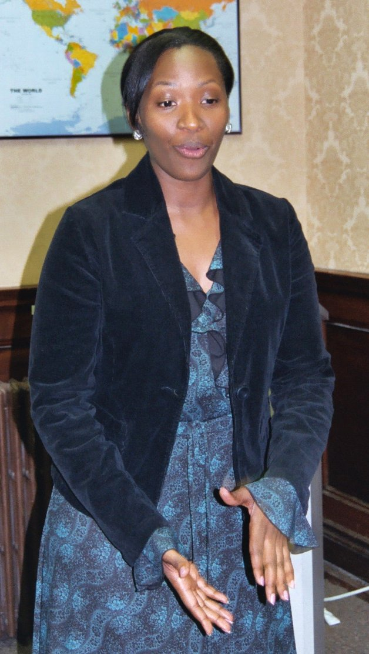
Monica Kahindo, one of OICI’s inaugural participants, benefited tremendously from her experience in the Building Global Bridges program. After completing her baccalaureate studies at Lincoln University in 2006, Monica consistently explored employment opportunities in the development arena. She wrote us: “Well it’s been a month at UNICEF and I am loving it.” Prior to this position, where she works in the Donor Relations Department, she found a brief stint as an Assistant Project Coordinator for CANORAA (Canadiens d’Origine Africain et Antillaise). At CANORAA, Monica used her French language fluency to help immigrant francophone youth find employment where they could use their native French language. Speaking on her current position with UNICEF, Monica admits that “I like it here and am working hard. BGB really helped me – especially with the résumé, it’s the one I have been using, that one that you looked over like a million times. I finally got over my fear of writing cover letters. Honestly, the training I got from BGB is what gave me the confidence I had interviewing, because I knew that I knew my stuff, so thanks to you OICI – send my regards to everyone there.”

- Kristen Kopko, Graduate, St. Joseph’s University

Ms. Kristen Kopko, a Spring 2006 participant and a Senior at the time of her participation in the Building Global Bridges program, is presently working in Washington, D.C. as an Office Assistant for Rockport Capital. This company oversees the operations of two non profits—Banyan Tree Foundation and the International Center for Nonviolent Conflict. The Banyan Tree Foundation, a grant making organization for educational programs in Africa and parts of India and Nepal, and the International Center for Nonviolent Conflict are in their 1oth year of operations. They educate about nonviolent strategies through mailings and lectures. Kristen provides staff with assistance in developing reports for the Board of Directors all the while learning immensely about the different organizations they (Banyan Tree) fund and the different people they help. She notes in a recent correspondence, “I had mentioned to my one colleague about the seminar through OICI. She said she was familiar with the name and knew of Rev. Sullivan and thought that BGB was an exceptional program.” She also mentions about her employer, “…they do very interesting work. I get the opportunity to talk over the phone with or meet very interesting and influential people.

Farming and Business Skills Development Project

USDA Food for Progress Initiative
Agreement FGR-681-2—4/034-00

CÔTE D’IVOIRE, FY 2006

A. Program Overview

- Project Objectives
Funded by the U.S. Department of Agriculture (USDA) through its Commodity Credit Corporation (CCC), the Farming and Business Skills Development Project in Côte d’Ivoire aims at achieving the following objectives:
- To assist local farmers in improving their farming skills and technologies through training and extension services.
- To establish and strengthen local farmer marketing associations.
- To train micro-entrepreneurs in better business management and provide selected micro-entrepreneurs with micro-credit.
- To establish income-generating enterprises that will sustain selected program activities beyond the life of project.

The USDA-OICI agreement in May 2004 provided for the supply and sales of commodities in order to fund the project’s activities. Such commodities included 6,000MT of rice for supply to U.S. ports in June 2004, and 6,000MT of the same for September 2004. CCC agreed to donate the commodities without charge and to pay for ocean transportation in addition to financial assistance for administration and monitoring purposes.

- Project Context
Local armed insurrection that began in 2002 created a context of crisis lasting into 2003. USDA agreement under its Food for Progress umbrella provided OIC Côte d’Ivoire the funds to re-establish its operations. At its agricultural training center in Angoua-Yaokro, near the city of Bouaké, OIC-CI already lost much of its training and farming equipment and program documentation when the 2004 funding agreement started.

The conditions for the 2004 funding agreement to take place included:

- That project funds be maintained in a bank account in Lomé, Togo
- That extension activities and the micro- enterprise program be relocated from Angoua-Yaokro and Bouaké to the relatively safer Yamoussoukro area;
- That training activities of the center in the capital city of Abidjan remain unchanged.

- Core Services
The USDA Food for Progress agreement enabled OIC-CI to provide services in:
- Off-center agricultural training and extension.
- Training in micro-enterprise management.
- Lending through micro-credit.

Supplementary services, some of which were supported by non-USDA funds, also took place in order to strengthen the impact and effectiveness of the above core services. They covered:
- Health and nutrition
- Training in how to read and write.

Under its revenue generating program, OICI-CI operated a computer school project that started in 2004-2005. However, in June 2006, the OIC-CI Board of Directors decided to close the project due to financial non-performance. OIC-CI also piloted two other income generating projects – one in reading and writing, the other in agricultural commodity trading. The first was not replicated. The second was yet to resolve its financial problems. OIC-CI management realized that its future income generation projects will require much more planning in order to include past lessons learned and measures to better ensure returns to investment.

  - Program Results

    - Off-Centre Services

 | Activities | Planned | Actual
1 | AGRO-PASTORAL TRAINING  - Number of target village for the training…………......  - Number of farmers to recruit…………………………  - Number of farmers mastering………………………  - Level of mastery of production techniques………… | 20  1200  900  75 to 80% | 24  1472  1218  75%
2 | MANAGEMENT OF COOPERATIVES  - Number of cooperatives created……………………  - Number of cooperative to be recruited……………… | 20  1200 | 23  1472
3 | MARKETING  - Number committees to the marketing to be created… | 20 | 24
4 | CONSERVATION  - Number of improved storage units set up ………… | 20 | 2
5 | LIVING CONDITIONS  - Level of farmer’s revenue improvement…………… | 15% | 35%
- Training in micro enterprise management

Objectives | Planned | Actual
Improve capacity building in the field of accountancy financial management, and marketing of promoters of promoters. | 640 promoters to be trained over the period. | 1,293 promoters trained
 | 20 training workshops of 16 participants each to be organized. | 21 workshops organized  with 20 participants each on average.

- Micro-Credit Services

Objectives | Planned | Actual | Remarks
Provide financial support through micro-credit to target populations in order to help them improve their income by 15% | Loans:  1,360 people on overage  To be trained and sponsored. | 913 were trained and benefited through sponsoring | The total loan amount was estimated at 78.175.000 CFA
 | Repayment:  Be able to collect the maximum of loans to ensure the revolving capacity | 94% repayment based on collection rate over the period

- Supplementary Services
HEALTH - NUTRITION  - Broaden Program of vaccination  - Sensitization about STD / HIV-AIDS  - Training in balanced diet  - Building improved fireplaces | 75 % of vaccinated children  1.472 people sensitized  More than 50 % of house holds trained  50 % of trained households use improved fireplaces
TEACHING HOW TO READ AND WRITE (USDA funded)  - Number of recruited villages…………  - Number of training teaching agents …  - Number of learners ………………… | 10  13  587
- CitiGroup Foundation-supported micro-credits
Similarly to the USDA-funded micro-credit activities, the Citibank program was a pilot-project administered by the OIC-CI centre in Abidjan that served as the base of micro-credit service to borrowers under this program. OIC-CI benefited from thee (3) funding instalments over the following calendar years:
- 2003 = US $ 25,000
- 2004 = US $ 30,000
- 2005 = US $ 30,000

For the last funding instalment, OIC-CI was able to administer credit cycles over the period from January 2005 through September 2006 and achieved the following results:

Objectives | Planned | Actual | Remarks
Support agro- businessmen through micro-credits | 40 associations with 760 members  to receive loans | 19 associations with 273 members received credits | - Loans total: 8,600,000 CFA  - Repayment rate: 52%

- Program Results in Logistics and Monetization Report (USDA Format)

Please see following pages. Programmatic outcome is in answers to questions 31-35

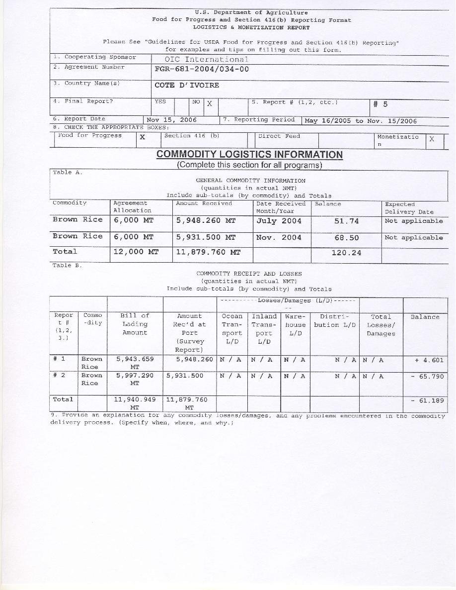



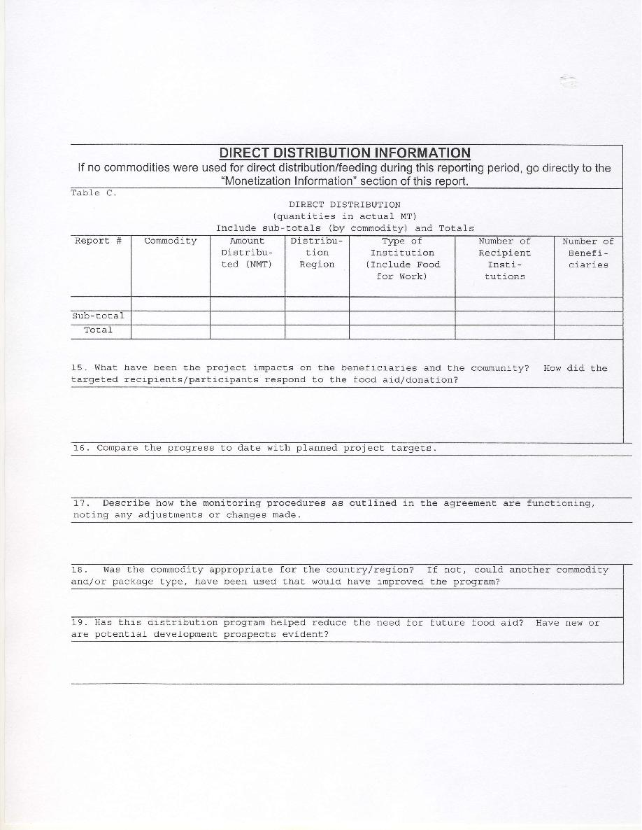

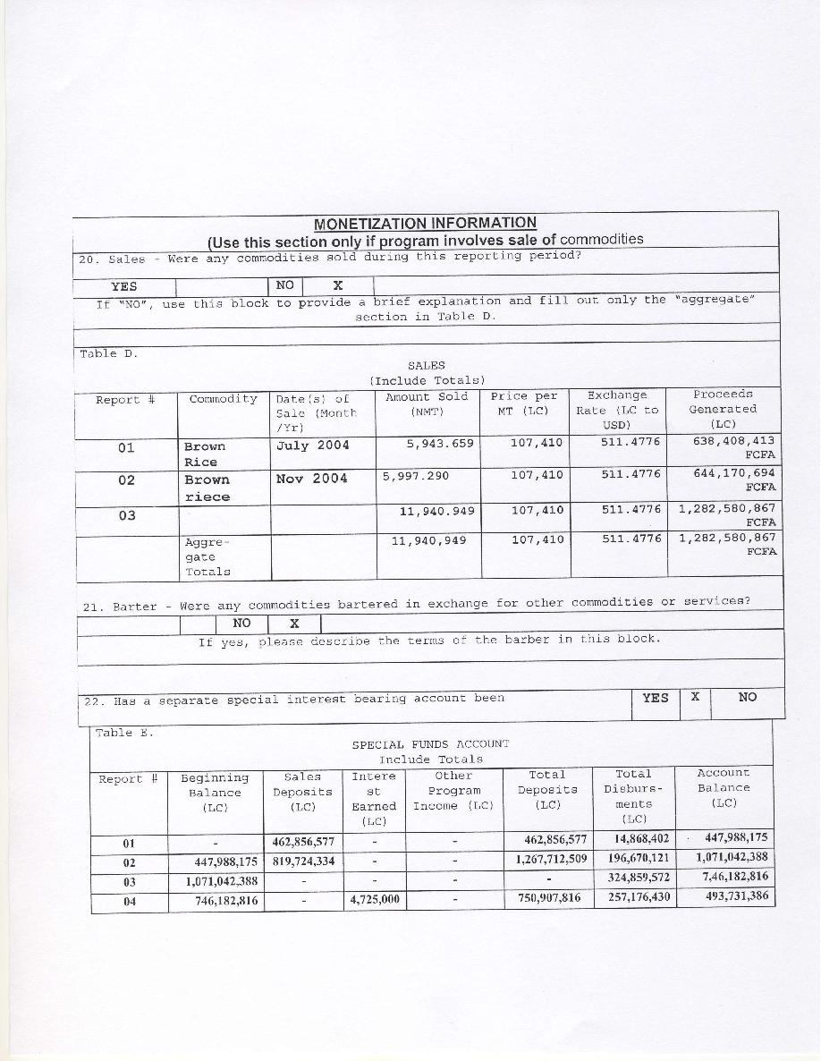

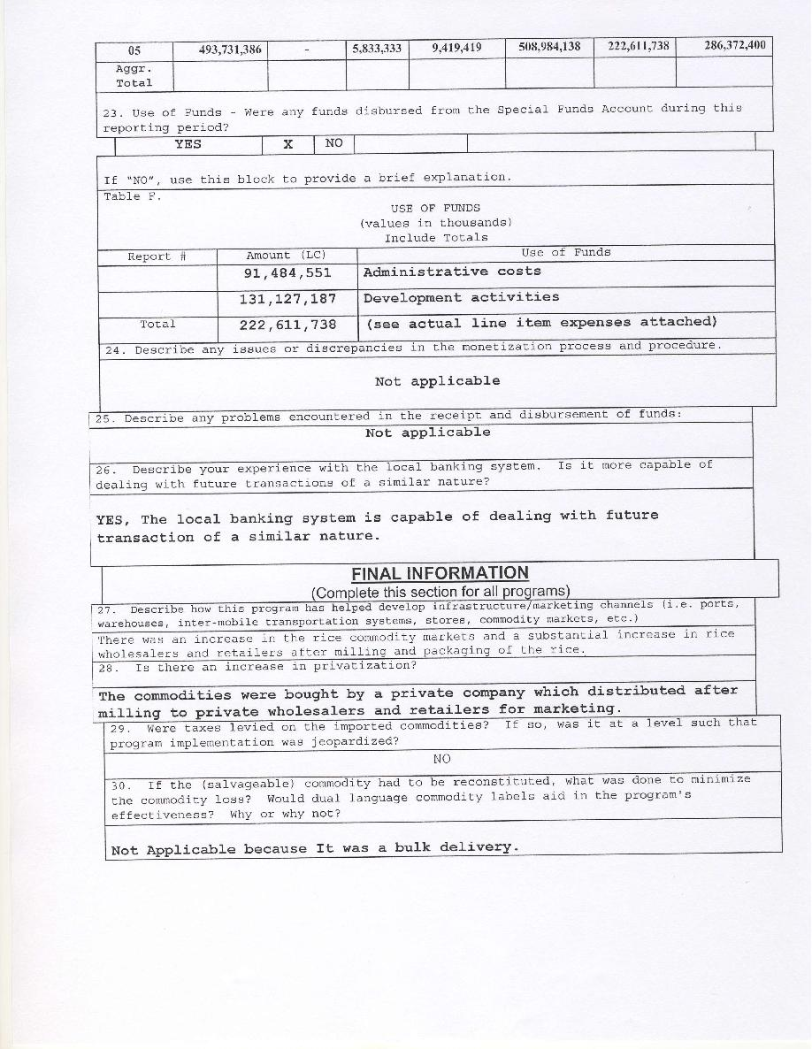

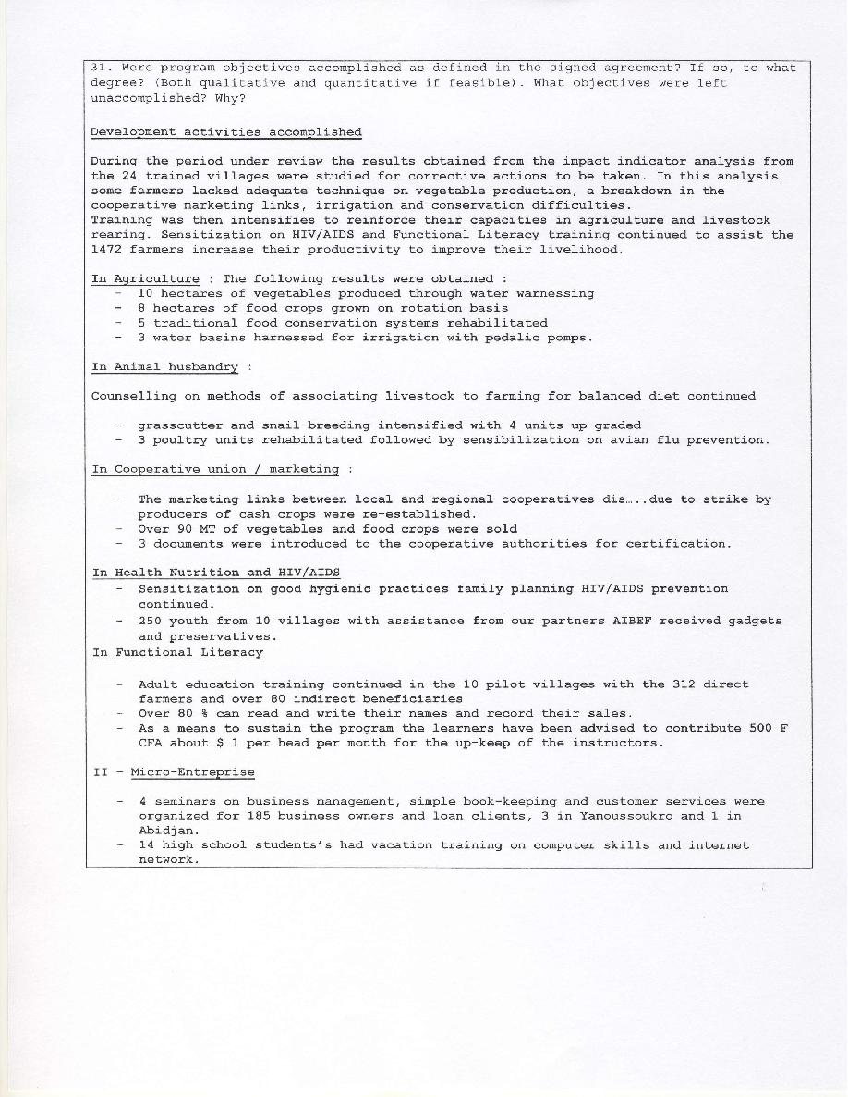

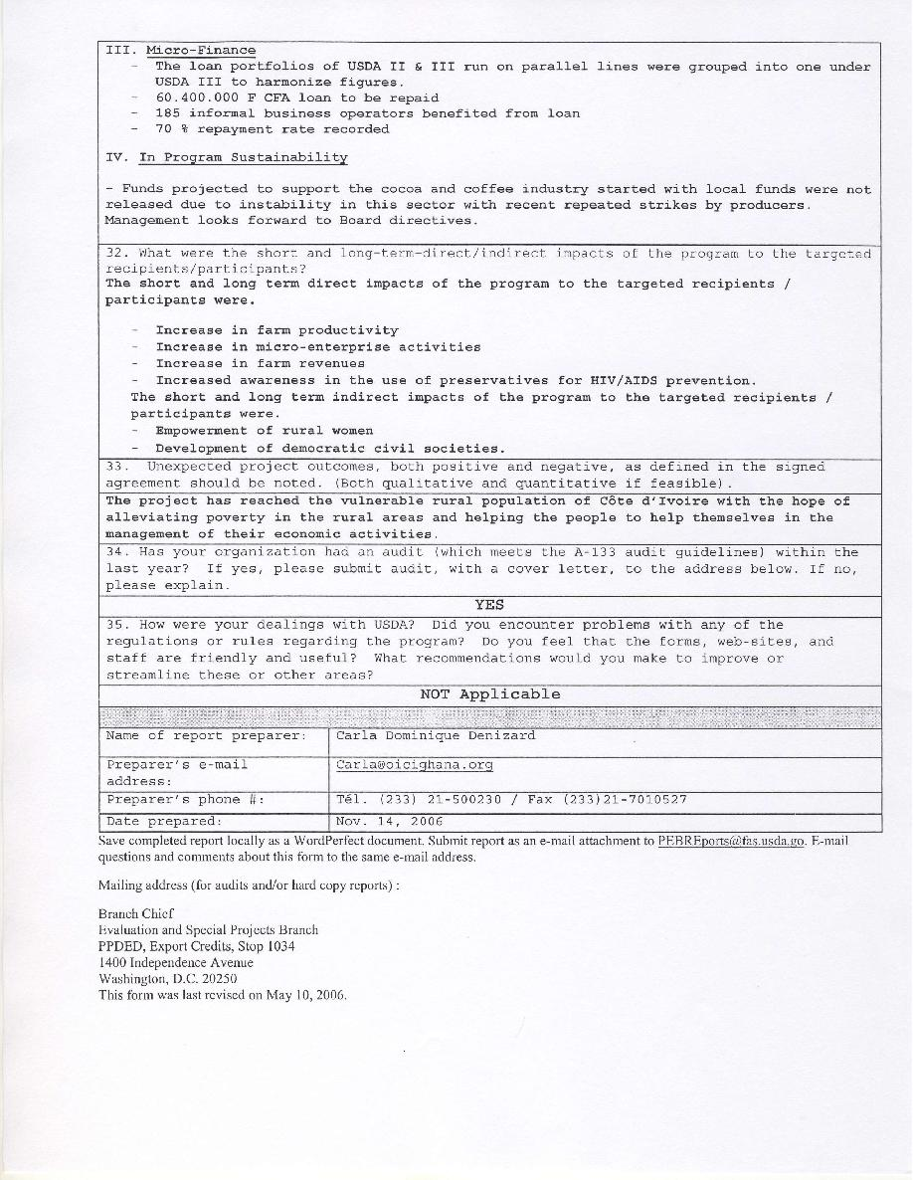

Togo Farm Income Improvement Project

USDA Food for Progress Initiative
Agreement FGR-693-2003/222-00

TOGO, FY 2006

A. Program Overview
- Project Objectives
The Togo Farm Income Improvement Project (TFIIP) is based in Notse in the Haho Prefecture. It is in its third implementation phase and presently covers a 100Km radius around the OIC TOGO Agropastoral Training Center at Todome, a locality situated within 7km at the East of Notse. The project is actively operating in the Maritime and Plateau regions and covers the Haho Prefecture, the southern part of Amou Prefecture, the south-west of the Ogou Prefecture, the northern part of the Zio Prefecture and the north-western part of the Mid-Mono Prefecture.
Funded for a period of three (3) years by the US Department of Agriculture (USDA) since 2003, the project is expected to end in 2006. At full operations, the project employs over 90 employees. Its primary objective is the improvement of the income of the farmers through the increase of the agricultural productivity. It comprises of five (5) key types of activities:

- Farmers and extension agents training on improved techniques in plant and small livestock production;
- Promotion of cooperatives and marketing;
- Promotion of post-harvest technologies;
- Promotion of microenterprise and granting of credit;
- Improvement of hygiene and sanitary condition of the clients through drinkable water conveyance (borehole) and the fight against HIV/AIDS.

  - Beneficiaries Selection Overview
Agricultural Extension, Training and Capacity Building
At the start of the program, OICI conducts a needs assessment and selects forty of the most needy communities within a 100 kilometer radius of the OIC Togo training center in the town of Notse in central-southern Togo. All selected communities will be within the maritime and plateau regions in southern Togo. Each community will have a minimum population of 25 households. Men and women farmers will be organized into cooperatives of 10 or more members. Participants in training and capacity building programs will include farmers and individuals employed in agriculture and livestock activities, including young farmers and agricultural entrepreneurs. Chosen beneficiaries/households participating in post-harvest activities must be willing to share the costs of constructing or improving grain storage facilities.
Beneficiaries must be resident farmers within a 100-kilometer radius of the Todome agro-pastoral training center of OIC Togo in the plateau region of the country. OICI would select farmers through a needs assessment, focusing on indicators such as a low household incomes and deficiency in the quantity and quality of food available to household members. OICI gives priority to the poor farmers with demonstrated needs for OICI’s services.
Farmers’ Cooperative Development
30 cooperative groups of which members have a very low income would be selected within 73 existing cooperative groups in 100 villages in the project zone.
Microcredit Program
Microcredit beneficiaries are residents in the same geographic areas as the agricultural programs. OICI selects clients based on their willingness and capacity to meet OICI’s loan policy requirements. Some of the indicators to be used for selecting target groups include: economically disadvantaged individuals or groups actively engaged in income-generating activities such as processing and marketing; first-time or novice borrowers with no existing loans and limited loan experience who possess a prepared business plan with commercially-viable activities, willingness to place at least 10 percent of the total loan fund aside as required savings/collateral; and successful repayment record for those applicants in the second cycle of a loan.
The OIC Togo savings and credit component selects beneficiaries from the areas of extension and will apply the following additional criteria:
- Members of a recognized, formal association in the village
- Member of a savings and credit solidarity group with a proven repayment track record
- Conducting an income-generating activities and willingness to participate in a saving plan.
Water and Sanitation
The selected communities must be within the project-operating zone (within 100 kilometers from the project center in Notse) and have a minimum of 2,000 residents without a potable water source. OICI expects to construct 05 new borehole wells.

HIV/AIDS Care

The CRS/Togo (Catholic Relief Service) project stakeholders will promote in Dapaong and Kouve areas the package of services and goods available in the project. The communities’ volunteer workers and families of the persons living with HIV/AIDS (PLWHA) will refer the PLWHA to the project centers. Promotion, self-registering and reference are the three areas for choosing the direct beneficiaries. Below are the highlights of the direct beneficiaries’ profile:

- Person who knows his or her serologic prevalence status through voluntary counseling test.
- Low income PLWHA who voluntarily agreed to be registered by the project centers.
- Female PLWHA who has been excluded by her parents or her husband due to her serologic status.
- In-kind contributions
In addition to USDA funding, OIC Togo will provide training facilities that include classrooms, 75-person capacity trainee dormitories, on-site cafeteria and kitchen facilities, 16-room office block, and an assembly hall. Within the training center are demonstration and production poultry houses, pig pens, animal feed store and feed mixing plant, small ruminant sheds, and a demonstration farm area of 144 hectares. The center also has a borehole well with a submersible pump, elevated 10,000-liter water tank and piping to needed locations of the facility. The value of land, facilities and equipments to be contributed by the local OIC Togo program is estimated at $350,000. All other costs not covered by USDA will be borne by OICI.
- Program Results
The following logistics and monetization report, using the USDA reporting format, provides the details of program results through May 15, 2006 as the project reached its end. The reported period – as shown in the report – is from November 16, 2005 through May 15, 2006 in order to comply with the USDAS reporting cycle.
The specific program outcome is described through answers to questions 31- 35 in the logistics and monetization report.
The accomplished development activities covered:
- General agriculture
- Animal husbandry
- Cooperative and marketing
- Post-harvest technology
- Microcredit program

Logistics and monetization report on Togo follows

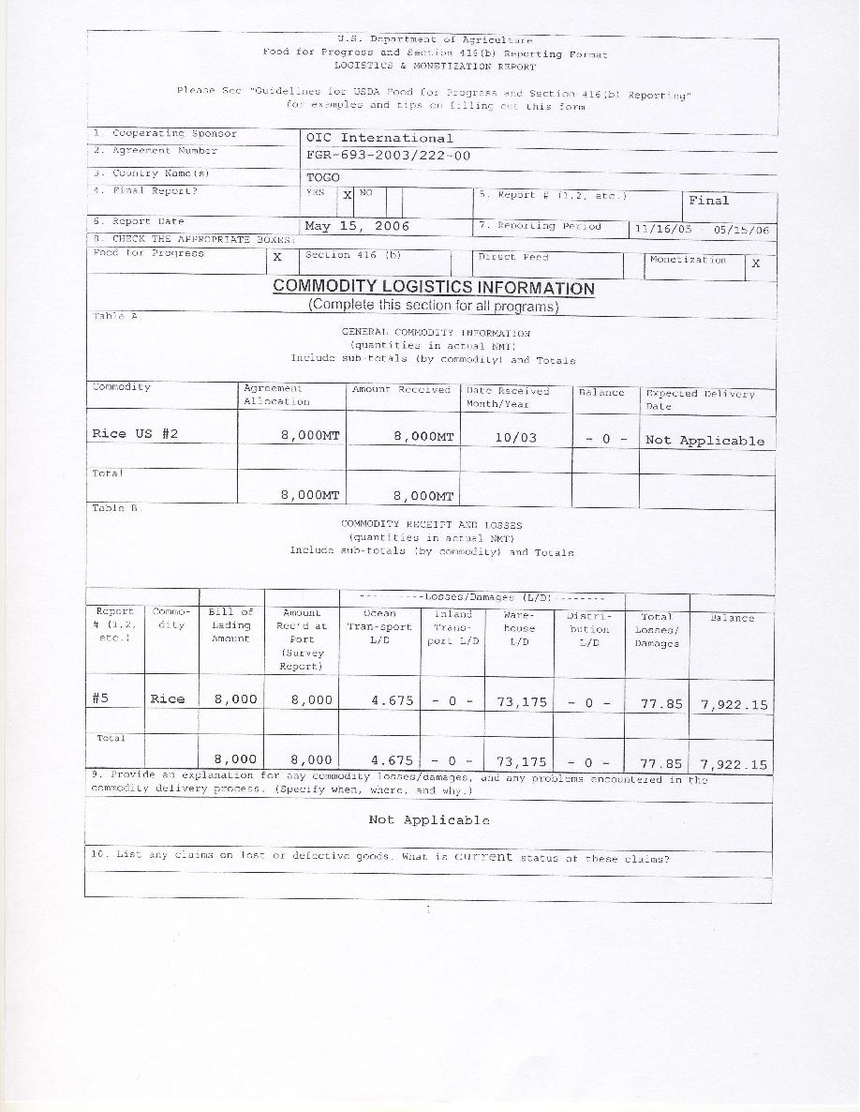



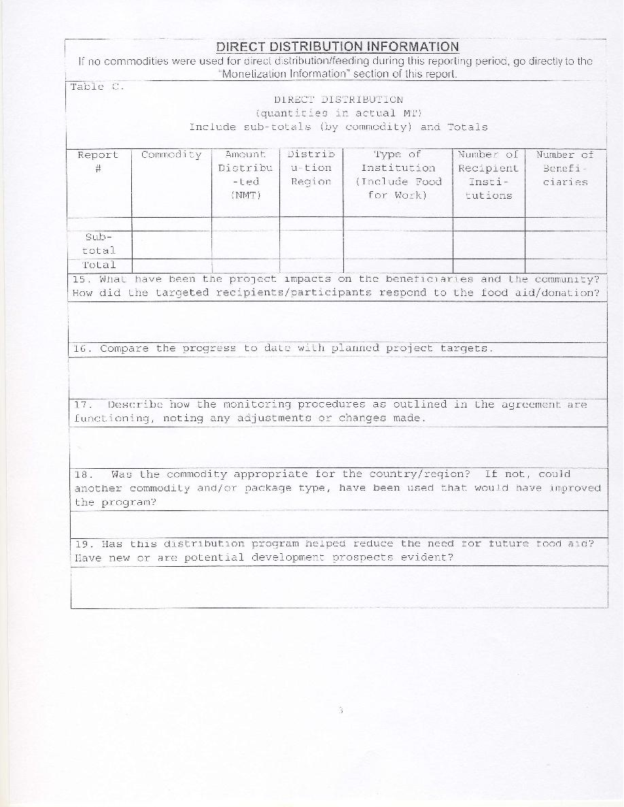

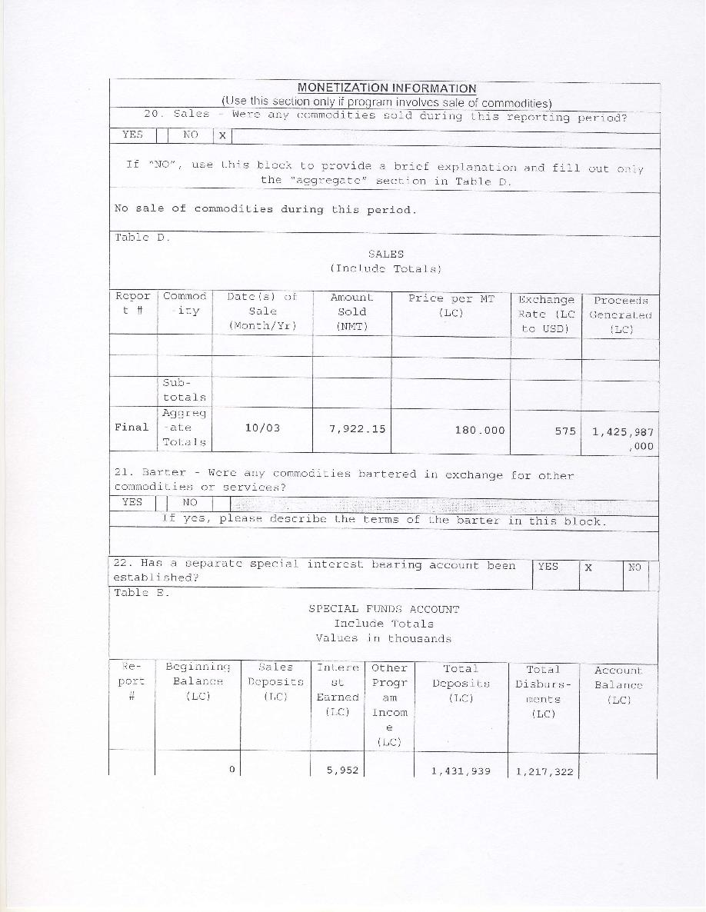

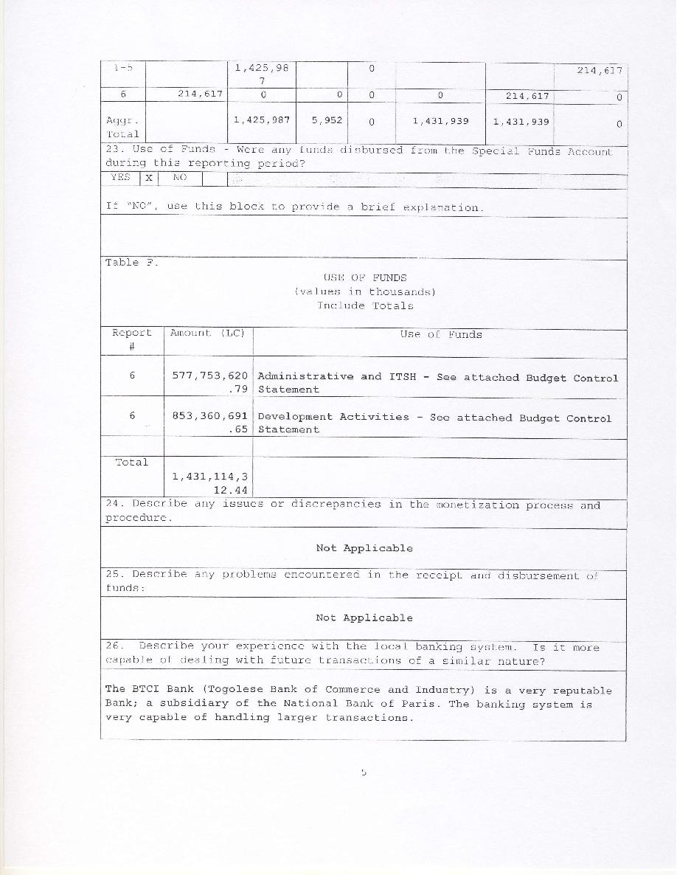

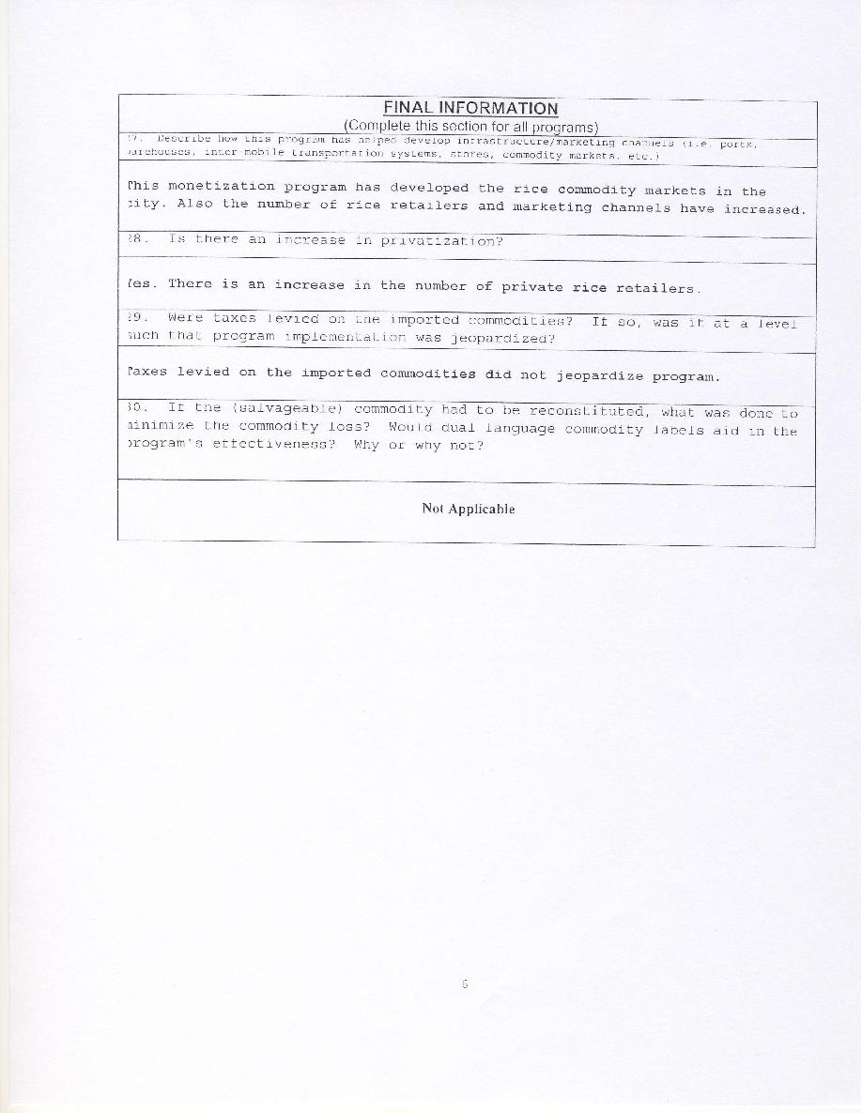

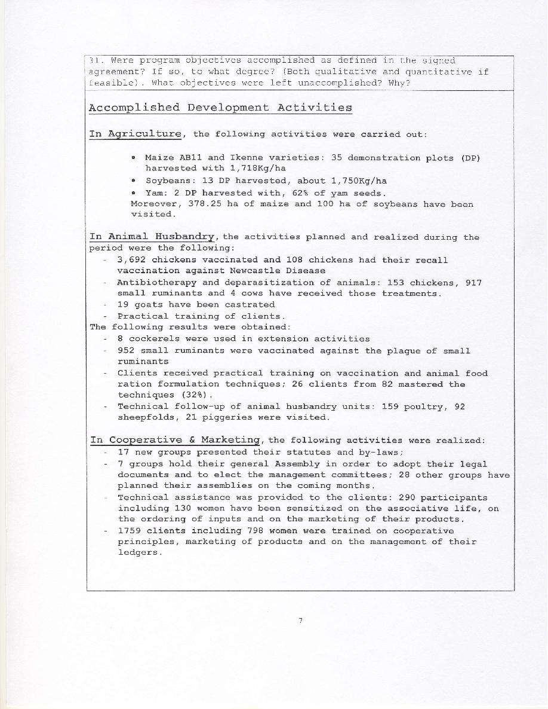

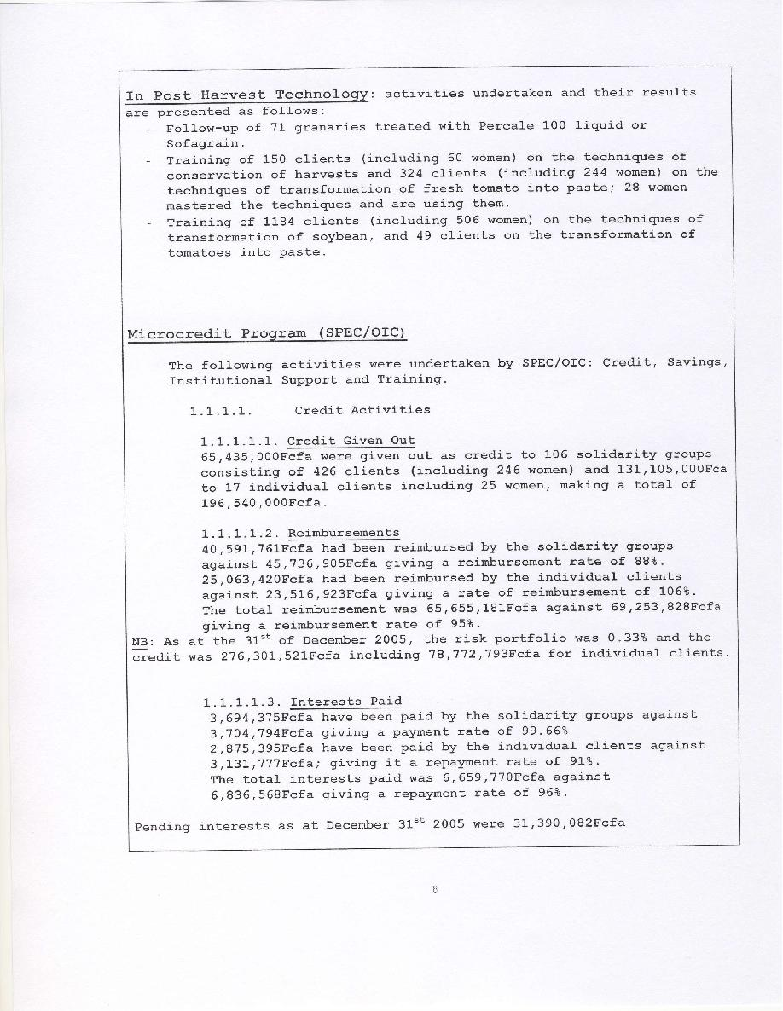

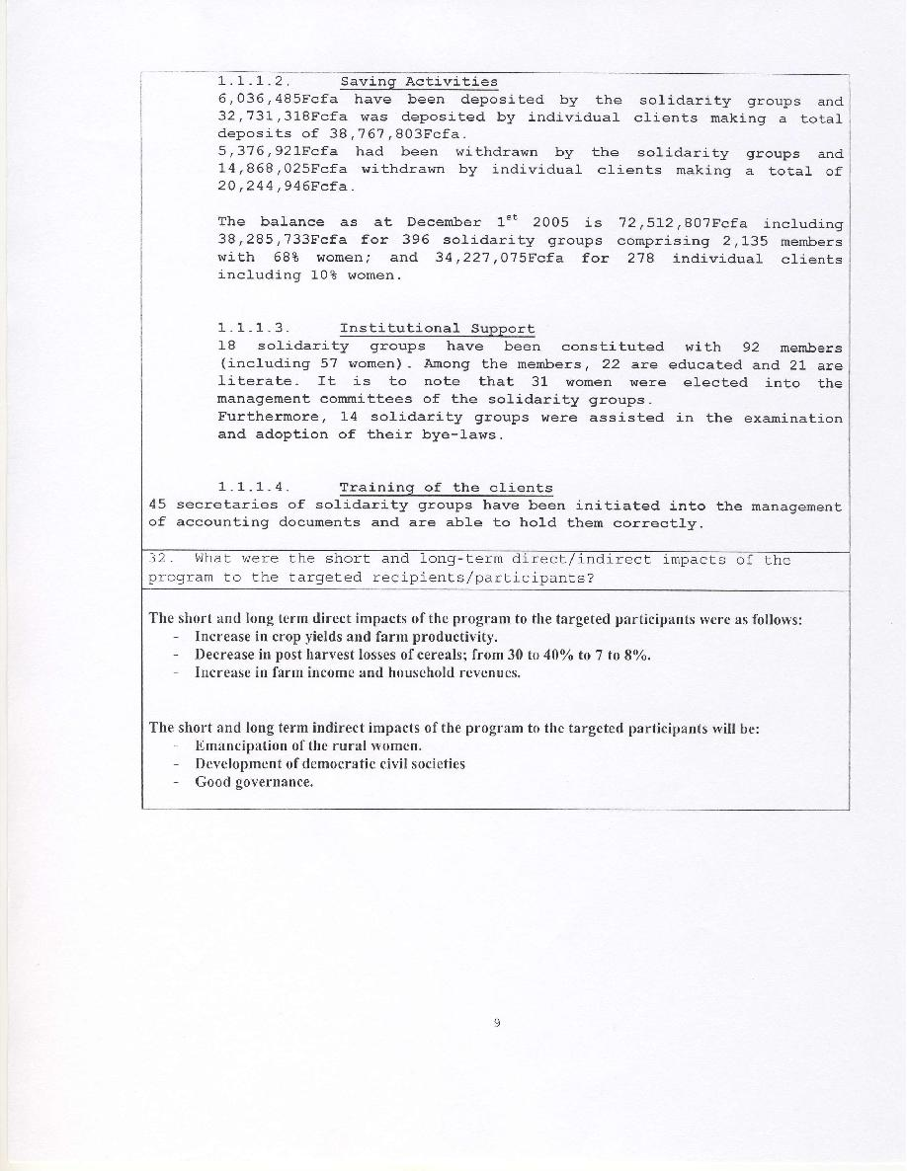

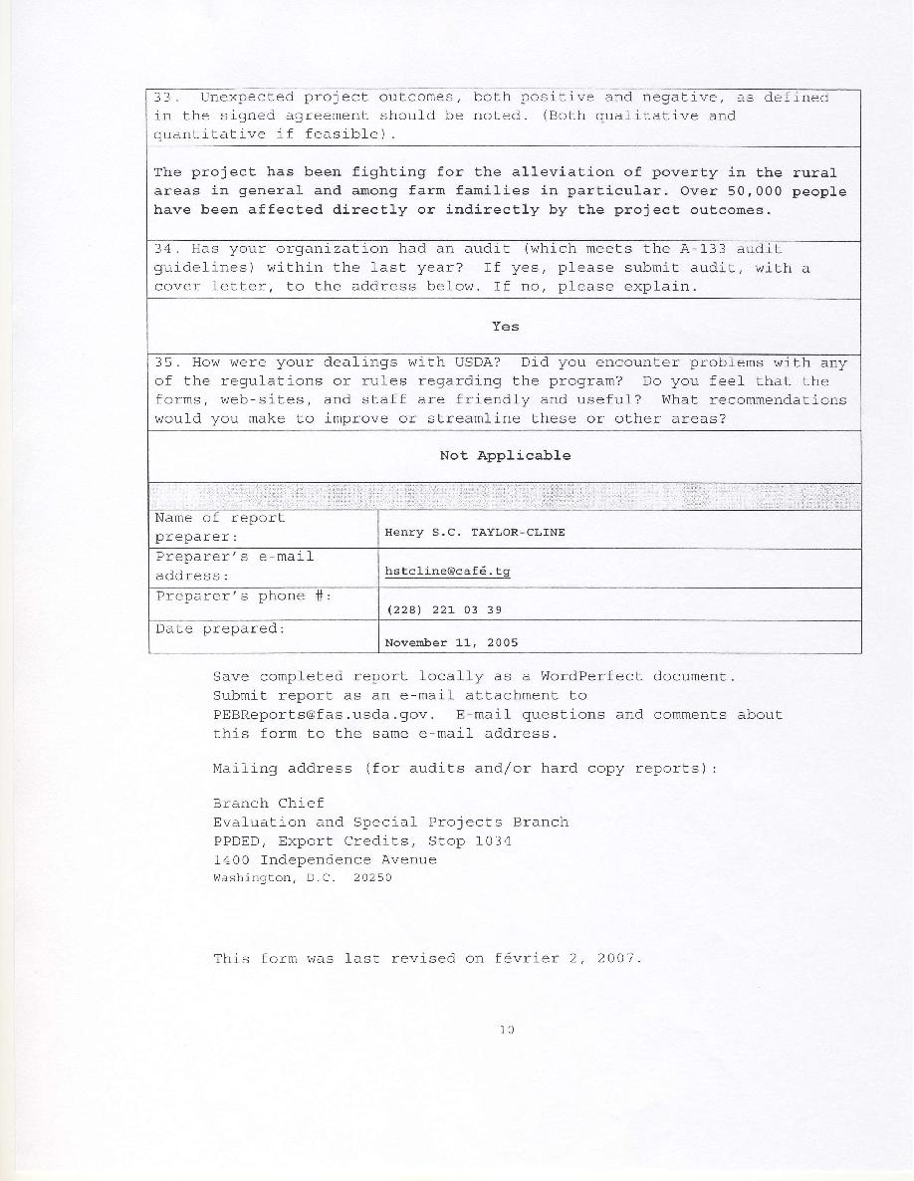

Major Private Sector Funded Projects of OICI
FY 2006

Reproductive Health Education and Skills Training for Youth in Ethiopia

An initiative funded by
The David and Lucile Packard Foundation
Reference Number: 2004-27002

Ethiopia, 2006

- Program Overview
  - Packard Foundation Funding
Since July 2001, OICI received two consecutive three-year grants from The David and Lucile Packard Foundation totaling $875,000 for a health and youth development program in Ethiopia. OICI is currently in the second three-year grant that began in 2004 with $400,000 in total funding and will end in June 2007. Its current program integrates reproductive health education and services with training in marketable skills targeted at underprivileged youth in the Oromiya and Amhara Regional States of Ethiopia.

- Program Objectives
The Reproductive Health Education and Skills Training for Youth in Ethiopia is to contribute – in the long term - to national development through developing the skills and enhancing the reproductive health knowledge and practices of youth. Its short-term goals are:
  - To provide reproductive health education and services to 800,000 youth and adults in the community to help them develop responsible and positive reproductive health attitudes
  - To provide training in marketable vocational skills to 1,296 economically disadvantaged youth to enable them become self-supporting and productive citizens.
  - To improve the competence of 14 in-school and 11 out-of-school ARH clubs in providing outreach services.
  - To increase the number of family planning users in the project areas.

- Program Content and Services
Components of the program include: Classroom-based reproductive health education; distribution of contraceptives and condoms, individual counseling in Reproductive Health/Family Planning (RH/PF) and referrals for testing and treatment for STIs; support of RH/FP education activities for sponsored schools and out-of- school youth clubs; library services; training of RH/FP peer promoters; life skills and entrepreneurship training; training in basic computer applications; vocational training in masonry, welding, bamboo carpentry, carpet making, catering and food preparation, bakery and confectionary, automobile operation; and job placement services.

- Program Approach
To accomplish the goals of the program, OICI and its local affiliate OIC Ethiopia, established two vocational technical training centers, one each in Combolcha and Jimma. The training centers were additionally used to offer recreational activities for area youth, creating further opportunities to offer RH/FP education and services to these visitors.

Key program activities and premises of success include:
- Assisting youth in developing a positive outlook on life and the knowledge needed for a successful and secured life. With the youth having some hope, the task of teaching them on how to protect their sexual health would be much easier than otherwise.
- Integrating adolescent reproductive health education with job skill training for employment. Having jobs that the youth can depend on for a decent livelihood would reduce the chance of them engaging in irresponsible and risky sexual behavior. The centers assist their trainees in finding jobs and apprenticeships and obtaining start-up capital to begin their own businesses in groups or individually.
- OIC centers offer library, recreational and TV-entertainment services to its visitors as a means to attract the youth and engage them in the good utilization of their free time. These services provide an entry point for OIC staffs to bring education on reproductive and health issues to the youth.

Additionally, funds are provided to selected local NGOs, youth associations and community-based organizations in the form of sub-grants for various innovative activities aligned with program goals. Through the school support program, staff nurses also visit designated rural and urban government schools twice each month to educate students on various RH/FP topics. These schools have received some financial support to strengthen their ARH clubs and purchase public address systems and recreational materials helpful to awareness campaigns on issues of RH/FP and HIV/AIDS.

  - Program Results
    - Global Achievements
      - Skills Training and Employment Generation
In the past two years 1,021 youth—118% percent of this project’s target—were trained in building masonry, welding and basic computer application. In addition to the provision of skills training, the OICI/OICE centers are also assisting trainees in finding jobs and apprenticeship opportunities through our job placement program. Accordingly, during the reporting period, 158 trainees (52% of targeted number) have secured jobs due to the efforts of the project’s job developers. Of these, 78 are female. In addition, apprenticeship arrangements have been made for 118 basic computer trainees to serve as apprentices in government, non-governmental and private organizations.

      - Reproductive Health Education, Counseling and Referral Services
OICI/OICE has provided RH education to 137,808 adolescents and adults, issued 2,779 cycles of contraceptives pills for youth clients and also distributed 39,131 pieces of condom to 5,895 clients, 709 Depo-Provera and 14 IUCD. The centers are providing counseling and referral services to the youth clients for various reproductive health problems. In this reporting period, 3,772 (1,191 males, 2,898 females) and 1,390 (476 males, 914 females) youths have received counseling and referral services; 20,034 youth have used the library facilities. In the school support and ARH education program, 8 urban and 8 rural government schools have been assisted. Two school clubs received financial assistance for the purchase of mini-media, recreational facilities, to carry out awareness campaign on HIV/AIDS and RH/FP issues.

      - Outreach
At the request of OICE, youth clubs in the project area have formed umbrella youth groups that represent the various youth clubs. The umbrella club serves as a link between OICE and the various ARH and anti-AIDS clubs that benefit from the program. Youth club members are benefiting from the vocational skills training program and the use of OICE’s facilities such as duplicating and printing services. A number of NGOs that are working in Ethiopia are becoming interested to internalizing OICE`s methodologies of integrating ARH services to skills training and job placement. The number of unemployed and unskilled youth in the project area who acquired marketable skills and secured employment and/ or started their own business as a result of skills acquired from the project is increasing year to year.

      - Stakeholders
OICI and OICE have also established effective working relationships with key stakeholders in the project areas. Efforts has also been made to further strengthen and expand the service provided by leveraging the resources of the Packard Foundation with resources of other donors. Financial support acquired from USAID’s Global Development Alliance has been also used to implement a program of computer-assisted learning to students and members of the community. This program is helping educationally and economically disadvantaged but highly talented students to secure additional tutorial as well to expand and ensure their innate love of learning.

  - Program Result Indicators
The following section summarizes the results of this program in FY06, although it adopts the actual reporting cycle used for its program reports to the Packard Foundation. The report below covers therefore the 11-month period from July 2005 through May 2006. The reporting format is that used as submitted to the Packard Foundation.

Short-term Outcome 1: Provide reproductive health education and services to 800,000 youth and adults in the community to help them develop responsible and positive reproductive health attitudes.
Indicator 1.1: Increase in the percentage of youth who take appropriate measures to protect themselves from STIs/HIV/AIDS, unwanted pregnancy and other reproductive health problems; from 80% in Combolcha and 78% in Jimma to 95% in both locations.
Projected Result: 20%
Progress on this Indicator: Time Period Progress during period Cumulative Progress
Year 2 (ending 5-’06) Refer to comment Refer to comment
Comment: The project document indicates that the short-term outcome is to increase the percentage of youth who take appropriate measures to protect themselves from unwanted pregnancy, HIV/AIDS and other reproductive health problems in the project areas from 80% in Combolcha and 78% in Jimma to 95% in both centers. Progress with respect to this performance indicator will be measured during the final evaluation at the end of the project period, and the accomplishment will be reported as a long-term result
Indicator 1.2: Increase in the number of youth who receive education on family planning, prevention of STIs and other RH problems; from 255,237 to 800,000.
Projected Result: 544,763
Progress on this Indicator: Time Period Progress during period Cumulative Progress
Year 2 (ending 5-’06) 137,808 (52%) 305,123 (56%)
Comment: Adolescent reproductive health (RH) education is designed to raise the awareness of the youth and the local community to protect themselves from reproductive health problems. For this purpose, the organization is working with already established school and out-of- school youth clubs that serve as the OICE centers outreach arms for the provision of ARH information by our nurses. ARH education is also given in each center for the youth who are coming to use the OICE facilities: library; DSTV and computer-assisted learning programs.

Short-term Outcome 2: Provide training in marketable vocational skills to 1,296 economically disadvantaged youth to enable them become self-supporting and productive citizens.
Indicator 2.1: Increase in the number of youth who receive skills training integrated with RH education and entrepreneurship development; to 1,296.
Projected Result: 1,296
Progress on this Indicator: Time Period Progress during period Cumulative Progress
Year 2 (ending 05-’06) 399 (92%) 1,021 (118%)
Comment: In the reporting year, the organization planned to train 432 underprivileged and unskilled youth in welding, building masonry and basic computer applications. Cumulative number of trainees who had completed their training exceeds the target. This is due to the high market demand and high interest of the beneficiaries in the field of the training, particularly the building masonry and welding trainees.
Indicator 2.2: Increase in the number of trainees who secure employment or start their own businesses through the project’s job placement program; from 192 to 900.
Projected Result: 708
Progress on this Indicator: Time Period Progress during period Cumulative Progress
Year 2 (ending 05-‘060 158 (52%) 386 (64%) Job secured
Apprenticeships arranged 118 261

Comment: The centers, in addition to providing vocational skills training to socially disadvantaged youth, also assist trainees in finding jobs and making arrangements for apprenticeship opportunities at private firms as well as at government and nongovernmental organizations. During this reporting period, 52 percent of the trained beneficiaries secured jobs; additionally, 118 (39%) are on their way of securing jobs and are now engaged as apprentices. The booming construction business in the country may open employment opportunities to trained construction workers. Securing gainful employment opportunities for those who are trained in basic computer applications has been difficult. This is due to the poor absorptive capacity of the market right now for this particular skill.
Short-term Outcome 3: Improve the competence of 14 in-school and 11 out-of-school ARH clubs in providing outreach services.
Indicator 3.1: Increase the number of youth utilizing library and educative entertainment video shows; from 29,895 to 114,000.
Projected Result: 114,000
Progress on this Indicator: Time Period Progress during period Cumulative Progress
Year 2 (ending 05-‘06) 44,326 (117%) 69,119 (91%)
      - Library users: 20,034
- Educative and entertainment DSTV & video show: 24,292
Comment: The interest of the youth in using the centers’ library and Extra Learning program facilities is increasing. Progress during the reporting period reached 117 percent. Presently, the library rooms are too small to accommodate the larger number of users. As a result, are trying to obtain a leverage fund to improve the library service by modifying the rooms and acquiring more textbooks.
Indicator 3.2: Increase in the number of schools that receive support for RH education: mini-media, IEC materials, sports and recreational activities and visits by staff nurse; from 10 to 14.
Projected Result: 4
Progress on this Indicator: Time Period Progress during period Cumulative Progress
Year 2 (ending 05-‘06) 16 (114%) 16 urban & rural schools
Comment: The organization planned to provide RH education and services for 14 schools (8 urban and 6 rural schools). In this reporting period, 2 additional schools were selected, one by each center, and included in our school RH education program. Currently, all school Satellite clubs have established multimedia. The school satellite clubs are used as outreach arms by the centers to provide information on HIV/AIDS and other RH issues as well as to distribute IEC materials for school.

Short-term Outcome 4.1: Increase the number of family planning users in the project areas.
Indicator 4.1: Increase in CPR in the project areas; from 54.5% in Combolcha and 25% in Jimma to 75% in both areas.
Projected Result: 50%
Progress on this Indicator: Time Period Progress during period Cumulative Progress
Year 1 (ending 05-‘06) Refer to comment Refer to comment
Comment: The short-term outcome indicator in the project document stipulated that the CPR in the project area would increase from 54.5% in Combolcha and 25% in Jimma to 75% in both areas. This indicator will be measured and reported based on end of project survey. In addition, this accomplishment will be reported as long-term result.

Short-term Outcome 4.2: Increase number of youth and members of the communities who receive family planning, counseling and referral services for STIs, VCT, and other RH issues in both areas.

.
Indicator 4.2: Increase the FP, counseling and referral services users to 40,000, 13,333 per year, in the project areas

Projected Result: 40,000

Progress on this Indicator: Time Period Progress during period Cumulative progress
Year 2 (ending 05-‘06) 14,559(109%) 26,609 (100%)

Detail Family Planning, Counseling and Referral Services:

- Pills issued: 2,779 cycles of pills for new and repeat youth clients X 0.067 = 186
- Condoms distributed: 39,131 pieces of condom for 5,895 youth clients X 0.0083 =325
- Depo-Provera: 709 new and repeat youth clients X 0.25 = 177
- Intra Uterine Contraceptive Device (IUCD): 14 youth clients X 3.5 = 47
- Counseling Services: 3,772 (1,191 male and 2,898 female youth clients)
- Referral Service: 1,390 (476 male and 914 female youth clients)

Comment: Family planning, counseling and referral services for STI treatment, VCT and other RH issues were provided in the reporting period as planned. As shown in the above, we have exceeded the outcome indictor. This result was achieved as the project has trained and deployed 21 peer promoters in both centers that can provide FP service to a larger number of people. The youth-friendly service provided at the center has also improved the reproductive knowledge and attitudes to a larger number of youth and community in the project area. These services were previously given by only one nurse; the provision
of scheduled in-school ARH education, FP, Counseling and referral services in each center with one nurse was a challenge to achieve the set target.

Qualitative Reporting from Ethiopia to the Packard Foundation (June 23, 2006)
The youth clients served by our centers finally appear to be breaking from the cycle of unemployment and despair. Youth who have received short-term vocational training at our centers are becoming successful in securing jobs and starting their own businesses. A German parastatal organization, GTZ, is currently negotiating with associations of our graduates to subcontract its project to construct a university in Combolcha town. Similarly, the Ethiopian Road Authority has expressed its interest in employing all the masonry graduates in its rehabilitation project of the Combolcha-Woldia road. Our graduates are also securing jobs in the Afar Regional State where construction is now a booming business.

Mining for Sustainable Development Program
Ghana

OIC International Servicing Communities in Mining Affected Areas
with support from
Newmont Ghana Gold Ltd. & GoldFields Ghana (GFG)

FY 2006

- Overview

  - Program Objectives
Through its Mining for Sustainable Development Program OIC International works to improve the quality of life and enhance the livelihood, economic opportunities and income of people in areas affected by mining operations in Ghana. Towards these objectives, OICI assists mining companies to implement best practices and meet the international resettlement performance standards required by the World Bank/International Finance Corporation. These standards are to ensure the proper resettlement, relocation, compensation and appropriate community development planning and services to population dislocated by mining operations.
OIC International’s vision is to offer and successfully demonstrate – through the above interventions - a high-impact, results-focused, sustainable community development program that focuses on economic growth, wealth creation, quality of life and empowerment that can be replicated in communities all over the world that are affected by mining exploration and operations.

      - Program Services
An experienced Accra-based team of Ghanaian OICI program managers and technical specialists, in addition to a Country Representative from OICI-USA and local operational staffs based in each of the program locations deliver the required variety of services in program design and implementation including management, day-to-day operations, and program monitoring and evaluation.
Under the umbrella of its Mining for Sustainable Development Program, OIC International has been collaborating with Newmont Ghana Gold Ltd (NGG) and GoldFields Ghana (GFG) in pursuing the objectives mentioned earlier. Drawing from its expertise and experience in resettlement and community development, OICI creates and implements the programs required for these mining companies to properly fulfill their obligations. In so doing it also assists the targeted local populations in developing various capacities and acquiring the necessary means to meet their needs, both in household term and as a community. OICI offers a wide range of services that include:
- Designing and conducting baseline and livelihood studies with comprehensive data gathering on mine affected populations.
- Conducting stakeholders identification and analysis.
- Conducting Social Impact Assessments (SIA) and Environmental Impact Assessments (EIA).
- Designing and implementing Alternative Livelihood and Comprehensive Community Development programs.
- Coordinating resettlement and relocation activities and meeting “Case Work” needs.
- Providing capacity building training and support to community consultative groups and the staffs of mining companies.
- Assisting the designated staffs of mining companies in communicating about their programs, including advice on how to strengthen their external and internal reporting and discussing strategy at senior management level.
- Designing and implementing public consultation and information disclosure plans.
- Providing strategic advice on the development and direction of community programs, including best practice in those areas and how to address the interests of the business and the local communities.
- Managing and advising on the selection of additional partners, including proper background research, briefing and managing communications with them, analyzing the strengths and weaknesses of their proposals, and making selection recommendations.
- Conducting monitoring and evaluation of program impacts that would also enable the companies to continually improve their productivity measurement plans.

The following sections provide a comprehensive account of OICI’s activities in FY06 as it implemented the Mining for Sustainable Development Program initiative.

- Program results

  - Sustainable Community Empowerment and Economic Development (SEED): A GoldFields Ghana – OICI Collaboration

    - SEED Target locations
GoldFields Ghana (GFG), in partnership with OICI, the Wassa West District Assembly (Western Region), other governmental ministries and local community members is implementing the Sustainable Community Empowerment and Economic Development Program called SEED over a period of 5 years. The sixteen (16) target and beneficiary communities (primary stakeholder communities) are located on, or immediately adjacent to the Abosso and Tarkwa mining leases of GFG and have been affected to varying extents by GFG's mining operations.

The communities located at the Tarkwa mining concession are: Samahu, Abekoase including Camp 43, Tebe, Huniso, Pepesa, Brahabebome, New Atuabo and Akoon. Those located in the Abosso (Damang) mining concession are: Damang, Kyekyewere, Subri, Nyamebekyere, Huni-Valley, Amoanda, Bompieso and Koduakrom. The program was launched in Tarkwa in November 2005.

- SEED goal and objectives.
As its goal the SEED program is to improve the livelihood and the quality of life of 30,000 poor, vulnerable men, women and children in 16 GFG primary stakeholder communities by 2010. Toward this goal, SEED aims at achieving the following objectives since it began operations in October 2005:
- To increase income and economic opportunities of 4,000 households in the 16 primary GFG stakeholder communities.
- To improve the health status of 30,000 living in the 16 primary GFG stakeholder target communities.
- To improve the level of education and livelihood skills of 5000 youth and adults residing in the 16 primary GFG stakeholder communities
- To increase the sustainability of SEED interventions for long-term results and impact.
- To increase the company’s social license to operate in the district.

  - SEED Performance Statistics

SEED: Sustainable Community Empowerment and Economic Development
FY 2006

 | FY 06 (Nov 2005 - Sep 2006)
Project Elements | Planned | Target | Actual
Project Objective 1: To increase income and economic opportunities 2,265 households in 16 GFG primary stakeholder communities.
Result 1: Increased sustainable food and animal production among 2,265 farm households to ensure food availability and access.
Indicator 1: Number of farmers trained in food production methods | - Group management/dynamics training | 1,035 | 905
 | - Train farm groups in improved farming practices & techniques
 | - Training in Participatory Farm Management (PFM)
Indicator 2: Number of farmers trained in sustainable cash crop production methods | - Provision of Extension services with MOFA in crop cultivation.
Indicator 3: Number of farmers groups formed and trained | - Formation and strengthening of farmer groups:  - Oil Palm  - Cassava  - Oil Palm Nursery
Indicator 3: Number of farmers groups formed and trained | - Community Sensitization on Ag Livelihoods | 15 | 15
Indicator 3: Number of farmers groups formed and trained | - Applications and selection of beneficiaries | 15 | 15
Indicator 4: Number of farmers applying new techniques | - Learning Tours
Indicator 5: Number of demonstration farms established | - Establish demonstration farms for role model and experimentation.  - Vegetables  - Oil Palm | 14  13 | 7  -
Indicator 6: # of hectares in which improved agriculture practices and inputs applied | - Oil Palm  - Cassava  - Vegetables | 525  70  50 | 464  32.8  40.4
Indicator 7: Number and type of improved inputs provided | - Provide improved seed, planting materials, fertilizer, tools and equipment for food production  - Cassava planting materials | 2045 bundles | 1,845
Indicator 8: Number of oil palm seedling distributed | - Distribution of Oil Palm seedlings | 32,550 | 28,766
Indicator 9: Number of participants trained in improved animal production & management | - Technical training for livestock groups | 532 | 459
Indicator 10: Number of Community livestock workers trained. | - Train community livestock workers (CLWs) in animal production, health and management. | 15 | 15
Indicator 10: Number of Community livestock workers trained. | - Community livestock worker review meeting | 12 | 12
Indicator 11: Number of inputs distributed to CLWs | - Bicycles for CLWs  - Medical box for CLWs | -  15 | -  15
Indicator 12: Average herd size by type of animal per household
Indicator 13: Number of animals distributed. | - Pigs  - Sheep  - Goat | 167  266  554 | 140  243  465
Indicator 14: Animal survival rate
Indicator 15: Number of farmers applying skills and knowledge learned.
Indicator 16: # of veterinary services provided | - Provide periodic veterinary services to beneficiaries | - | 393
Indicator 17: Number of livestock farmers that have been supplied with animal feed | - Provision of animal feed | 147 | 147
Indicator 18: # of quarantine stations established | - Construction of quarantine station | - | -
Indicator 19: # of veterinary drugs distributed. | - Provision of veterinary drugs
Indicator 20: Type of veterinary drugs distributed
Indicator 21: Number of farmers using improved inputs distributed by the program
Result 3: Increased processing, value addition and marketing of products for 625 beneficiaries especially women to enhance and diversify income and livelihood.
Indicator 22: Number of beneficiaries trained in food processing technologies and transformation methods | Train processing groups in improved techniques:  - Palm Oil processing  - Gari Processing  - Bakery | 250  225 | -  -
 | Technical training for  - Batik, tie & Dye  - soap and pomade making | -  - | -  -
 | - Train in general equipment use and maintenance. | 475 | -
 | - Group sensitization training: management/dynamics | 475 | 325
Indicator 23: Number of appropriate technology distributed by activity | Train and provide equipment, supplies, appropriate technology in palm oil, gari processing, bakery, batik tie and dye and soap and pomade making  - palm oil  - gari processing  - bakery | 10  9  - | 10  9  -
Test Production of
- Palm oil
- and Gari
Indicator 25: Number of groups formed | Group Formation for MED  - Palm Oil  - Gari  - Bakery  - Batik, Tie & Dye  - Soap and Pomade | 10  9 | 10  9
Indicator 26: Number of those practicing new techniques
Indicator 27: # of beneficiaries trained in finance and entrepreneurial skills development | - Palm Oil  - Gari  - Bakery  - Batik, Tie & Dye  Soap and Pomade | 250  225 | 124  128
Indicator 30: Number of beneficiaries trained in micro-enterprise development, management, and marketing. | - Training in micro-enterprise development, & management | 475 | 252
Project Objective 2: To improve the health status of 30,000 people living in the 16 GFG primary stakeholder target communities.
Result 6: Improved health and nutrition practices of 5000 households for improved quality of life.
Number of CHFs trained and functional. |  | 16 | 16
Number of beneficiaries attending health and nutrition BCC education sessions. | - Sensitization on health and sanitation program |  | 5,000
Number of bicycles distributed. | - Provide bicycles to CHFs for home visits as incentive and for movement within communities | 16 | 16
Number of home visits completed | - CHFs perform home visits and refer to health clinics | - | -
Number of referrals given by CHFs. | - CHFs perform referrals to health clinics | - | -
Number of groups formed. | - Formation of age and gender balanced groups for health and nutrition education.
Number of first aid kits distributed |  | 16 | 16
Number of workers completing refresher courses |  | 16 | 16
Number of refresher courses given per year | - Organize refresher training for CHFs | 12 | 12
Number of review meetings conducted. | - Monthly review health review meetings with stakeholders including DA, MOFA, GES and GHS | 12 | 12
Result 7: Increased access to potable water and sanitation facilities for 4,500 persons in 16 GFG primary stakeholder communities.

Number of water wells constructed and functional.
Number of water wells rehabilitated and functional. | - Provide hand pump, well maintenance, latrine and repair training.
Number of functioning water and sanitation committees established. | - Formation and training of water and sanitation committees. | 16 | 16
Number of toilets constructed and functional
Number of wells/boreholes not functional
Number of toilets unused, un-maintained or pose health hazards
Project Objective 3: To improve the level of education and livelihood skills of 5000 youth and adults in the 16 GFG primary stakeholder communities in Tarkwa & Damang.
Result 8: Increased school enrollment by 10% and attendance by 25%.
% Increase in girls & boys enrollment per school | - Facilitate access to female and male role models and career options.
% Increase in girls & boys enrollment per school | - Gender role sensitization in communities
% Increase in girls & boys enrollment per school | - Education on risks/consequences associated with ASM
Attendance rate per school
Drop out rate per school
Number of career fairs organized per school
Number of career talks organized per school
Number of children moving from Primary to JSS
Number of qualifying children moving from JSS to SSS (BECE)
Number of qualifying children moving from SSS to tertiary (SSCE)
Number of youths/children/women involved in ASM
Number of persons trained on risks associated with ASM
Average Amount of Scholarships
Number of scholarship recipients
Number of “special events” organized at schools
Type and number of new activities or sports played at school
Number of students provided lunch per month
Type of crops and hectares of land cultivated for school farm.
Value of school farm produce
Result 9: Improved quality of education in 16 GFG primary stakeholder communities.
Number of teachers provided new training materials and supplies. | - Liaise with International Foundation for Education and Self-Help (Books for Africa program) for books and supply donations.
 | - Collaborate with GAIT II
Types of training materials and supplies provided.
Number of houses constructed for teachers
Number of teachers accommodated in new houses
Project objective 4: To increase the Sustainability of the CDP interventions for long-term results and impact and to increase company’s social license to operate in the district.
Result 14: Increased engagement and collaboration of the Regional administration, District Assembly, Ministries, local and international NGOs, donors, and other stakeholders in community development plan.
Number of DMCC meetings | Damang Mine Consultative Committee meetings | 12 | 12
Number of TMCC meetings | Tarkwa Mine Consultative Committee meetings
Number of CDP meetings | - Presentation of CDP to DA, govt. agencies, and communities |  | 1

      - Livelihood Enhancement and Community Empowerment Program (LEEP): A Newmont Ghana Gold – OICI Collaboration

- LEEP Target Locations
OIC International, in partnership with Newmont Ghana Gold Ltd., the Asutifi District Assembly (Brong Ahafo Region), other governmental ministries, non-governmental partners and local community members is implementing a Livelihood Enhancement and Community Empowerment Program or LEEP. The target group consists of towns, villages and hamlets including the principal towns of Ntotoroso, Gyedu, Wamahinso, Kenyase No. 1, Kenyasi No.2 and surrounding small communities in the Asutifi District that are in need of resettlement and relocation due to mining operations.

- LEEP Goal and Objectives
As its goal LEEP aims at improving the livelihood security and the quality of life of 10,000 poor, vulnerable men, women and children who are affected directly by the mining operations and are in dire needs of resettlement and relocation support.

LEEP is to achieve the following three (3) key objectives:
- To improve the livelihood capacities of 2,000 households, reaching a total of 10,000 direct beneficiaries (men, women and children).
- To enhance the human capabilities of 2000 households in health, nutrition and education, including increased access to potable water and sanitation facilities.
- To strengthen community resiliency and ensure the participation of resettled and relocated people in community actions, which would lead to an increase in their social/organizational and motivational capacities – particularly those of the youth.

LEEP: Livelihood Enhancement and Community Empowerment Program
FY 2006
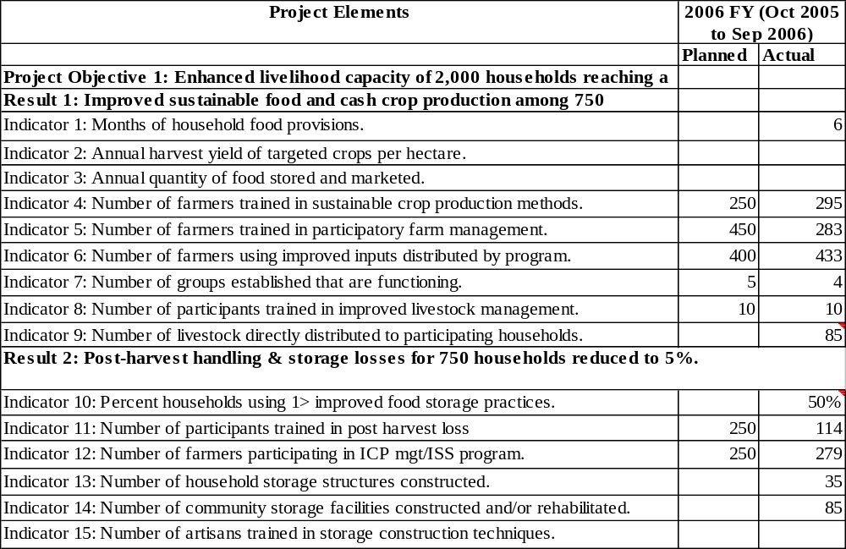
To continue in following page
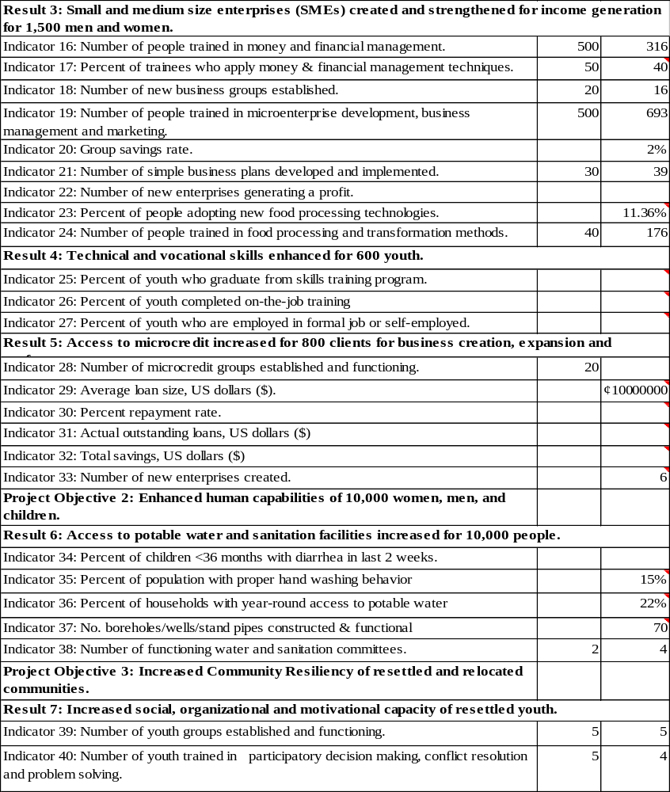

Economic Empowerment Project
OIC Côte d’Ivoire

A Micro-Credit Project
funded by
Citigroup Foundation

FY 2006

- Overview
  - Program Objectives
During this fiscal year OIC Côte d’Ivoire (OIC-CI) continued its Economic Empowerment Project - a micro-credit initiative with three-year funding from Citigroup since January 2003. This project was to assist agro-business operations in Abidjan (capital city area) and Bouaké (Northern Côte d’Ivoire), through revolving loan funds for operators already in business. The Citigroup grant also requires that a part of the funding be allocated for business and management training of the operators. The overall project objective is to alleviate the poverty of the disadvantaged populations. Beneficiary households would experience a significant increase in their income, and borrowers should be able to achieving savings equivalent to 10% of the loaned amount.

Citigroup funding totaled $85,000 provided to OIC-CI in three installments:
- January 2003 $25,000
- December 2003 $30,000
- December 2004 $30,000
Total $85,000
Due to delayed start-up – in March instead of January 2003 – the project continued through September 2006 instead of December 2005.
  - Operating environment
The project represents a development effort that immediately followed a devastating armed conflict in Côte d’Ivoire and that witnessed continued socio-economic and political instability throughout the 3 years of grant support from Citigroup Foundation. The project design provided little if any for the unexpected ravages of civil war and its aftermaths in terms of a crippled economy, spiraling inflation and masses of dislocated citizens. Such an operating environment presented both a challenge and a de facto experimental milieu for micro-credit operations by OIC-CI. Most micro-credit models pre-suppose stability both among the targeted beneficiaries and in local economic conditions.
Due to extensive and extended armed conflict in the initially designated project area of Bouaké in northern Côte d’Ivoire, OIC-CI relocated project operations to Yamoussoukro (south central part of the country) and Abidjan, the sprawling administrative center, commercial capital, largest city and former capital of Côte d’Ivoire. Finally, as Yamoussoukro – with its population grounded mostly in farming - did not provide an adequate clientele interested in micro-business credit – OIC-CI selected to operate this project mainly in Abidjan – covering several of its districts and suburbs including Adjamé, Abobo, Anyama, Koumassi, Marcory, Port-Bouët, Williamsville.
One important factor to note is that the project operated in a totally different environment than initially designed. It served a much larger area and a much more diversified and mobile population than the clientele initially expected in Bouaké.

- Program results
The project served 1,237 clients in total by September 30, 2007 or much below its projected target. The difficult operating environment as described earlier – that differed greatly from the stable environment expected in the project design – explained to a large extent the shortcoming in number of clients covered.

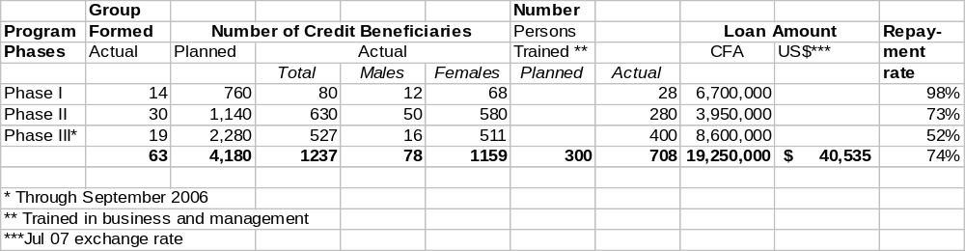
The cumulative amount of loans during life-of-project added to a significant total of CFA 19,250,000 or the equivalent of $40,535. Credit ceiling for each group of borrowers maximized at 300,000 CFA (or about $630) on the average. 703 men and women received training in management and micro-enterprise. Per grant agreement with Citigroup, the project would set aside a minimum of 85% from its funds to serve women specifically. The above table indicates that women accounted for 1,159 of the 1,237 clients served or 94% of the total.
The project achieved its major objective of serving the most disadvantaged and people outside of the economic mainstream, particularly women. Given the average African family size of eight (8) members, indirect beneficiaries approximated 9,272. Both direct and indirect beneficiaries added up therefore to 10,431 people in total.
Other benefits included the formation of vendors in the same trade into associations for cost-sharing and cost-reduction in some of their expenses such as transportation. On the average, project management estimated that the standard of living of the beneficiaries has increased by 15%.
The experience of this project confirmed:
- Need of credit services
- Courage and hard work of women in the informal sector
- Need of improved organization in the agro-business sector
- Importance of value added in the food production sector
- Need to develop saving practice
Project management already began taking steps to establish a “tontine” banking system. Its greatest need is funds for credit service.
As a result of the OIC-Citigroup partnership, goodwill had been developed between OIC-Citigroup and the small and micro-business men and women served by the project in several local areas. Communications through mass media and public events involving the borrowers and OIC-Citigroup presence highlighted the important contributions of this project to the people of Côte d’Ivoire.

Success Stories from Field Programs

These are unedited materials from the indicated program countries

FY 2006

OICI GUINEA

SUCCESS STORIES

- Health and Nutrition

“I got back my child Aissata” with OIC international benediction said Mariama Bah the sick child’s mother. This happened in one of OIC International zones, the sub prefecture of Timbi Touny, district of Hore Oury. The following pictures show:

- The nutritional statute of a child when brought to OICI hearth center in Hore Oury (a remote area) manages by an OICI field agent and three village health promoters trained by OICI.
- Different steps taken from this center to the hospital in Pita.
- The day that OIC International brought the child to his family in Hore Oury

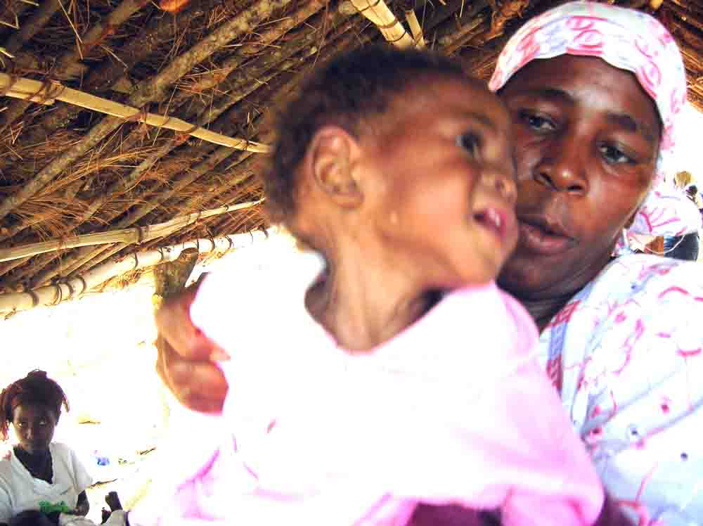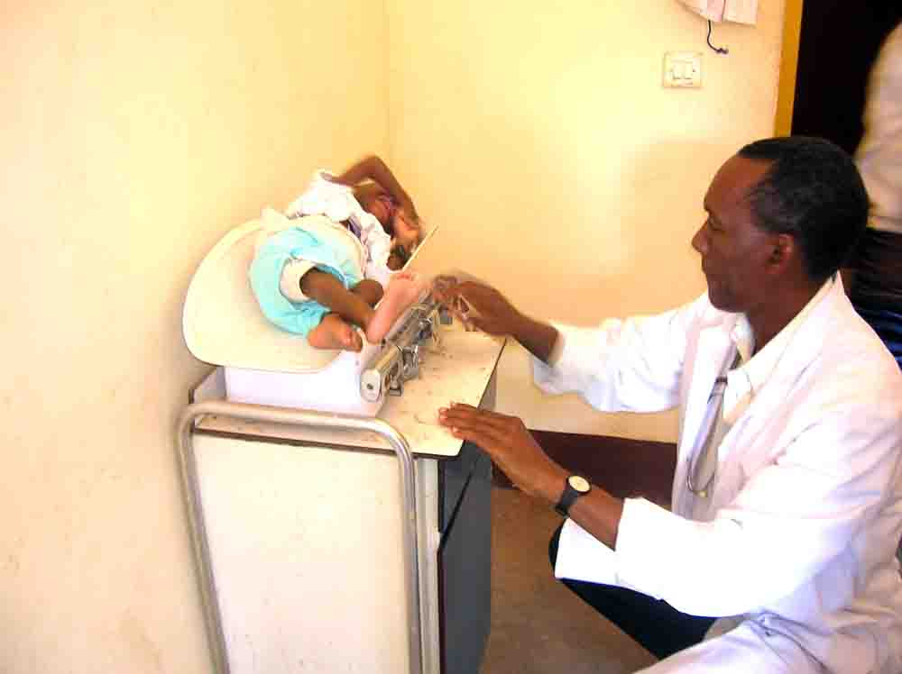
Admitted with 3.2 kg of weight, 18 months of age (first day) at Pita Hospital

Day of admission at OICI health centre
(May 14, 2007)

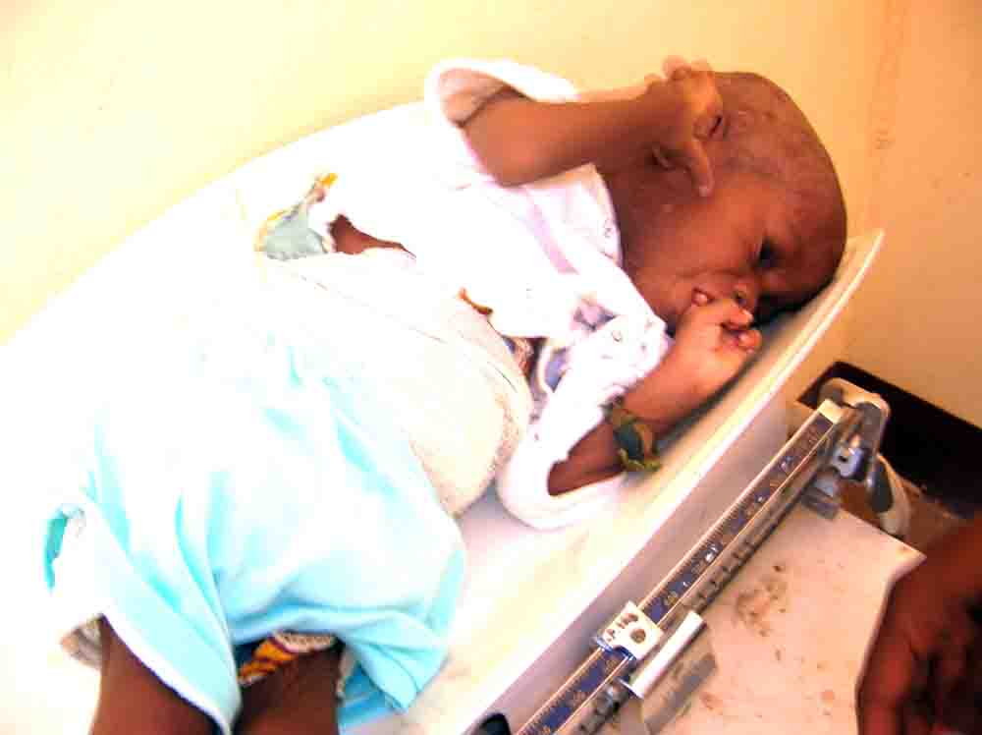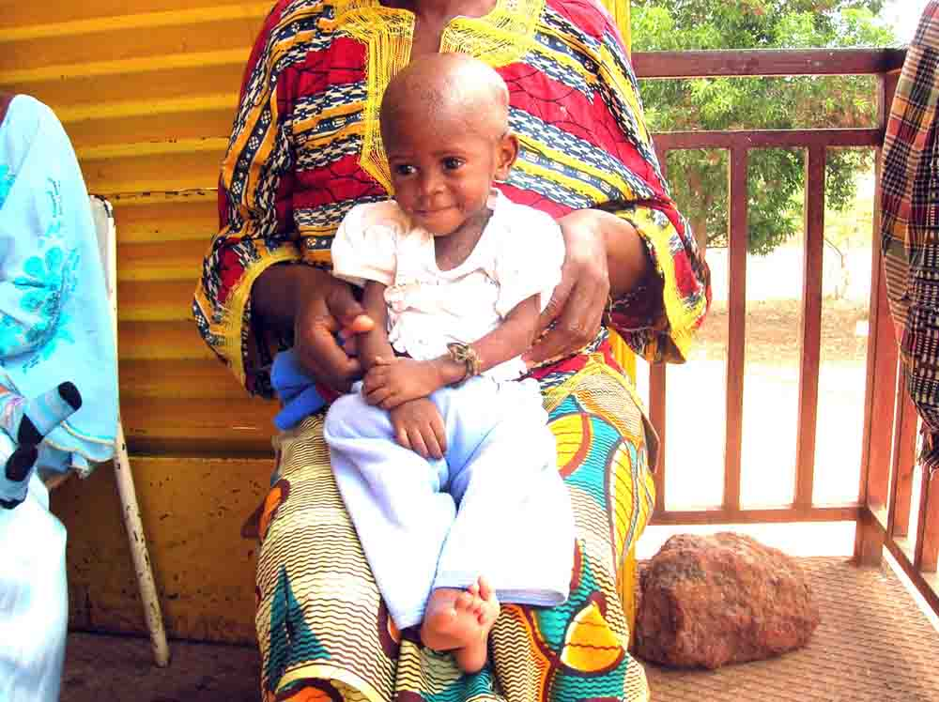
The last day at the hospital in Pita with 5.4 kg of weight
3rd day (May 16, 2007)

On the third day at the hospital, Mariama Bah said « OIC International is with God, unless God sent his staff to act as angels. I will stand for OICI for good and will carry everywhere, its messages »

Background of the history told by Mariama
« When OICI field agent at her habitual in house visits in our district, found my child in a bad condition, she asked me to bring my child to the health center, I will refer your child to them, I will be with you there. I told her, that it is a malediction to three of mothers in this village, the village seer (fetisher) said to us. With me, she visited the two other mothers who refused as me to bring our children to the health center. She spent this night to my house, and all night she was trying to convince me and my husband that my child will survived if I accept her proposition. The next day, I told her, that I accept your proposition, but I will not let my dying child goes at the hospital in Pita because, whatever he will past away, I believe to the village seer. The OICI field agent tried to convince the two other families, but she couldn’t succeed.

As soon as we are at the health center, I found OIC international car packed in front of the health center, but the field agent told me, that her supervisor came for his habitual site visits.
At the health center, when the physician looked at my child, he grounded me and the OICI field agent told him that, I want just you refer this child to the hospital. I reacted by taking my child with the physician and told the field agent that I am bringing my child to my house, I will not leave the village because whatever my child will die and I have no money to buy medicine there. At the health center, the field agent with the support of her supervisor succeeded to convince me brings my child to Pita. Three days later, with an extraordinary weight recuperation of my child, I asked the health supervisor to take picture of my child and bring it to our village; this will convince my pals bring their children immediately to Pita. OIC did it, and my pals brought their children to the hospital. Today all our three children are living and in good shape God will always bless who brought OICI to Guinea, because if OICI is not in Guinea, he will never be in Hory Oury. That is three mothers’ chances”

- Soil fertility enhancement with the use of compost

During a workshop organized by ACA on commodities exchange workshop held in Labe,
participants pointed out that prices of chemical fertilizers are always increasing and actually farmers cannot grow potatoes in actual conditions without undergoing tremendous losses. They said that the state must subsidy the price of chemical fertilizers. To close that debate, a participant farmer, trained by OICI Guinea informed the audience that “In OICI intervention zones, we are not actually using chemical fertilizers, but organic fertilizers: We are growing healthy products, with less post harvest losses. Lets a farmer leaders trained by OICI, help you produce compost that can replace chemical fertilizers you are using actually” The USAID delegate said, lets move to another matters, because with OICI we have solved chemical fertilizer matter

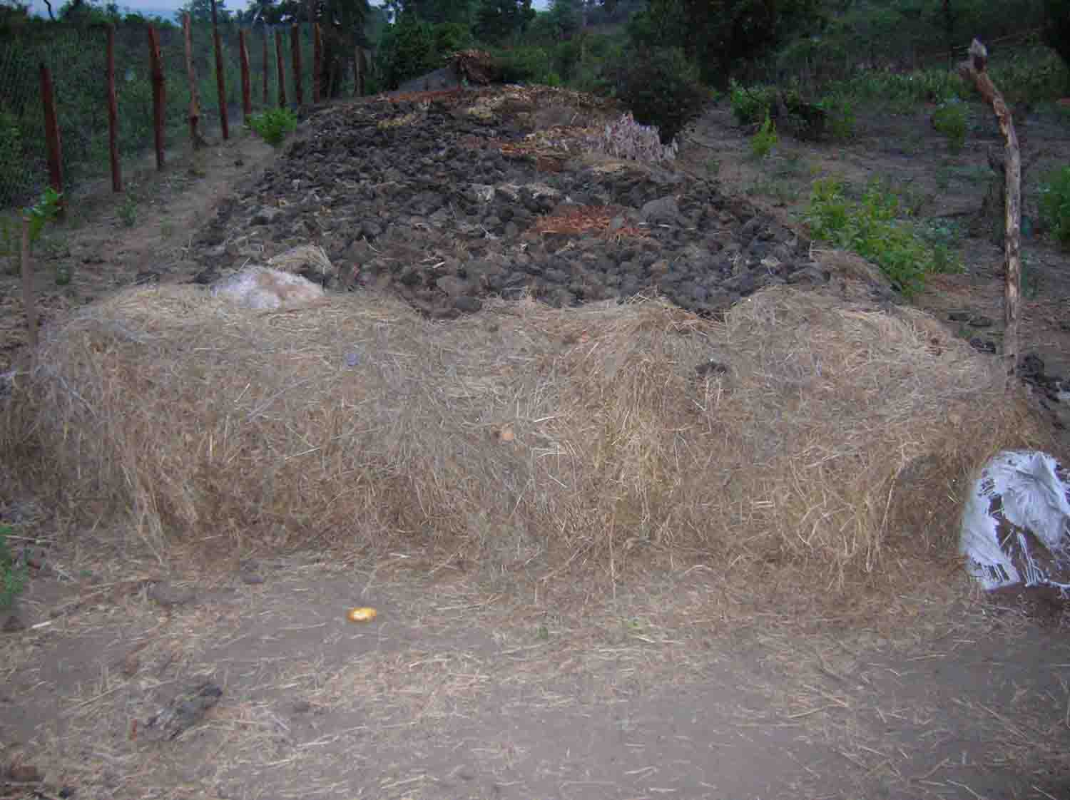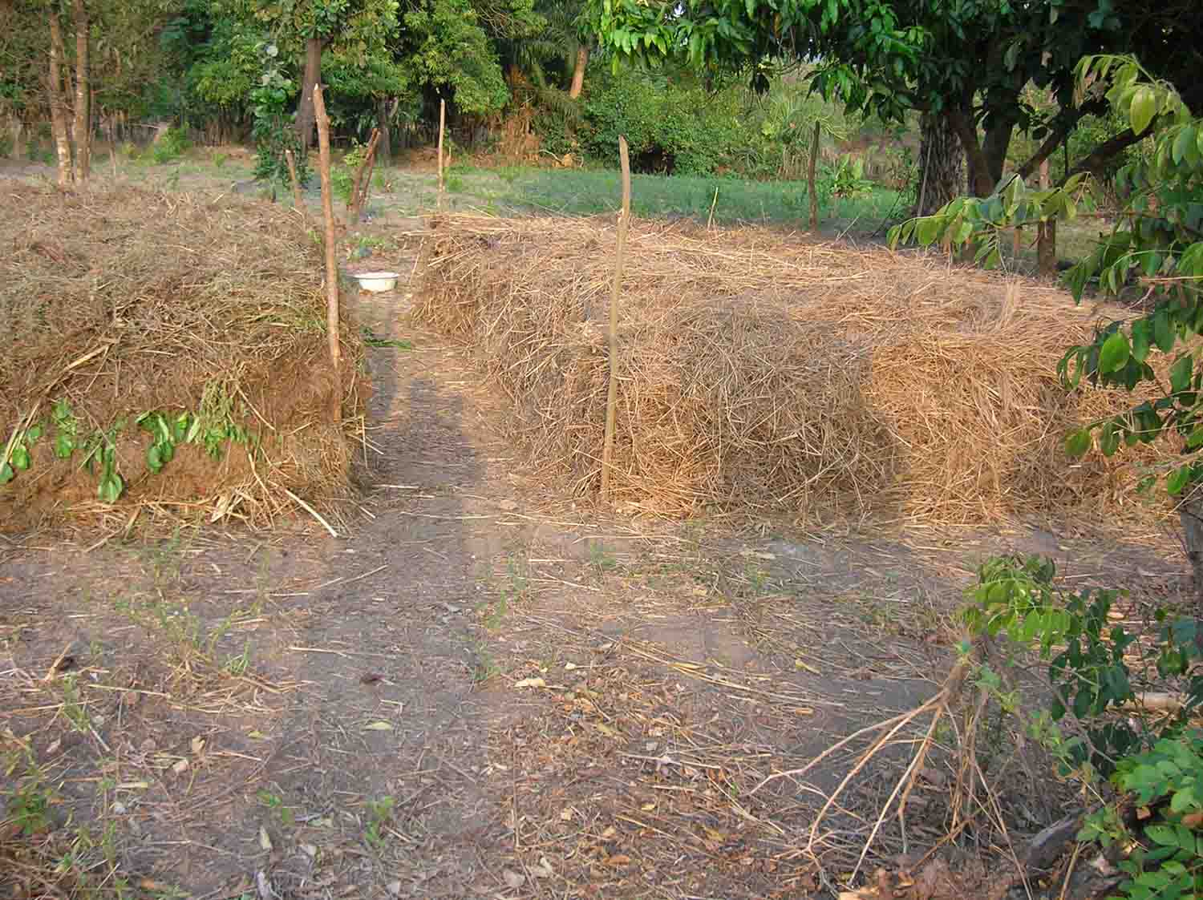

- Diet diversification and improvement

A woman said that “before working with OICI, it was a luxury to eat vegetables and only rich people in our village had access to vegetables. Now we produce them in our own villages, eat a good part of our production and sell the other part to the market to increase our family’s revenue. My husband is proud of me”

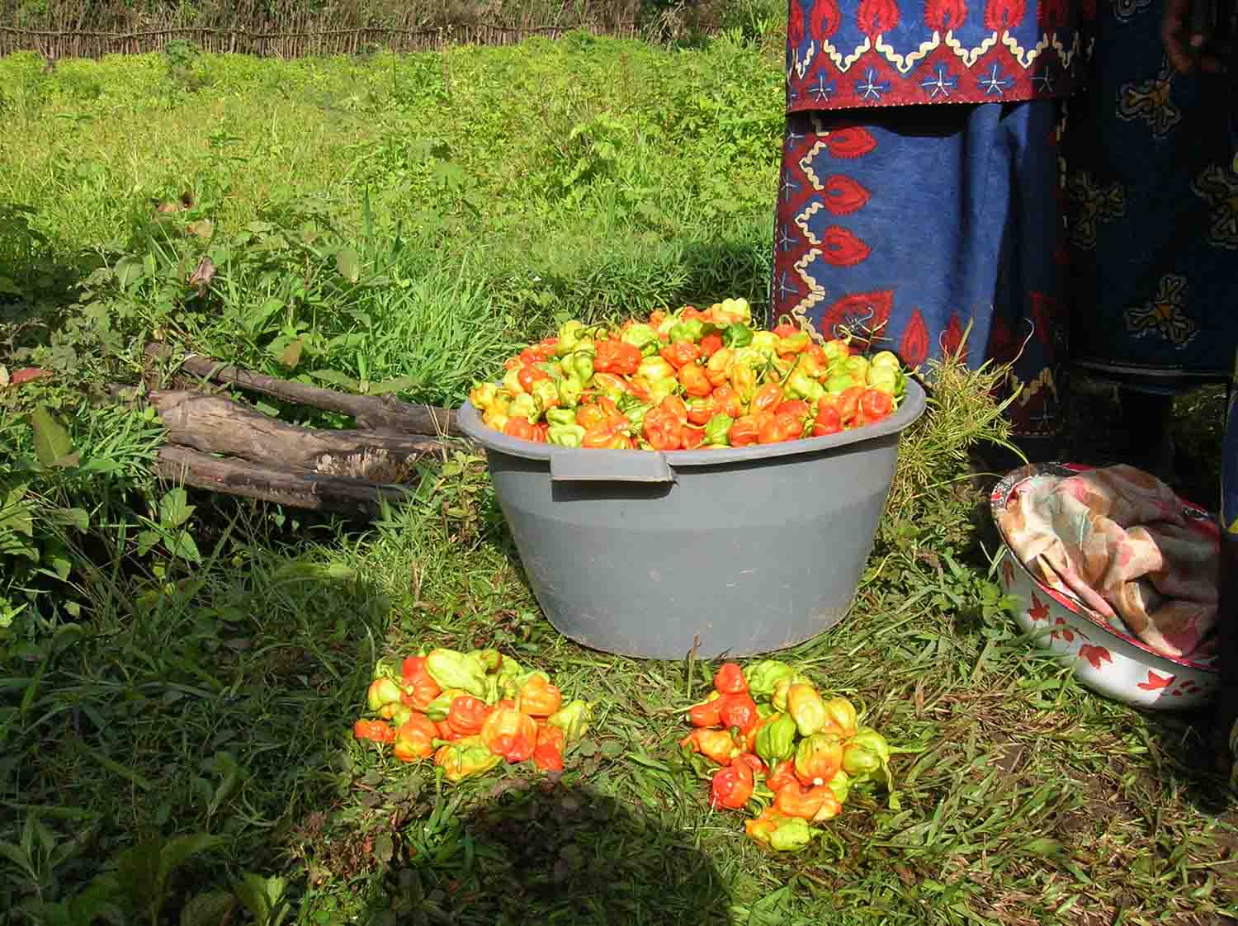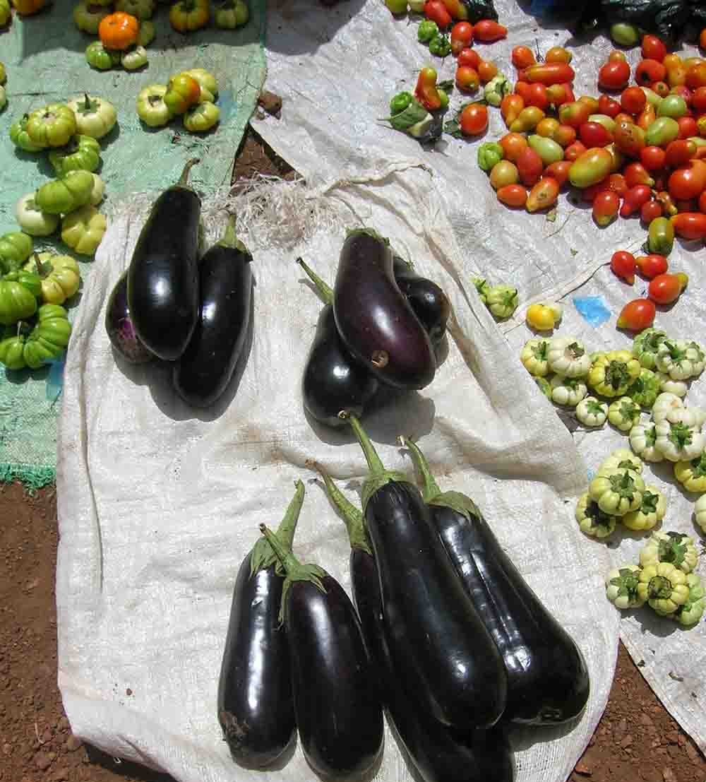

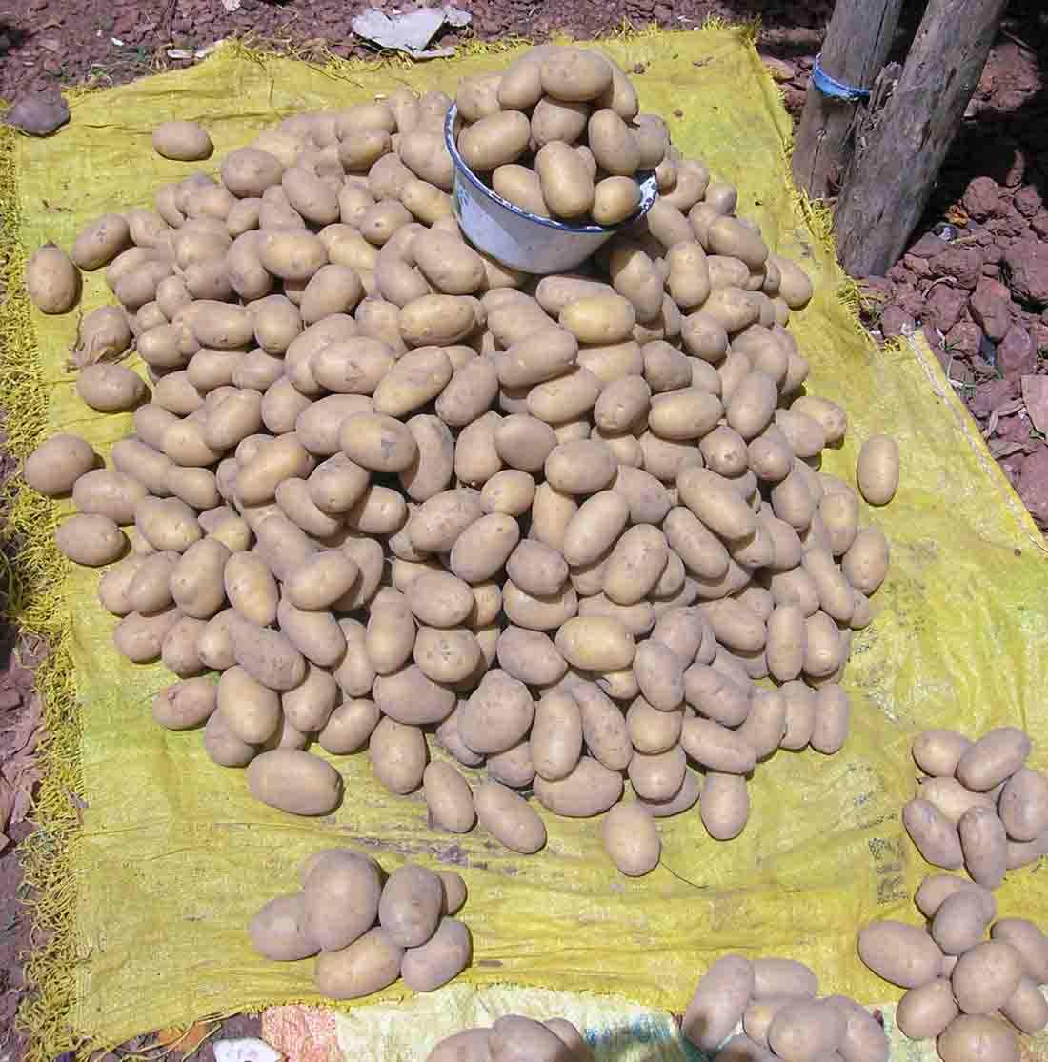
- Good governance and improvement of women position in the society
Women, trained in decision-making, poultry and small ruminants raising and vegetable production. One said: “Actually, to take a decision, my husband is referring to me, because I am participating to increase my family incomes. I am in charge of all fees related to our kids such as school, medicines, clothe and sometimes even getting for my husband some presents such as clothes or shoes. He is recognizing my merit in contributing in our household wellbeing. Thank OICI for telling me stand up to get what I want.”

- Food Distribution

  - OICI project supported the construction of a five kilometers community road with food for work component to connect the national road to a big village in the Gougoudjè district area. The first time a vehicle arrived in this village, the notability said that was the first time after fifty years of independence. Inhabitant of this village said: “This is the first time a vehicle arrived in our village. This road built with OICI support and this first vehicle is an OICI vehicle. This is a memorable date for us”.

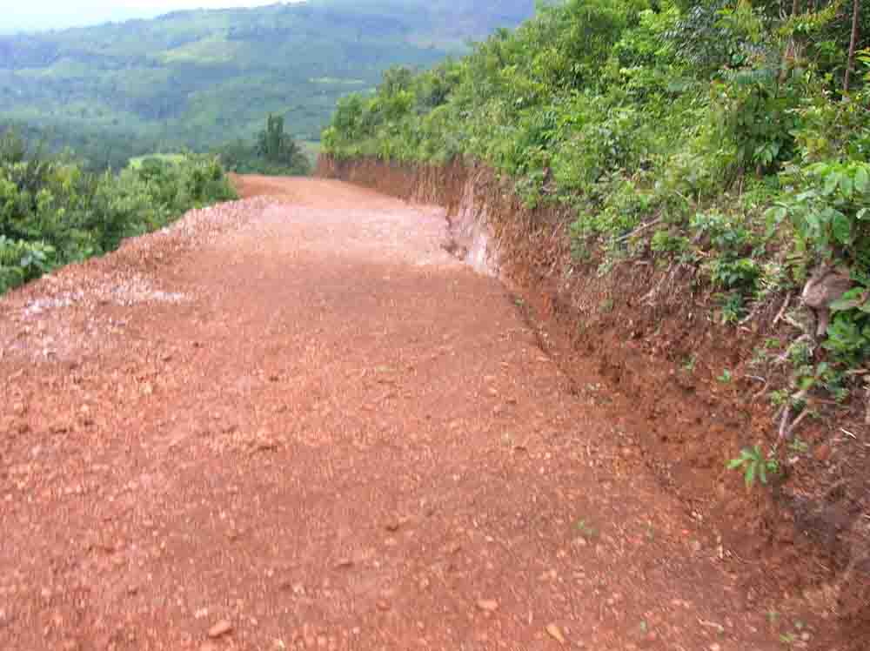

  - OICI succeeded to solve the potable water problem in the village of Missidè Kebou, sub prefecture of Gougoudjè, after several attempts by other development projects. When the well maker got, the first seal of water, inhabitants of this village organized a big ceremony in which they killed a cow as a sacrifice for OICI. That day the imam of the mosque said: “As long as I will be alive, I will bless OICI and when I will retire I will recommend the same message to my successor. God blesses Americans”

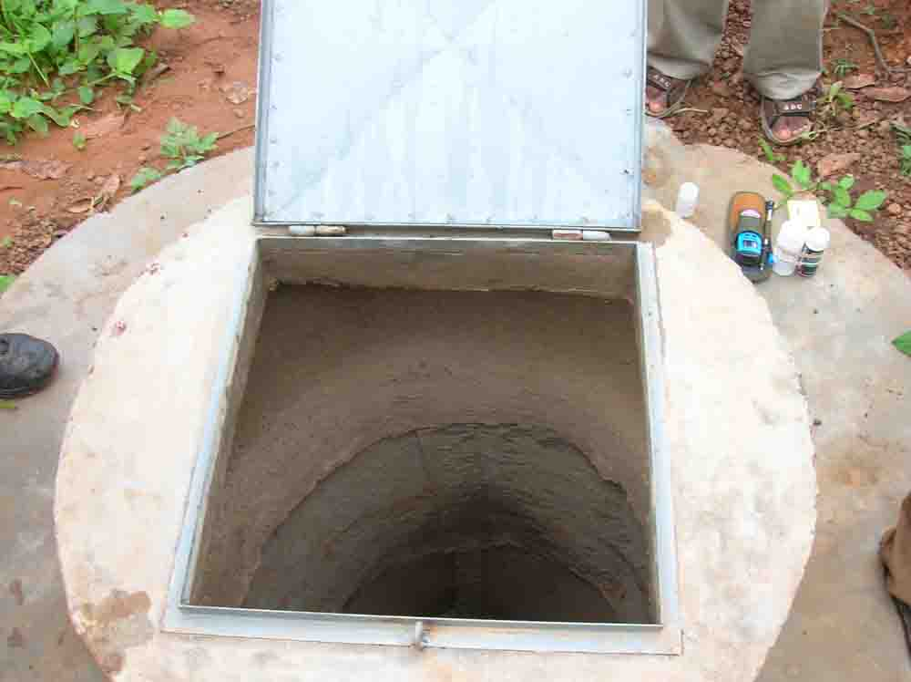
OICI GHANA

SUCCESS STORIES

From the partnership & collaboration of
OICI and GoldFields, Ghana

Sustainable Community Empowerment and Economic Development
(SEED)

- “My name is Dorcas Agyemang of New Atuabo. I am a popular cabbage and other vegetables seller. Because I was not having land, I joined the SEED program with the help of a friend called Florence Eshun who has land. We agreed to work together and we decided to cultivate and sell exotic vegetables ourselves. Initially, I was skeptic whether I could produce to meet the quality I bought to sell. Thanks to OICI for their training, technical and inputs support which have imbibed confidence in us now. Passers by who pass here to their farms are surprised at our performance and that is our pride”.

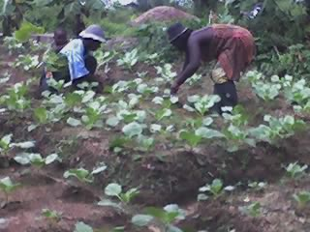
Ms Dorcas Agyemang & Florence Eshun applying fertilizer
on their cabbage in the early hours of Saturday, 3rd June 2006

- “I am Adwoa Nhyiraba of Pepesa, A beneficiary of 2 female goats. It has always been my dream to rear animals but I was not having the money and technical know-how to do it. When OIC International came to my community, I joined the livestock group and attended all the training they organized for us. Having constructed my structure, OICI gave me two female goats. With the knowledge in group development, animal rearing and feeding practices thought me by OICI, I have been able to take care of these animals for over three months now. One of the goats has given birth to one strong male goat. I am therefore happy to be part of the ‘SEED’ program from Gold Fields Ghana Limited and OICI and hope it continues for long.”

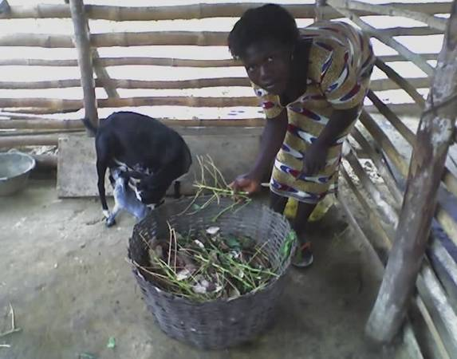
Young Billy goat enjoying breast milk of its Dam and Adwoa Nhyiraba of Pepesa preparing feed for her animal after cleaning the pen

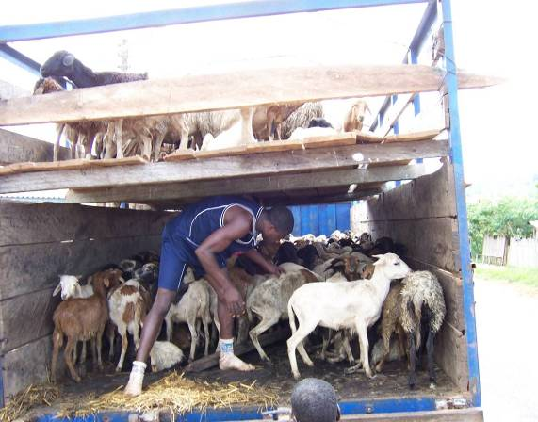

A flock of sheep from Ejura Breeding Station for Distribution to farmers

*
* *

- “I am a forty-two year old farmer and a trader in Samahu for several years. In considering which crops to plant and what commodities to sell to earn more income, it never occurred to me to find out what my customers wanted to be able to supply them in time. I only became aware of this after OICI had taken me through topics in marketing and market related issues. Having practiced what I was told to do by enquiring from my customers about what commodities they wanted, my business has seen a dramatic success. I am still optimistic that there would be ready markets for my farm produce since I cultivate what my customers want”. (Maxwell-Samahu Vegetable Group)

OICI GHANA

SUCCESS STORIES

From the partnership & collaboration of
OICI and Newmont Gold Ghana Ltd

Livelihood Enhancement and Community Empowerment Program
(LEEP)

“I have expanded my sheep and goat pen by buying two (2) female and one (1) ram to add to the two that OIC provided. Things have improved and any other support will be welcome. My wife Dorcas has purchased and added 3 goats to the two she was given as well.” Steven Effah, see photo below.

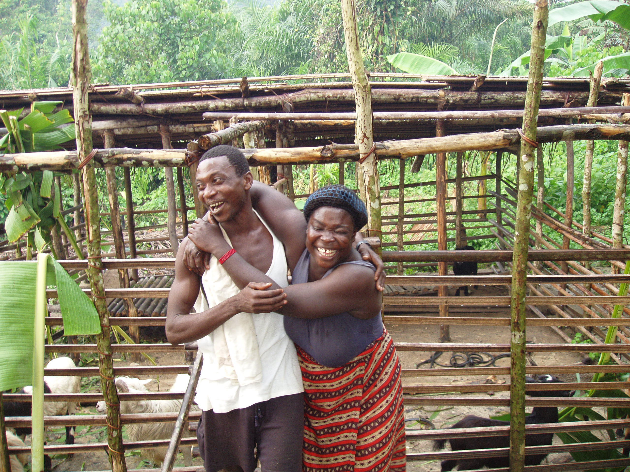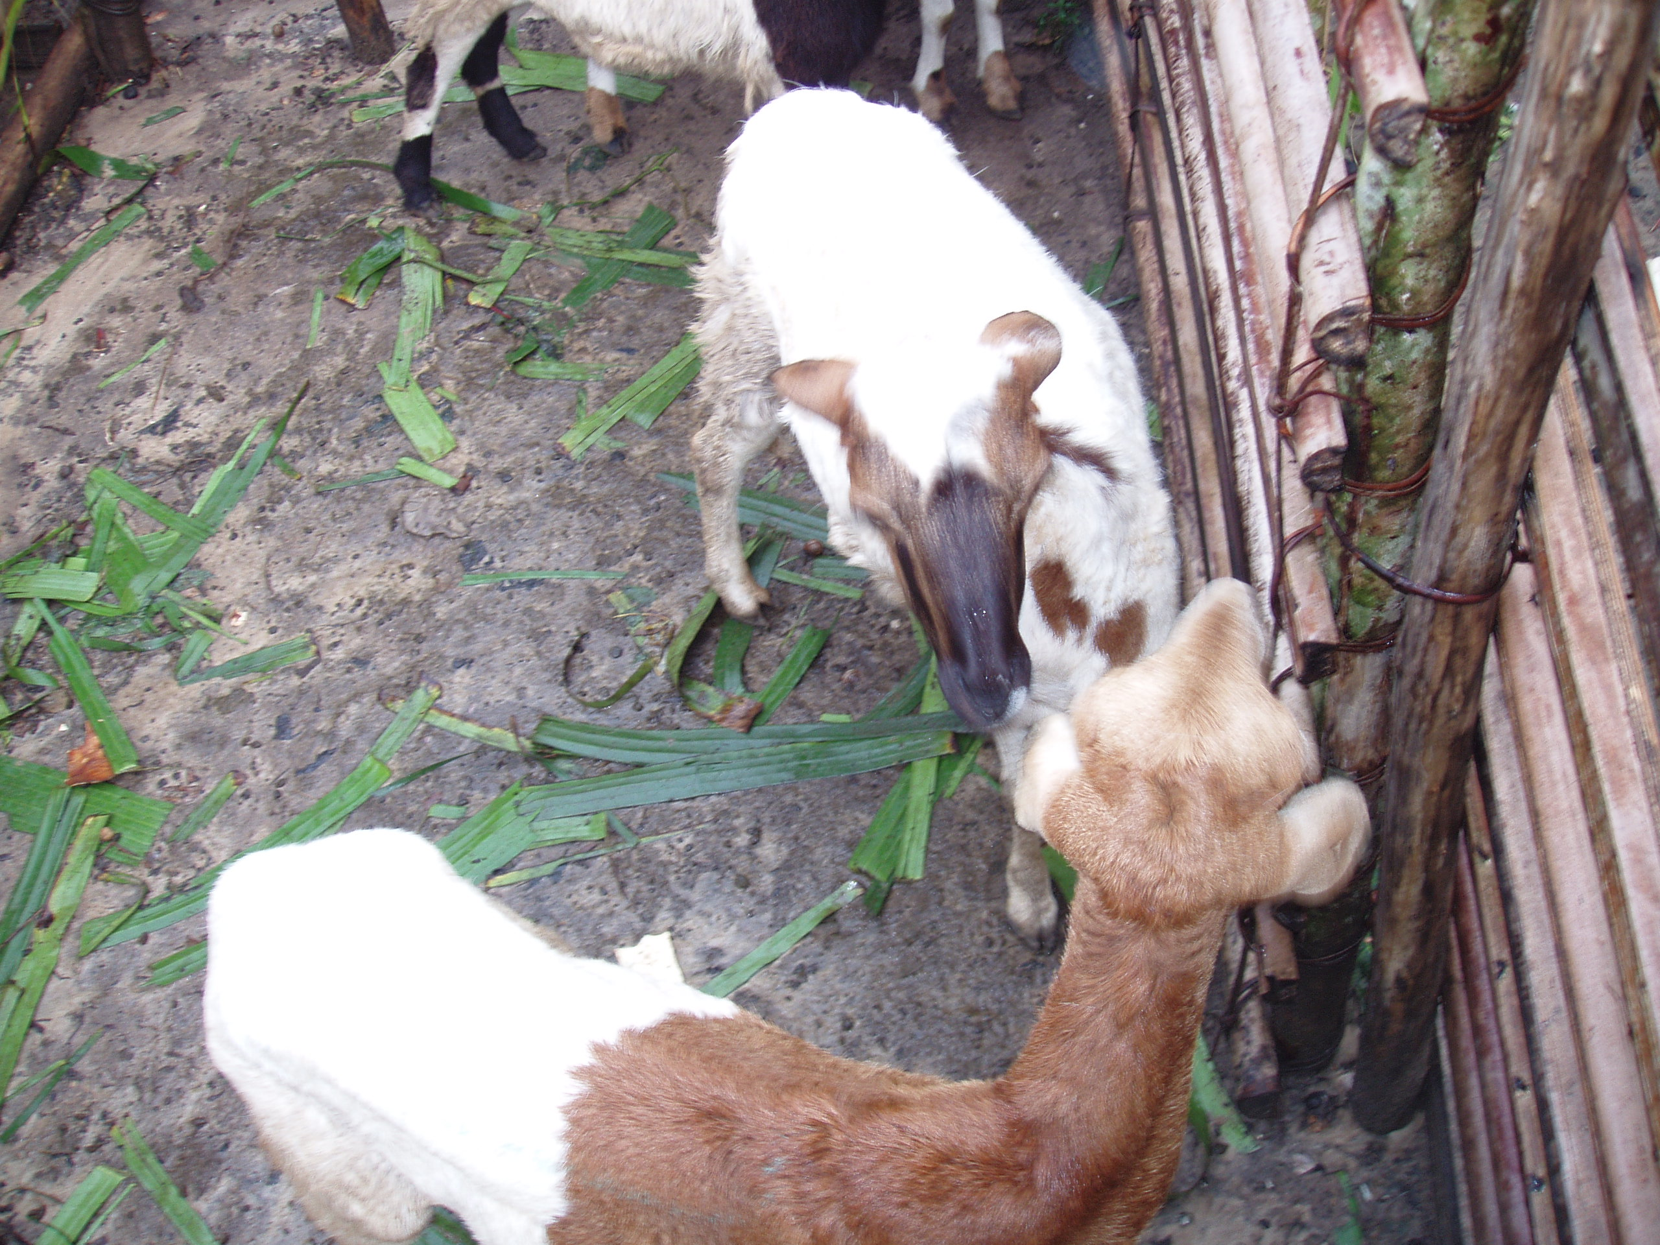

*
* *

“Gifty Amankwaah is my name (photo below). I am a housewife at the OLA resettlement camp at Kenyasi. Our land and cottage was affected by the mining activities of Newmont Gold Ghana. OICI requested for resettlers to be trained in various enterprises. I opted for grass cutter production. Initially, people were criticizing and cynical that a female was going for this enterprise training, including my own husband. With determination, I participated in a 10-day training course, after which a 2-tier cage and a family of grass cutters, consisting of a male and four females, was supplied to me free of charge. Now I can boast of 3 pregnant females who are expected to litter in about 2 months time. My husband’s contract at Newmont has expired and now we intend to expand our grass cutter business to commercial operations in order to establish a breeding station to sell starter stocks to prospective grass cutter farmers. Thanks to OICI, our financial situation will soon improve and we can take good care of our children and also improve our food intake by consuming some of the animals when the need arises. Our children’s school fees will now be paid in time.”

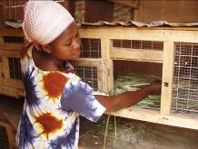

Gifty Amankwaah raising grass-cutters

OIC INTERNATIONAL, INC.
Annual Report
FY 2006
October 1, 2005 – September 30, 2006

ANNEXES

ANNEX I

OIC International Directory

Cameroon Opportunities Industrialization Centers (COIC)
Board Chair: Barrister Samuel Ekontang Elad
Address: P.O. Box 16, Buea, South West Province, Cameroon
Tel: (237) 779-5064
Fax: (237) 332-2644
samelad2002@yahoo.com
Program Director: Sammy Ekema Monono
Address: COIC, P.O. Box 57, Great Soppo, Buea, South West Province, Cameroon
Tel: (237) 332-2586
Fax: (237) 332-2586
camoic@yahoo.com

Opportunities Industrialization Centers Chad (OIC Chad)
Program Director: Mr. Kelly Ouyanga Jé Guindja
Address: OIC Chad, B.P. 226, Sarh, Chad
Tel: (235) 681-671
Fax: (235) 681-670
ouyanga@yahoo.fr

Opportunities Industrialization Centers Côte d'Ivoire (OIC-CI)
Board Chair: Mr. Yao Armand
Address: 20 BP 1523, Abidjan 20, Côte d'Ivoire
Tel: (225) 21-26-74-87
Fax: (225) 21-28-46-42
oici@aviso.ci
Executive Director: Mr. N'doua Affely
Address: BP 2269, Yamoussoukro, Côte d'Ivoire
Tel: (225) 30-64-06-55
Fax: (225) 30-64-00-13
oicyakro@aviso.ci

Opportunities Industrialization Centers Ethiopia (OIC Ethiopia)
Board Chair: Mr. Tilahun Giday
Address: Pathfinder International, P.O. Box 12655, Addis Ababa, Ethiopia
Tel: (251) 11-661-3549
Fax: (251) 11-661-4209
tgiday@pathfinder.org
Program Director: Mr. Yalew Melesse
Address: P.O. Box 2486, Addis Ababa, Ethiopia
Tel: (251) 11-275-0151
Fax: (251) 11-550-7847
oicethiopia@ethionet.et

The Gambia Opportunities Industrialization Centers International (GOIC)
Board Chair: Mr. Bakary L.O. Sonko
Address: Director, Department of Cooperative Development, 14 Marina Parade, Banjul, The Gambia
Tel: (220) 422-7504
Fax: (220) 422-7502
registrardocd@gamtel.gm; bakary_sonko@yahoo.co.uk
Program Director: Mr. Habib F.K. Touray
Address: The Gambia OIC, Self Development & Training Center, P.O. Box 6034, Farafenni, North Bank Division, The Gambia
Tel: (220) 992-2245
Fax: (220) 573-5259
hfktouray@yahoo.co.uk

Opportunities Industrialization Centers Ghana (OIC Ghana)
Board Chair: Dr. Emmanuel Dogbatse
Address: Swan Clinic, P.O. Box AN7954, Accra-North, Ghana
Tel: (233) 208-153297
Fax: (233) 21-764144 / (233) 21-502036
oicghana@yahoo.com
Program Director: Mr. K.A. Keelson
Address: OIC Ghana, P.O. Box AN 6241, Accra-North, Ghana
Tel: (233) 21-286235
Fax: (233) 21-7010527
oicghana@yahoo.com

Lesotho Opportunities Industrialization Centers (LOIC)
Board Chair: Adv S.M. Seeiso
Address: P.O. Box 1358, Maseru, Lesotho
Tel: (266) 588-51289
seeiss@lesotho.com
Program Director: Mr. P. Sekhesa
Address: Lesotho OIC, P.O. Box 2542, Maseru 102, Kingdom of Lesotho, Southern Africa
Tel: (266) 223-13119
loic@leo.co.ls

Liberia Opportunities Industrialization Centers (Liberia OIC)
Board Chair: Rev. Dr. Walter D. Richards
Address: Liberia OIC, P.O. Box 3596, New Matadi, Sinkor, Monrovia, Liberia
Tel: (231) 651-8004
walterdoss2002@yahoo.com
Program Director: Mr. George Kpawulu
Address: Liberia OIC, P.O. Box 3596, New Matadi, Sinkor, Monrovia, Liberia
Tel: (231) 6-55-4034
liberia_oic@yahoo.com

Opportunities Industrialization Centers Mali (OIC Mali)
Board Chair / Program Director:
Mr. Simpara Ibrahim
Tel: (233) 675-7848
oic-mali@cefib.com

Opportunities Industrialization Center Niger (OIC Niger)
Board Chair: Mr. Djibo Garba
Address: B.P. 12671, Niamey, Niger
Tel: (227) 73-37-89
Fax: (227) 73-37-89
oicniger@intnet.ne
Program Director: Mr. Hassane Karanta Assoumane
Address: OIC Niger, BP 12671, Niamey, Niger
Tel: (227) 73-37-89
Fax: (227) 73-37-89
ha_karanta@yahoo.fr; oicniger@intnet.ne

Nigeria Opportunities Industrialization Centers (NOIC)
Board Chair: Mrs. Victoria E. Odia
Address: NOIC, Plot A14, Oshodi-Oworonski Express Way, Gbagada, Lagos, Nigeria
Tel: (234) 01-774-2390
noicsecretariat@yahoo.com
Executive Director: Mr. Olufemi Abiona
Address: NOIC, Plot A14, Oshodi-Oworonski Express Way, Gbagada, Lagos, Nigeria
Tel: (234) 0802-307-9943
noicsecretariat@yahoo.com

Opportunities Industrialization Centers Poland (OIC Poland)

Polska Fundacja Ośrodków Wspomagania Rozwoju Gospodarczego (OIC Poland)
Ms Teresa Bogacka
Executive Director
20-209 Lublin, ul. Mełgiewska 7/9
tel.: + 48 81 749 17 70
fax: + 48 81 749 32 13
e-mail: sekretariat@oic.lublin.pl
www.oic.lublin.pl

Sierra Leone Opportunities Industrialization Centers (SL-OIC)
Board Chair: Dr. Mori Nanyeh
Address: PND 388, 4 Hillview Drive, Murraytown, Freetown, Sierra Leone
Tel: (232) 76-604-811
sloic_nationaloffice@yahoo.com
Program Director: Samuel Maligi
Address: PND 388, 4 Hillview Drive, Murraytown, Freetown, Sierra Leone
Tel: (232) 76-611-527
samligi747@yahoo.com

Opportunities Industrialization Centers Tanzania (OICT)
Board Chair: Ms. Bernadetta Ndunguru
Address: P.O. Box 78384, Dar es Salaam, Tanzania
Tel: (255) 22-286265
bndunguru@hotmail.com
Program Director: Mr. Kawa E. Kundaeli
Tel: (255) 22-0744-276018
kundaeli@yahoo.com; oictanzania@gmail.com

Opportunities Industrialization Centers Togo (OIC Togo)
Board Chair: Mr. Arouna Sema
Address: 155, rue 43 des Rossignols (Ex rue Agnes GABA), Kodjoviakope, B.P. 3665, Lome, Togo
Tel: (228) 903-7186
oic-togo@cafe.tg
Program Director: Mr. Dondja Tchayiza
Address: 155, rue 43 des Rossignols (Ex rue Agnes GABA), Kodjoviakope, B.P. 3665, Lome, Togo
Tel: (228) 442-0004
Fax: (228) 442-0194
tchayiza@yahoo.fr; oic-togo@cafe.tg

Zimbabwe Opportunities Industrialization Centers International (ZOIC)
Board Chair: Mr. John Chitekuteku
Address: P.O. Box A1626, Avondale, Harare, Zimbabwe
Tel: 263-470-8909
Fax: 263-425-2768
admin@zoic.co.zw
Program Director: Mr. Phillip Bohwasi
Address: P.O. Box A 1626, Avondale, Harare
Zimbabwe
Tel: 263-470-8909
Fax: 263-425-2768
Phillip@zoic.co.zw

ANNEX II

OIC International Board of Directors

Chairman:  Mr. Edmund D. Cooke, Jr.  Mintz, Levin, Cohn, Ferris, Glovsky and Popeo  701 Pennsylvania Ave., N.W.  Washington, DC 20004-1601  Tel: (202) 434-7409  Fax: (202) 434-7400  Home: (703) 239-8697  ecooke@mintz.com  Admin Asst: Pamela Smith  (202) 434-7369  plsmith@mintz.com | Secretary:  Dr. Emma Durazo  1400 S. Joyce Street  Apt. 1732  Arlington,VA 22242  Office: (703)741-7795  Fax: (703)741-7313  Home:(703)521-1639  mickeycd @aol.com
Vice Chairman:  Mr. James Talton  229A1 Millcreek Blvd.  Suite 285  Shakerheights, OH 44122  Home: (216) 765-4106  Cell: (216) 990-6811  JTalton@hotmail.com | Treasurer:  Mr. Joseph L. Mayfield  Time Inc.  1271 Avenue of the Americas Room 42-021  42nd Floor  New York, NY 10020  Office: (212) 522-9496  Home: (203) 661-8446  Cell: (917) 865-2220  joemayfield@ timeinc.com
Cody Anderson  3819-33 Chestnut St.  St. Leonards Court, Suite 325 Philadelphia, PA 19104  Office: (215) 823-6970  Fax: (202) 823-6973  Home: (215) 848-3790  wcody22@aol.com | The Honorable Vivian Lowery Derryck  Academy for Educational Development  1875 Connecticut Avenue, N.W.  Washington, DC 20009-1202  Office: (202) 884--8970  Fax: (202) 884-8400  Home: (202) 545-0022  vderryck@aed.org
Oliver St. Clair Franklin  International House Philadelphia  3701 Chestnut Street  Philadelphia, PA. 19104  Office: (215) 895-5625  Home: (215) 370-2063  Fax: (215) 895-6550  ofranklin@ihphilly.org | Ms. Carol A. Peasley  4469 Q Street, N.W.  Washington, D.C.20007  Office: (202) 338-3153  cpeaslev@starpower.net
Gloria D. Pualani  8206 Waterside Ct.  Fort Washington, MD 20744  Home: (703) 875-8451 Gloria.Pualani@noc.com | Mr. Ernest Wilson  19370 Magnolia Grove Square  Unit 302  Lansdowne, VA 20176  Home:(703) 858-5401
Board Emeritus:

Rev. Gus Roman

1401 Wistar Dr.
Wyncote, PA 19095
Home: (215) 576-7698
eurablk@aol.com

ANNEX III
OIC International Headquarters Staff, FY 2006

President & CEO (Interim): Ronald W. Howard
(215) 842-0220 ext. 103, rhoward@oici.org
Vice President Business Operations: Quy D. Nguyen
(215) 842-0220 ext. 104, quynguyen@oici.org
Vice President Programs: Steven J. Wisman
(215) 842-0220 ext. 119, sjwisman@oici.org
Director of Development: Dr. Molly Roth
(215) 842-0220 ext. 108, mroth@oici.org
Director of FarmServe: Michelle Frain-Muldoon
(215) 842-0220 ext. 118, mfrain@oici.org
Director of Finance: Joel D. Affognon
(215) 842-0220 ext. 121, daffognon@oici.org
Director of Food Security: Emmanuel Atieku
(215) 842-0220 ext. 113, eatieku@oici.org
Director of Vocational Training & Job Creation: Dr. Jeffrey Tines
(215) 842-0220 ext. 111, jtines@oici.org
Monitoring & Evaluation Specialist: Dr. Alfred Tambe
(215) 842-0220, atambe@oici.org
Program Manager – USDOL Project: Rachelle Martinez
(215) 842-0220 ext. 122, rmartinez@oici.org
Human Resources Officer: Vanessa Kilcrest
(215) 842-0220 ext. 108, vkilcrest@oici.org
Executive Program Assistant: Colin Hagans
(215) 842-0220 ext. 102, chagans@oici.org
Program Assistant: Natasha Acheampong
(215) 842-0220 ext. 139, nacheampong@oici.org
Senior Accountant: Ivan Llewellyn
(215) 842-0220 ext. 116, ivanl@oici.org
Grant Accountant: Abiba Konate
(215) 842-0220 ext. 105, abibak@oici.org
Staff Accountant – Part-Time: Wadeeah White
(215) 842-0220 ext. 115, wadeeah@oici.org

COUNTRY REPRESENTATIVES

Ethiopia Country Representative: Dr. Fantaw Makonnen
251-1-505160, makonnen@oici.org

Ghana Country Representative: Carla Dominique Denizard
233-21-500-230, carla@oicighana.org
Guinea Country Representative: Leon Sakho
224-1-2504618, lsakho@oici.org

Nigeria Country Representative: Jacqueline Hardware Glin
234-64-201-361, jahardware@oici.org
Togo / Cote d'Ivoire Country Representative: Henry Taylor-Cline
228-221-0339, hstcline@cafe.tg

ANNEX IV

Capability Statement: OIC International, Inc.

1. Alleviating Human Suffering in Developing Countries Worldwide

1a. For over thirty years, OIC International (OICI) has attempted – and successfully accomplished – a most difficult task: training the least-educated, most socially and economically underprivileged youth and adults who live in developing countries and turning them into productive, well-esteemed members of their communities. Mostly in their teens and early twenties, OIC trainees typically never held a job and faced the prospect of a life of continued unemployment or underemployment before coming for training in one of OICI’s affiliate programs. Over the years, OIC board members, managers, and staff in almost two dozen African, Asian, Latin American, and Eastern European countries have taken the raw human potential of countless individuals--who were often judged by others as highly unlikely to succeed--and turned out skillful carpenters, masons, plumbers, electricians, typists, tailors, shoemakers, commercial artists, motor mechanics, computer technicians, caterers, bookkeepers, farmers, and entrepreneurs after just a few months of training. This is a tribute to the inherent ability of youth in the many nations where OICI has been privileged to serve and at the same time testimony to the uniqueness of the OICI program model. OICI takes a non-traditional, non-formal approach to transforming school dropouts and high-school graduates – and in some cases, former combatants and child soldiers – into productive citizens who are highly valued in their home communities.

1b. Since 1970, OICI has specialized in creating indigenous non-governmental organizations in developing and transitional countries – community-based organizations that provide training in vocational and technical skills, agricultural and rural development, post-conflict rehabilitation and reintegration, and entrepreneurship. Today, OICI works with 49 affiliated programs in 19 countries – 17 of them in Africa, one in Poland, and one in the Philippines. These OICI-affiliated programs work in close partnership with local governments, community groups and individuals, and public and private donors. The programs have easily served over a quarter-million youth and adults, more than half of them women, in a broad range of countries.

1c. Over 50 percent of OICI's beneficiaries have been impoverished, socially and politically disadvantaged women who have benefited not only from the vocational and technical skills training OICI supports but also from our health and nutrition programs that offer strategies to improve women’s health and child survival. By promoting breastfeeding and complementary infant feeding practices, immunization, maternal and infant healthcare, diarrhea-management programs, and water and sanitation projects involving borehole and well digging, for example, OICI has provided a foundation for meeting some of the greatest challenges to survival that women and children in developing countries face.

2. Distinguished Record of Achievement

2a. The first community-based OIC training center was started in an abandoned jailhouse in a North Philadelphia ghetto back in 1964 by the Reverend Leon H. Sullivan, a renowned American civil rights leader who later also contributed significantly in the struggle to end Apartheid in South Africa. Providing non-formal, entry-level skills training to disadvantaged minority youth, this self-help skills-training project soon became a model for similar community-based training programs across the United States. Today, 75 OIC of America program sites carry on training programs for economically disadvantaged trainees--mainly African Americans and Native Americans--who acquire job-market-relevant skills that build their self-esteem and allow them to successfully enter the world of work.

2b. Founded in 1969, five years after the first OIC training center opened in Philadelphia, OICI was established at the request of Africans who wished to implement in their own countries the OIC training model that had proven so successful in the United States. The first OIC affiliate programs started in Nigeria, Ghana, and Ethiopia in 1970, and similar programs soon followed in other parts of Africa and elsewhere in the world. Today, 49 OICI programs deliver services to disadvantaged youth and adults in 19 countries. OICI’s resilience and success is attributable largely to the organization’s ability to adapt to changing social, political, economic, environmental conditions in the countries where OICI operates and to the organization's efficient and effective responses to the needs of its clients as defined by the clients themselves.

2c. Flexibility in the OICI program model has allowed us to expand beyond its vocational skills-training focus to become an organization that now also promotes food security through agricultural outreach and extension, health and nutrition education, and agribusiness development and credit extension to farmers. OICI has taught thousands of farmers how to increase their food production and has saved literally tons of harvested food from spoilage and loss by teaching enhanced food-storage technologies. Drawing on resources from agencies and organizations such as USAID’s Office of Food for Peace, USDA’s Food for Progress program, and the UN World Food Programme, OICI has fed its trainees, helped distribute food to victims of war and other emergencies, and encouraged farmers displaced by war to resettle their home communities.

2d. In microenterprise development, OICI’s affiliated programs have provided business training and services and extended credit to small entrepreneurs and spurred the growth of thousands of new income-generating enterprises in Eastern Europe and East and West Africa. In natural resource management, OICI has helped communities create tree nurseries, reforest denuded lands, and replenish overworked soils by training community leaders in environmentally sound and sustainable farming practices that help curb soil erosion and stop deforestation while augmenting food production.

2e. The civil wars in Liberia and Sierra Leone of the 1990s propelled OICI into supporting emergency and post-war rehabilitation services for refugees, the internally displaced, former combatants and child soldiers, and others adversely affected by war. In Liberia, OICI has assisted tens of thousands of refugees and displaced persons resettle in Liberia by offering them agricultural training, food, seeds, and farm implements through a network of satellite centers. WE also provided learning opportunities for orphans during the Liberian civil war. In Sierra Leone OICI similarly turned training centers into shelters and feeding centers for refugees and set up new, short-term training programs to enable the displaced to start their own small businesses. In both countries, war-trauma-counseling programs have helped the severely traumatized recover from the shocks of civil war and begin to resume normal life again.

3. Innovations in Program Design and Program Implementation

3a. OICI is one of a very small number of non-governmental organizations to have offered comprehensive services to the disadvantaged over several decades. Supporting non-formal, experiential, competency-based programming that develops the “whole person,” OICI motivates the downtrodden and gives them the skills they need to enter the world of work. Equally if not perhaps more important are the ancillary services OICI provides: literacy and numeracy training, basic health and nutrition education, communication skills and conflict resolution training, career advice and personal counseling, apprenticeships and on-the-job training, job-placement assistance, and follow-up support to ensure that trainees do not fall back into unemployment and poverty after they graduate.

3b. Over time, OICI has added to the technical and vocational skills-training programs on which its reputation was established to assist in new areas – namely, agricultural development, health and nutrition, natural-resource management, and small-business development, and in some places, war-trauma healing, peace education, and post-conflict reconstruction and reintegration. As an example, young graduates from the OICI agricultural training program in Togo came together and pooled their newly acquired skills and resources to start a new farming village. Entrepreneurship training in several OICI countries has encouraged young trainees to start their very own businesses. On another front, thousands of persons affected by war in Liberia and Sierra Leone have benefited from OICI's trauma-counseling programs and resettlement packages, through which they have rebuilt their war-ravaged homes and communities and returned to gainful employment. OICI's viable training model and set of innovative tools and systems to have played and important role in assisting the most vulnerable.

4. Organizational Capacity and Administrative Efficiency

4a. The 49 OIC programs currently operating in 19 countries are linked together by the OICI headquarters staff of twenty professional managers, technical specialists, and logistical support persons who assist with institutional development and resource mobilization and provide other demand-driven technical assistance. Among these staff members are a half-dozen specialists assigned to overseas programs as country representatives and/or regional program developers. Coming from the U.S. and from developing countries in Africa and Asia, OICI’s staff is a highly diversified workforce with cross-cultural working experience, an in-depth understanding of the clients they serve, flexibility and adaptability, and diverse language capabilities. Most have spent several years living and working in developing countries and have accumulated extensive and relevant educational and professional experience. Organized into strategic objective teams, the OICI staff members further focus their skills and their work in four specific areas: education and training, food security, entrepreneurship and business development, and financial and administrative support.

4b. Among OICI’s major projects in its thirty years of existence have been 44 USAID-funded projects valued at nearly $75 million. Annual independent audits have verified OICI’s ability to comply with federal-government regulations and to effectively manage and assist overseas projects. OICI has achieved similar success in meeting the contractual and grant requirements of its donors and in meeting project objectives.

4c. Three decades of technical assistance provided by OICI staff have produced a global network of over 400 OIC affiliate board members serving today. Representing a cross-section of prominent high-profile figures in their countries and communities, these women and men are active and successful in their own diverse fields of endeavor, both public and private. They are leaders in government, business and industry, religious and educational institutions, and local community organizations. Working on a voluntary basis on the OICI local boards, they provide the necessary policy-making support and the enlightened, solid leadership that accounts for the successful track record of the OICI affiliates. Many have served on their boards for over twenty years and continue to provide the necessary policy direction, administrative oversight, motivation, and quality leadership that keep their affiliate programs moving forward.

4d. Essential to the OICI network of affiliate programs is the active workforce of one thousand local women and men staff in the 19 OICI-affiliated program countries. Hired by their national or local boards, these staff members bring together valuable combinations of professional and technical skills and expertise. They represent an outstanding and unique workforce with a reputation for providing effective, practical training and, most of all, for being firmly committed to their trainees and to OICI’s self-help philosophy and methods. Many have worked in the OICI programs for years and have benefited from the counterpart training OICI offers through in-country technical assistance, regional conferences, and exchange visits. Exemplifying OICI's self-help philosophy, the board and staff members of the affiliates engage in diverse resource-mobilization efforts, including fundraising events, drives for international donations and grants, economic ventures, fundraising efforts among local businesses, and parent and alumni contributions. The income and publicity generated by these efforts testify to the strong, lasting impact of OICI programs in the communities they serve.

5. Collaboration and Sustainability

Born out of close collaboration with local communities, host governments, and international donors, OICI and its local affiliates are deeply committed to fostering long and fruitful working relationships with diverse individuals and groups from both public and private sectors. Initially, our affiliates are created by indigenous interest-group members, who secure support from their target communities and often their host governments then receive technical assistance from OICI in developing and implementing their programs. In many countries, OICI has collaborated actively with international agencies such as the UN Development Program and the World Food Program. Always seeking to build its own capacity, OICI has formed strategic alliances and mentoring partnerships with other non-profits recognized for excellence such as Catholic Relief Services, the Adventist Development and Relief Agency, and Africare. Freedom from Hunger also has supported OICI in implementing the Credit-with-Education model, a microcredit program providing health and nutrition training to disadvantaged women as well as financial support for their own businesses. Other organizations have directly assisted our affiliates. For example, the Latter Day Saints Charities recently helped upgrade our Ghana program's information-technology capacity, which has helped our training graduates qualify for higher paying, high technology jobs.

6. Demonstrated Long-Term Impact

6a. OICI's concept of sustainable development is based not on the notion of purely implementing projects with short-term perspectives. Rather, the strength of OICI's approach lies in its emphasis on creating sustainable institutions, on assisting our affiliates become self-governing and financially independent. To facilitate and expedite affiliates' growth, OICI provides technical assistance in all aspects of institutional development, including board development, staff training, management and financial system implementation, and resource mobilization.

6b. The best testimony to the long-term impact of OICI's focus on institution-building is the ability of its affiliates to continue to develop skilled graduates, year after year, long after initial donor support has ended. Although the initial grant funding for the first OICI affiliate in Nigeria ended in 1975, 25 years later Nigeria OIC is still going strong, producing almost 1,000 program graduates each year and starting programs in new locations. Continuous service and expansion also holds true for the OICI affiliates in Ghana, Ethiopia, Liberia, Sierra Leone, Lesotho, Gambia, and Togo – all over twenty years old but still contributing actively to their countries' human resource development. The OICI affiliates begun more than ten years ago in Cameroon, Cote d'Ivoire and Guinea and those started during the 1990s in Poland, the Philippines, South Africa, Tanzania, and Zimbabwe demonstrate the same institutional strength and potential for longevity as the older affiliates. Today, only four OIC country affiliates operate with grant support channeled through OICI; the remaining 14 are standing on their own. OICI's record of successful institutional development may be unsurpassed by any comparable organization in Africa. On yet another level, the long-term impact of the global OIC movement is directly evident through the program beneficiaries who have acquired skills that will last them for a lifetime. Job employment, self-employment and increased earnings for the target beneficiaries of OICI programs are more long-term benefits resulting from our work.

6c. The societal impact of OICI's programs also is considerable. Besides the many oral and written accolades from African heads of state and high government officials in appreciation of OICI’s contributions to reducing unemployment, host country governments have provided material support of various kinds. In Ghana, Lesotho, Liberia, Sierra Leone, Cameroon, Côte d' Ivoire, Gambia, and Guinea, financial subventions have covered substantial portions of OICI program-operating costs, and almost every OIC country program has received in-kind government support such as land, training facilities and equipment, seconded personnel, tax and duty-free privileges, and access to bilateral and multilateral donors.

7. Program Areas of Specialization

7a. Education and Training

OICI's Education and Training Program seeks to improve the lives of individuals in developing countries by providing vocational skills training and job development services for employment; conflict prevention and peace building services in conflict situations, and civil society strengthening through working with local NGOs.
- Skills Training and Job Development: Skills Training and Job Development promotes a comprehensive and adaptable approach to human resource development that has ensured that the vocational skills training and employment services provided by OICI's affiliates are always relevant to a developing country’s market demand for skilled labor. We target disadvantaged youth and others who are critical to the future development of the countries in which we work.
We focus on both the supply and demand-side of individual country’s workforce. Engaging the leadership from both the training institutions and employment organizations. Providing non-formal education with a balance of training: 70 percent practical and 30 percent theoretical. Practical skills training leading to job placement or self employment; training courses tailored to respond to current market demands for labor based on regular job market surveys and employer forums; life skills education, job counseling, on-the-job-training and employment support services to address the psychological needs which may pose barriers to success; business training courses for trainees interested in self-employment.
- Conflict Resolution, Reconciliation and Peace Building: OICI’s activities in conflict prevention and peace building began in the early 1990s in Sierra Leone and Liberia as a result of civil conflict overtaking development priorities in those countries. What started as an extension of skills training and job development services to ex-combatants and child soldiers slowly expanded to serve the needs of various individuals and communities affected by violence and conflict. We provide: Trauma counseling services, psychosocial support, training of trauma counselors, reintegration skills training, resettlement and conflict resolution training in conflict and post-conflict settings; peace education, peace building workshops and mediation activities in conflict-prone regions. Our community-based approach to social reconciliation includes community sensitization, participatory planning and integrating local knowledge systems and traditions in all projects. Our beneficiaries include the internally displaced, refugees, amputees, ex-combatants, child soldiers, war widows, youth, women and others affected by war.

- Civil Society Strengthening: Civil society development projects build the capacity of local NGOs and other community-based organizations, enabling them to work effectively on behalf of local groups and communities. Our Education and Training program designs and delivers workshops and technical advisory services to enhance basic management systems for local organizations. OICI’s experience includes: Forming, training and developing local boards of directors; strategic planning and business plan development; training in resource mobilization and resource management strategies; developing monitoring systems and conducting participatory evaluation; training in grant writing and reporting; improve collaboration among local NGOs through strengthening information-sharing and providing networking opportunities; improve civil society-government relations through civic education, advocacy and training for government officials.

7b. Food Security

OICI’s Food Security strategy focuses on the areas of agriculture and natural resource management, and health and nutrition. OICI currently works in Ghana, Guinea, Togo, Chad and Cote d’Ivoire in creating community-based solutions to problems of unsustainable farming practices, environmental degradation, inadequate knowledge about nutrition, and lack of access to health services and potable water.

Agriculture and Natural Resource Management. OICI introduces improved farming methods, such as post-harvest technologies and bullock traction, adapted to local cultural and environmental conditions. OICI also offers credit to small farmers to provide access to critical farming inputs. Other areas of intervention are agroforestry, inventory credit, post-harvest management and processing, storage and agricultural marketing, including formation of farmer groups that support an integrated approach to finding solutions to increasing farm productivity. Under a complementary Farmer-to-Farmer program, OICI places US volunteer agricultural specialists for short-term technical assistance benefiting African farmers. The American volunteers and local agricultural committees work together on projects such as small-scale irrigation systems, seed multiplication, integrated pest management, and reforestation methods.

OICI works with affiliate partner NGOs and provides direct technical assistance to farmer groups in their communities. We use teams of field extension agents/facilitators who live and work with the selected groups in the communities. These agents promote changes in attitudes in addition to improving their client’s skills in agriculture, as well as other areas such as business development, income generation, health, water management, and sanitation. Agents use participatory approaches in teaching and learning, and technical materials developed by OICI. Under the Farmer-to-Farmer program, US agricultural specialists spend three to four weeks in rural communities providing technical training to community groups, as well as to technical specialists from government agencies, partner organizations, and local OICI staff.

Health and Nutrition. OICI includes health education in food security activities to enable individuals and their families to make healthy choices regarding maternal and child health and nutrition, adolescent reproductive health with a focus on HIV/AIDS prevention. OICI has projects introducing health education coupled with skills training for young adults, health education to mothers participating in microcredit programs, and community-wide HIV/AIDS awareness campaigns. Our strategy also includes projects that increase the availability of and access to potable water sources in rural communities. Deep borehole wells are built with the participation and contribution of community members. OICI works with these same communities to establish water and sanitation committees who take on the responsibility of transferring messages using the training they received in hygiene, sanitation, and well and pump maintenance to other community members.

OICI partners with local health institutions and health organizations to provide a holistic set of health and nutrition, and water and sanitation interventions at the community level. Community facilitators who live and work with the selected groups in the communities promote changes in attitudes and behavior. OICI also conducts center-based skills training, and provides reproductive health education, family planning and counseling services to young adults.

7c. Entrepreneurship and Business Development

The mission of the Entrepreneurship and Business Development (EBD) program is to assist small and micro-business men and women in increasing their earnings, access to capital and wealth creation ability. Toward this end, OICI provides capacity building support in business development and microfinance services to affiliate OIC programs and other local providers serving the small and microenterprise sector.

OICI adapts market-driven business development and microfinance service products that assist resource-poor entrepreneurs in self-employment and in improving their profits and productivity. It targets in particular current small and micro-business owners with growth potential, aspiring entrepreneurs in expanding economic sectors, unemployed at-risk youths with marketable vocational technical skills, farmers and poor women in rural areas, and adults with potential self-employment capacity in post-conflict countries.

Business Development Services. Our services include training-of-trainers, assistance in product development, and service delivery support as an integral part of our capacity building process. We work with our OICI affiliates and other local partners in developing market-driven BDS products for maximum outreach, impact and cost-effectiveness. Our products range from training on business start up, feasibility study and market survey to consulting on business plan development, credit access, marketing and business expansion.

Most of these services focus on livelihood skills and specific businesses such as tie-and-dye and batik production, furniture making, dress making, ceramics, poultry and hog raising, and food processing. In May 2002, OICI partnered with SEEP in presenting a seminar on state-of-the art in business development services to 35 participants from 21 NGOs and private organizations. We are now completing the design of a business model for sustainable information-technology programs for both training and income generation purposes. Countries with such programs include: Cameroon, Côte d’Ivoire, Ghana, Guinea, Sierra Leone, Tanzania, Zimbabwe and Poland.

Microfinance Services. OICI's microfinance program provides resource poor, largely rural microentrepreneurs with the working capital they need to start, expand and diversify their existing businesses. We design support packages on the basis of clients’ needs and local business conditions. OICI has developed innovative microfinance service products in areas such as: agricultural/rural credit; small business credit; vocational-technical graduates credit; and, savings mobilization for microentrepreneurs. In most cases, training in capacity building, women leadership, functional literacy, and business education are an integral part of the financial support package. These services strengthen the clients as entrepreneurs by facilitating the development and the conduct of their businesses. They also contribute to further ensuring proper and timely loan repayment. Countries with OICI microfinance retailers include: Chad, Côte d’Ivoire, Ghana, Guinea, Niger, Nigeria, Togo, Philippines.

Sustainability Services. In facing the challenge of sustainability in its BDS and microfinance programs, OICI has expanded its scope of work on the sustainability issue to cover the NGO sector as a whole. In collaboration with Lassen Associates, a small specialized firm dedicated to improving solutions for poverty alleviation, OICI is offering training and support in organizational and financial sustainability to both the network of OICI affiliates and the NGO community. OICI and Lassen Associates conducted sustainability seminars for NGOs in Ghana in November 2001, and at two locations in Tanzania in February 2002. These seminars benefited a total of over 150 participants nearly 70 NGOs and private organizations. These seminars, together with others being planned for the near future, address the questions of how to increase NGO income, improve cost saving and management, and strengthen leadership and organizational capacity for sustainability.

7d. Training in International Development Career

In April 2005 OICI began piloting its Building Global Bridges program that aimed at helping Philadelphian college graduates and young adults in learning about international work as a career option and how to gain related employment. Funded by the U.S. Department of Labor, Building Global Bridges (BGB) objectives were to:

- Raise awareness of opportunities in the field of international development among sixty (60) adult job-seekers;
- Provide intensive, practical training to thirty-five (35) adults;
- Work with thirty (30) high school students, introducing them to the field and giving them the information they need to make informed decisions vis-à-vis their career goals;
- Offer individualized mentoring to all students, maximizing program impact and guiding their next steps;
- Cultivate linkages with employers in the field, moving sixty percent (60%) of skills-training participants into placements at the end of the program.

The program design is to bridge the employment gap between International Development Employers and college graduates/young adults who desire to pursue International Development as a viable career path. Through partnerships with seven (7) Philadelphia-area universities, OICI has successfully trained over one hundred and twenty (120) college juniors, seniors, and recent college graduates for careers in the International Development industry. Many of our graduates have gone on to pursue opportunities with reputable organizations such as UNICEF, World Learning for International Development, and the USDA’s Foreign Agricultural Service. The success of BGB has generated a demand among the college community, with new requests from other area universities for partnership.

Facilitated by OICI staff, BGB provides intensive, ten (10) week training sessions which delve into the core of international development operations—organizational development; project development, planning, implementation, monitoring and evaluation, and sustainability; resource generation and proposal development, and cross-cultural communications. At the end of this ten week session, BGB participants formally present to a panel of experts their projects their projects, which is essentially a reflection of their learning experiences in the classroom.

The attractiveness of our program is in its pragmatism—using experienced professionals to teach concepts with the flavor of their own professional experiences—and in the career guidance and resources that OICI staff provides to help participants shape their career goals and find employment opportunities.

Major donors providing these grants in FY 06 included: USAID, USDA, Packard Foundation and CitiGroup Foundation.
* Asterisked program countries are those with program activities funded through OICI in FY 06.
PLWHA: People living with HIV/AIDS
OVC: Orphans and vulnerable children
In this report the terms farmers and farm households, when used with statistics, are interchangeable and mean the same: the farmers.
In this report, the terms Farmer-to-Farmer (FtF), FarmServe Africa (FAS) and FSA/FtF are used interchangeably to mean the same John Ogonowski Farmer-to-Farmer (FtF) Program, Cooperative Agreement #: EDH-A-00-03-00021-00 that OICI is implementing. FtF is the generic name from USAID; FarmServe Africa is a program brand name of OICI.
VEGA=Volunteers for Economic Growth Alliance
An agriculturalist is defined as an individual working in agriculture, such as a farmer, extension agent, professor, researcher, vendor, etc. FSA/FTF target agriculturalists are those working with small family farmers producing on less than 10 hectares of land.
Recruitment piece refers to the advertisement or announcements sent to targeted lists and people by OICI. See Annex for examples of recruitment pieces.
See FarmServe Africa Detailed Work Plan FY07.
See OICI’s profile on VEGA website www.vegaalliance.org
Average farm size per individual farmer is ½ hectare.
Ministry of Agriculture Mali Agriculture Census 2003
This figure comprises beneficiaries that were counseled and
This figure comprises the computer training provided at the JOBS Center in Kano, Nigeria.
This indicator was previously noted as the Percent increase in level of income of clients. The methods applied to obtain information on this indicator remains the same.

